# MaxAir Tasmota Lamp Zone Setup Guide

## Introduction

The purpose of this guide is to describe the setup of a zone comprised of multiple Tasmota controlled lamps. The configuration is based on the ‘standard’ four-layer model, where the Tasmota switches are added as nodes and configured as Relay devices.

|  |
| --- |
| **Schedules** |
| **Zones** |
| **Devices** |
| **Nodes** |

### Step 1 – Layer 1 Configuration - Connect the Nodes

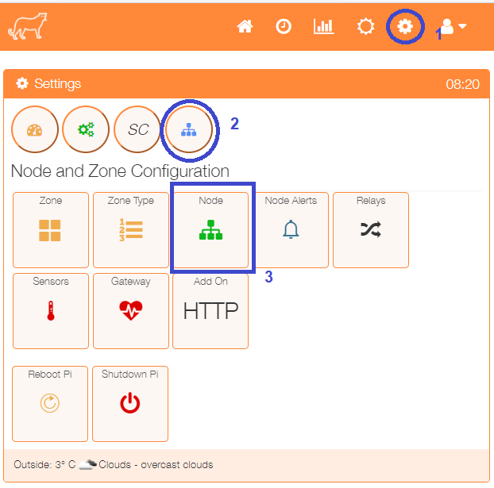This example configuration will use three Tasmota switched, which will need to be manually added as nodes. Select Node from the Settings/Node and Zone Configuration menu.

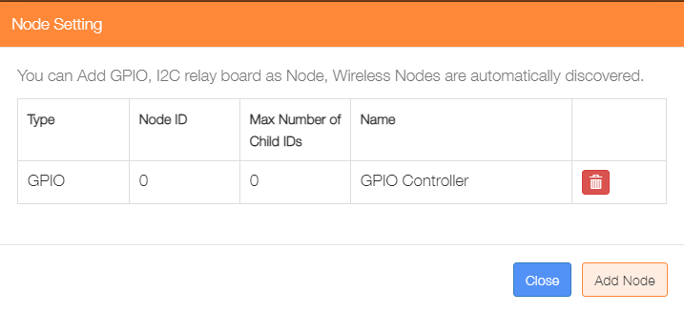Click on ‘Add Node’.

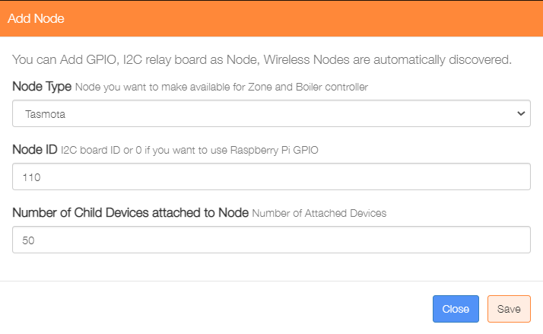

Select Tasmota from the Node type dropdown list

Enter a value of for the Node ID

Enter the last octet of the IP address to be used for this device

Click on the ‘Save’ button to update the nodes table.

Repeat the process for the remaining two Tasmota switches, allocating a Node ID to each one. The value for Number of Child Devices attached to the Node should represent the hast segment of the IP address for the Tasmota switch, e.g. if the switch’s IP address is 192.168.0.50, then the value entered would be 50.

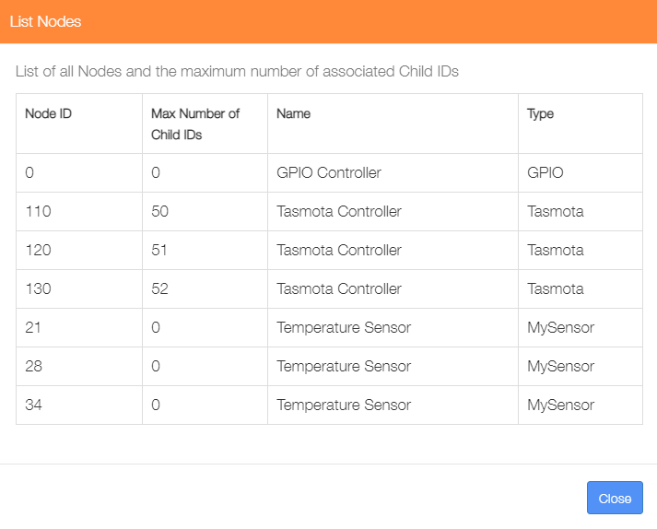Re-displaying the nodes from the Settings/System Configuration menu will show that the Tasmota nodes have been added.

**This completes the Layer 1 configuration.**

### Step 2 – Layer 2 Configuration - Add Devices

This step will add the Tasmota Switches as Relay devices.

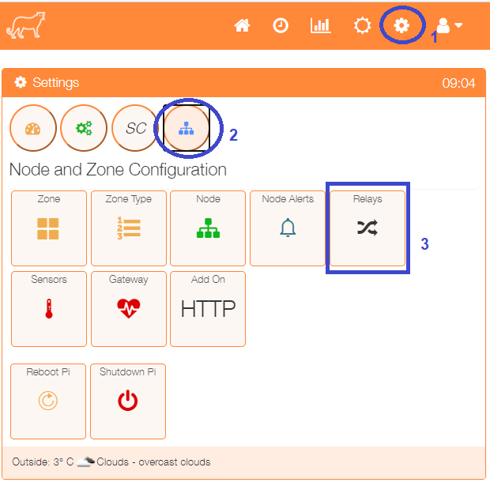Select the Relays menu item from the Settings/Node and Zone Configuration menu to display a list of any currently configured relays.

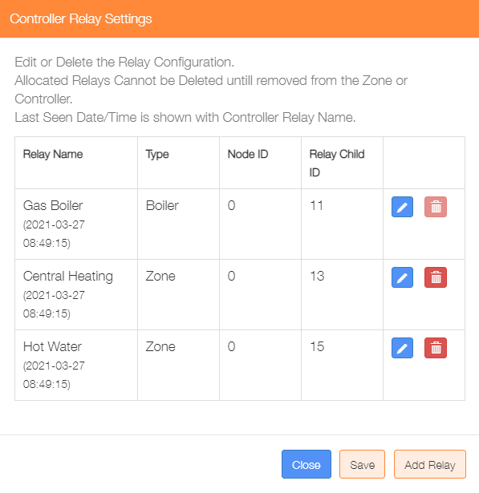Click on the ‘Add Relay’ button to configure each Tasmota switch as a relay

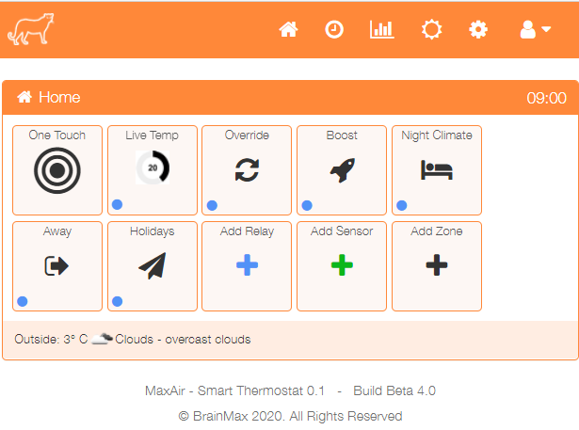

An alternative method to go directly to the Add Relay dialogue, is from the Home screen click on the ‘One Touch’ button then select the ‘Add Relay’ menu item.

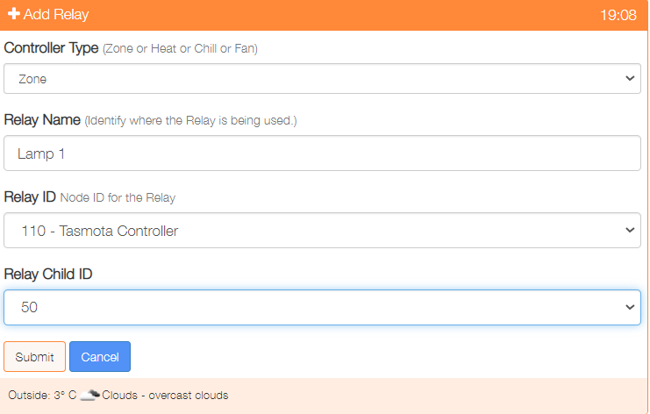

Select the Controller Type - Zone

Provide a name for this relay device

Select the Relay ID from the dropdown list of available Nodes

Choose the Child ID from the dropdown list, use the last value from the list

Click on ‘Submit’ to add the device.

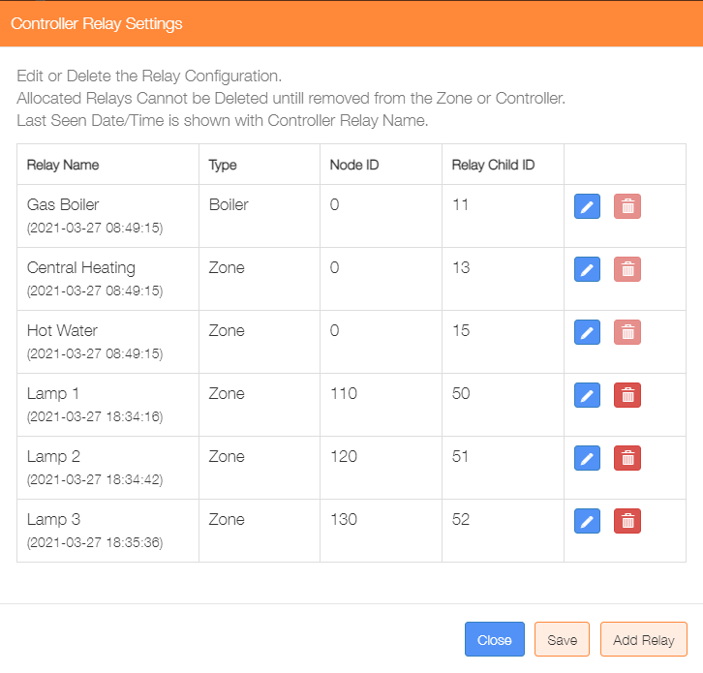

Repeat the process to add the remaining Zone Controller relays.

Re-selecting the Relays menu item from the Settings/Node and Zone Configuration menu will display the updated list of currently configured relays.

This dialogue can be used to Add/Delete/Edit the relay configurations.

**This completes the Layer 2 configuration.**

**Layers 1 and 2 define the basic hardware configuration of the system.**

### Step 3 – Layer 3 Configuration - Add Zone

The example configuration will have add the three lamps to a single zone, so that they can be controlled by a single schedule. An alternative approach would be to allocate each lamp to a single zone, with an individual schedule for each.

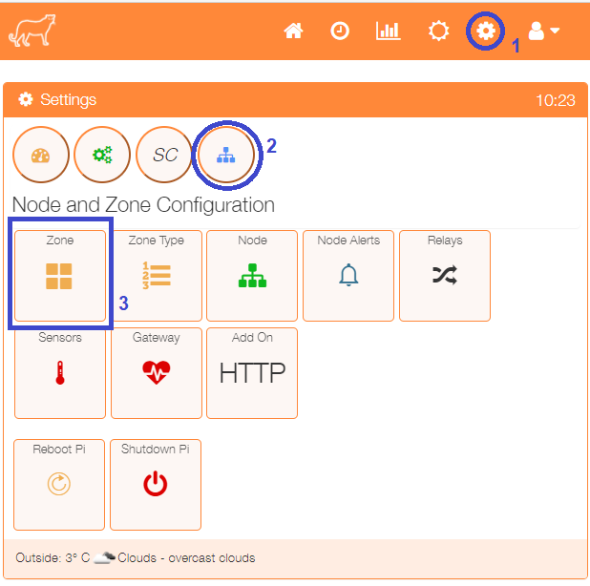

Select the Zone menu item from the Settings/Node and Zone Configuration menu to display a list of any currently configured sensors.

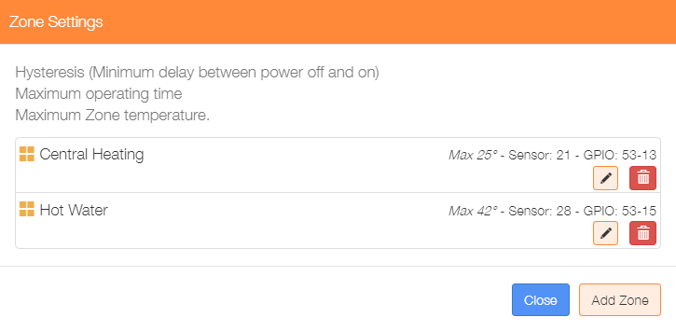Click on the ‘Add Zone’ button to configure the first zone.



An alternative method to go directly to the Add Zone dialogue, is from the Home screen click on the ‘One Touch’ button then select the ‘Add Zone’ menu item.

There are currently four types of zone, Heating, Water, Immersion and Lamp, the configuration of the Add Zone dialogue will depend on the type of zone selected. Immersion type zones will disable ‘System Controller’ selection, while Lamp type zones will disable all temperature sensor related selections, together with the ‘System Controller’ selection, as these parameters do not apply to these zone types.

The example below shows a Lamp zone configuration, with the three Tasmota switches associated. Use the **+** located adjacent to the Zone Controller ID selection box to add the second then third Tasmota Relat device.

Once the parameters have been entered, click on the ‘Submit’ button.

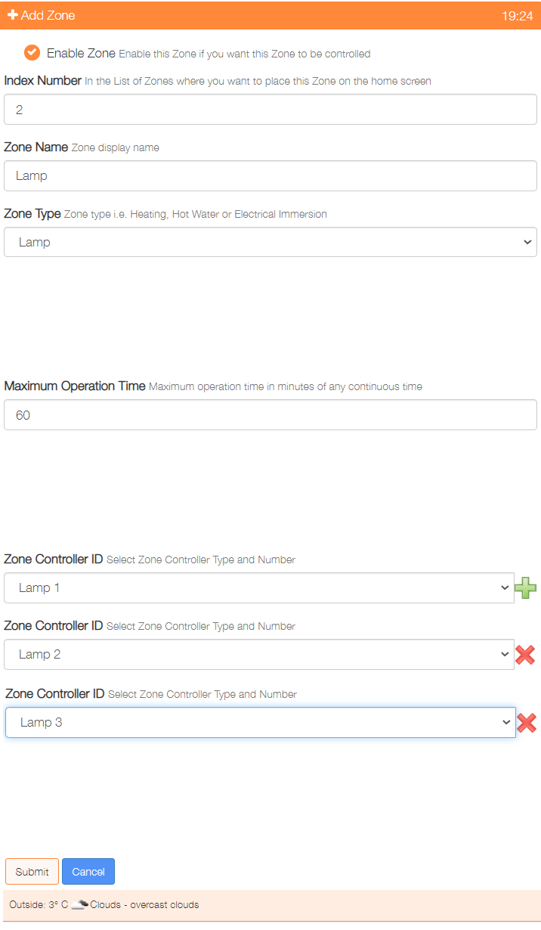

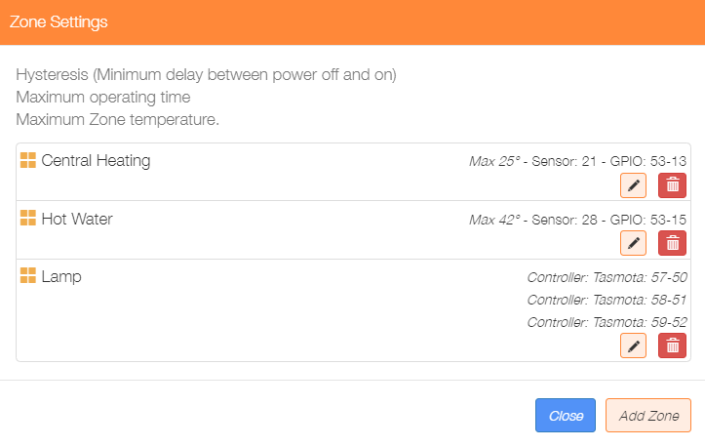

Re-selecting the Zone menu item from the Settings/Node and Zone Configuration menu will display the updated list of currently configured zones.

This dialogue can be used to Add/Delete/Edit the zone configurations.

**This completes the Layer 3 configuration.**

### Step 4 – Layer 4 Configuration - Add Schedules

The example configuration will have a single schedule to control the Lamp zone.

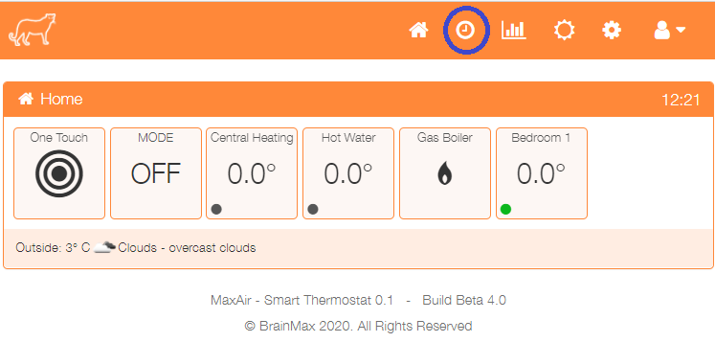Click on the toolbar clock icon to configure the first schedule.

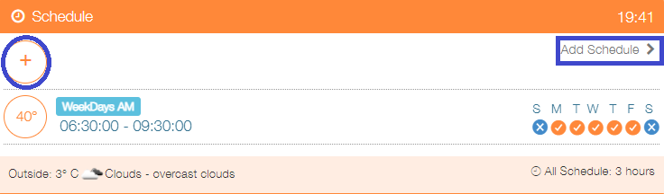

Click on + or ‘Add Schedule’

The Add schedule screen will be presented, the example below shows:

* An enabled schedule
* Operated every day of the week
* Titled Lamp
* Operated between 2030 hours and 2330 hours
* Sunset override enabled with an offset of 35 minutes

#### Sunset Override Function

If enable will use the sunset time from the weather input, an addition offset can be applied to cause start time to be sunset +/- the offset value in minutes.

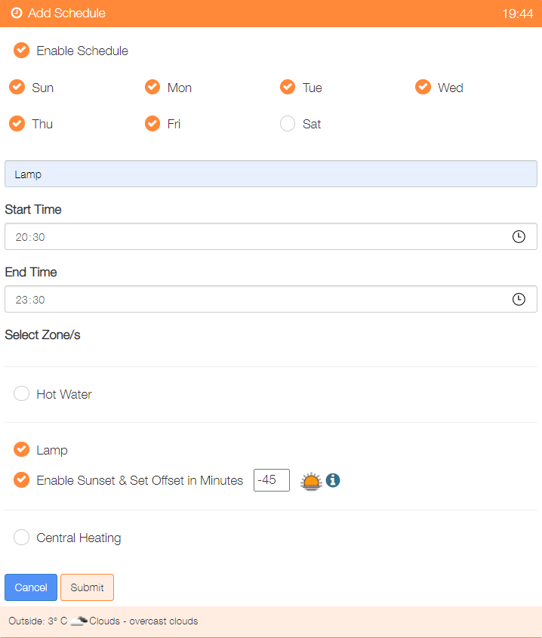

Once configured, click on the ‘Submit’ button to add the schedule.

Add any other schedules as required.

**This completes the Layer 4 configuration.**

### Step 5 – Network Configuration

The Tasmota switch devices are allocated an IP address on the same network as is being used by the MaxAir system. The MaxAir system may have multiple network interfaces e.g WiFi and Ethernet, the Tasmota need to be associated to the same IP subnet as the MaxAir system.

For example The MaxAir system as a WiFi interface with a gateway IP address of 192.168.0.1 and an Ethernet interface with a gateway IP address of 10.0.1.1, the three Tasmota switches have IP addresses of 192.168.0.50m 192.168.0.51 and 192.168.0.52.

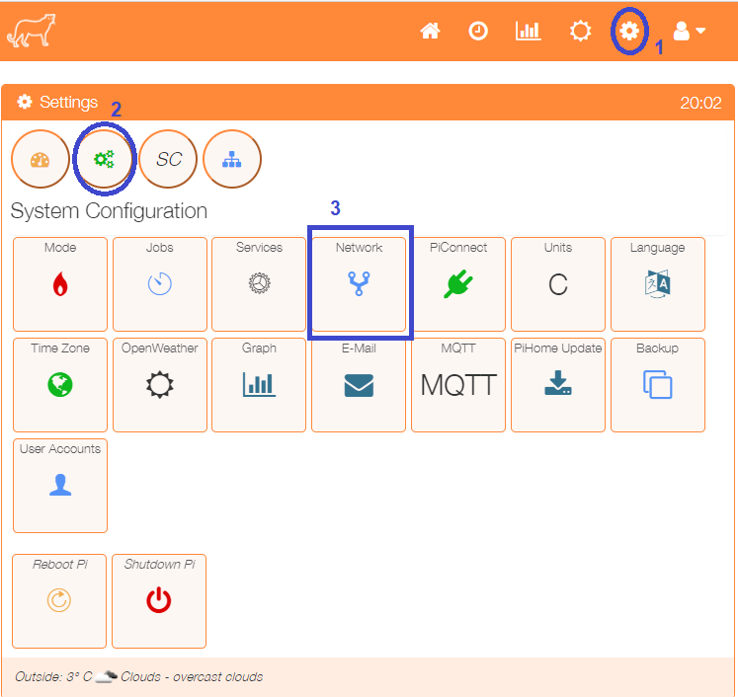

Select the Network menu item from the Settings/System Configuration menu to add a network configuration.

The configuration shown below shows:

* **Network Interface wlan0 set as the primary interface**
* **MaxAir system IP address is 192.168.0.100**
* **Router gateway IP address is 192.168.0.1**
* **NetMask set to 255.255.255.0**

The other fields can remain blank.

This configuration will ensure that the MaxAir system can communicate with the Tasmota switches.

After entering the parameters click the ‘Save’ button.

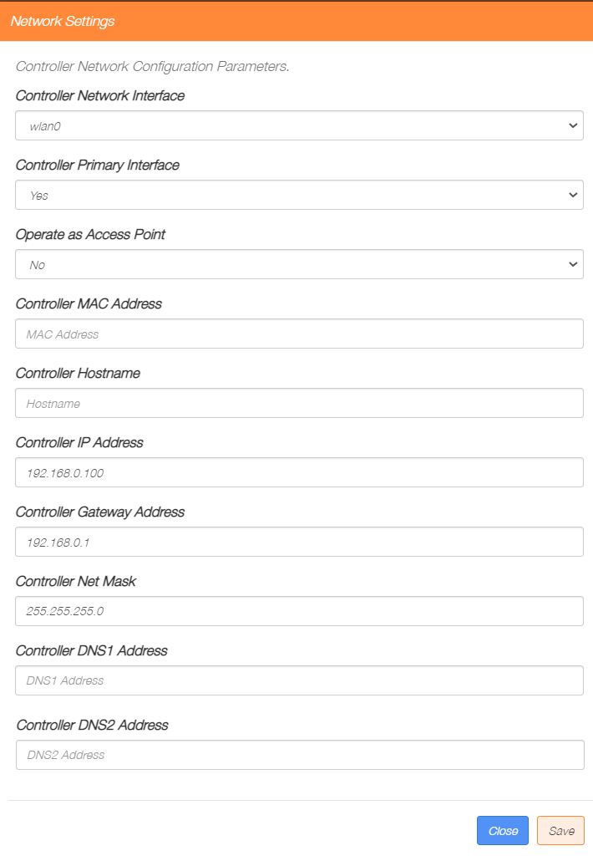

### Step 6 – HTTP Messages

MaxAir passes messages to devices by the use of a message queue. The message identifies the target device by the use of a two-field address (node_id and child_id) and passes a single action parameter. In most instances a ‘0’ is used for the OFF state and a ‘1’ for the ON state.

The Tasmota switch device requires a ‘Power OFF’ message to switch the device OFF and a ‘Power ON’ message to switch the device ON. A means of translation is required to map ‘0’ to ‘Power OFF’ and ‘1’ to ‘Power ON’.

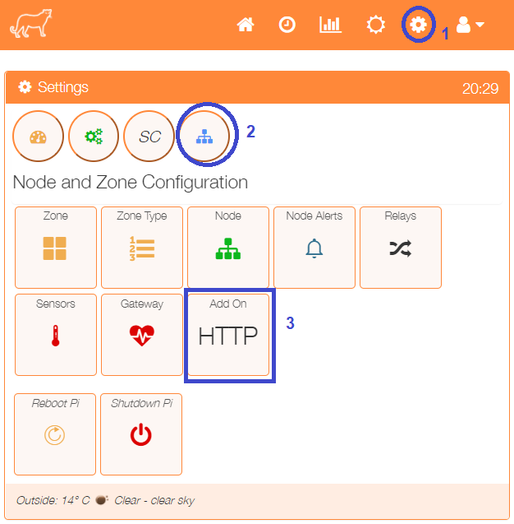 MaxAir provides functionality to implement this mapping, select the ‘HTTP’ menu item from the ‘Settings/Node and Zone Configuration menu.

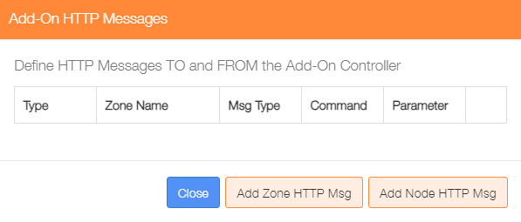As we have already associated the Tasmota switch to the Lamp zone, click on the ‘Add Zone HTTP Msg’ button.

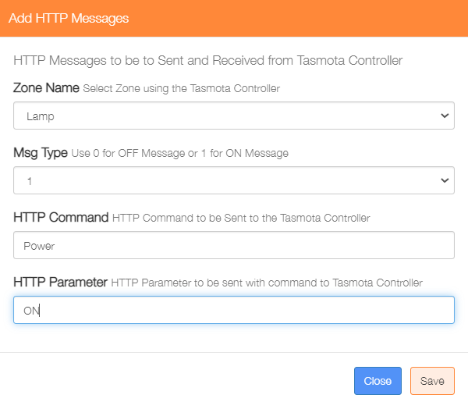Create the Power OFF message and click on the ‘Save’ button, then create the Power ON message and click on the ‘Save’ button.

