# MaxAir Zone Setup

The example configuration will have two zones, one for the Central Heating and a second for the Hot Water. If we were setting up a HVAC system then there would only be a single zone.

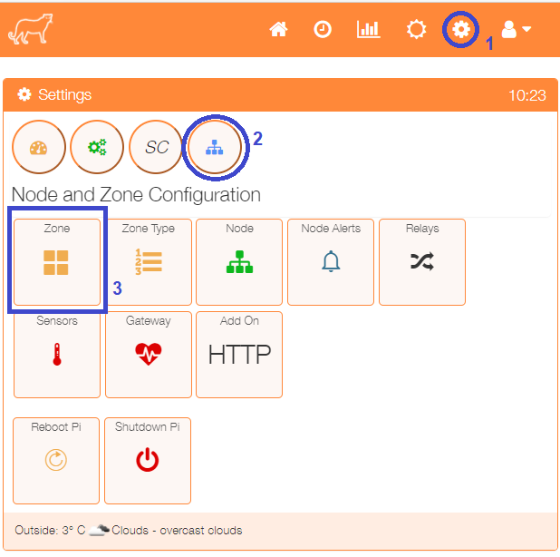

Select the Zone menu item from the Settings/Node and Zone Configuration menu to display a list of any currently configured sensors.

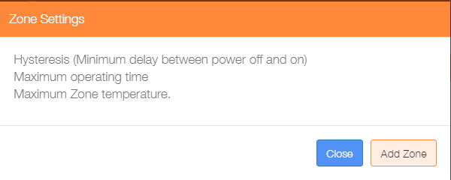Click on the ‘Add Zone’ button to configure the first zone.

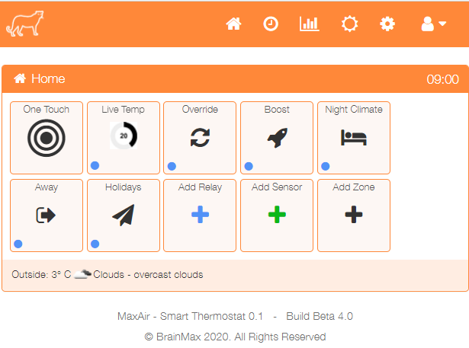

An alternative method to go directly to the Add Zone dialogue, is from the Home screen click on the ‘One Touch’ button then select the ‘Add Zone’ menu item.

There are currently five types of zone, Heating, Water, Immersion, Lamp and HVAC. The configuration of the Add Zone dialogue will depend on the type of zone selected. Immersion type zones will disable ‘System Controller’ selection, HVAC type zones will enable a ‘Minimum Temperature’ field, while Lamp type zones will disable all temperature sensor related selections, together with the ‘System Controller’ selection, as these parameters do not apply to these zone types.

The example below shows a typical Heating zone configuration. A similar configuration would be used for the hot water zone. Once the parameters have been entered, click on the ‘Submit’ button.

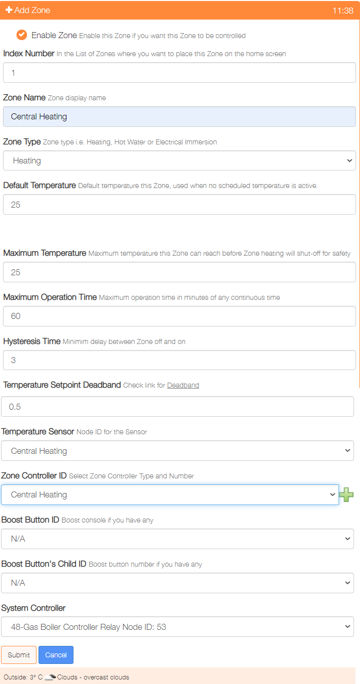

Repeat the process to add any other zones.

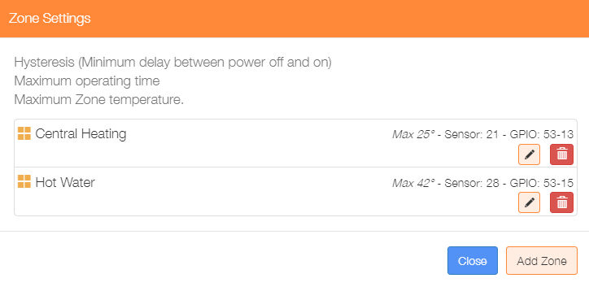

Re-selecting the Zone menu item from the Settings/Node and Zone Configuration menu will display the updated list of currently configured zones.

This dialogue can be used to Add/Delete/Edit the zone configurations.