# MaxAir – Software Install

MaxAir includes a number of 3rd party add-on modules to enhance the capability of the system. At the present time two add-on modules are available:

1. Amazon Echo – uses the ‘fauxmo’ add-on to enable boost control through the use of the Amazon Echo Home Assistant, which includes voice control, see <https://github.com/n8henrie/fauxmo>
2. HomeKit – uses the ‘homebridge’ add-on to enable boost control through the use of Apple’s HomeKit application, which includes ‘Siri’ voice control, see <https://github.com/homebridge/homebridge/wiki/Install-Homebridge-on-Raspbian>

These add-on modules are not installed by default, the user needs to install and configure them before they are usable, this can be achieved from the user interface.

## Software Install

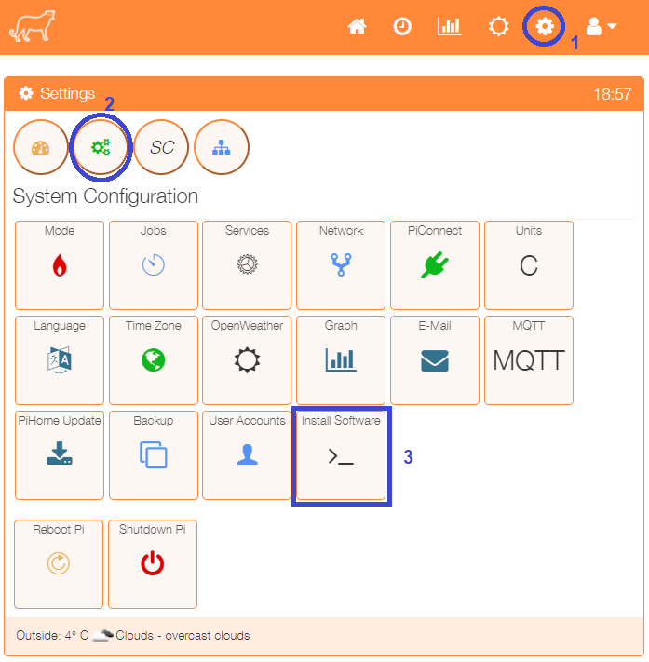

Select ‘Install Software’ from the Settings/System Configuration menu.

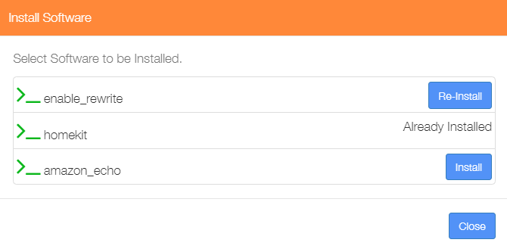

The Install Software selection menu will be displayed, for any software not yet installed, click to install as required.

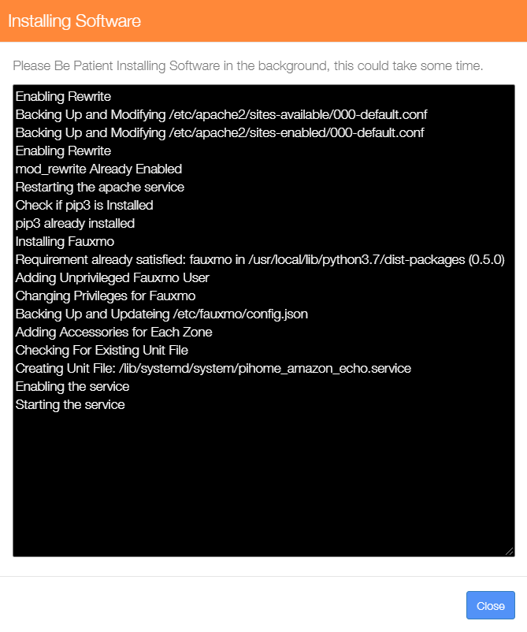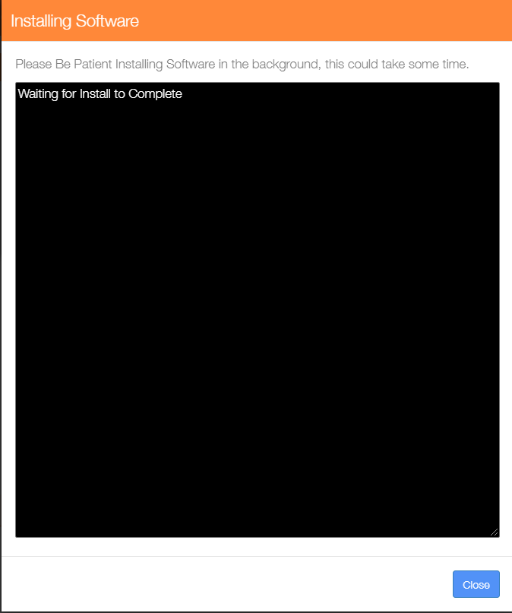The software will be installed as a background task, a progress dialogue will be displayed. The dialogue can be closed before completion without interrupting the background installation task.

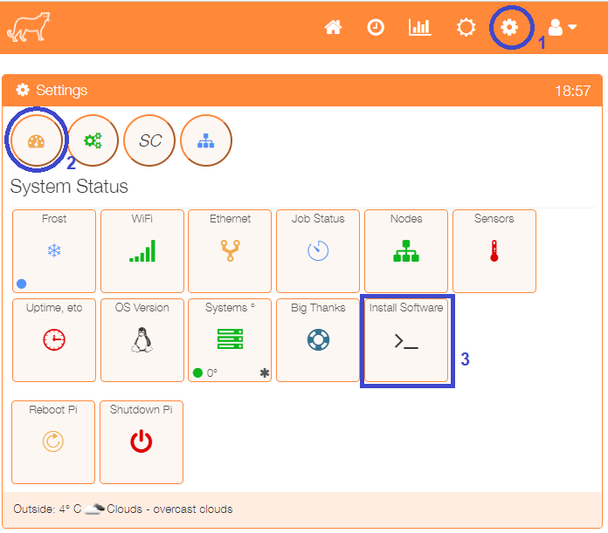

The results of the last software installation task can be shown by selecting ‘Install Software’ from the Settings/System Status menu.