The current copy of the MaxAir software code is held in the GitHub Repository - <https://github.com/pihome-shc/PiHomeHVAC.git>. Any updates to the MaxAir code will be reflected in this repository.

MaxAir executes a script each day at mid-night, this script compares each software code module on the controller executing MaxAir against the corresponding software code modules in the Repository. If there are any discrepancies then an ‘Update’ icon will be displayed on the toolbar:



Clicking on the ‘Update’ icon will display a list of any software code modules files which require updating:

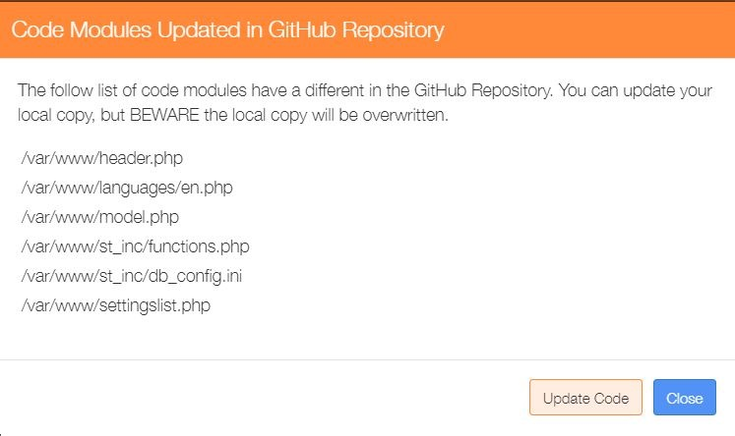

Clicking on the ‘Update Code’ button will display a confirmation dialogue:

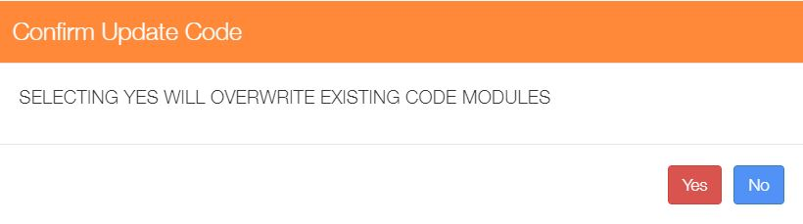

Selecting ‘Yes’ will overwrite the existing software code modules with the corresponding updated software code modules held in the Repository.

## Displaying the MaxAir Code Version Status

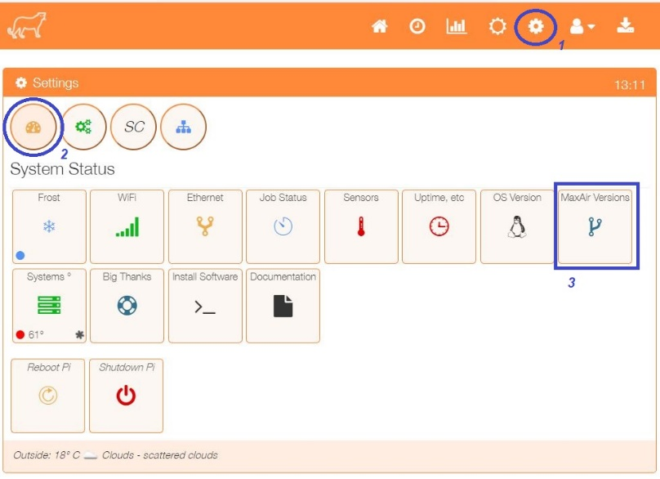From the ‘Settings/System Status’ menu, select ‘MaxAir Versions’.

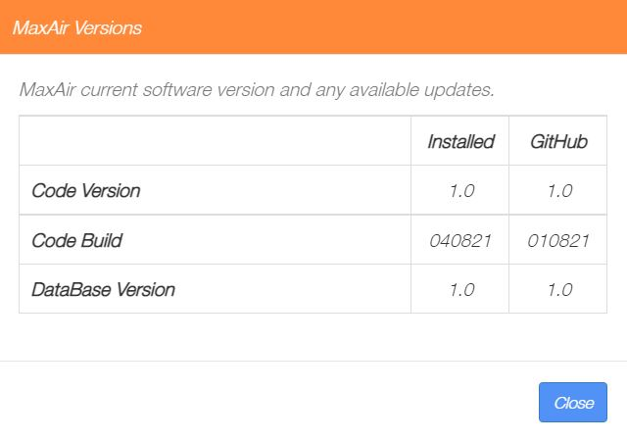The current and Repository versions will be displayed.

## Force a check for Updates

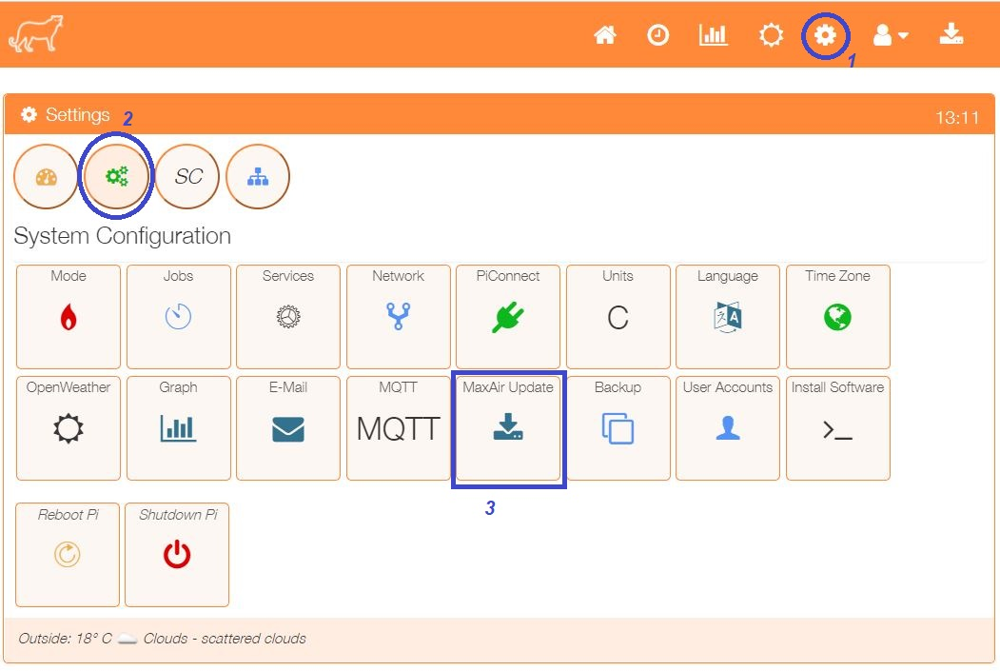From the ‘Settings/System Configuration’ menu, select ‘MaxAir Update’.

A dialogue will be displayed, if the ‘Check for Updates’ button is clicked, then the script to compare each software code module on the controller executing MaxAir against the corresponding software code modules in the Repository will be executed as a background task. This could take 2 to 3 minutes to complete execution, if there are any discrepancies then the ‘Update’ icon will be displayed on the toolbar.

