# MaxAir Technical – Task Scheduling

MaxAir requires a number of background tasks to be actioned periodically, a task scheduler, running as a system service, is provided to achieve this functionality. The task scheduler executes once every second, this determines the maximum repetition rate. The list of tasks to be executed is dynamic, so that tasks can be added or deleted from the schedule as required. The tasks will typically be script files and can be, for example, coded as ‘Shell’, or ‘Python’ or ‘PHP’ scripts.

MaxAir has six pre-installed tasks:

1. The ‘controller’ Task – main engine for the system, controlling the target heating system, it executes once every 60 seconds.
2. The ‘check_gw’ Task – manages the System Gateway hardware to send and receive messages, it executes once every 60 seconds.
3. The ‘system_c’ Task – reads the CPU temperature from the systems control board, it executes once every 300 seconds.
4. The ‘weather_update’ Task – collects weather data from the ‘openwather’ API, it executes once every 1800 seconds.
5. The ‘reboot_wifi’ Task – checks the status of the wifi connection and attempts to restart if required, it executes once every 120 seconds.
6. The ‘sw_install” Task – checks for software install requests, it executes every 10 seconds.

### Checking TheTask Scheduler is Running

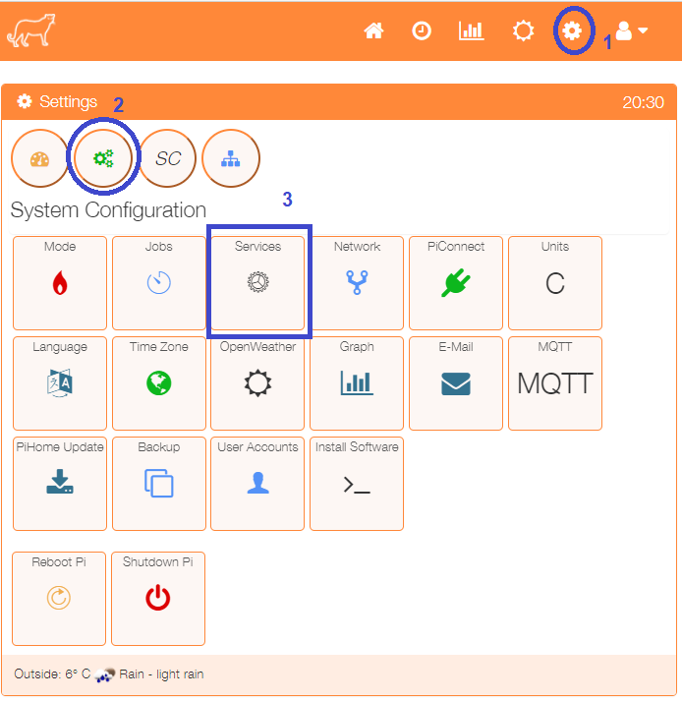

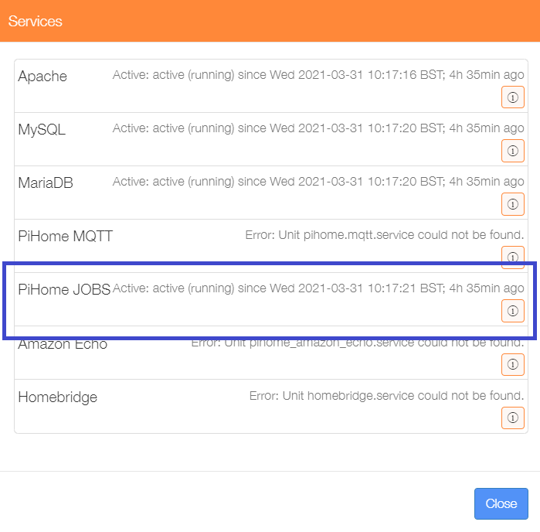Click on the ‘Services’ menu item in the ‘Settings/System Configuration’ menu. This will display a list of the currently installed services and their status.

The PiHome JOBS service is shown to be Active. Close the menu.

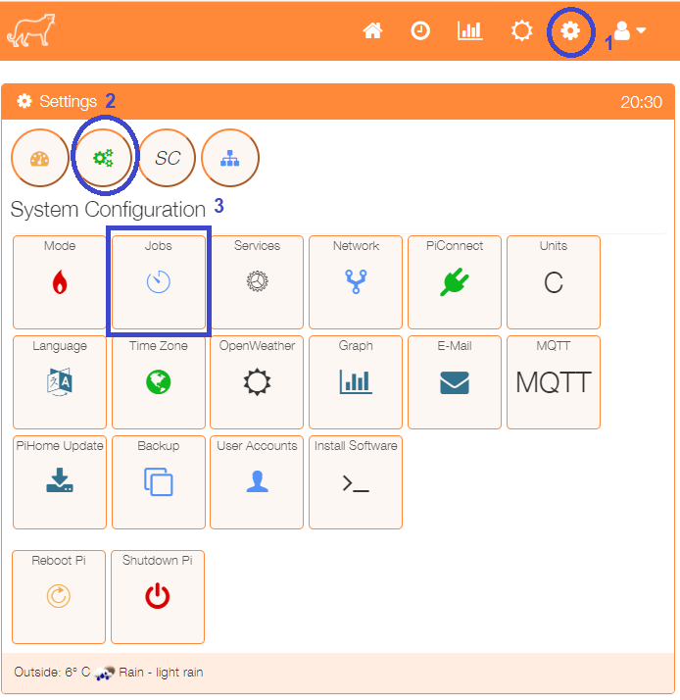

To show the list of active tasks, click on ‘Jobs’ menu item from the ‘Settings/System Configuration’ menu.

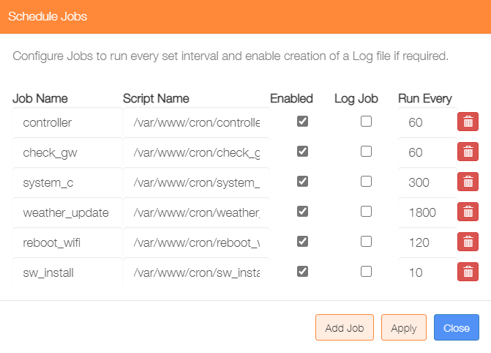

The 6 pre-installed tasks are shown, they will be enabled by default and will not be writing their output to a log file. The log to file option for any job can be activated by checking the tickbox. The execution frequency can be edited and tasks delete if chosen. If changes have been made, they will not be actioned until the ‘Apply’ button is clicked.

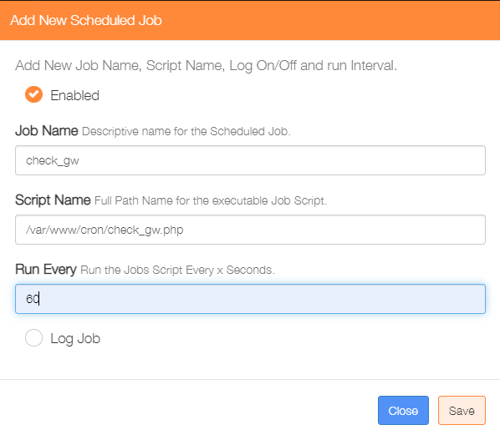

New tasks can be added to the scheduler by clicking on the ‘Add Job’ button

Check to enable the task.

Enter a name for the task.

Enter the full path name of the task script file.

Enter the repetition rate in seconds.

Check if a log file is to be written.

Click on ‘Save’ to update the task scheduler.

Note: log files will be written to directory /var/www/cron/logs/

### View Last Job Output

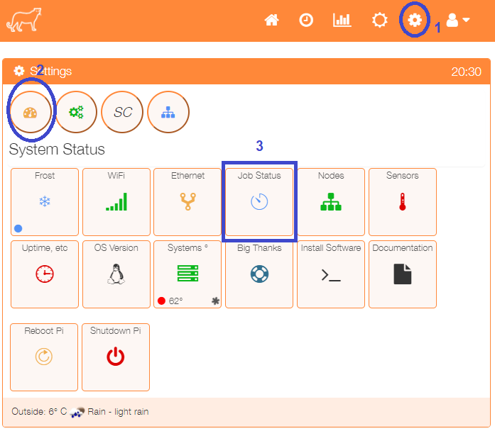

Click on the ‘Job Status’ menu item from the ‘Settings/System Status’ menu.

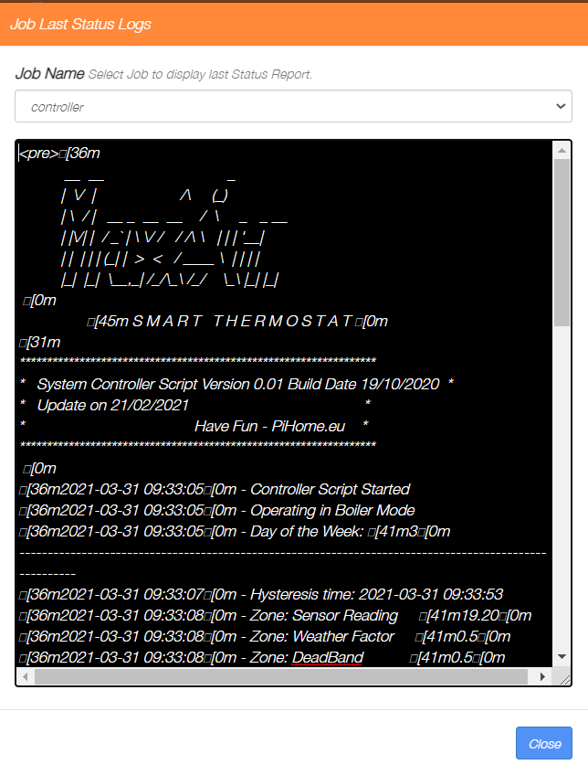

Select the task of interest from the dropdown list of installed tasks to display the results of the last execution in the display window. Click on the @Close’ button when finished.