# MaxAir Technical – Zone Types

MaxAir supports nodes based on their type, these types define the basic capability of the zone:

* A node which is associated with both a temperature sensor and a system controller relay
* A node which is associated with only a temperature sensor
* A node which is associated with only a system controller relay
* A node which is not associated with either a temperature sensor or system controller relay

A number of Zone Types are pre-defined:

* Heating – has both a temperature sensor and a system controller relay
* Water – has both a temperature sensor and a system controller relay
* Immersion – has a temperature sensor
* Lamp – has system controller relay
* HVAC – has both a temperature sensor and a system controller relay

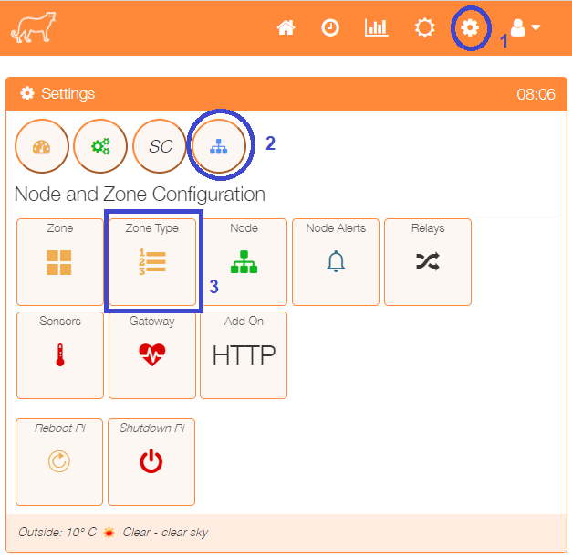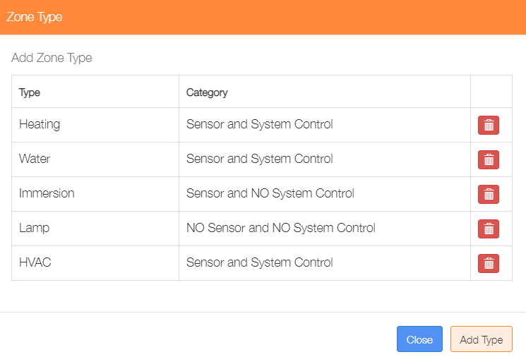The currently defined Zone Types can be viewed from the ‘Zone Type’ menu option in the ‘Settings/Node and Zone Configuration’ menu.

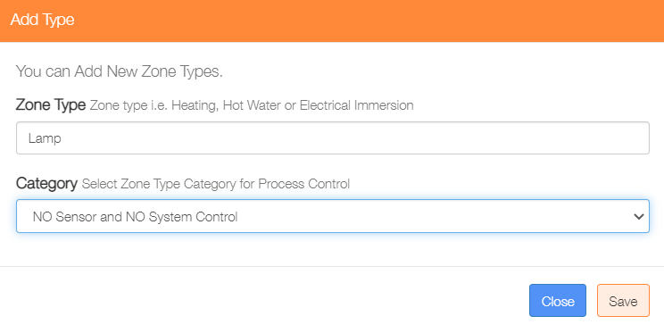Zone Types can be deleted by clicking on the ‘trash’ icon or addition ones added by clicking on the ‘Add Type’ button.

Enter a name for the new Zone the and select the appropriate ‘Category’ from the dropdown list, finally click on the ‘Save’ button.