Class Channels(db.Model):  
Id=db.Column(db.Integer,primary_key=True)  
name=db.Column(db.string(50),unique=True,nullable=False)  
private=db.Column(db.Boolean,default=False,nullable=False)  
subs=db.relationship(‘subscriptions,backref=’channel’)

Class Users(db.Model):  
id=db.Column(db.Integer,Primary_Key  
name=db.Column(db.string(50)  
subs=db.relationship(‘subscriptions,backref=’channel’)

**This class will now join the two together:**Class Subscriptions(db.Model):  
id=db.Column(db.Integer,Primary_key=True)  
id=db.Column(db.Integer,db.foreignkey(‘users.id’)  
channel_id=db.Column(db.Integer,db.Foreignkey(‘channels.id))  
  
**CRUD - Create**  
db.session.add(new_game)  
db.session.commit()

**CRUD - Read**

**CRUD - Update**new_game.name = “Hitman”  
db.session.commit()

Start with: Tablename.query  
End with: all()

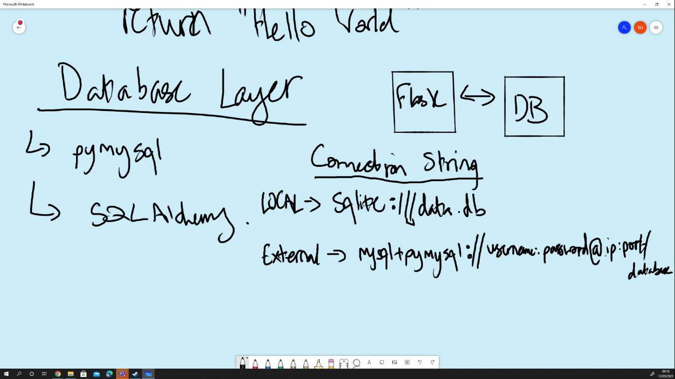

Models:

* A class is a set of attributes – E.g: class Dogs:
  + Name = “Bilbo Waggins”
  + Dog-1 = Dogs()
* A model is a class that describes your table

Flask

* Framework
* It’s a structure for python code to make web apps
* Micro framework – can’t do much on its own, need other things like (SQLAlchemy)
* Structure of a flask app:
* My project
  + App.py – the app itself (it’s at the root of the project)
  + Index.html – the routes
  + Routes.py
  + Templates
  + --Init --.py
* To install we use – “(Sudo) pip3 install flask” – PIP is an appstore for python
* Simplest Flask App:
  + From flask import Flask - #second Flask is a class
  + app = Flask(_ _name_ _) - #app is a variable |
  + @app.route(‘/’) - # @ is a decorator | (‘/ ’) is an index
  + def hello_world()
    - Return “hello world”
* If _ _ name _ _ == “ _ _main _ _”: - #YOU need this code for importing
  + App.run(debug=True) - #Shows error instead of “500 SERVER ERROR”
* @app.route(‘/home’, methods = []) - #By default it is a get request
* Redirect (‘/new_page’) - #Redirects to new page
* @app.route(‘/’)
* Def home():
  + Return “hello world”
* Dynamic URL’s
* Variables into url.
* App.route(‘/home/<name>’)

**Database Layer**

* Flask App – #Performs operations
* Database – #Stores Data
* SQLAlchemy – #Works with flask to perform DB operations
* PyMySQL – #Connects
* App.config[‘SQLALCHEMY.DATABASE_URI] = sqlike:///data.db #adding to dictionairy (sqlite is local)

**Connection String**

* Mysql + pymysql://username:password@ip:port/database_name  
  sqlite:///data.db protocol://LOCATION

**Telling Python to connect**

* From flask_sqlalchemy import SQLAlchemy 🡨 Class
* db = SQLAlchemy(app)
* app.config [‘SQLAlchemy_DATABASE_URI’] = “Connection String”
* db.create_all() - #Creates all of our tables LOCALLY
* db.drop_all() - #Deletes all of our tables LOCALLY