2014

Team Eevee

01/01/2014

Integration Project Architecture & Platforms

 

Table des matières

I. About Project 2

A. Diagram WBS 2

B. Environment 2

C. Goal 3

II. Risks & Solutions 3

III. Activities Management 4

A. Skills sheets 4

B. Gant Chart 5

1. Initial Gantt 5

2. Final Gantt 5

C. Technical choices 6

1. Web Supervisor 6

2. Applicative Server 6

3. Mobile Client 6

4. Database server 6

IV. Quality 7

Dop Eevee

# About Project

## Diagram WBS

## Environment

This project is an academic purpose. The most important part is to make technologies choices across benchmarks for a platform mobile project on which we had to mix golf and tourism in a game.

## Goal

On this project we would see how much important the technologies choices are and how they impacts the length of the different tasks. They can also increase the challenge but it’s a good way to push our limits and discovering new API and/or technologies. There is more and more mobile device so increasing knowledge and difference of the existing is really important.

# Risks & Solutions

|  |  |  |  |  |
| --- | --- | --- | --- | --- |
|  | Quite likely | Probable | Very Likely | Workaround |
| Absent Member |  |  |  | Adapt the Gantt and anticipated workload |
| Undervalued Task |  |  |  | Quickly assign a new resource to avoid brook effect |
| Wrong interpretation |  |  |  | Taking time to understand subject and ask questions |
| Material problem |  |  |  | Having multiple copies |
| Bad Technical choices |  |  |  | Evaluate if remaining time allows to switch |

# Activities Management

## Skills sheets

|  |  |  |  |  |  |  |  |
| --- | --- | --- | --- | --- | --- | --- | --- |
|  | **C++** | **Android** | **Web** | **Data Base** | **Project Management** | **Design and Modeling** | **Communication Http** |
| Dan Castro Lopez |  |  |  |  |  |  |  |
| Mathias Da Costa |  |  |  |  |  |  |  |
| Julien Loève |  |  |  |  |  |  |  |
| Justine Sabbatier |  |  |  |  |  |  |  |
| Thomas Prak |  |  |  |  |  |  |  |
| After Project | | | | | | | |
| Dan Castro Lopez |  |  |  |  |  |  |  |
| Mathias Da Costa |  |  |  |  |  |  |  |
| Julien Loève |  |  |  |  |  |  |  |
| Justine Sabbatier |  |  |  |  |  |  |  |
| Thomas Prak |  |  |  |  |  |  |  |

Legend

|  |  |  |
| --- | --- | --- |
| Novice | Intermediate | Good |
|  |  |  |

## Gant Chart

### Initial Gantt

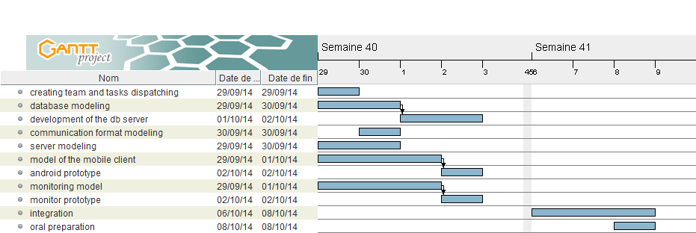

### Final Gantt

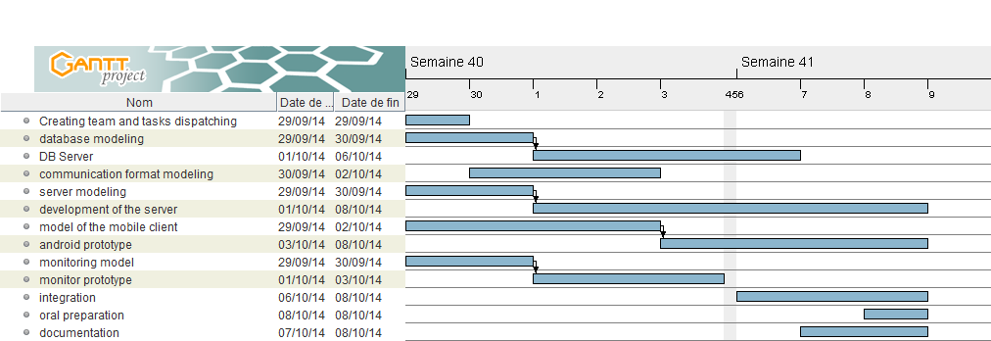

We divided some task on subtask to clarify the priorities. For most of the tasks, we didn’t planned enough time because we didn’t realised that some task were harder than what we though so it took more time.

## Technical choices

### Web Supervisor

HTML5, CC3, Jquery has been used with Bootstrap for making interfaces. As said Jquery, we write less and do more in a short laps of time.

Json was used for following objective’s teachers with Ajax for more effective loading.

### Applicative Server

### Mobile Client

### Database server

For the DBMS (Data Base Management System) we choose to use MySQL mostly for the possibility to use the type “Point” like that we can use the DBMS for some calculus like the distance between the golf ball and the nearest POI (Point Of Interest).

To communicate with the database we decide to make a web service in php. This script interpret the Json provided by the Applicative Server, send the appropriate request and generate a json given as a reply.

This database was fill with information from several “office du tourisme”.

# Quality

To evaluate the quality of the application, we can identified standards as:

* Response time
* Ergonomics
* Intuitive use
* Consummation data
* Application size
* Fluidity