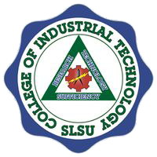Republic of the Philippines

**SOUTHERN LUZON STATE UNIVERSITY**

College of Industrial Technology

Bachelor of Science in Mechanical Technology

**TOPIC: Fundamentals of Information Technology**

* History and evolution of computers.
* Types of computers (desktop, laptop, mobile devices).
* Basic hardware components (CPU, memory, storage devices).
* Introduction to operating systems.

**Part 1: "The Role of Fundamentals of Information Technology in Modern Businesses."**

This topic explores how foundational IT concepts—like hardware, software, networking, and cybersecurity—are essential for businesses today.

* The importance of IT infrastructure in companies
* How businesses use IT for productivity and efficiency
* Cybersecurity threats and IT solutions
* Emerging trends like cloud computing and AI in business

**Warm up: What is IT infrastructure?**

IT infrastructure, also called technology infrastructure, is what enables a company to build and run the applications that underpin its business. It includes compute, network, workplace, and data platform and edge capabilities. Traditional infrastructure primarily concerns hardware, data centers and servers that are manually configured, managed and maintained.

**Activity 1: Research about the Top 10 IT Company in the Philippines.**

**History of Computers**

The history of computers is a fascinating journey that spans centuries of innovation and technological advancement. Below mentioned table summarizes the historical development of a computer.

|  |  |  |
| --- | --- | --- |
| **Time** | **Devices invented** | **Description** |
| **3000 BCE** | **Abacus** | This is the earliest computing device. This was used to do basic arithmetic calculations. In this computer, beads were moved along rods to represent numbers. |
| **17th century** | **Mechanical Calculators** (Pascaline and Stepped Reckoner) | Mechanical methods were introduced to perform arithmetic calculations. Mechanical calculators are devices that perform mathematical calculations using mechanical mechanisms rather than electronic components. These calculators were widely used before the advent of electronic calculators and computers. The popular devices of this century were Pascaline and Stepped Reckoner. |
| **18th century** | **Mechanical computer** (Step Reckoner, Turk's Head, Difference Engine, Analytical Engine). | Mechanical devices and ideas that were important precursors to the development of computers and automation were introduced. It uses mechanical components, such as gears, levers, and switches, to perform calculations and process information. The popular mechanical devices developed during 18th century were Step Reckoner, Turk's Head, Difference Engine, Analytical Engine. |
| **19th century** |  |  |
| **Electromechanical Computers**Devices like the Z3, Mark I | Computers developed during 19th century were crucial in shaping the concepts and ideas that eventually led to the creation of the computers we use today. Most of the devices were based on the combination of mechanical and electrical switches to perform computation. The 19th century was the time where invention of computing devices was more and more. The size of computer was reduced and the devices with large storage and high computations were introduced. Interconnectivity with multiple devices and data sharing, remote accessing were recorded as the features of the computers which makes it popular in the world and make the computer as most demandable computing device in the world. |
| ENIAC (1945) |
| Stored-Program Computers (1940s-1950s) |
| Transistors and Integrated Circuits (1950s-1960s) |
| Minicomputers (1960s-1970s) |
| Microprocessors and Personal Computers (1970s-1980s) |
| Graphical User Interfaces (1980s-1990s) |
| Internet and World Wide Web (1990s) |
| **20th century** | Laptops, Smartphones, and Tablets (2000s-Present) | 20th century is the time where computer technology is the next level. Portable and light weighted high computing devices are introduced and in trend. Cloud Computing technology makes the internet as a more useful platform to keep the data centralize in terms of accessing and its computation on server. Hence, cloud computing involves delivering various services over the internet, such as computing power, storage, and applications. The 20th century saw significant developments in the field of artificial intelligence (AI) also. AI technologies began to be integrated into various applications, such as speech recognition, image processing, natural language processing, and robotics. These developments set the stage for the further evolution of AI in the 21st century, where the focus shifted toward more data-driven approaches. |
|  |

**Activity 2: Research about the computer devices 3000 BCE to 20th century.**

The history of computers is marked by a continuous cycle of innovation, with each generation building upon the achievements of the previous one. This overview provides just a glimpse into the rich and complex evolution of computing technology.

**Generations of Computers**

The history of computers let us know the advancements of computing devices as per the time; as years goes the new version of computers were developed. To understand this lets study the generation of computers.

The development of computers has gone through different generations, each generation marked by significant advancements in terms of technology and architecture. These generations are classified as follows:

1. First generation
2. Second generation
3. Third generation
4. Fourth generation
5. Fifth generation

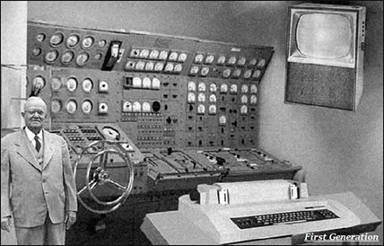**First Generation**

The timeline for the first generation computers was **1940** to **1956.**

The **first generation** computers were developed using vacuum tube or thermionic valve machine.

Punched cards and paper tape were used as input/output.

Magnetic drums and magnetic tapes were used as a memory device to save the data.

**Second Generation**

The timeline for the second generation computers was 1956 to 1963.

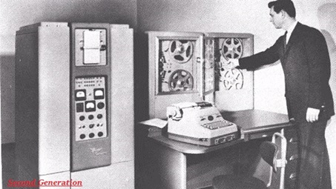Transistors were used to develop.

In comparison to the first generation, second generation computers were small in size.

Punched cards and magnetic tape were used for input /output.

Electricity consumption was low and produces less heat.

Magnetic core memory was used.

Fast computing and were used in business, scientific research, and government applications.

**Third Generation**

The timeline for the third generation computers was 1963 to 1971.

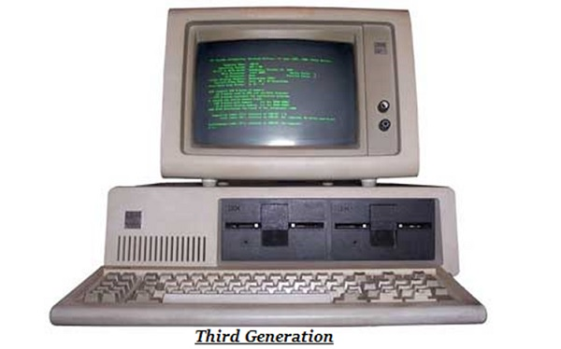Integrated Circuit (IC) was used to develop.

In comparison to the second generation, third generation computers were small in size.

Magnetic tape, keyboard, monitor, printer devices were used as input and output.

Computation power was higher as compare to second generation computers.

The third generation computer consumed less power and also generated less heat.

The maintenance cost of the computers in the third generation was also low as these were consuming less power and generated less heat.

These were most widely used in commercial purposes.

**Fourth Generation**

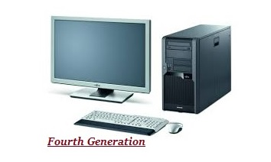The timeline for the fourth generation computers was 1972 to 2010.

Microprocessor technology was used to develop.

These were surprising in terms of size and computing power.

Portable computers.

Very less power consuming and affordable.

Semiconductor memory such as RAM, ROM were used which makes computation faster.

Keyboard, pointing devices, optical scanning, monitor, printer devices were used for input and output.

It became available for the common people as well.

## Fifth Generation

The timeline for the fifth generation computers is form 2010 to till date.

These computers are based on artificial intelligence, Ultra Large-Scale Integration (ULSI), Quantum computation, Nanotechnology, Parallel processing technology.

Very fast and multiple tasks could be performed simultaneously.

These are smaller in size as compare to fourth generation computers.

Consumes very low power.

Keyboard, monitor, mouse, touchscreen, scanner, printer are used as an input output devices.

*Examples − Laptops, tablets, smartphones are most popular examples of fifth generation computers.*

**Part 2: "Types of computers (desktop, laptop, mobile devices)”.**

A computer is an electronic device that has storage, computations, input (data), output (data) and networking capabilities. With the growing AI, computers also have learning capabilities from the data provided. The input and output data can be in different forms like text, images, audio and video. A computer processes the input according to the set of instructions provided to it by the user and gives the desired output. Computers are of various types and they can be categorized in two ways on the basis of size and on the basis of data handling capabilities.

**Types of Computer**

There are two bases on which we can define the types of computers. We will discuss the type of computers on the basis of size and data handling capabilities. We will discuss each type of computer in detail. Let’s see first what the types of computers are.

1. Super Computer
2. Mainframe computer
3. Mini Computer
4. Workstation Computer
5. Personal Computer (PC)
6. Server Computer
7. Analog Computer
8. Digital Computer
9. Hybrid Computer
10. Tablets and Smartphone

**Supercomputer**

When we talk about speed, then the first name that comes to mind when thinking of computers is supercomputers. They are the biggest and fastest computers (in terms of speed of processing data). Supercomputers are designed such that they can process a huge amount of data, like processing trillions of instructions or data just in a second. This is because of the thousands of interconnected processors in supercomputers. It is basically used in scientific and engineering applications such as weather forecasting, scientific simulations, and nuclear energy research. It was first developed by Roger Cray in 1976.

**Characteristics of Supercomputers**

1. Supercomputers are the computers that are the fastest and they are also very expensive.
2. It can calculate up to ten trillion individual calculations per second, this is also the reason which makes it even faster.
3. It is used in the stock market or big organizations for managing the online currency world such as Bitcoin etc.
4. It is used in scientific research areas for analyzing data obtained from exploring the solar system, satellites, etc.

**Mainframe computer**

Mainframe computers are designed in such a way that they can support hundreds or thousands of users at the same time. It also supports multiple programs simultaneously. So, they can execute different processes simultaneously. All these features make the mainframe computer ideal for big organizations like banking, telecom sectors, etc., which process a high volume of data in general.

**Characteristics of Mainframe Computers**

1. It is also an expensive or costly computer.
2. It has high storage capacity and great performance.
3. It can process a huge amount of data (like data involved in the banking sector) very quickly.
4. It runs smoothly for a long time and has a long life.

**Minicomputer**

Minicomputer is a medium size multiprocessing computer. In this type of computer, there are two or more processors, and it supports 4 to 200 users at one time. Minicomputer is similar to Microcontroller. Minicomputers are used in places like institutes or departments for different work like billing, accounting, inventory management, etc. It is smaller than a mainframe computer but larger in comparison to the microcomputer.

**Characteristics of Minicomputer**

1. Its weight is low.
2. Because of its low weight, it is easy to carry anywhere.
3. less expensive than a mainframe computer.
4. It is fast.

**Workstation Computer**

A workstation computer is designed for technical or scientific applications. It consists of a fast microprocessor, with a large amount of RAM and a high-speed graphic adapter. It is a single-user computer. It is generally used to perform a specific task with great accuracy.

**Characteristics of Workstation Computer**

1. It is expensive or high in cost.
2. They are exclusively made for complex work purposes.
3. It provides large storage capacity, better graphics, and a more powerful CPU when compared to a PC.
4. It is also used to handle animation, data analysis, CAD, audio and video creation, and editing.

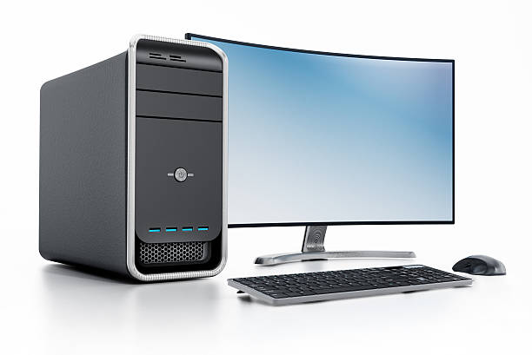**Personal Computer (PC)**

Personal Computers is also known as a microcomputer. It is basically a general-purpose computer designed for individual use. It consists of a microprocessor as a central processing unit (CPU), memory, input unit, and output unit. This kind of computer is suitable for personal work such as making an assignment, watching a movie, or at the office for office work, etc. For example, Laptops and desktop computers.

**Characteristics of Personal Computer (PC)**

1. In this limited number of software can be used.
2. It is the smallest in size.
3. It is designed for personal use.
4. It is easy to use.

**Server Computer**

Server Computers are computers that are combined data and programs. Electronic data and applications are stored and shared in the server computer. The working of a server computer is that it does not solve a bigger problem like a supercomputer but it solves many smaller similar ones. Examples of server computer are like Wikipedia, as when users put a request for any page, it finds what the user is looking for and sends it to the user.

**Analog Computer**

Analog Computers are particularly designed to process analog data. Continuous data that changes continuously and cannot have discrete values are called analog data. So, an analog computer is used where we don’t need exact values or need approximate values such as speed, temperature, pressure, etc. It can directly accept the data from the measuring device without first converting it into numbers and codes. It measures the continuous changes in physical quantity. It gives output as a reading on a dial or scale. For example speedometer, mercury thermometer, etc.

**Digital Computer**

Digital computers are designed in such a way that they can easily perform calculations and logical operations at high speed. It takes raw data as input and processes it with programs stored in its memory to produce the final output. It only understands the binary input 0 and 1, so the raw input data is converted to 0 and 1 by the computer and then it is processed by the computer to produce the result or final output. All modern computers, like laptops, desktops including smartphones are digital computers.

**Hybrid Computer**

As the name suggests hybrid, which means made by combining two different things. Similarly, the hybrid computer is a combination of both analog and digital computers. Hybrid computers are fast like analog computers and have memory and accuracy like digital computers. So, it has the ability to process both continuous and discrete data. For working when it accepts analog signals as input then it converts them into digital form before processing the input data. So, it is widely used in specialized applications where both analog and digital data are required to be processed. A processor which is used in petrol pumps that converts the measurements of fuel flow into quantity and price is an example of a hybrid computer.

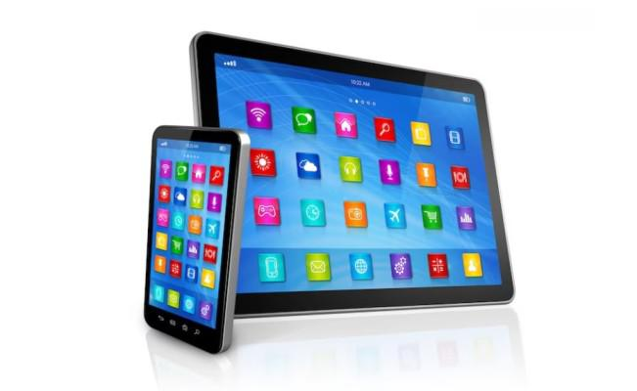**Tablet and Smartphones**

Tablets and Smartphones are the types of computers that are pocket friendly and easy to carry is these are handy. This is one of the best use of modern technology. These devices have better hardware capabilities, extensive operating systems, and better multimedia functionality. Smartphones and tablets contain a number of sensors and are also able to provide wireless communication protocols.

*We generally classify computers on the basis of size, functionality, and data handling capabilities.*