|  |  |  |  |
| --- | --- | --- | --- |
| **WORKSHEET** | | | |
| **Topic:** | Introduction to Microsoft Excel | **Week No.** | 7 |
| **Course Code:** | IT001 | **Term** | 2nd Semester |
| **Course Title:** | Introduction to Information Technology, Word Processing/ Spreadsheet | **Academic Year** | 2024-2025 |

**Introduction to MS Excel**

**What is MS Excel**

Excel is a part of the Microsoft Office suite software. It is an electronic spreadsheet program that features a grid of rows and columns, making it easy to input and organize data. With 1,048,576 rows and 16,384 columns in Excel 2007 and newer versions, it can handle vast datasets without hassle. Each intersection of a row and column forms a cell, identified by a cell reference like A1 or D2. These references help users store data, perform calculations, and link information effortlessly.

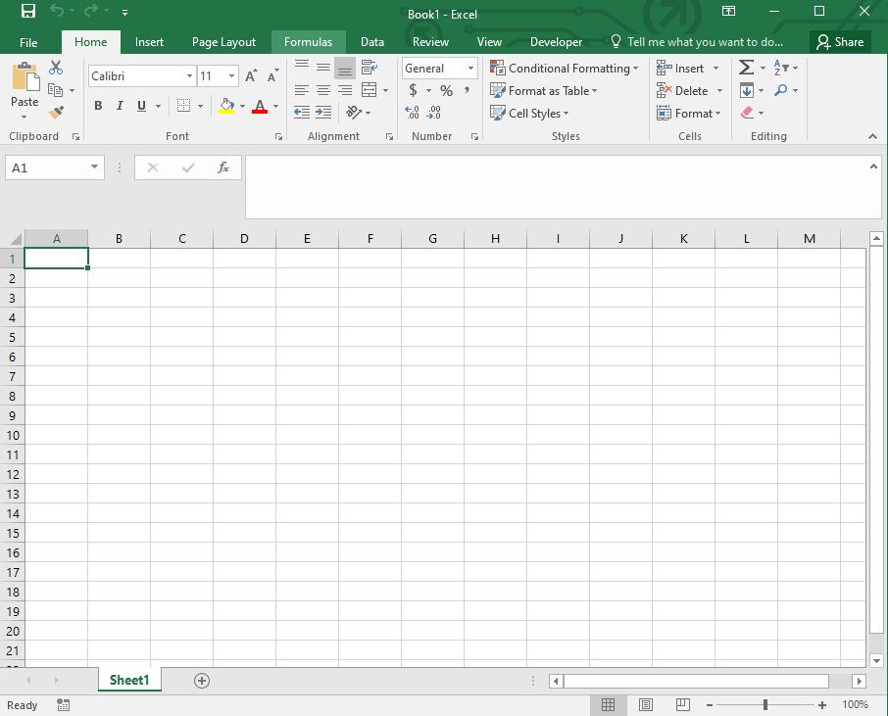Excel is much more than a tool for basic data entry. It enables users to create charts, analyze trends, and streamline repetitive tasks, making it indispensable for tasks like budgeting, inventory management, and report generation. Whether you’re managing personal finances, working on a project, or analyzing business performance, Excel provides the tools you need to achieve your goals effectively.

*Interface of ms. excel*

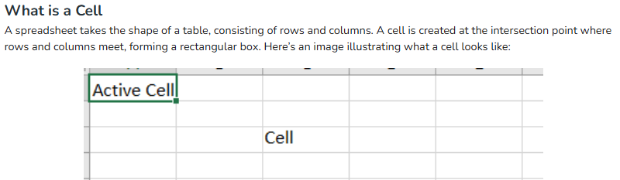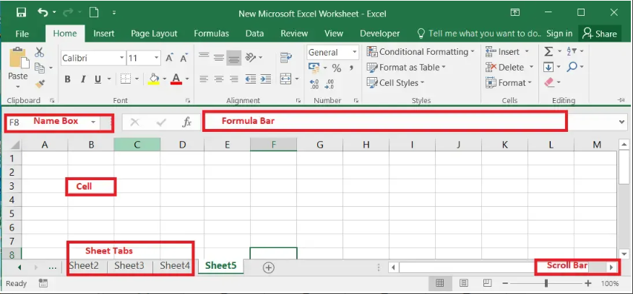

**Features of MS Excel**

**Ribbon**

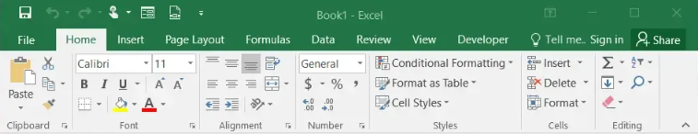Th eRibbon in MS-Excel is the topmost row of tabs that provide the user with different facilities/functionalities. These tabs are:

**Home Tab**

It provides the basic facilities like changing the font, size of text, editing the cells in the spreadsheet, autosum, etc.

**Insert Tab**

It provides the facilities like inserting tables, pivot tables, images, clip art, charts, links, etc.

**Page layout**

It provides all the facilities related to the spreadsheet-like margins, orientation, height, width, background etc. The worksheet appearance will be the same in the hard copy as well.

**Formulas**

It is a package of different in-built formulas/functions which can be used by user just by selecting the cell or range of cells for values.

**Data**

The Data Tab helps to perform different operations on a vast set of data like analysis through what-if analysis tools and many other data analysis tools, removing duplicate data, transpose the row and column, etc. It also helps to access data(s) from different sources as well, such as from Ms-Access, from web, etc.

**Review**

This tab provides the facility of thesaurus, checking spellings, translating the text, and helps to protect and share the worksheet and workbook.

**View**

It contains the commands to manage the view of the workbook, show/hide ruler, gridlines, etc, freezing panes, and adding macros.