
QuikStep
ME 3024: Engineering Design and Econ
ME Professor Dr. Dewey Spangler
CRN: 20717

Team Number: 46
DP3
Members:
Agapi Gladhill
Aprameyo Chakravarty
John Santosuosso
Kendrick Nedtranon

Due Date: May 7, 2025

Statement of Responsibility
Team 46 created an equal distribution of work by upholding responsibility. Each member of the team worked with diligence, integrity, and professionalism in order to achieve their goals. The equal workload created a fair allocation of responsibilities based on individual strengths. Team members are expected to communicate with the team when issues arise and members are also responsible for finishing allocated work on time.
Agapi Gladhill was responsible for completing the introduction and the project planning. She was also responsible for completing the formatting of the document including the title page and the table of contents. Lastly she was responsible for the final review of the document.
Aprameyo Chakravarty was responsible for completing the Establishment of Target Specifications and the conclusion of the document.
John Santosuosso was responsible for completing the project management and the Identification of Customer Needs sections of the document.
Kendrick Nedtranon was responsible for completing the economy section of the document as well as the customer interviews.
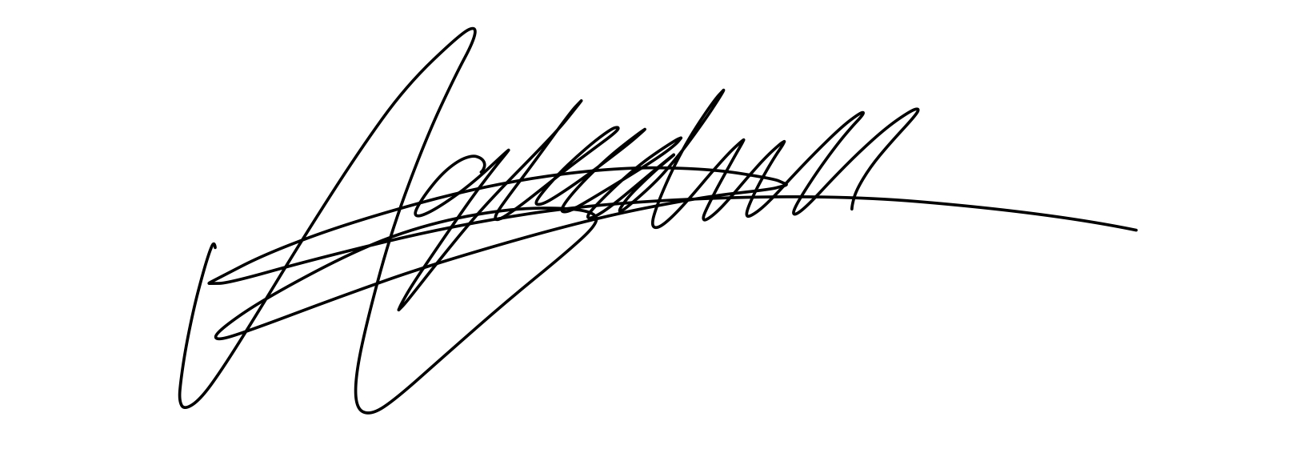
_______________ (25% contribution to DP3)
Agapi Gladhill (Team Lead)

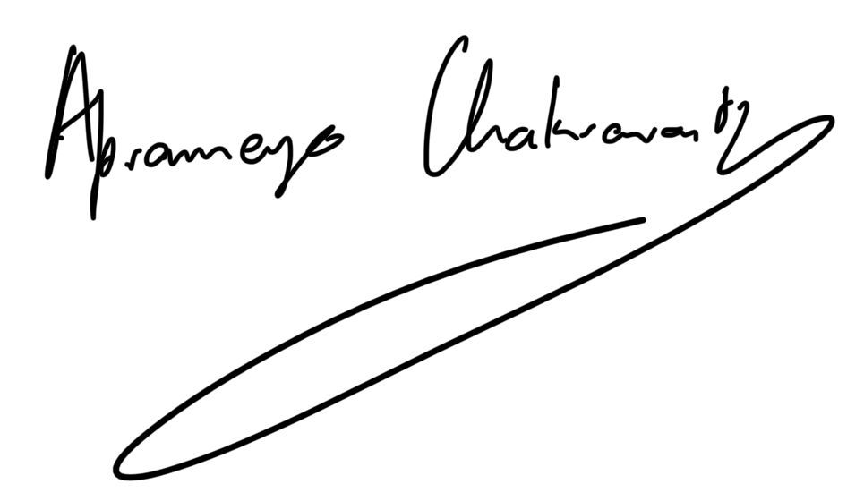
_________________ (25% contribution to DP3)
Aprameyo Chakravarty

_____________________ (25% contribution to DP3)
John Santosuosso

_____________________ (25% contribution to DP3)
Kendrick Nedtranon
Table of Contents
Introduction – Agapi Gladhill 4
Project Planning – Agapi Gladhill 4
Project Management - John Santosuosso 5
Specifications - Kendrick Nedtranon 6
Economics - Kendrick Nedtranon 9
Intellectual Property - Aprameyo Chakravarty 10
Concept Generation and Selection - Aprameyo Chakravarty 11
Failure Modes and Effects Analysis - Aprameyo Chakravarty 12
3D Cad Model and Final Prototype - John Santosuosso 12
Design for Assembly (DFA) - Aprameyo Chakravarty 13
Bill of Materials (BOM) / Cost Sheet / Design for Manufacturing (DFM) - Agapi Gladhill 13
Reflections on Physical Prototypes and Product Improvements (i.e., Next Generation) - Kendrick Nedtranon 14
Conclusion - John Santosuosso 14

Table of Figures
Figure 1: Gantt Chart 5
Figure 2: QFD 8
Figure 3: Economic Analysis 10
Figure 4: Gallery Poster 12
Figure 5: Isometric View of QuikStep CAD Model on NX 14
Figure 6: Orthographic Drawings of QuikStep 14
Figure 7: Drawing of QuikStep Mount 14
Figure 8: Final Prototype for QuikStep 14
Figure 9: Physical QuikStep prototype 16
Figure 10: Customer Demographics 17
Figure 11: Raw Customer Needs Data 19
Figure 12: Customer Opinions 19

Table of Tables
Table 1: Customer Survey Results 5
Table 2: Competitive Benchmarking Analysis 9
Table 3: Patent search summary for an automatic stair 11
Table 4: FMEA Chart 13
Table 5: Bill of Materials 14

Introduction – Agapi Gladhill
This report will cover how Team 46 created a product named Quikstep. Quikstep is an automated step system that is designed to hook onto a bedside ladder in the upright position and with the help of a motor can autonomously move to the 90 degree position creating a step for the user to utilize. Throughout this report the reader will be able to understand how Team 46 came up with Quikstep and the planning that went into it. The report will also cover the management of the project, customer needs and specifications for Quikstep, the economics, and what went into the prototyping of the project itself.

Project Planning – Agapi Gladhill
Ultimately the team's chosen idea was to create an automated step system that is collapsible; this is because the idea is fundamentally new and has not yet been completed. This system would be attached to a bed side and be activated whenever the individual is ready to climb into bed. The step system would make it easier for those with disabilities to be able to use bunked beds. We chose this option because it seems plausible to complete and was the most unique.
In order to develop the customer profile the team thought of who the product was being catered to. Ultimately the team decided the product would be the most useful to those with physical disabilities so that is who was chosen for the customer profile. The team wanted a customer who may have some issues doing everyday activities because of their disability but ultimately does not let that define what they do.
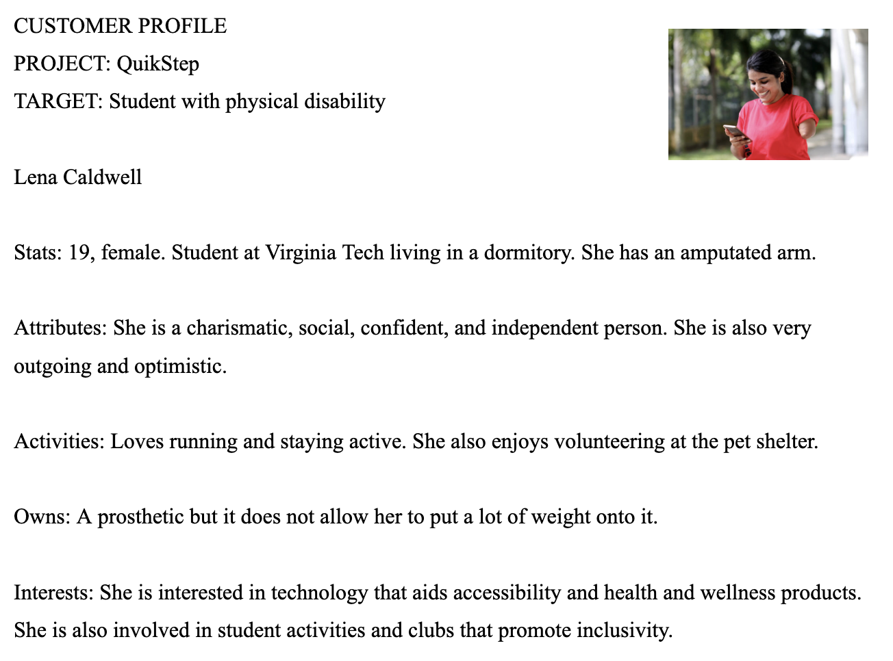

Figure : Customer Profile
In order to use the product QuikStep, the user is expected to mount the device on the side of their bed or wherever they want to climb to and when they are ready to use it they will either hit a button or flip a switch and the steps will autonomously unfold out of the device. When the user then safely uses the steps to get into their lofted bed or to climb wherever they need to, they can then autonomously fold the steps back into the device in order to save space.
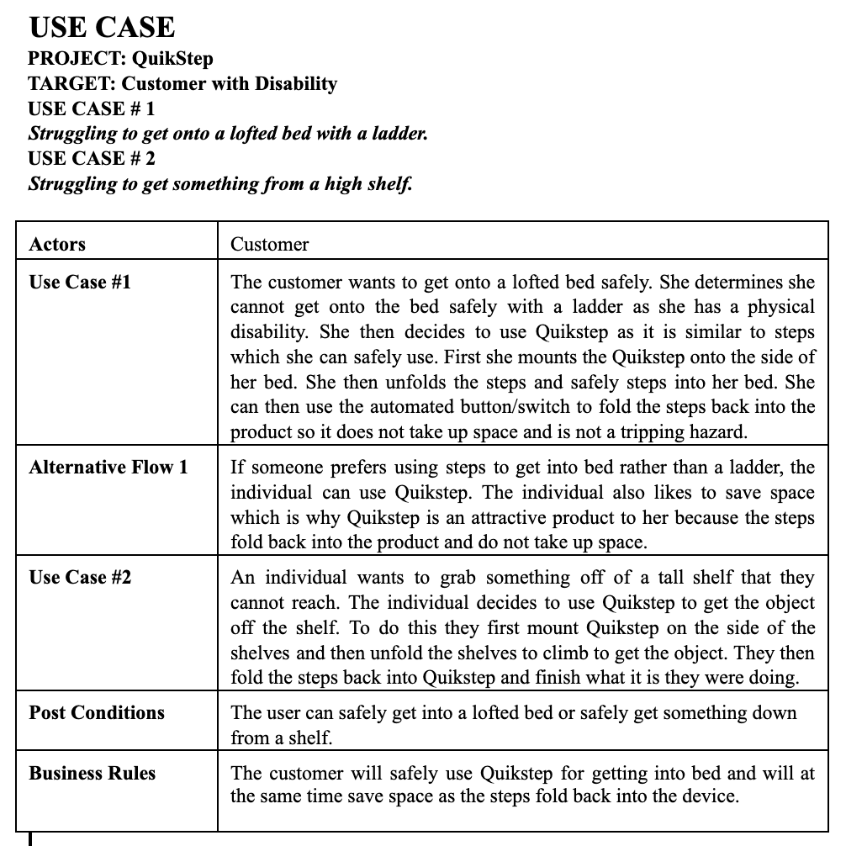
Figure : Use Case

Project Management - John Santosuosso
The team utilized the Gantt chart as a calendar system (shown below), doing their best to maintain schedule and updating the Gantt chart to match any timing changes. The team did follow the Gantt chart in the beginning of the project but during the design phase, there were many creative differences between the members of the team. Each member had their own separate idea for the design. Although there were similarities between all of them, there were key differences that could affect the whole fabrication process that the team had to agree on. This caused a massive delay in the process before the design and fabrication process was agreed upon. Looking back on the project, the team could have optimized the process by testing and assembling the circuitry in parallel to machining the parts.

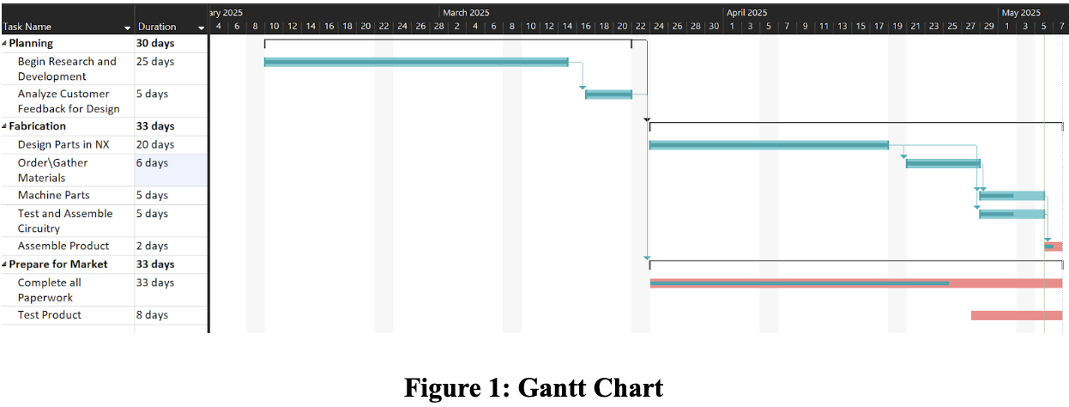

Customer Needs - Aprameyo Chakravarty
Customers were chosen to account for several different stakeholders that would be using the product. Factors like gender, lifestyle, and age were accounted for so that the design could be catered to all groups’ needs. Customers interviewed all use a lofted bed, with a climbable wooden frame that allows them to reach their mattresses; QuikStep aims to replace these frames with a more comfortable solution. See all customer responses in Appendix 1.

Table 1: Customer Survey Results
 | Customer Statement (raw data) | Interpreted Need | P or S
1 | The steps feel flimsy | Make the steps more rigid | P
2 | Rungs are too narrow | Make the rungs thicker | S
3 | The ladder is hard to see in the dark | Lights or glow-in-the-dark strips | P
4 | Rungs are slippery when climbing with socks. | Add grips to the rungs | P
5 | It would be nice to have a storage or pouch so it has more than one use | Create a pouch for a water bottle or just storage | S
6 | Climbing down is hard, especially when I’m hungover or half-asleep. | Add guide handles | S
7 | It looks plain and boring and needs more color | Add more colors and decorative options | S
8 | Takes too much space sometimes and I bump my head when I need to get underneath it. | Make it an adjustable/ foldable option or design and length options/ length adjustability. | S

Specifications - Kendrick Nedtranon
QuikStep aims to make dorm life a much more convenient endeavour. However in order to accomplish that purpose, QuikStep must focus on five key specifications which include: maximizing . These specifications are directly correlated to the customer’s needs and will help us build QuikStep to be reliable and the first choice for our customers.
The correlation numbers show the relation between the specification and the customer needs. These numbers are ranged 1 to 5 where 1 shows minimal relation between the specification and the customer need and 5 shows maximum or complete correlation between the two parameters.
Furthermore, we have a separate section that defines the difficulty to meet its respective specification. These numbers range from 1 to 5 and in this case, a 1 means it is not difficult at all while a 5 indicates great difficulty. Meanwhile, the priority rankings signify the priority of specifications that have to be met. This ranges from 1 to 9, where 1 is most important and 9 is least important.
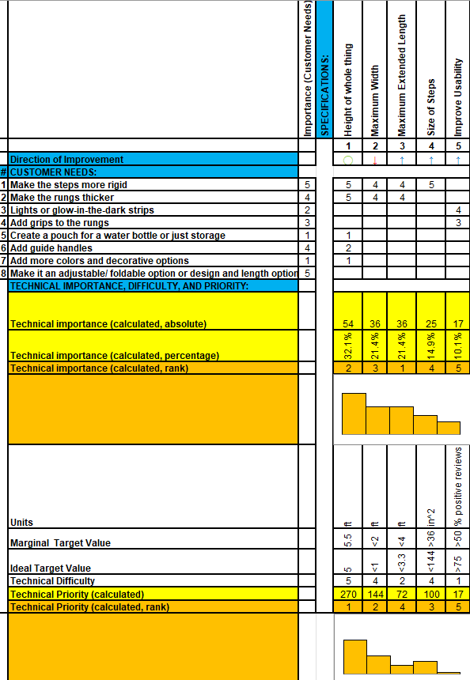

Figure 2: QFD
Team 46 looked for products that fulfilled the same purpose as QuikStep. The closest product was loft bed stairs. However, these are not automated and do not extend out. They are usually much more expensive than our current budget. Team 46 decided to add more functionality and features to this without taking any purpose from its closest competitors away in addition to making it cheaper. This decision would cause QuikStep to stand out to potential buyers.

Table 2: Competitive Benchmarking Analysis
Website URL for Product: | Loft Bed Stairs
Picture and/or Title of Product: | 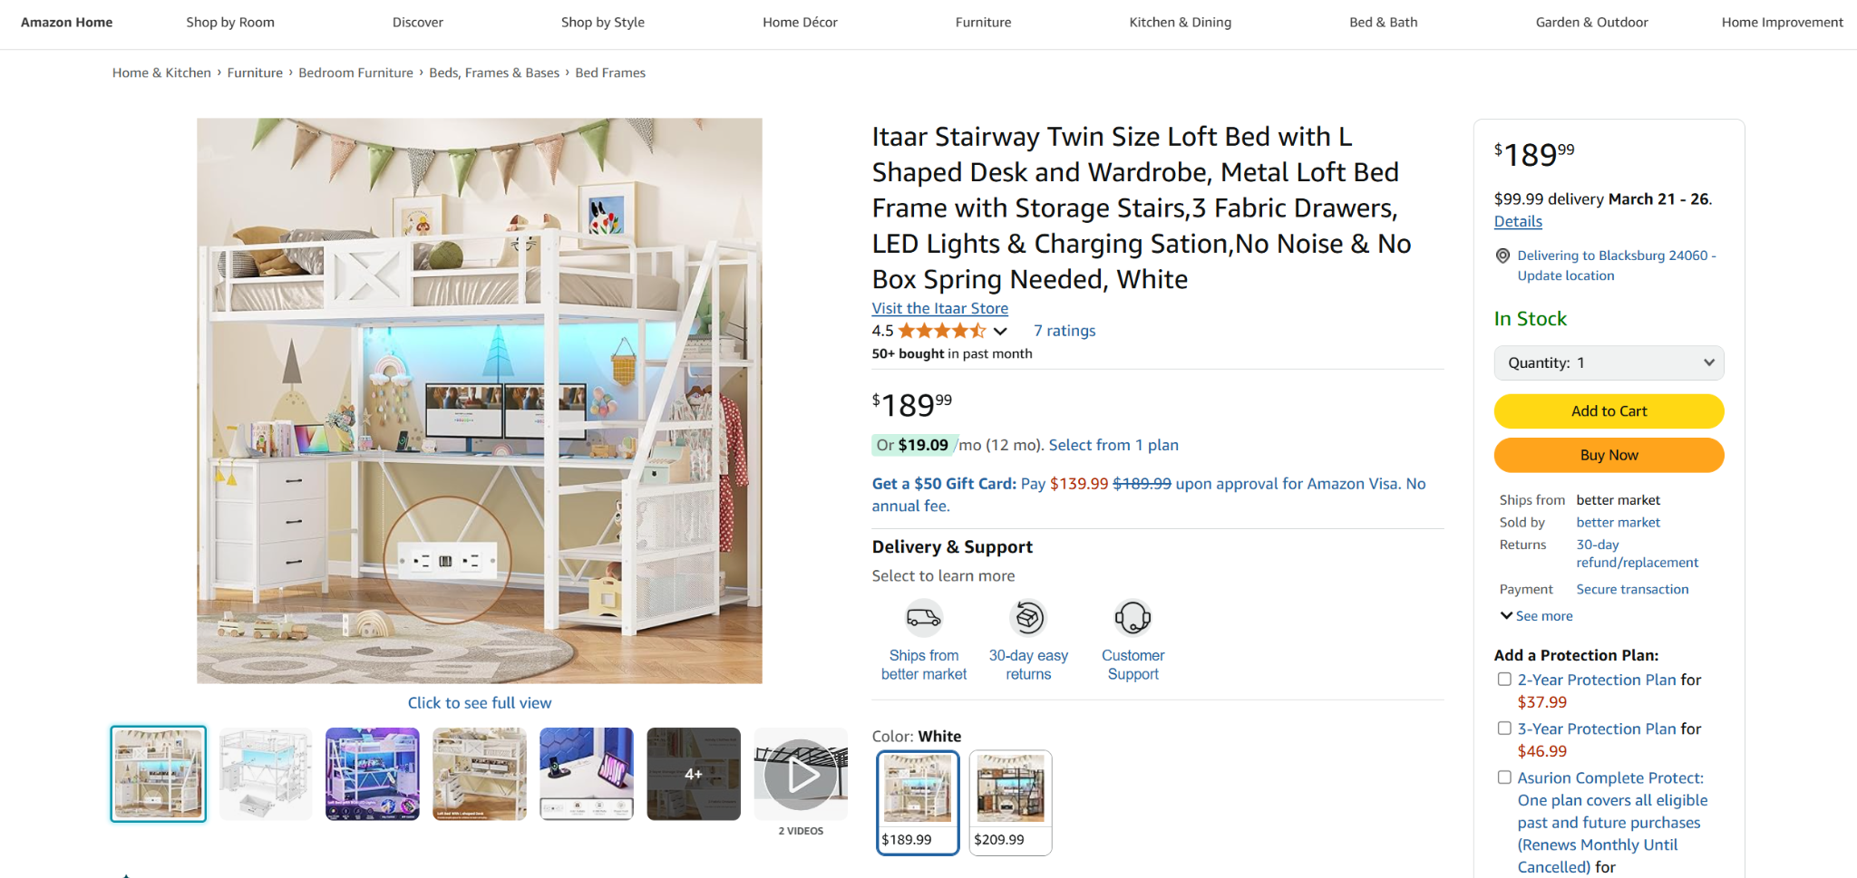
Relevant Data Found for Product:  (metric, value, unit) | Cost: $189.99  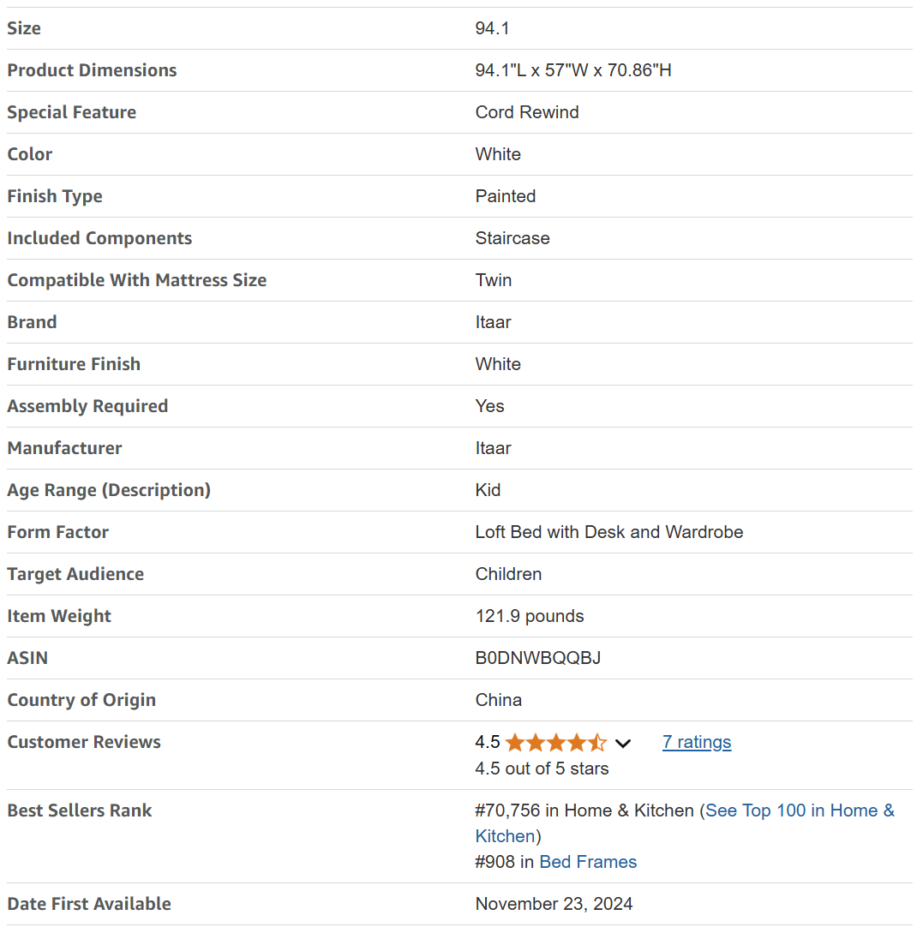

Economics - Kendrick Nedtranon
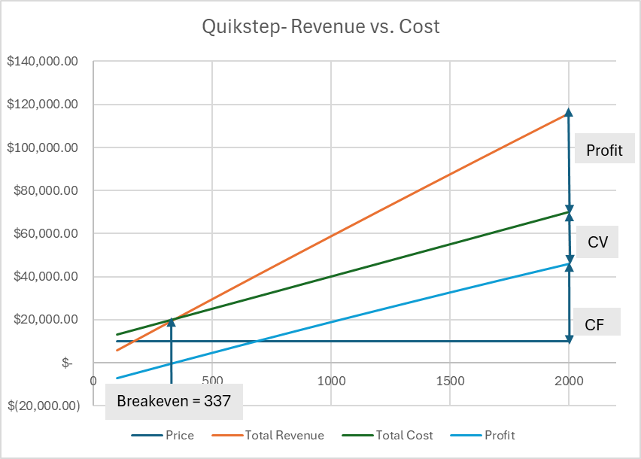

Figure 3: Economic Analysis
Team 46 decided on a scenario with variable pricing, and the number of units sold determines the profit margin. This encourages consumers to buy our product in bulk as the prices lower with the amount of units sold. The total manufacturing cost was chosen to be $30 per unit. With the fixed cost of $10,000 and the manufacturing cost, the price per unit is estimated to be $60. Based on the data, the breakeven point occurs at approximately 337 units, where total revenue equals total cost. Since the variable cost is fixed, total revenue increases directly with sales volume. While in theory, profit could continue increasing indefinitely. The team set a goal of 2000 units to be sold with a profit of $46,000.00, knowing there might be some setbacks in development, a realistic goal of 1000 units was selected with a predicted profit of $19,000. In closing, 337 units would need to be sold to reach the breakeven point, if more units are sold the total revenue would increase indefinitely.

Intellectual Property - Aprameyo Chakravarty
The review of related intellectual property revealed several important themes that guided the development of Quik-Step. Across multiple patented products, there was a clear pattern of compactness through the designs, user safety through stability and anti-slip features, and efficient use of space in tight living environments. While these patents created some limitations—such as avoiding specific folding mechanisms, linkage systems, and different methods of storing—they offered valuable inspiration. The key ideas that have influenced our concept include the use of segmented folding steps for easier storage, the use of anti-slip surfaces, and the possibility for our design to serve multiple functions.
Table 3: Patent search summary for an automatic stair
Patent Number, Title, and Issue Date | Key Features of This Invention | Impact of This Patent on Current Design
6,942,271  Truck Bed Step Apparatus  9/13/2005 | A ladder assembly with side rails and steps that can be folded in. | Limitations on team’s design: Must ensure hinge folding mechanism does not infringe on design.  Ideas gained from this design: Use of segmented foldable steps to allow compact storage.
20,150,272,337  Bed Step Device and Method  10/1/2015 | A stable, portable step device with anti-slip features. Designed for safe bed access. | Limitations on team’s design: May not replicate portable form factor exactly.  Ideas gained from this design: Integration of anti-slip surfaces and stability-focused features.
11,130,448  Folding Ladder Assembly for Elevated Platform  9/28/2021 | A ladder system with upper/lower sections connected via linkages for folding and compact storage. | Limitations on team’s design: Linkage system concept may be protected.  Ideas gained from this design: Incorporate a similar folding linkage to maximize compactness.
6,578,905  Stowable Ladder Mechanism for Overhead Bed  6/17/2003 | A ladder that stows horizontally under a truck bed that can be deployed as needed. | Limitations on team’s design: Storage configuration should differ structurally.  Ideas gained from this design: Horizontally stowable features to reduce space usage.
6,851,139  Folding Cabinet Bed  2/8/2005 | A foldable bed stored in a cabinet form to optimize space, integrating sleep and storage functions. | Limitations on team’s design: Cannot directly mimic the fold-to-cabinet function.  Ideas gained from this design: Emphasize multifunctionality and seamless integration into room layout.

Concept Generation and Selection - Aprameyo Chakravarty

Potential Solution | 1 | 2 | 3 | 4
Selection Criteria
Compacted | + | - | + | -
Motorized | + | + | + | +
Ease of use | + | + | + | +
Durability | + | + | + | +
Safety features | + | + | + | -
Multi-use | 0 | + | + | +
Sum | 5 | 4 | 6 | 4
Ranks | 2 | 3 | 1 | 3

The team utilized the gallery method to break down each of the members’ concept ideas into four main characteristics: automation method, storage placement, safety, and compactness. Doing so helped the team clearly visualize the advantages and disadvantages of each concept. Furthermore, the team gained proper visualization of each others’ concepts and was able to take ideas from each other to create a most optimal arrangement of characteristics and constraints to which design QuikStep out of.
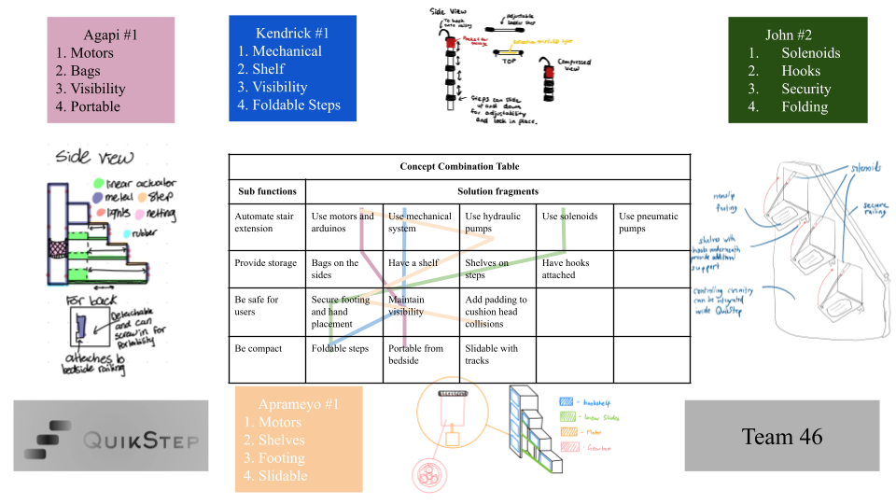

Figure 4: Gallery Poster

Failure Modes and Effects Analysis - Aprameyo Chakravarty
There are several different failure modes that could cause the product to fail while in use and pose a serious risk to the customer. However, all the risks are due to mechanical or electrical failure. Thus, we can prevent said risks by designing the product to be electrically insulated from external aspects and to be made from materials that maximize strength and toughness.

Table 4: FMEA Chart
Item/Function: | Motor | Axle | Step | Gear
Potential Failure Mode | Motor seizing | Axle snapping | Step breaking | Gears Stripping
Potential Effects of Failure | Step doesn't move | Slab is free for all degrees of motion, customer could be injured or killed | If customer is on the step it could cause injury | Gears strip and cannot grip on each other, step will not move after
Severity | 3 | 10 | 10 | 6
Potential Causes of Failure | Overuse, liquid entering the system, fatigue | Excessive weight, overuse and material fatigue | Excessive weight and material fatigue | Overuse, too much heat, material fatigue
Occurrence | 5 | 2 | 6 | 3
Current Detection Method/Design Controls | Visual inspection, prevented by using high torque motor | High factor of safety N >= 4, welded attachment of axle to slab | High factor of safety N >= 4, welded attachment of axle to slab | Product stops moving
Detection | 3 | 3 | 1 | 2
RPN | 45 | 60 | 60 | 36
Recommended Action(s) | Use higher torque motor to ensure sufficient power | Using stronger materials, extensive testing | Durable material, extensive testing | Using stronger materials, lubricate gear joints

3D Cad Model and Final Prototype - John Santosuosso
The models below display the project QuikStep. The CAD models show the step being connected to a clamp which is then connected to a bedside rung. The step in this model is controlled by a step motor that rotates the step up and back down at the user's command. The back of the project contains a box which is holding the arduino and the circuitry of the project.
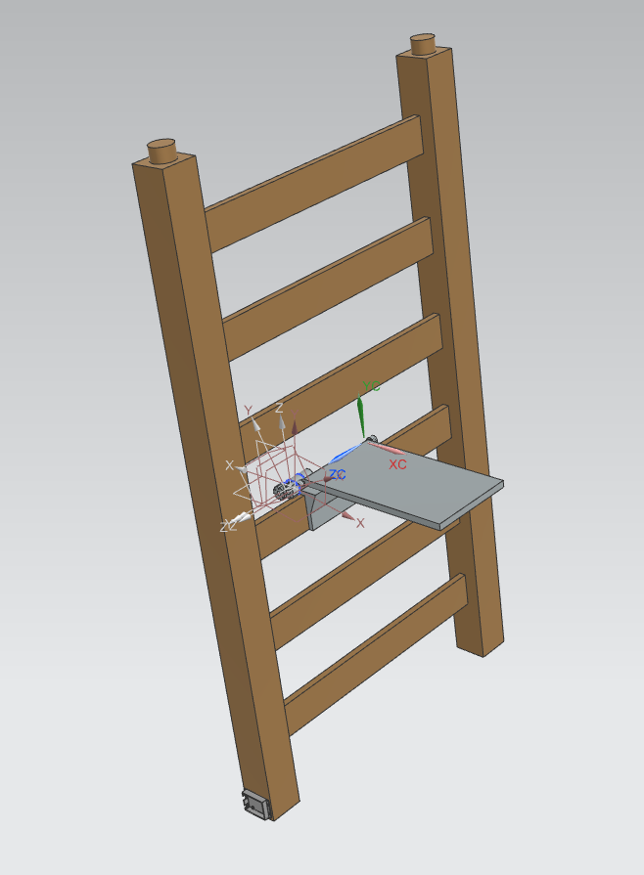
Figure 5: Isometric View of QuikStep CAD Model on NX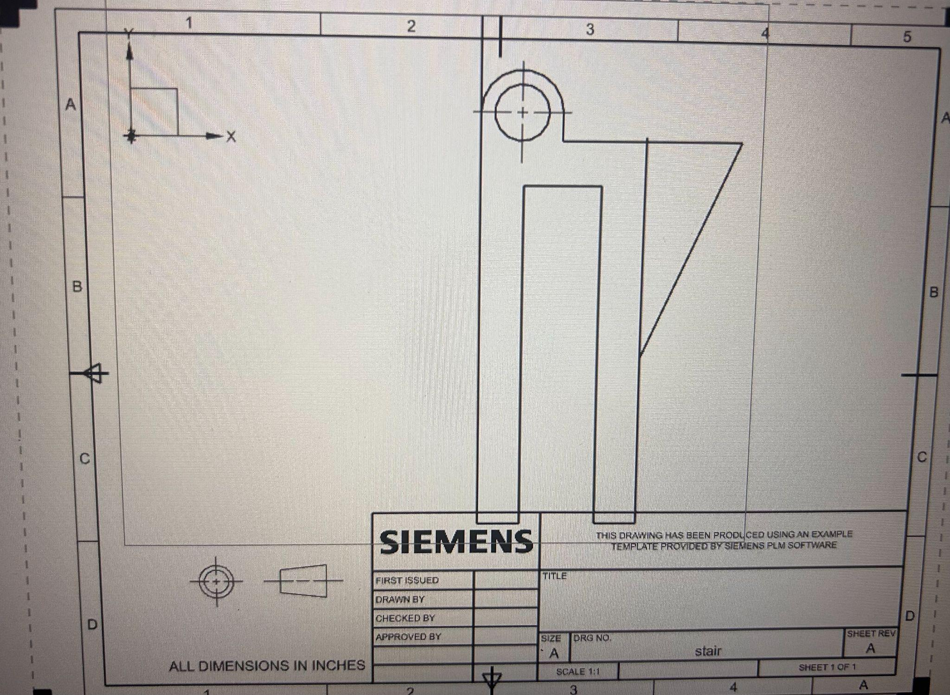
Figure 7: Drawing of QuikStep Mount
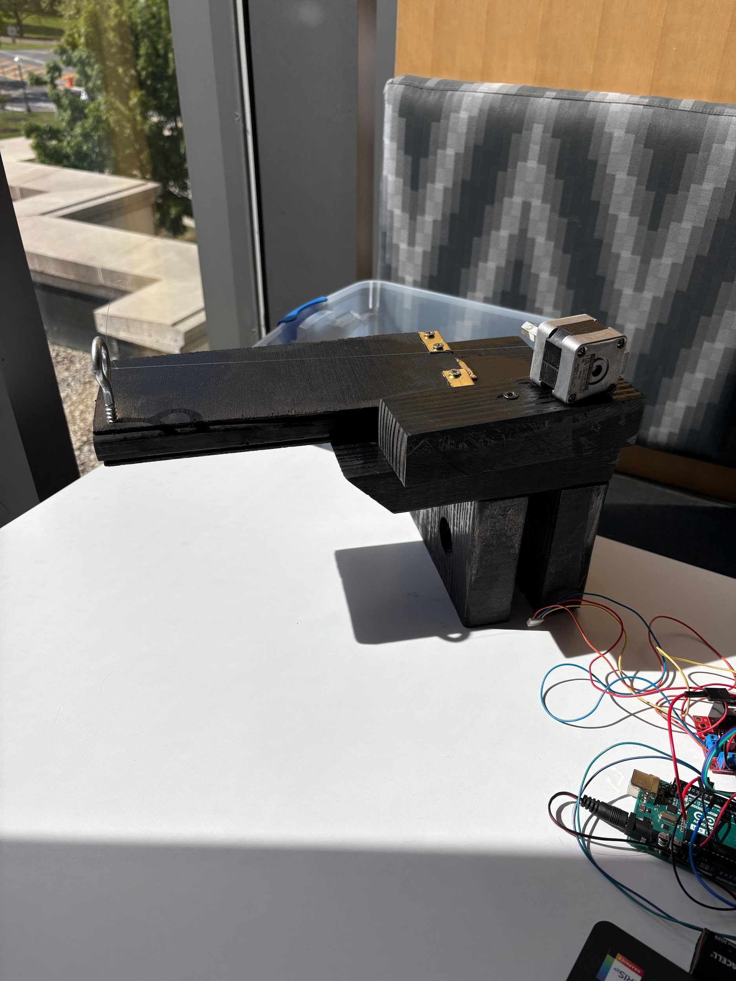

Figure 8: Final Prototype for QuikStep

Design for Assembly (DFA) - Aprameyo Chakravarty
To assemble the first unit of Quikstep it takes about 8 hours. Our team used the learning curve method to estimate total assembly time and cost, assuming an 85% learning curve based on trial builds and typical industry rates. We set the assembler pay rate at $20/hour. Using the learning curve formula, we calculated decreasing average times per unit, helping forecast labor costs and set realistic production quotas. This method allowed us to optimize scheduling and staffing. Design for Assembly (DFA) further improved efficiency by reducing part count and simplifying tasks, which accelerated learning, lowered costs, and improved scalability. Overall, both approaches were essential to improving the project’s economic performance and manufacturability.

Bill of Materials (BOM) / Cost Sheet / Design for Manufacturing (DFM) - Agapi Gladhill
Team 46’s design is an automated step system that attaches to the bedside ladder of a bunk bed. This system is motorized and the step itself will be activated into motion by a button. As shown in the CAD drawing, the step when unactivated will be in the vertical position so it will not take up space that will otherwise be unused by the ladder. When deployed, the steps will be at the horizontal position for the user to step on as a step. These step systems will be placed on each ladder rung in a diagonal formation so that the user can walk on them regularly and use the ladder as a railing if needed. The materials needed for the assembly are shown below.

Table 5: Bill of Materials
Part #: | Description: | Quantity: | Cost: | Total Cost:
1 | Arduino - This was given to us so it will not need to be manufactured or bought | 1 | - | -
2 | DC Motor - We will purchase this from Amazon, its model number is B072R57C56 | 1 | $14.99 | $14.99
3 | Step - This part will be manufactured by us out of wood | 1 | - | $14.99
4 | Step clamp - This part will be manufactured by us out of wood | 1 | - | $14.99
5 | Fishing line - To connect to the motor and step | 1 | $2.99 | $17.98
6 | Arduino box - We will manufacturer this by 3D printing using PLA | 1 | - | $17.98
7 | Gear box - We will manufacturer this by 3D printing using PLA | 1 | - | $17.98
8 | Spray paint - To make the product look nicer | 1 | $2.48 | $20.46
9 | Pushbutton - This was given to us so it will not need to be manufactured or bought | 1 | - | $20.46
10 | Jumper Wires - This was given to us so it will not need to be manufactured or bought | 5 | - | $20.46

Reflections on Physical Prototypes and Product Improvements (i.e., Next Generation) - Kendrick Nedtranon
We would like to improve our product by using a lower voltage motor so that we can attach more common battery types into it other than a 9V battery. In order to accommodate the lower voltage motor, we should use a belt system that increases the torque output of the motor. The belt will be manufactured out of reinforced polyurethane to improve its longevity and reduce the chance of gear stripping. Furthermore, we can create the step and slab out of 3D printed carbon-fiber reinforced ABS. We believe that this will lower the cost of the product, allowing us to sell it at a lower price.
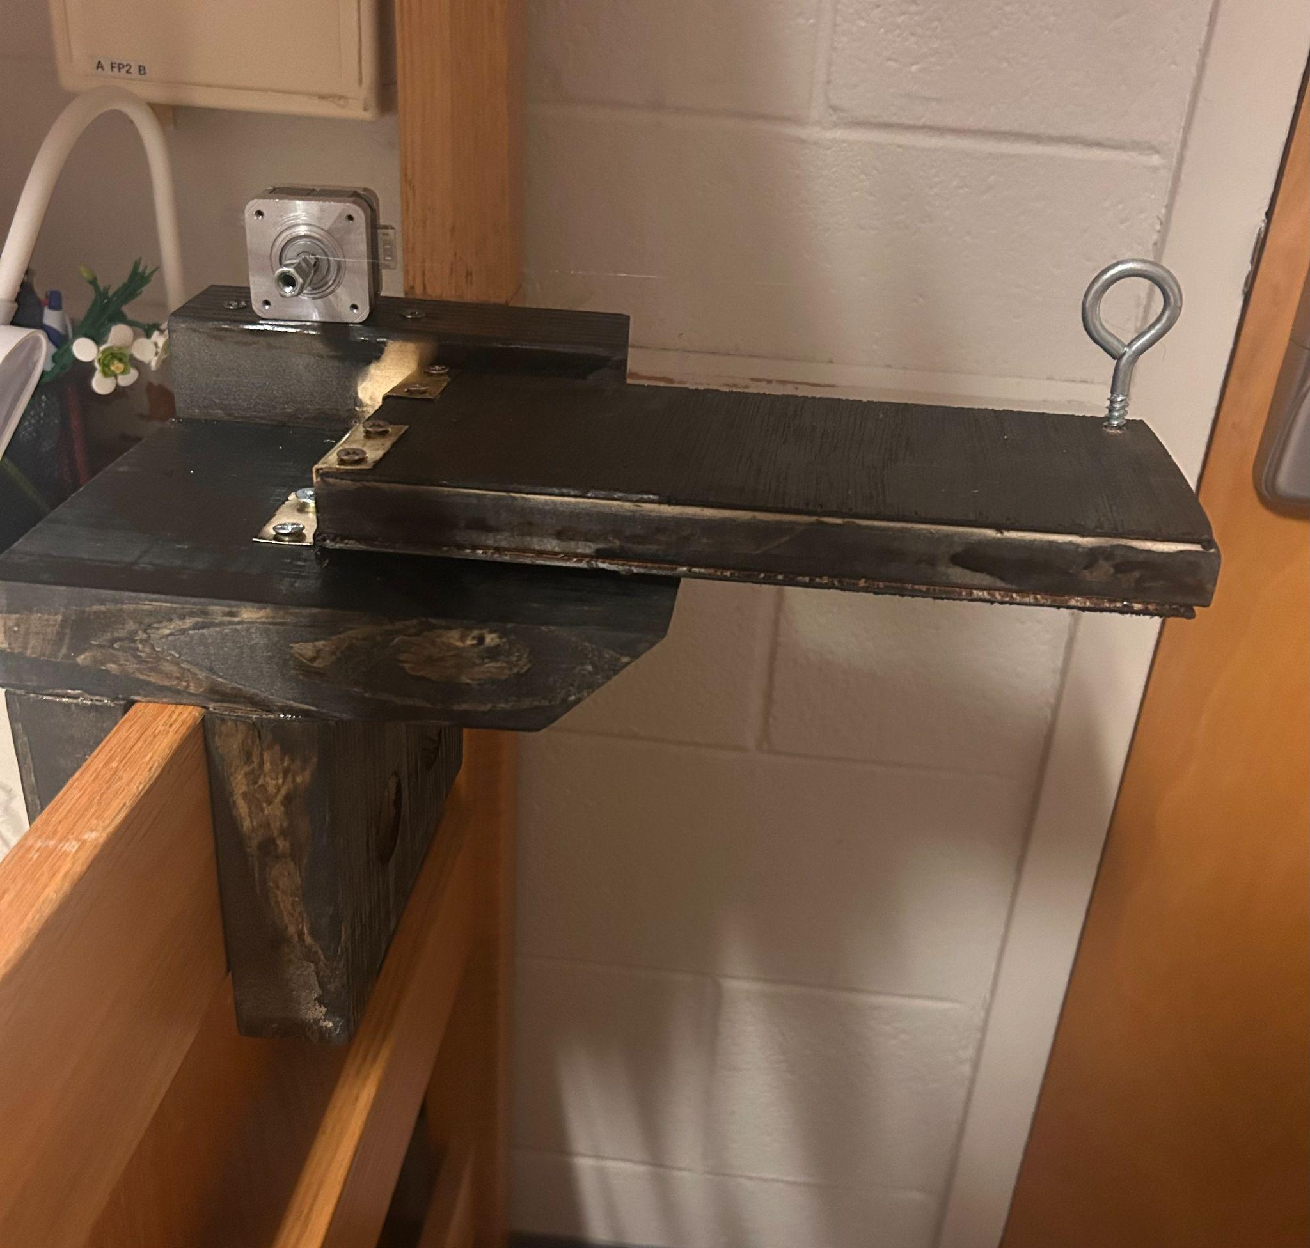

Figure 9: Physical QuikStep prototype

Conclusion - John Santosuosso
In conclusion, Quikstep is the best solution for solving a real problem in dorms to maximize people's comfort and to accommodate people with physical limitations. Through extensive research and testing, the team was able to create a functional and cost-effective prototype. The team was able to develop a product that combines functionality, safety, and affordability by using strategic planning, economic modeling, consumer feedback analysis, and iterative design procedures. For the future, advancements to the motor system, materials, and manufacturing strategy provide a clear route to advancing with QuikStep to future production and commercialization, establishing it as a practical and inclusive solution for everyday accessibility difficulties.

Appendix 1: Customer Interviews
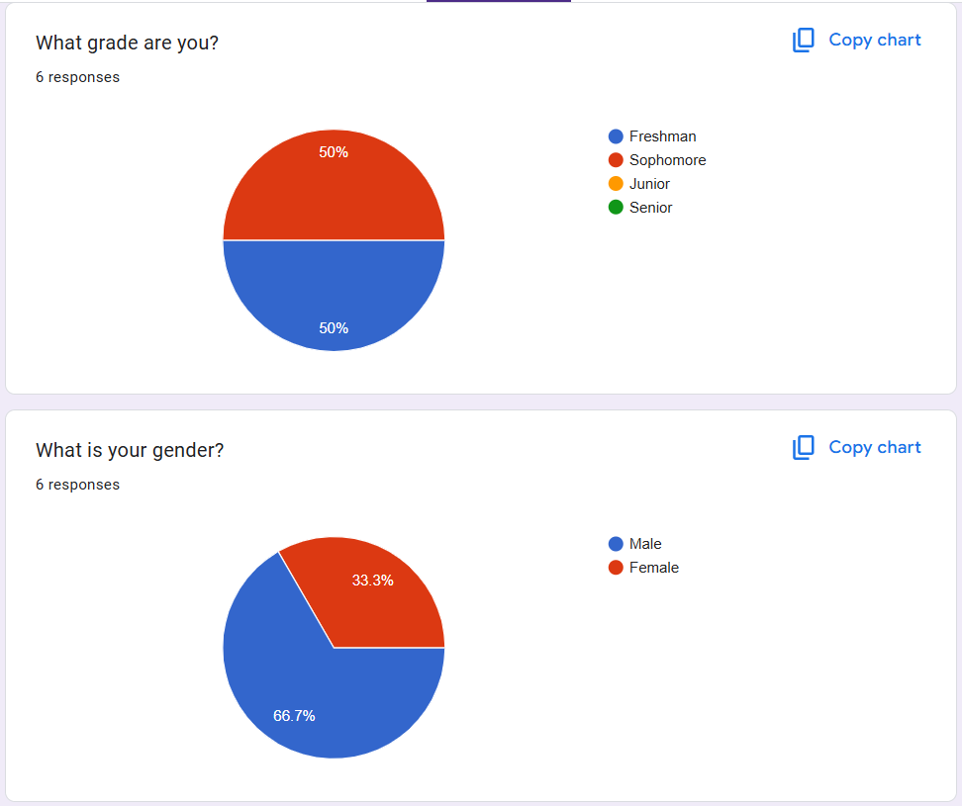

Figure 10: Customer Demographics

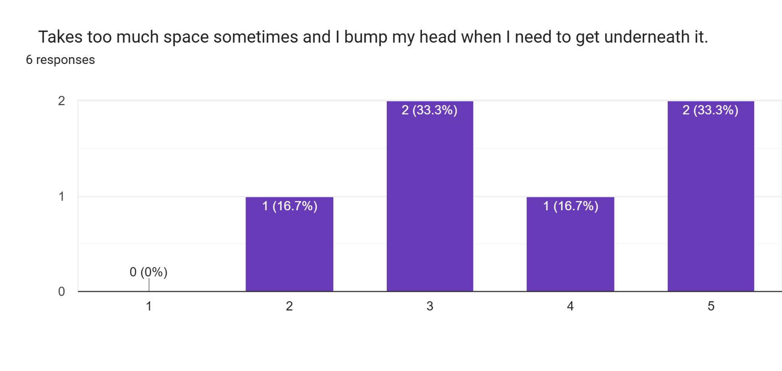
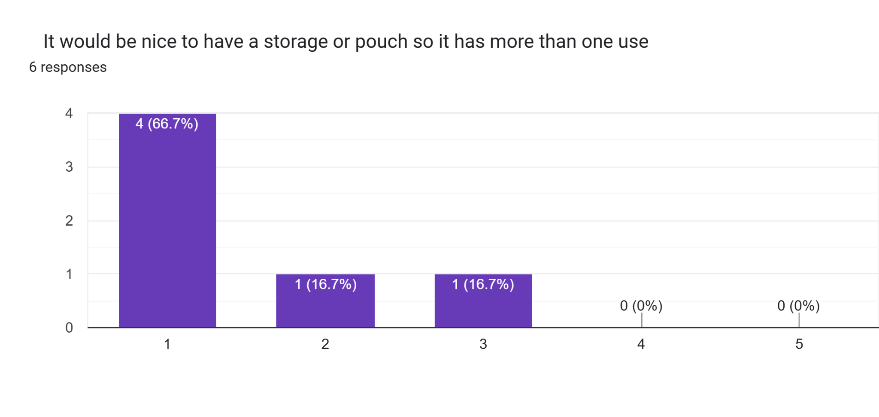
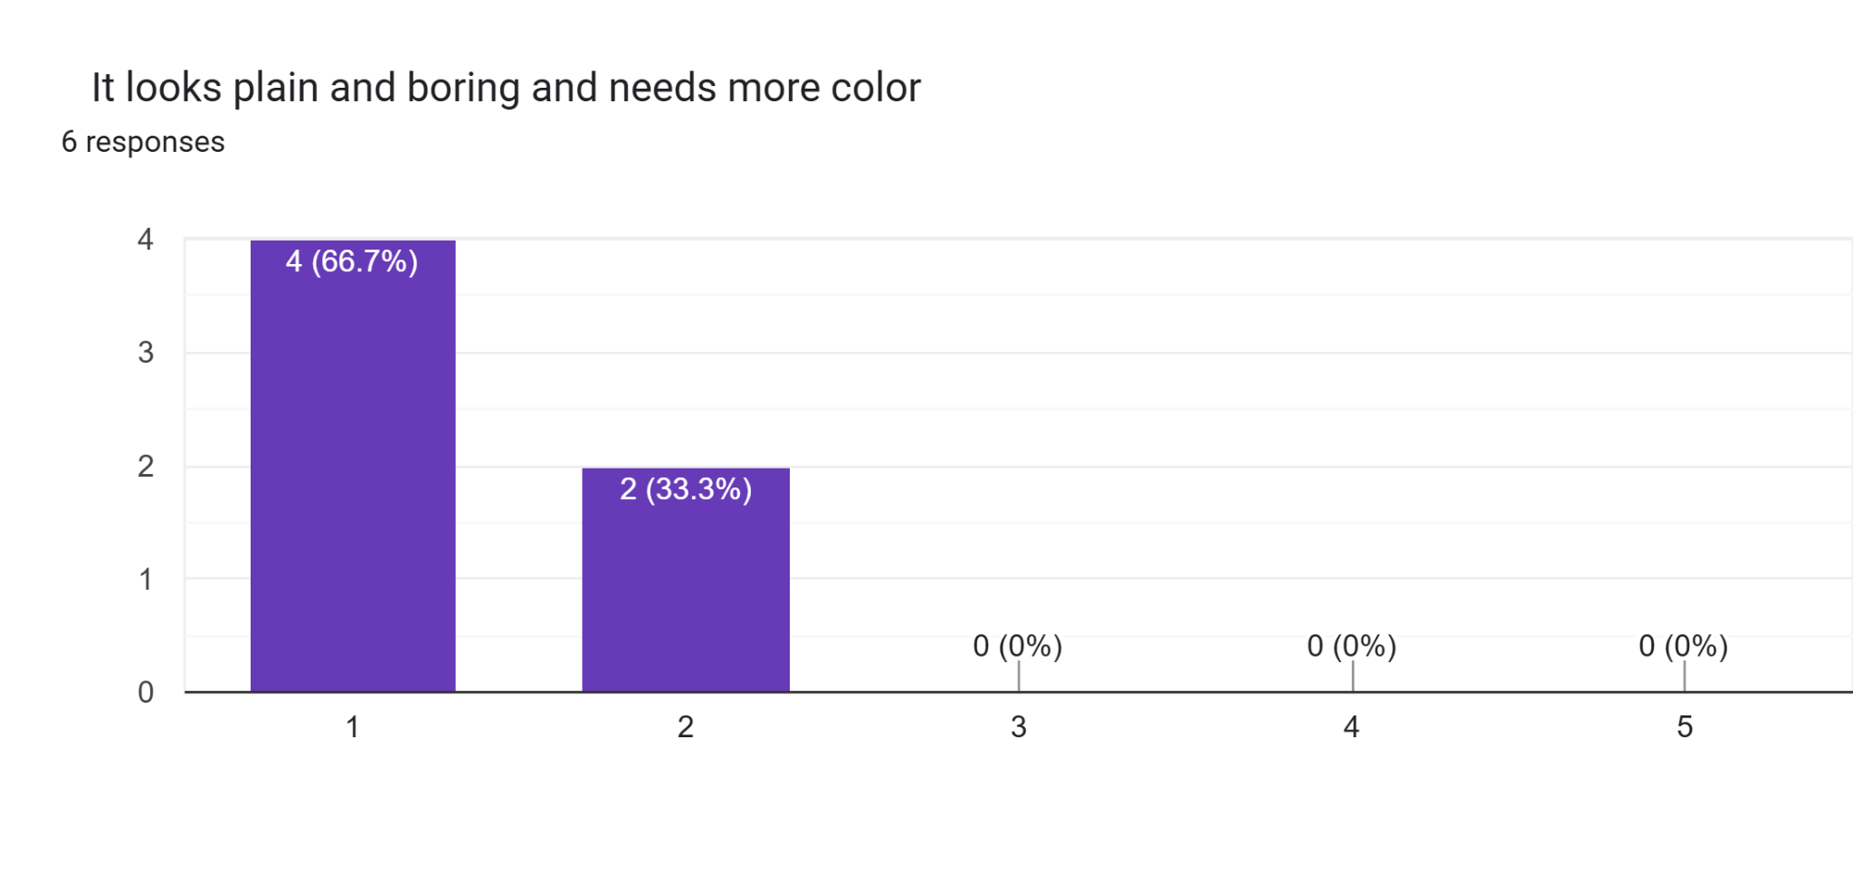
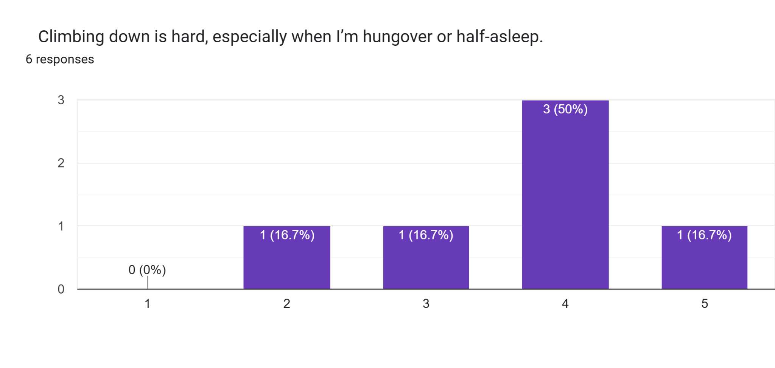
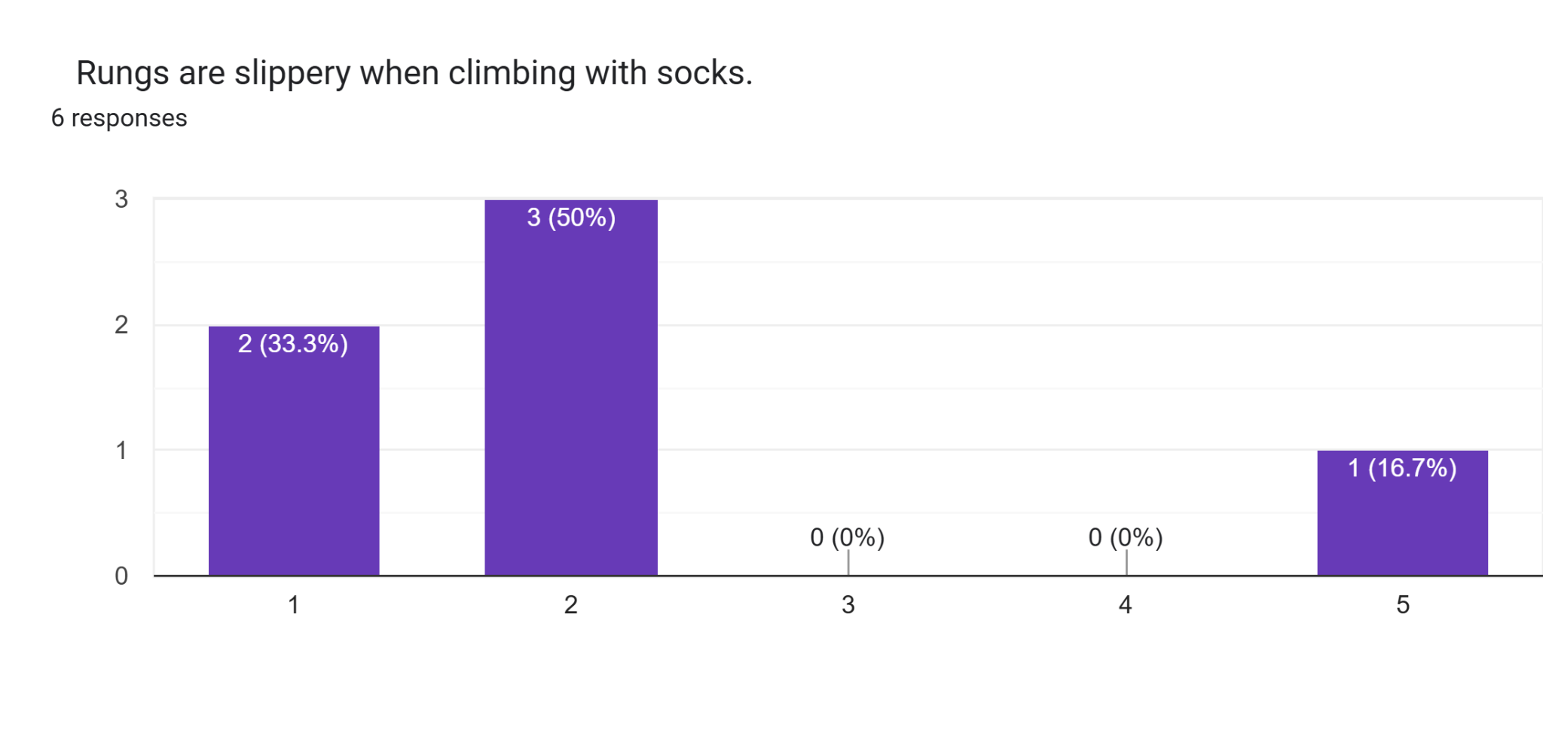
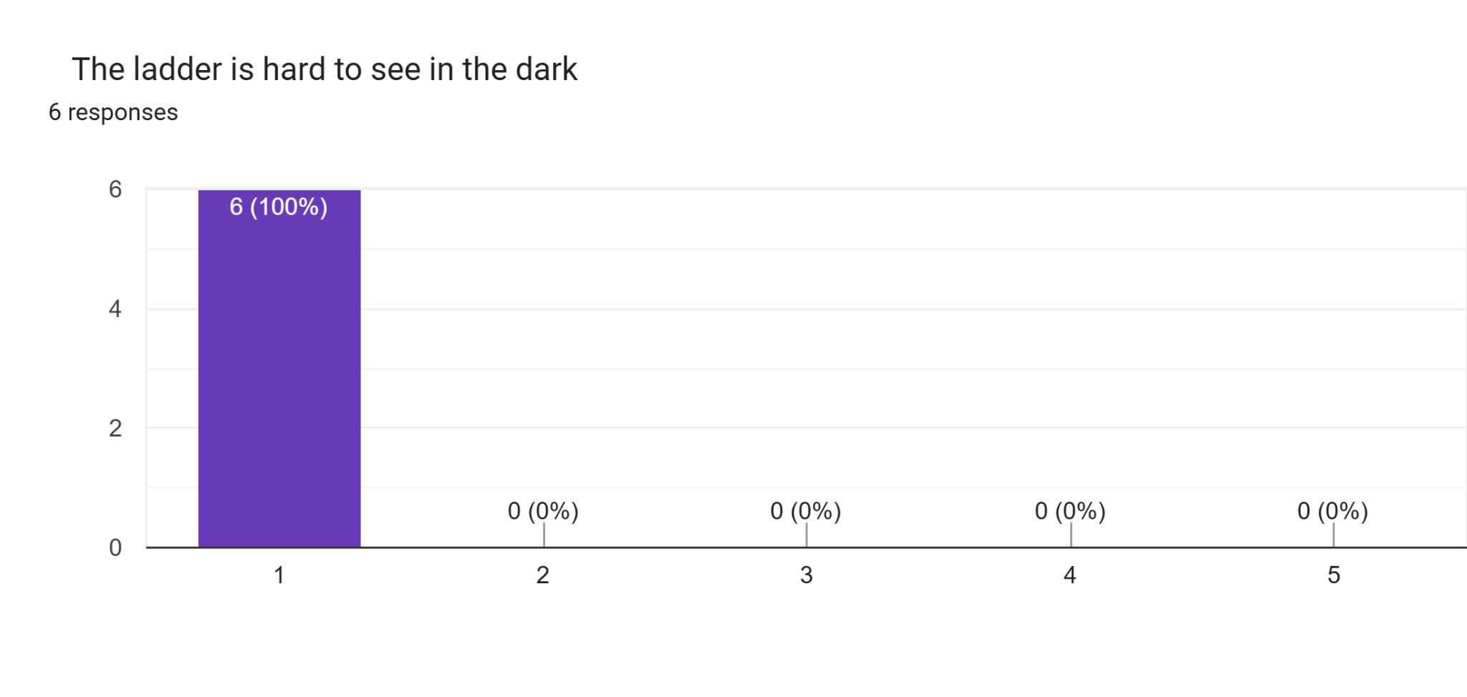

Figure 11: Raw Customer Needs Data
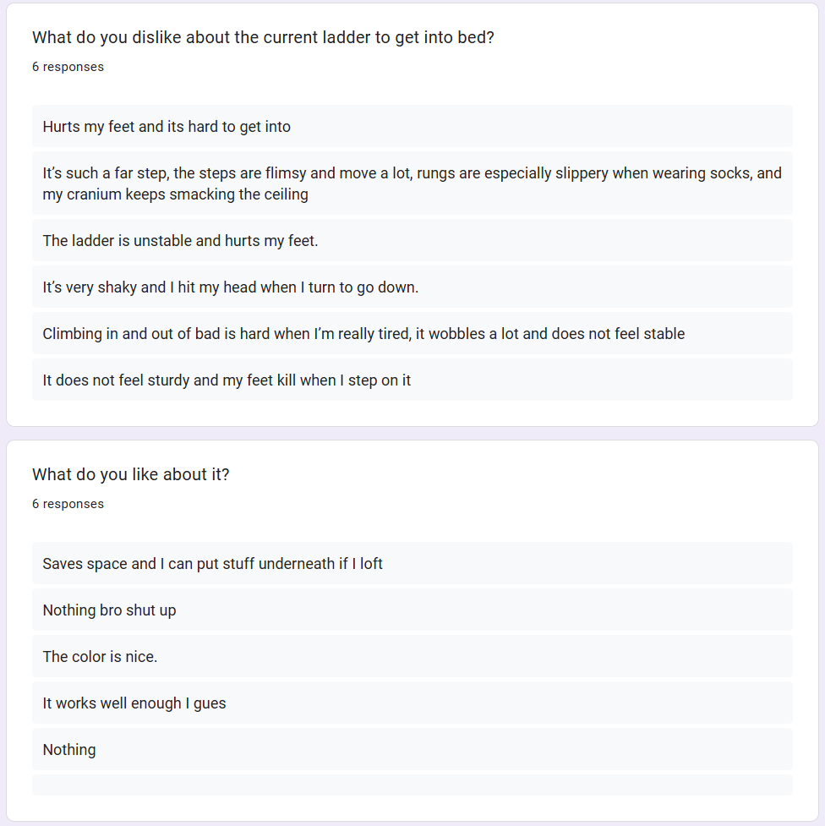

Figure 12: Customer Opinions

