Your BMR (Basal Metabolic Rate) is an estimate of how many calories your body burns at rest. It represents the minimum amount of energy needed to keep your body functioning, including breathing and keeping your heart beating. Your BMR uses up about two-thirds of your daily calories. Your caloric intake to lose, maintain, or gain weight will be based on your BMR, but will not be the same figure.

The **BMR formula** uses the variables of height, weight, age and gender to calculate the Basal Metabolic Rate (BMR). This is more accurate than calculating calorie needs based on body weight alone.

Age, height, weight, and gender determine a person's BMR, also known as basal energy expenditure (BEE). There are multiple formulas used to calculate BMR due to different schools of thought in the health and fitness community. Our calculator uses the Harris-Benedict equation, which works as follows:

<http://www.healthfitonline.com/resources/harris_benedict.php>

<https://my-calorie-counter.com/calorie-calculator/>

<http://www.bmrcalculator.org/how-many-calories-should-i-eat-a-day/>

important

<http://www.bmi-calculator.net/bmr-calculator/harris-benedict-equation/>

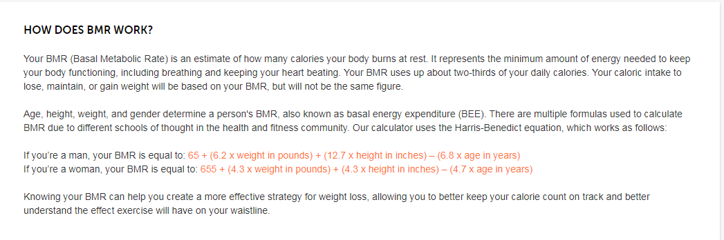

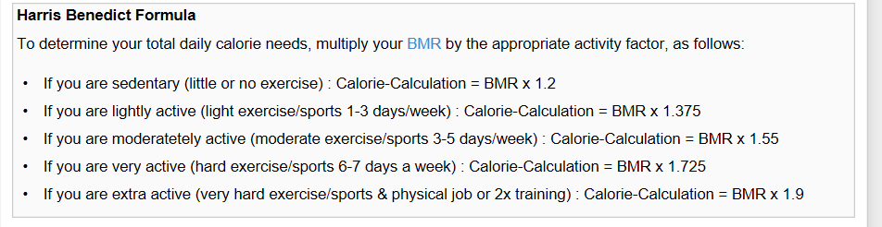

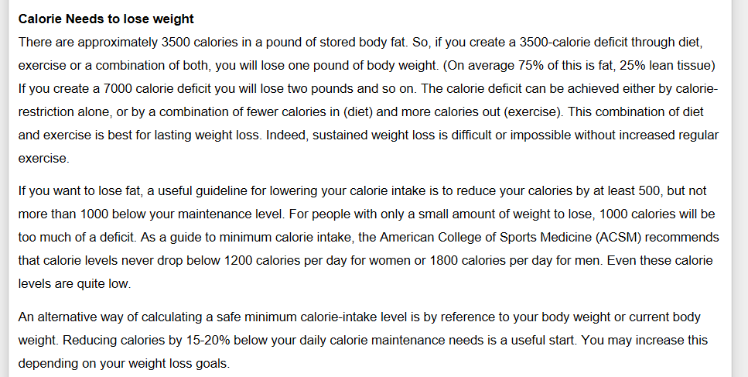

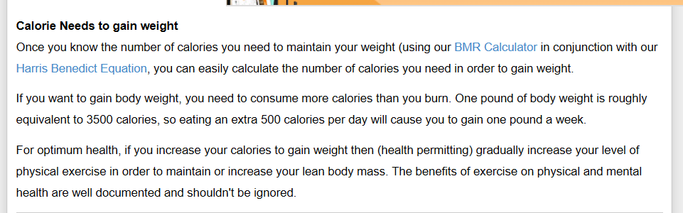

The weight loss and weight gain was calculated on a 500 calorie deficient or increase per day.