Lab 09.01 Databases

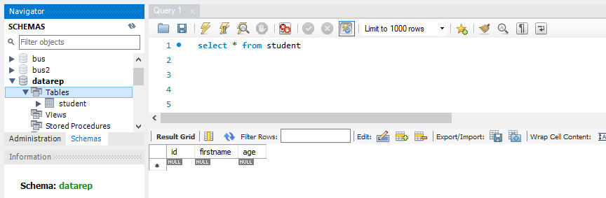

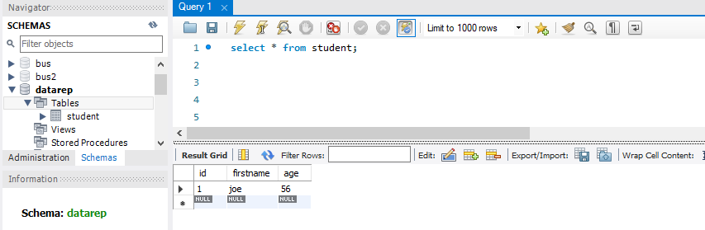

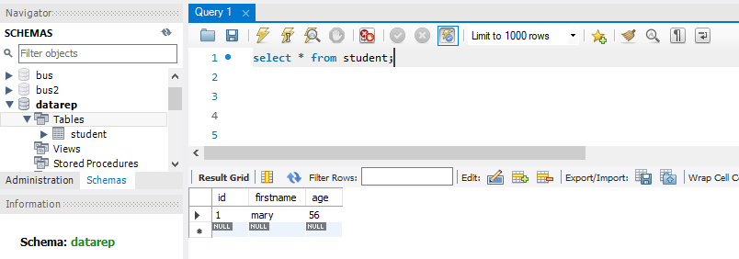

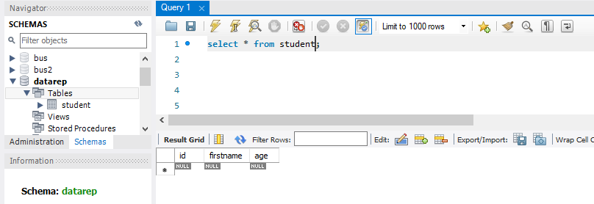

mysql> create table student (

id int NOT NULL auto_increment,

title varchar(100),

author varchar(100),

price int(3),

PRIMARY KEY(id)

);

mysql> insert into book (title, author, price) values ('PHP and MySQL for Dummies',

'Janet Valade', 25);

mysql> select * from book;

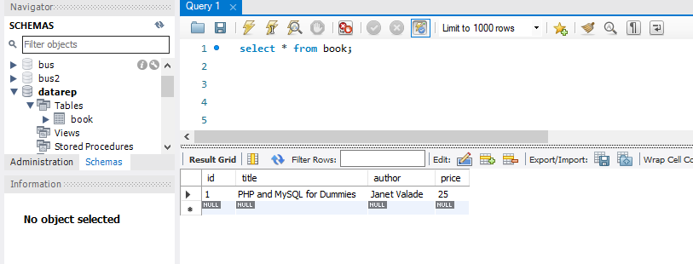

Had trouble with PHPmysql…

Lab 09.02 Python and Databases

[Done] exited with code=0 in 0.41 seconds

[Running] python -u "c:\Users\JS\repos\DR_work\week09-simple-database\insertIntoTest.py"

1 record inserted, ID: 8

[Done] exited with code=0 in 0.419 seconds

[Running] python -u "c:\Users\JS\repos\DR_work\week09-simple-database\zteststudentDAO.py"

test create and find by id

(9, 'mark', 45)

test update

(9, 'Fred', 21)

test get all

(1, 'Joe', 33)

(3, 'Ja', 22)

(6, 'Mike', 44)

(7, 'Ann', 43)

(8, 'Tim', 33)

(9, 'Fred', 21)

[Done] exited with code=0 in 0.476 seconds