Jordan Schalter

Konja IT402

Assignment5

2/16/23

Prototyped Facebook:

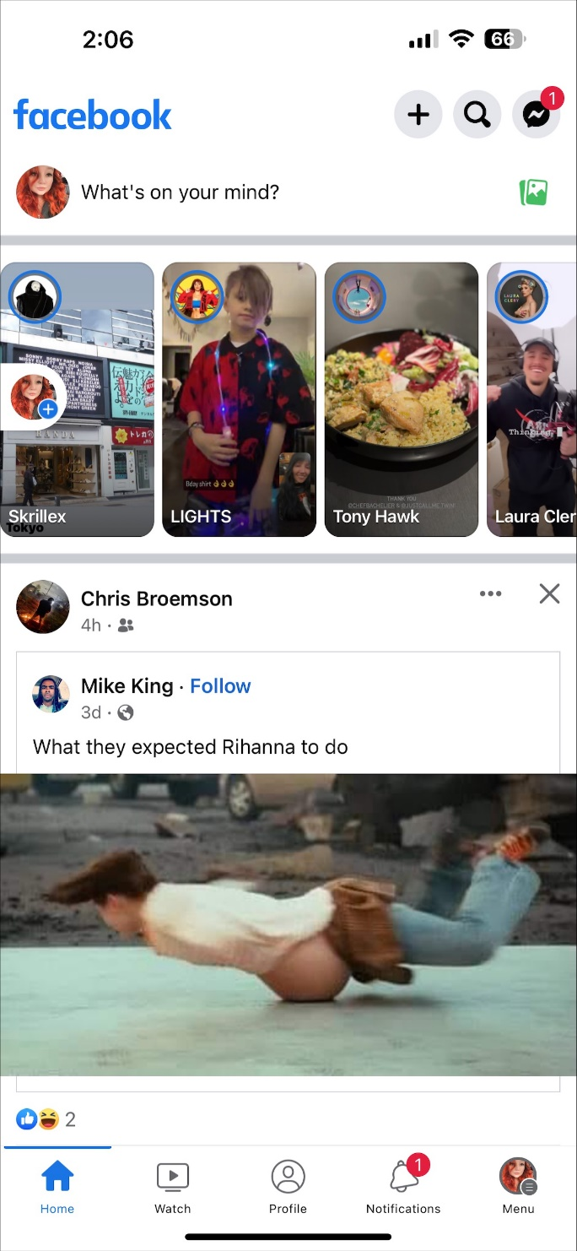

Mocked Facebook:

