N =2  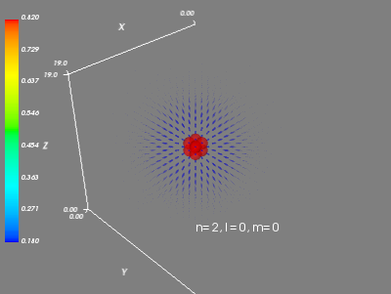  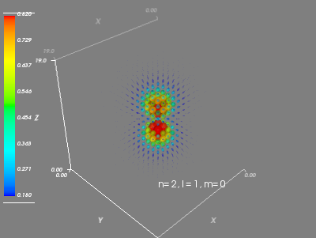 | 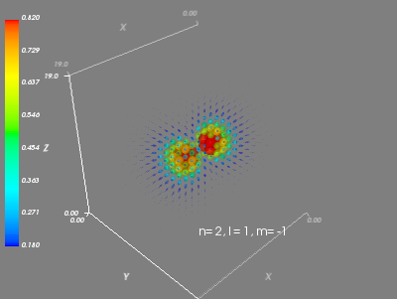  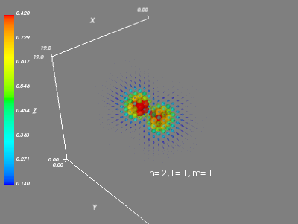

N = 3  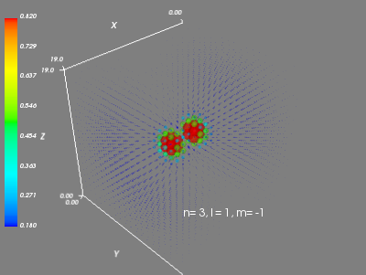  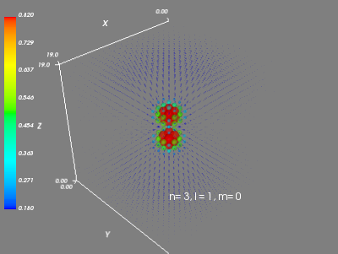  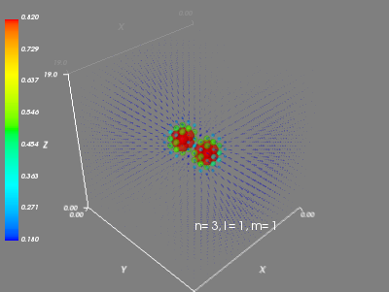 | 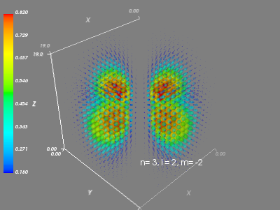  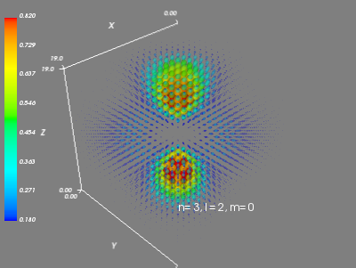  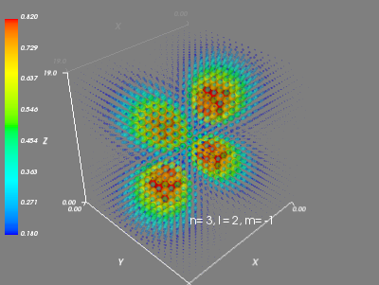  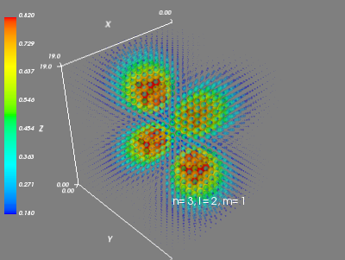  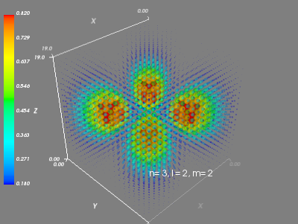

N = 4  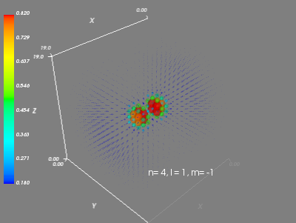  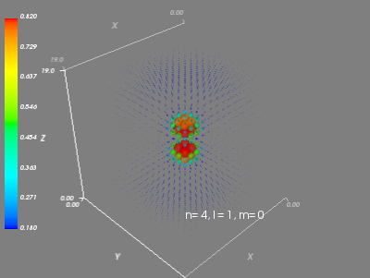  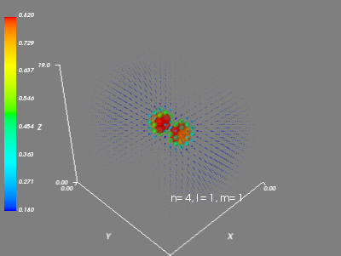 | 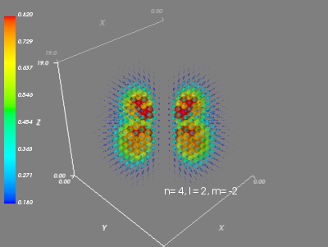  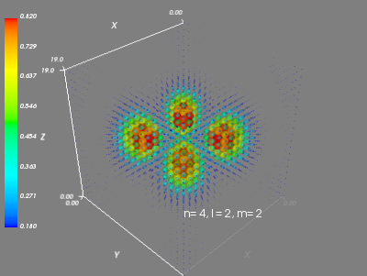  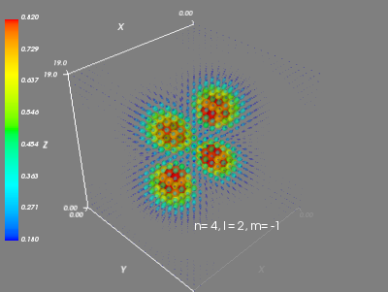  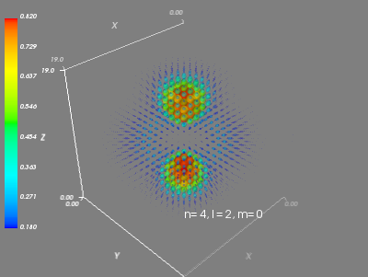  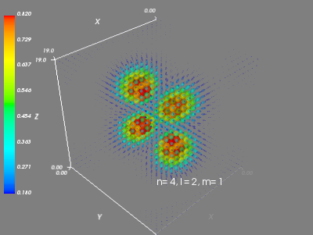

N = 4  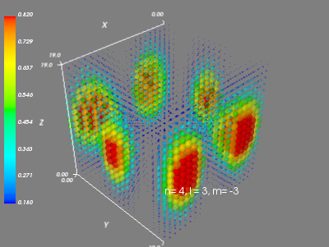  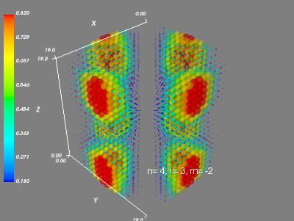  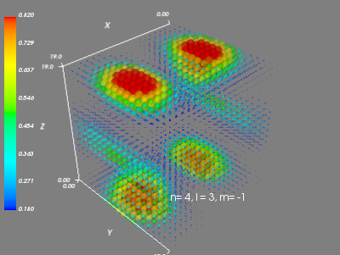 | 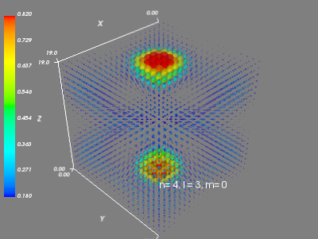  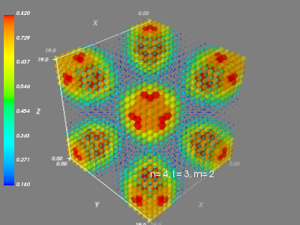  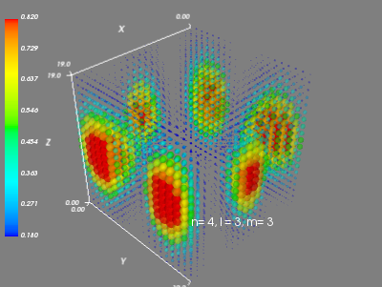

Laguerre and Legendre functions were generated algorithmically for large values as it was tedious to compute by hand and computers exist.

Code:
import numpy as np
import scipy.constants as c
from sympy import diff, factorial, simplify, symbols, E
import math

def fact(n):
"""
factorial of n
:param n: int
:return: int
"""
if type(n) != int:
n = int(n)

if n == 1:
return 1

else:
acc = 1
for x in range(1,n+1):
acc = acc * x

return int(acc)

# Q4

def assoc_legendre(m,l):
def f00(a):
x = symbols('x')
#x, l, m = symbols('x l m')
if m == 0 and l == 0:
return 1
else:
diff_l = diff((x**2 - 1)**l,x,l)
#print(type(l))
fact_l = factorial(int(l))
fact_l = 1.0/((fact_l) * (2**l))
lp = fact_l * diff_l

asslegen = ((1-x**2)**((abs(m))/2)) * (diff(lp,x,abs(m)))
print asslegen
return asslegen.evalf(subs={x:math.cos(a)})
#return diff_l
return f00

def assoc_laguerre(p,qmp):
def f(a):
x = symbols('x')
if p == 0 and qmp == 0:
return 1
else:
y = (E**(-x))* (x**(qmp+p))
eel = (E**(x))
diff_l = eel * y.diff(x, qmp+p)

ass_l = ((-1)**p)*diff_l.diff(x,p)
#print(ass_l)
return int(round(ass_l.evalf(subs={x:a}),0))
return f

