**Creating a Docker Compose file with Prometheus, Grafana and Node Exporter**

**Install Compose (Ubuntu 20.04)**

Download the current stable release of Docker Compose (@April 2022)

sudo curl -L "https://github.com/docker/compose/releases/download/1.29.2/docker-compose-$(uname -s)-$(uname -m)" -o /usr/local/bin/docker-compose

Apply executable permissions to the binary

sudo chmod +x /usr/local/bin/docker-compose

Test the installation

docker-compose --version

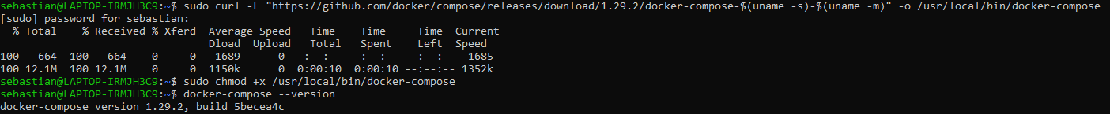

**Creating the Docker compose file**

Create the folder that will hold the project

mkdir <directory-name>

Create the Docker Compose file inside the directory

touch docker-compose.yml

Configure the Docker Compose so it integrates Prometheus, Grafana, Node-exporter (and optional, cAdvisor)

Run the containers using docker-compose up from the project directory

sudo docker-compose up

Test the deployment by entering <http://localhost:9090>. It should show Prometheus Dashboard.

**Setting up Grafana dashboards**

Enter <http://localhost:3000> and login as admin/admin in Grafana

Click on “Add your first data source” and select “Prometheus” in the new page.

Add the URL to Prometheus server (<http://localhost:9090> by default) and click on Save and Test. If there is an issue with the connection, replace the <http://localhost:9090> for <http://server_ip:9090>. To find the server ip where Prometheus is running, you can use sudo docker network inspect <network_name>

**Add Node Exporter Full dashboard**

Access <https://grafana.com/grafana/dashboards/> and look for “Node Exporter Full” dashboard

Copy Node Exporter Full dashboard ID and import the dashboard to Grafana. To do so, click on the “+” at the left menu, then Import, write the dashboard ID and click on Load.

Select Prometheus as the data source and click on Import

The Node Exporter Full dashboard is ready

