**Establish SSH login on Fedora virtual machine**

In guest machine:

Update system packages:

sudo dnf -y update

Create a new user:

adduser <USERNAME>

Give super user privileges to the new user:

sudo usermod -aG wheel <USERNAME>

Create .ssh folder and authorized_files folder in home:

sudo mkdir ~/.ssh

sudo chmod 700 ~/.ssh

sudo touch ~/.ssh/authorized_keys

sudo chmod 600

~/.ssh/authorized_keys

sudo chown -R <USERNAME>:<USERNAME> ~/.ssh

In host machine:

Generate SSH key pair:

ssh-keygen

In Windows, copy the public key to clipboard:

type C:\Users\<USER>\.shh\<KEY_NAME>.pub | CLIP

In guest machine:

Copy the public key to authorized_keys file:

sudo echo “<PUBLIC_KEY>” >> ~/.ssh/authorized_keys

In host machine:

Login to the guest machine using ssh:

ssh <USERNAME>@<GUEST_IP_ADDRESS>

**Installing Docker on Fedora virtual machine**

Update system

sudo dnf -y update

Add Docker CE repository to system

sudo dnf -y install dnf-plugins-core

sudo tee /etc/yum.repos.d/docker-ce.repo<<EOF

[docker-ce-stable]

name=Docker CE Stable - \$basearch

baseurl=https://download.docker.com/linux/fedora/35/\$basearch/stable

enabled=1

gpgcheck=1

gpgkey=https://download.docker.com/linux/fedora/gpg

EOF

Install Docker CE

sudo dnf makecache

sudo dnf install docker-ce docker-ce-cli containerd.io

Start Docker service

sudo systemctl enable --now docker

Check Docker service status (should be active)

systemctl status docker

Add user to docker group (to avoid using sudo for Docker commands)

sudo usermod -aG docker <USERNAME>

newgrp docker

Check version

docker version

**Installing Jenkins on a Docker container**

Pull most recent Jenkins LTS version (can be checked in <https://hub.docker.com/r/jenkins/jenkins>):

docker pull jenkins/jenkins:lts-jdk11

Create a new container to run Jenkins using Docker:

docker run -p 8080:8080 -p 50000:50000 -v jenkins_home:/var/jenkins_home jenkins/jenkins:lts-jdk11

Make sure to have initial administrator password at hand (automatically generated and shown in logs):

Jenkins initial setup is required. An admin user has been created and a password generated.

Please use the following password to proceed to installation:

1883c809f01b4ed585fb5c3e0156543a

This may also be found at: /var/jenkins_home/secrets/initialAdminPassword

Wait for this message to be shown in logs:

Jenkins is fully up and running

Then go to the browser, open a new tab and go to http://<LOCAL_HOST_IP_ADDRESS>:8080. Add the initial administrator password and click on Continue.

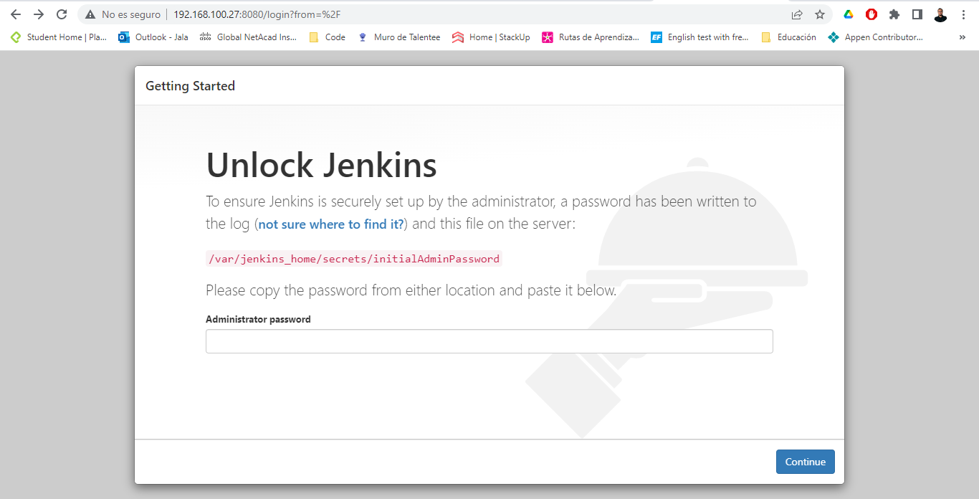

Choose “Install suggested plugins” and wait until the installation is finished.

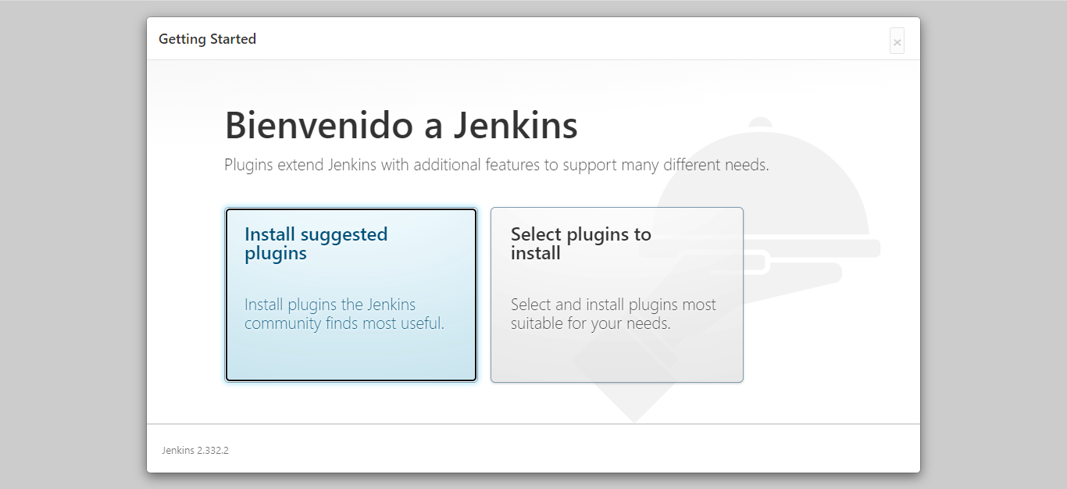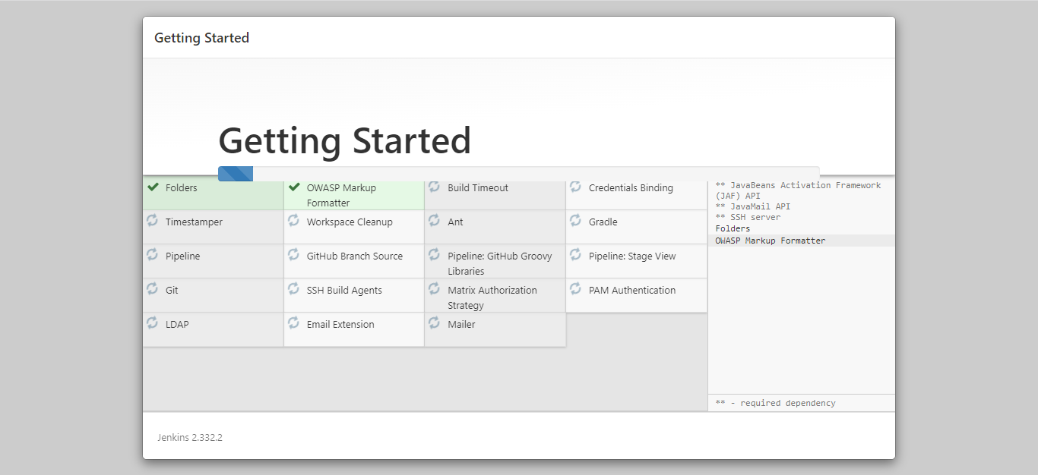

Create the first admin user. Fill all the fields and click Save and Continue.

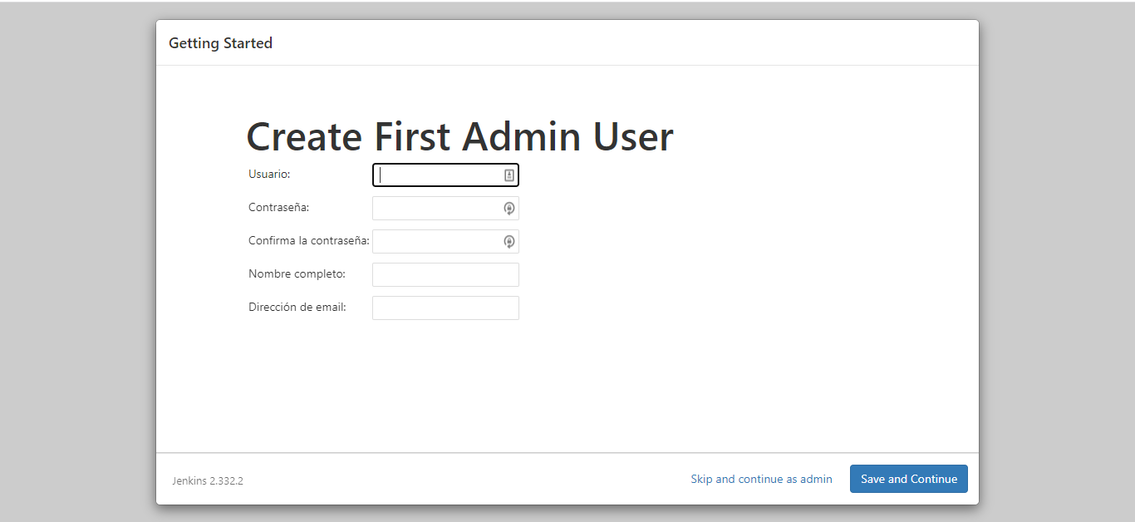

Choose the Jenkins URL to access Jenkins. Leaving the one that is default is recommended.

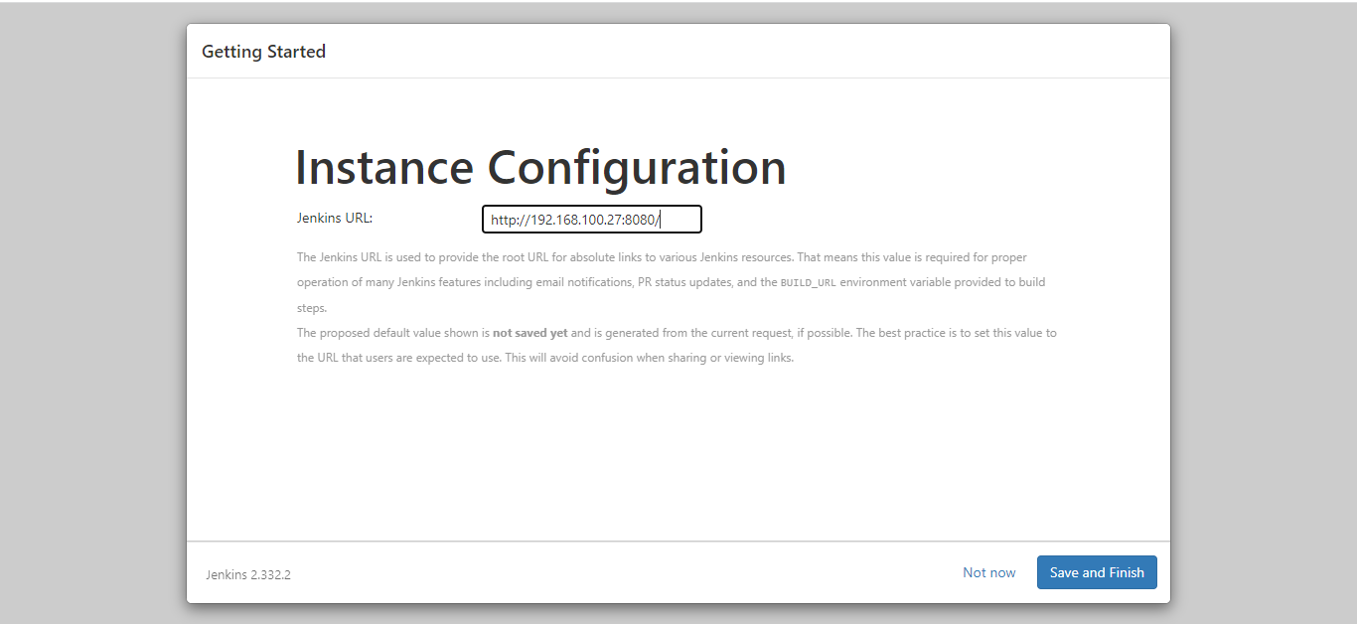

Jenkins has been installed and is ready to use.

