Jason Secula

Thermo Pre-Exam Study Guide

1. (True or False?) A closed system undergoing a process such that $S_{2}=S_{1}$ must be an internally reversible process.
2. The amount of heat and work are ________ the process a system undergoes between two states.
   1. Independent of
   2. Dependent on
3. An ___ process involves no heat transfer
   1. Obtuse
   2. Arbitrary
   3. Adiabatic
   4. Irradiated
4. SI Bas Units include
   1. Kelvin (K), newton (N), Seconds (s).
   2. Seconds (S), meter(m), pound mass ($lb_{m})$.
   3. Kelvin (K), meter(m), Second (s).
   4. Kilogram (kg), meter(m), newton(N).
5. Classify the items a through g on the diagram below as a *property, state, or process.*

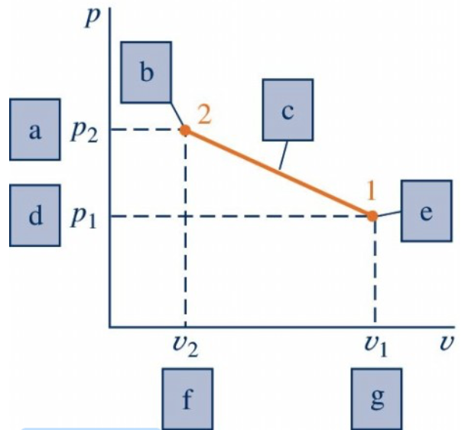

1. The five bas dimensions commonly used in thermodynamics are
2. What is transferred between a closed system and its surroundings during a process?
   1. Heat
   2. Work
   3. Energy
   4. All of the above
   5. A or B
3. The number of independent properties required to fix the state of a simple compressible system is
   1. Zero
   2. One
   3. Two
   4. Three
   5. An infinite number are required
4. A state a which a phase change begins or ends is called a ____ state.
   1. Saturation
   2. Compressed
   3. Vapor
   4. Liquid
   5. Solid
5. In the two-phase regions on the p-v-T surface of a pure substance, two or more phases of matter exist when the system is in _____.
6. The quality of a saturated vapor is ____; the quality of a saturated liquid is ___.
   1. 1.0, 0.0
   2. 1.0, 2.0
   3. 0.0, 1.0
   4. 2.0, 1.0
7. A two-phase, liquid-vapor mixture with equal ___ of saturation liquid and saturated vapor has a quality of 0.5.
   1. Volumes
   2. Temperatures
   3. Pressures
   4. Masses
   5. Energies
8. (True or False?) The temperature and pressure fix the state of a two-phase liquid/vapor mixture.
9. (True or False?) All ideal gases have constant specific heats.
10. The change in internal energy of an ideal gas undergoing a constant temperature process is
    1. > 0
    2. = 0
    3. < 0
    4. Unknown/not enough information to answer
11. The compressibility factor, Z, is equal to ___ for an ideal gas
    1. 1.0
    2. 2.0
    3. 0.5
    4. 0.0
12. The specific enthalpy of an ideal gas is a function of ____ only.
    1. Pressure
    2. Volume
    3. Temperature
    4. Specific Entropy
13. Mass flow rate for a flow modeled as one-dimensional depends on all of the following except:
    1. Density of the work fluid
    2. Cross-sectional area through which fluid flows
    3. Velocity of the working fluid
    4. Total volume of the working fluid
14. Way too much for me to type quickly…

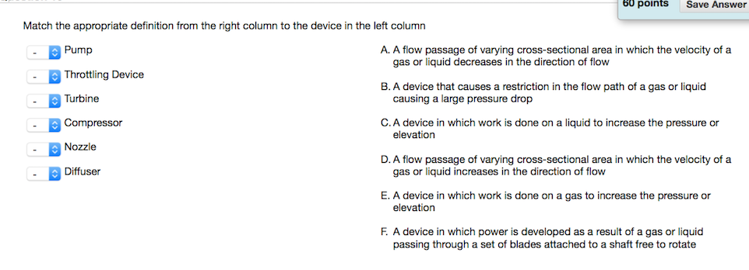

1. (True or False?) The change in entropy between two states is the same for every process between the two states.
2. (True or False?) A process of a closed system that violates the second law also always violates the first law.
3. (True or False?) The maximum thermal efficiency of any power cycle operating between two thermal reservoirs maintained at $1000°C$ and $500°C$ is 50%.
4. A power cycle operates between thermal reservoirs at $1500°F$ and $1000℉$ with efficiency of 45%. This cycle is
   1. Reversible
   2. Irreversible
   3. Impossible
   4. Not enough information to determine
5. (True or False?) When $σ_{cycle}=0$ in the Clausius Inequality, the corresponding cycle is able to occur in the real world.
6. Entropy is ___ by irreversibilities in a process.
   1. Produced
   2. Destroyed
   3. Transferred
7. For a one-inlet, one-outlet control volume at steady state, the specific entropy at the exit must be ____ than the specific entropy at the inlet if there is no heat transfer.
   1. Less than
   2. Greater than
   3. Equal to
   4. Less than Equal to
   5. Greater than or Equal to
8. ­­­(True or False?) For an adiabatic process, the entropy rate balance says that the change in entropy can be positive, negative, or equal to zero
9. The change in entropy for an irreversible process is ____ a reversible process between the same two states
   1. Greater than
   2. Less than
   3. Equal to
10. Saturated R-134a vapor enters a compressor at $6℉$. At compressor exit, the specific entropy is the same as that at the inlet, and the pressure is 80 psia. Determine the R-134a exit temperature, in $℉$.
11. Saturated R-134a vapor enters a compressor at $5℉$. At compressor exit, the specific entropy is the same as that at the inlet, and the pressure is 80 psia. Determine the R-134a exit temperature, in BTU/lb.
12. Saturated R-134a vapor enters a compressor at 100 kPa at a rate of $0.7 m^{3}/min$ and exits at 1 MPa. The inlet tube has a diameter of 3 cm and the outlet tube has a diameter of 2 cm. If the isentropic efficiency is 87 percent, determine the temperature of the refrigerant at the exit of the compressor, in $℃$.

*There is no stray heat transfer, and the effects of the potential energy can be ignored.*

1. Saturated R-134a vapor enters a compressor at 100 kPa at a rate of $0.7 m^{3}/min$ and exits at 1 MPa. The inlet tube has a diameter of 3 cm and the outlet tube has a diameter of 2 cm. If the isentropic efficiency is 87 percent, determine the Power input, in kW.

*There is no stray heat transfer, and the effects of the potential energy can be ignored.*

1. If you have thoroughly read the syllabus, please enter the keyword or phrase here.