Mini-Project 1 – Simple Chat Service

Overview
The aim of this practical was to create a program to exchange text messages between two computers using TCP. In my implementation of this program I completed the following features:
- The application can connect to another machine and exchange chat messages using TCP
- If a connection to a specified machine fails a number of times, it can host a connection.
- The chat can be closed as desired.
- The user can choose to host the connection instead.
- Provides a simple Text-based UI.
- The application can deal with abnormal connection terminations.
- It can send and receive files of arbitrary type.

Design
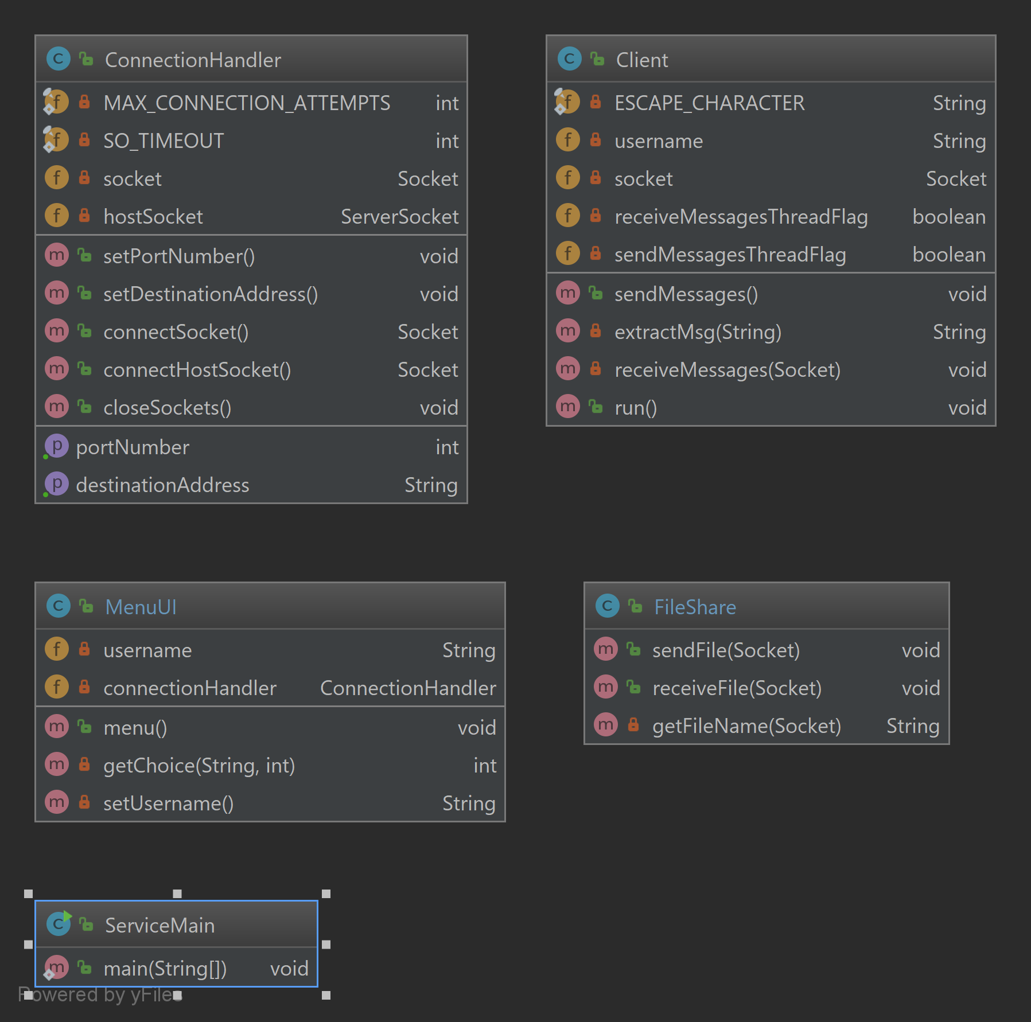
I decided to split my application into 4 primary classes:
- The MenuUI class is meant to be the point of contact for the user.
- The Client class provides the implementation for messaging services.
- The ConnectionHandler Class provides an object that connects to other users and gives that connection to the Client program in order for it to send and receive messages.
Figure 1. Final Class Diagram
- The FileShare class represents the filesharing extension. It only requires a socket to send/receive files.
Figure 2. Initial Class Diagram
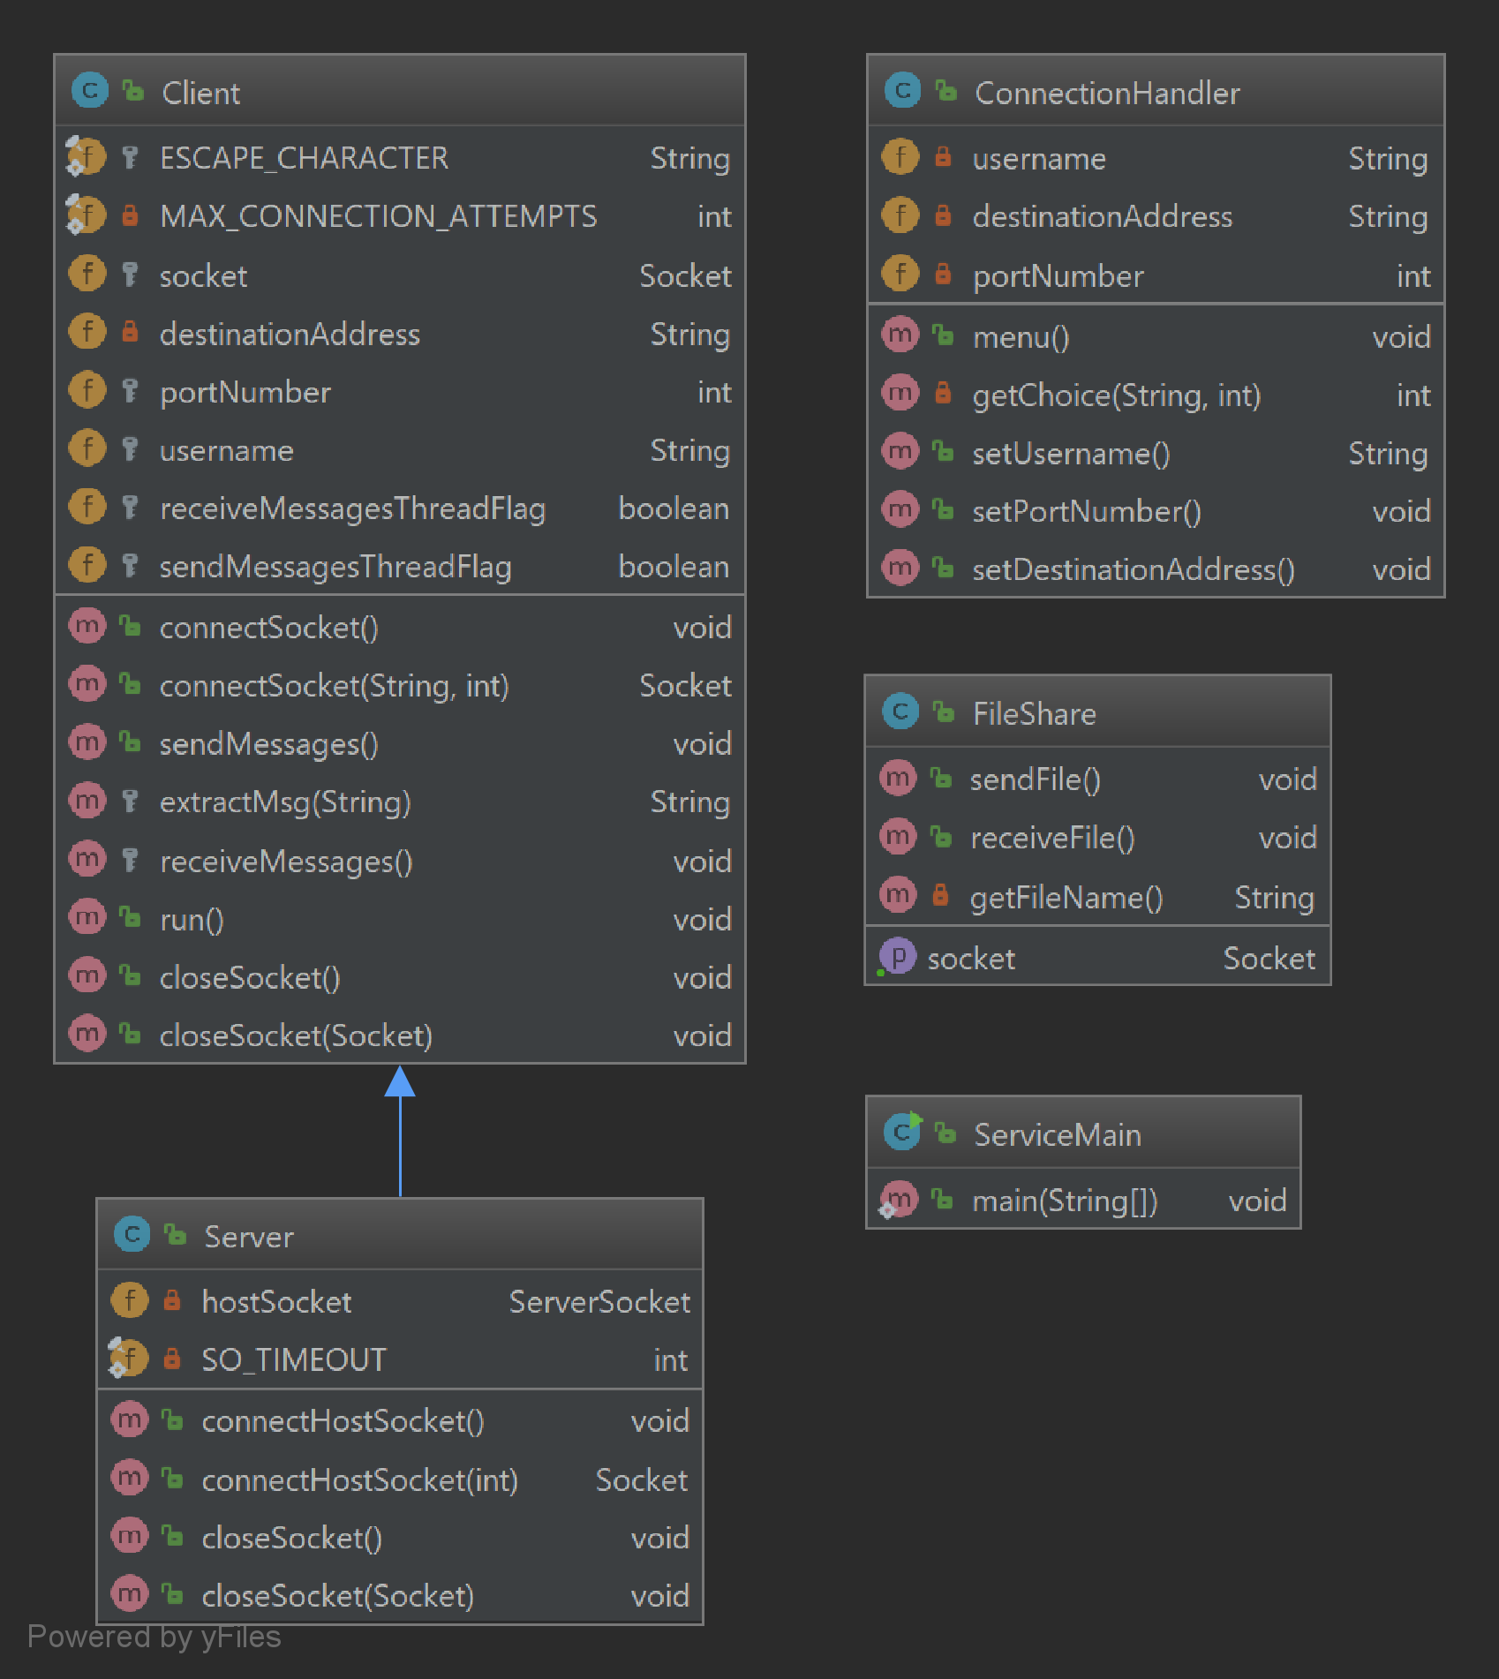
Initially I considered having the server be a subclass of the client. This was because the only difference between the two would be that the server would host a connection whereas the client would connect to a specified address. I ultimately change my mind because in order for my filesharing class to I would have to pass it a socket to use which would require either adding extra methods to the Client and Server classes just for use by FileShare (Figure 2 – connectSocket(String,Int) and connectHostSocket(int)) or have it extend the Server class and gain many unnecessary methods and properies.
I ultimately chose Figure 1 as it involved the least duplication of unnecessary code and
Imp

