**CMSC203 Assignment 0**

Class: CMSC203 Summer

 Program: Assignment 0

Instructor: Professor Shah

 Summary of Description: Setting up JDK, Eclipse IDE, JUnit, and JavaFX

 Due Date: 05/30/2025

 Integrity Pledge: I pledge that I have completed the programming assignment independently.

 I have not copied the code from a student or any source.

**Complete the following five parts of Assignment 0. Name your file as FirstInitialLastName_Assignment0.docx**

**Part1: Setup GitHub:** Provide the screen shots of your GitHub account with Assignment 0 file is uploaded on GitHub:

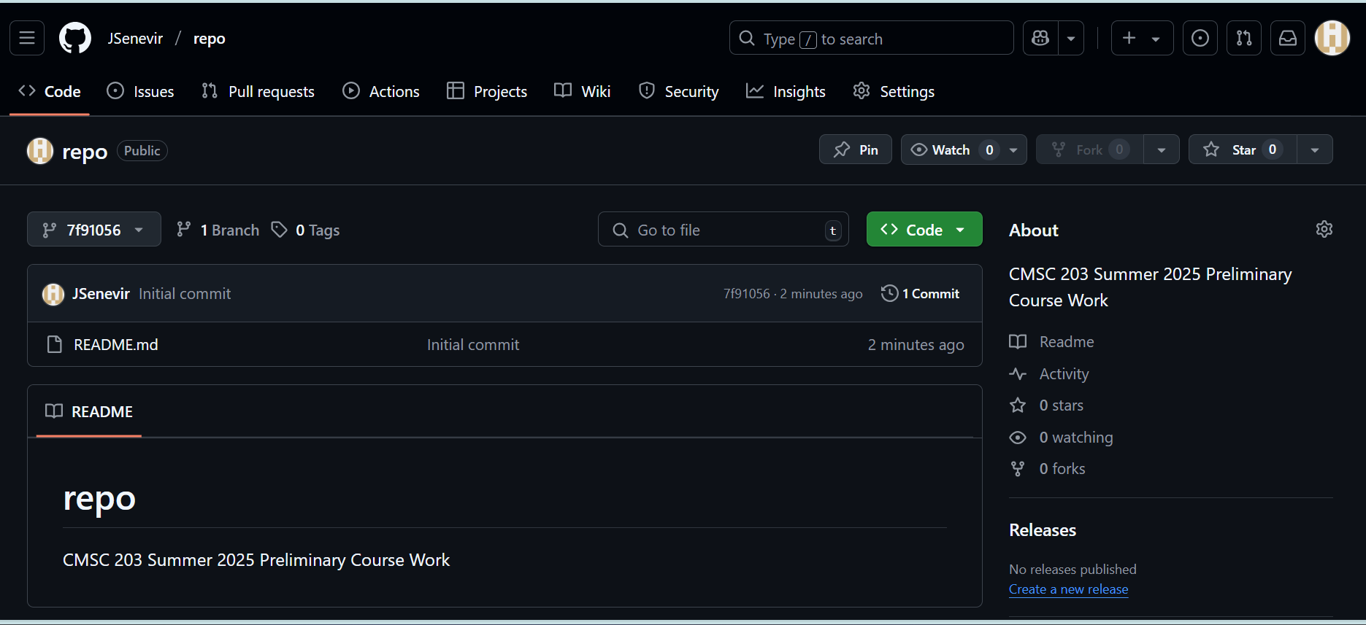

**Part 2 -Install JDK, Test java Application from Command Line**

Provide the screen shots from Step 1 and 2 here:

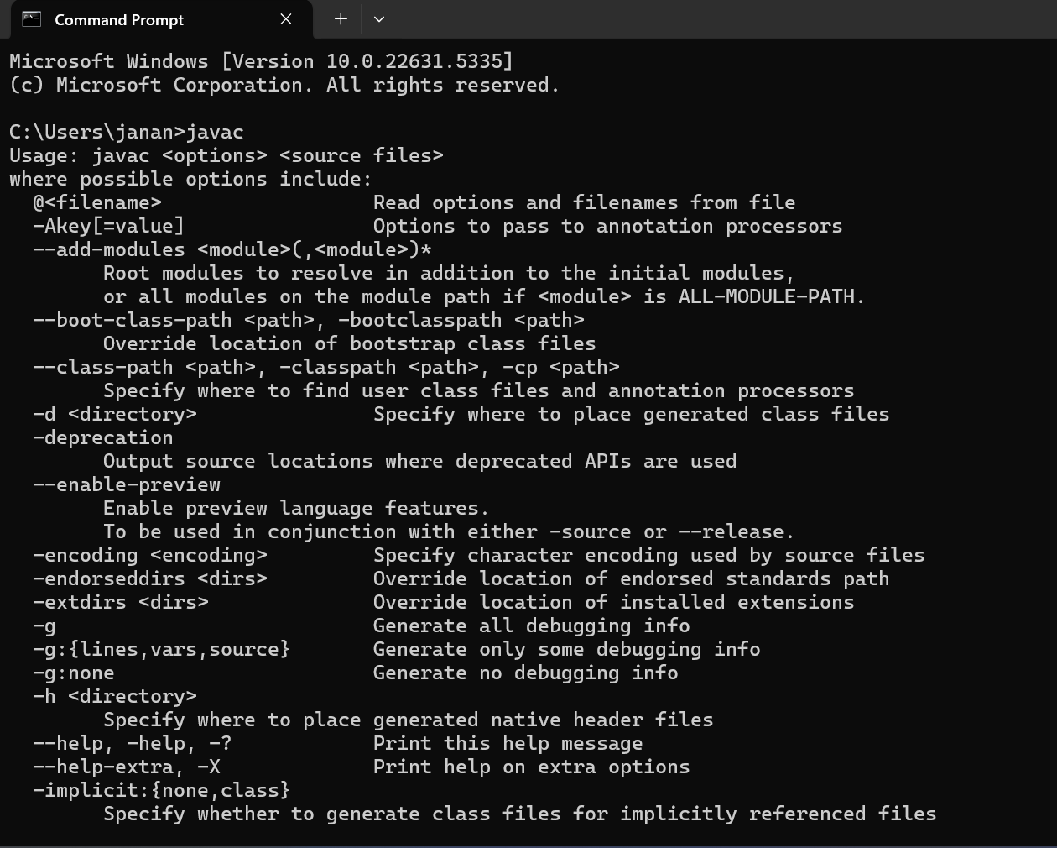

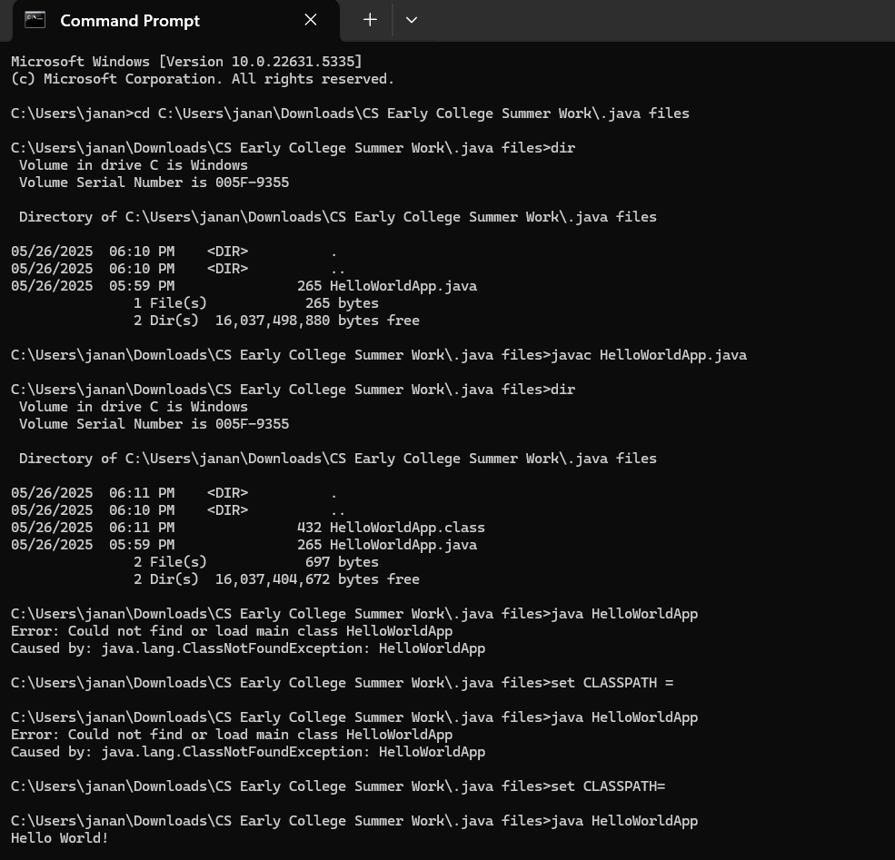

**Part 3 - Install Eclipse, Test Eclipse Java Application**

Provide the screen shots from Step 1 and 2 here:

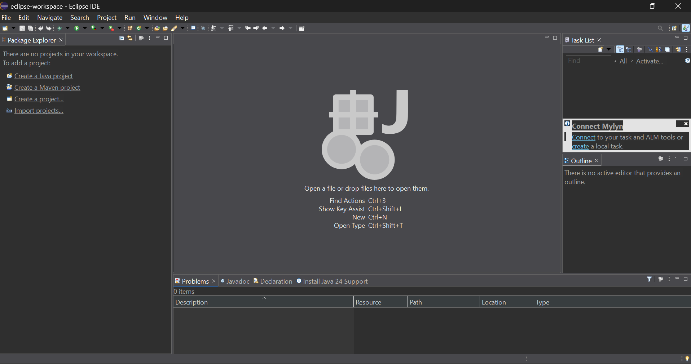

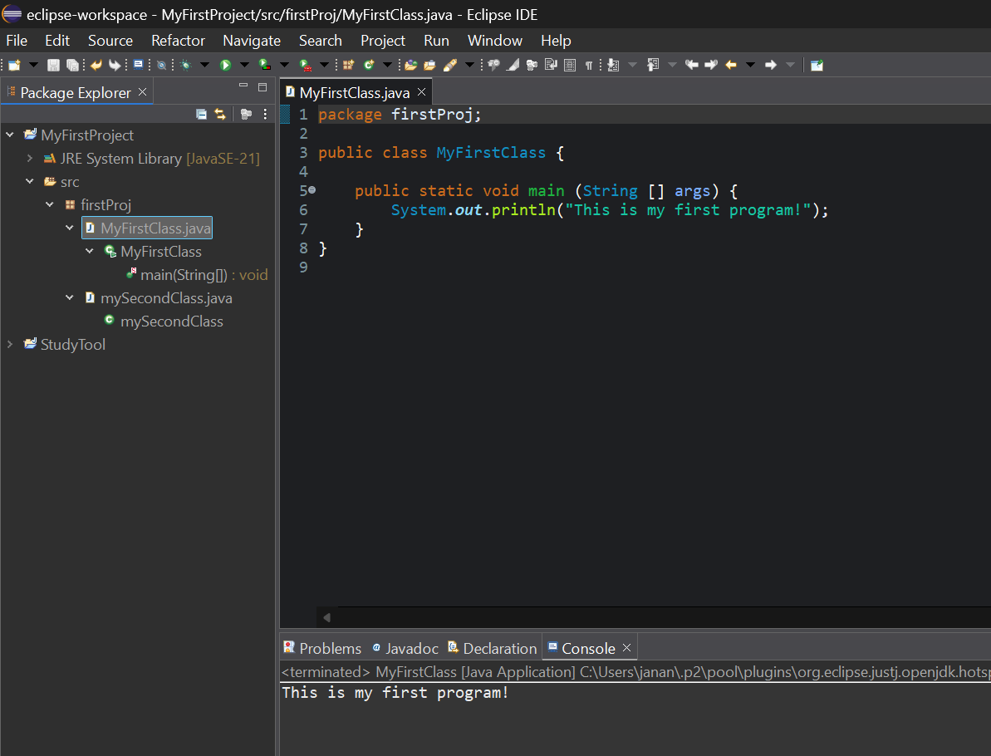

**Part 4 - Install, Setup, Test Junit Program.**

Provide the screen shots showing:

* 1. Eclipse with working JUnit Test example

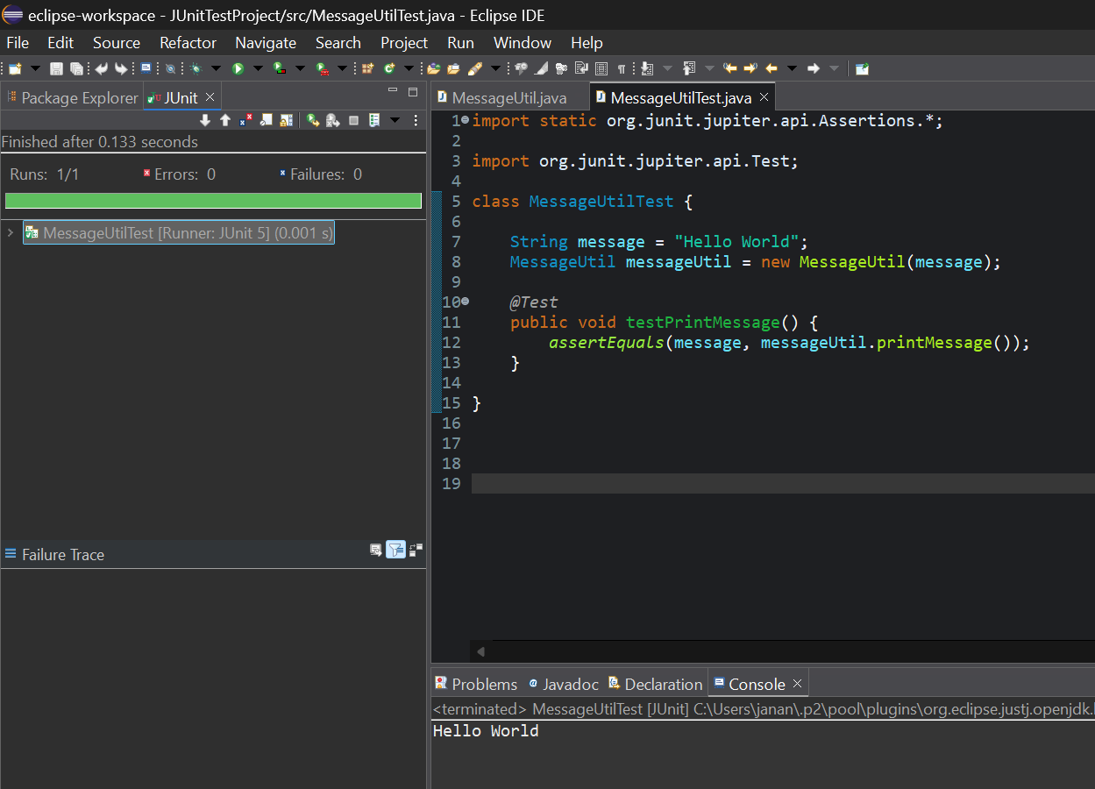

* 1. Project screenshot

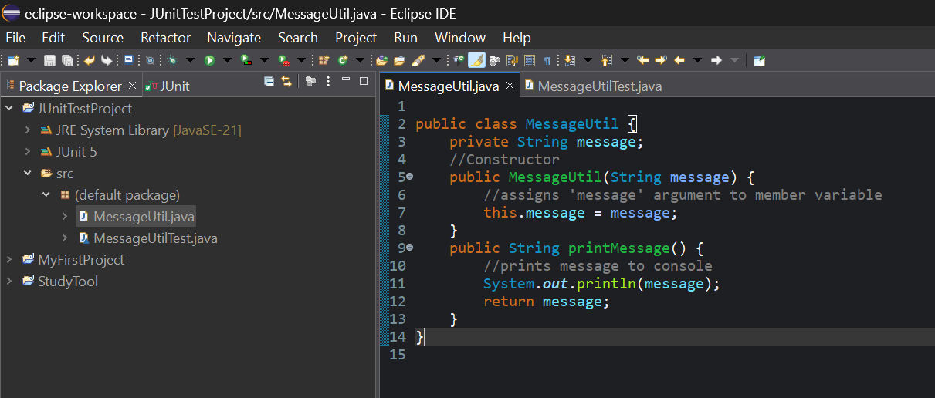

* 1. Running example screenshot

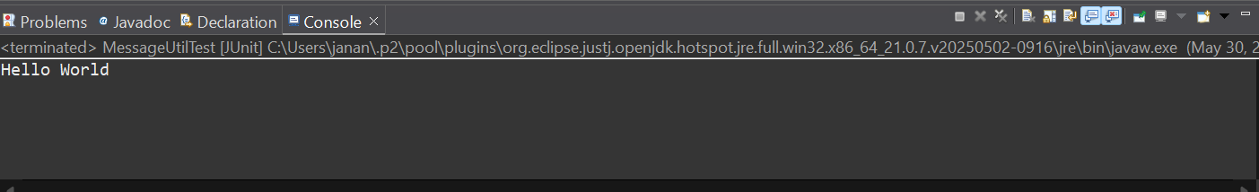

**Part 5 - Install, Setup, and Test JavaFX Application.**

Provide the screen shots showing:

1. JavaFX Project screenshot

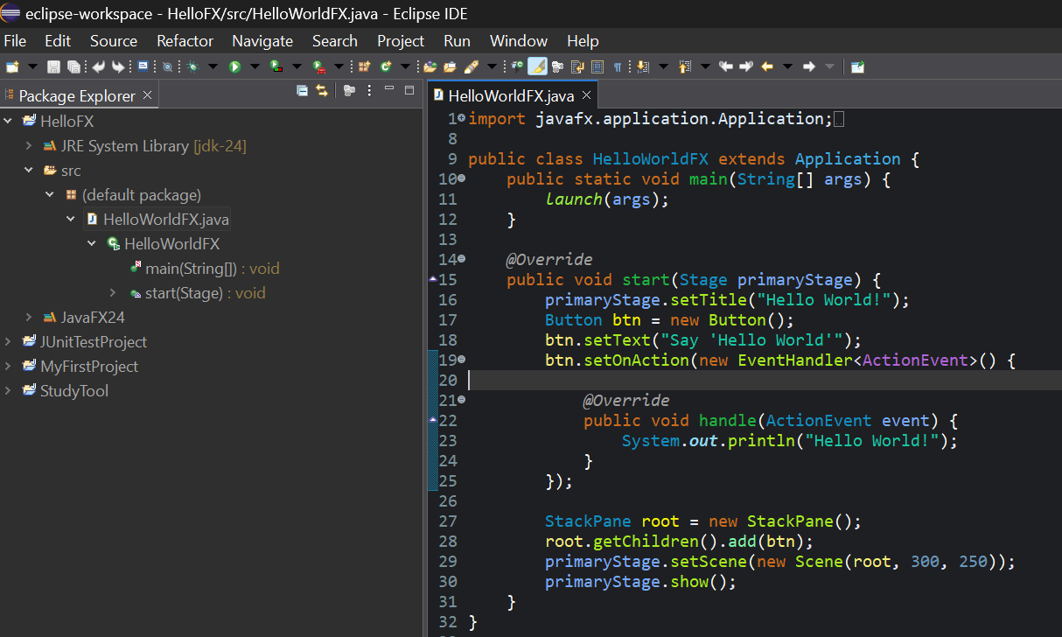

1. Running example screenshot

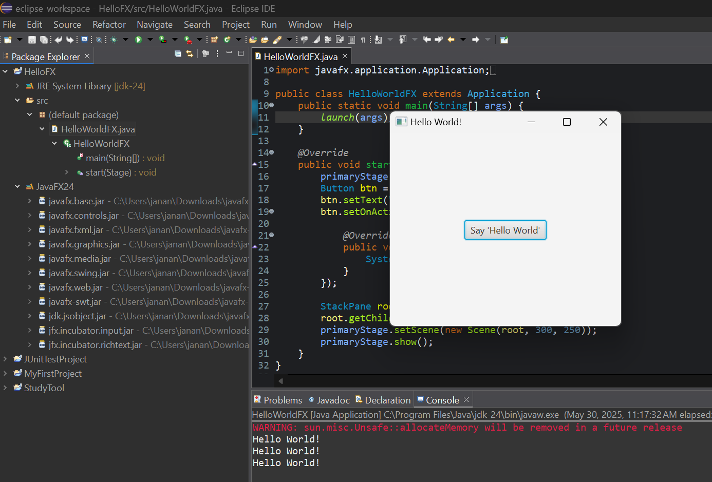

**Lessons Learned:**

Write about your Learning Experience, highlighting your lessons learned and learning experience from working on this assignment.

What have you learned? *I learned how to navigate the Eclipse IDE, designating workspaces and creating packages and classes. I learned about how to use JUnit tests to test parts of my program separately, such as a specific method* *of a class. I learned how to use JavaFX to create a graphical user interface and where to write VM arguments to link the program to the libraries.*

What did you struggle with? *Getting the JavaFX to run was confusing as there were many steps involved, downloading the FX SDK, then adding the library files to the project, and linking them. I got error messages several times until I realized I had added the VM arguments in the wrong place.*

What parts of this assignment were you successful with, and what parts (if any) were you not successful with?

*In the end, I was successful with all parts of the project.*

Provide any additional resources/links/videos you used to while working on this assignment.

*Zip file instructions & Oracle PowerPoints*

**Check List:** <Provide answers to the column Y/N or N/A >**:**

|  |  |  |  |
| --- | --- | --- | --- |
| **#** |  | **Y/N** | **Comments** |
|  | **Assignment files:** |  |  |
|  | * FirstInitialLastName_Assignment0.docx/pdf | **Yes** |  |
|  | * Source java files | **n/a** | java files have already been provided by instructor |
|  | **Program compiles** | **Yes** |  |
|  | **Program runs with desired outputs related to a Test Plan** | **Yes** |  |
|  | **Documentation file: Screenshots of** |  |  |
|  | * Part1: Setup GitHub | **Yes** |  |
|  | * Part 2 -Install JDK, Test java Application from Command Line | **Yes** |  |
|  | * Part 3 - Install Eclipse, Test Eclipse Java Application | **Yes** |  |
|  | * Part 4 - Install, Setup, Test Junit Program | **Yes** |  |
|  | * Part 5 - Install, Setup, and Test JavaFX Application. | **Yes** |  |
|  | * Lessons Learned | **Yes** |  |
|  | * Checklist is completed and included in the Documentation | **Yes** |  |