**Project Management Application**

The purpose of this application is to help Project Management Companies assign, organize and complete their tasks. Each employee in the company can log in to the website as their own user. Here they can keep track of their stats, such as how many hours of work they put in, number of open tasks, their billable hours and so on. Further, they can view or update tasks, or add new ones. This website is a great way for consultants to organize themselves so that they can work efficiently.

**Login**

The login page prompts the user for their username and password. If it’s correct, they will be successfully logged in. Otherwise, an error message will be displayed. If the ‘Remember me’ checkbox is checked off, the user will automatically get logged in the next time they access the site. The user can choose to logout at any time either by pressing on ‘Log Out’ on the side navigation bar or on the Log Out button on the bottom of the side navigation bar.

**Profile**

The profile page can either be accessed from the profile icon in the top left corner of every page, or the side navbar. Here the user’s information is displayed. The Top Project is the project the employee is working on the most, he/she has the most tasks for that project.

**Dashboard**

Once the user logs in, the dashboard page will be opened. Here, they can view their current stats. On the top there are four small cards that show the users total hours this year, billable hours, number of projects and number of open tasks. Below these cards are two charts next to each other. One is a donut chart that depicts the number of hours the user has worked on each project. If The user hovers over a section, the project name and number of hours will pop up. To the right is a pie chart that shows the number of tasks completed by the estimated due date. With this chart too the user can hover over it to display the project name and number of tasks completed. Below to the right is a list of all active projects the company is currently working on. Each project contains a list of profile images of each member working on the project. If the user hovers over the image, the employees name will appear. The company’s hourly rate and the total number of hours that has been worked on it, is shown. To the right, there is a list of all current tasks open for the user.

There is a side bar navigation that is present on all pages. From here the user can navigate to any page on the website. The top of the page is also present on all pages. This includes a welcome back message to the user and a profile icon where the user’s profile can be opened.

**Add New Task**

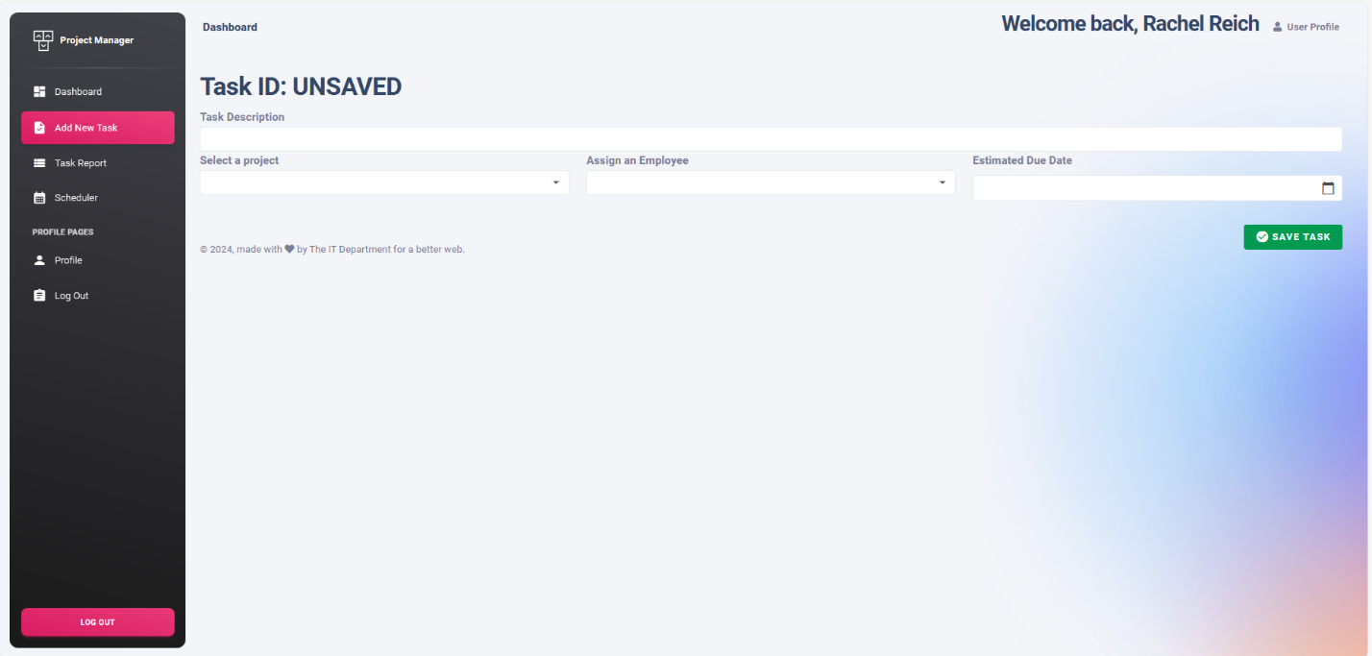

This page allows the user to add a new task. Each task requires a description. The user needs to select a project from the dropdown box, assign an employee from the dropdown, and an estimated due date. By pressing the Save Task button, the task is saved to the system.

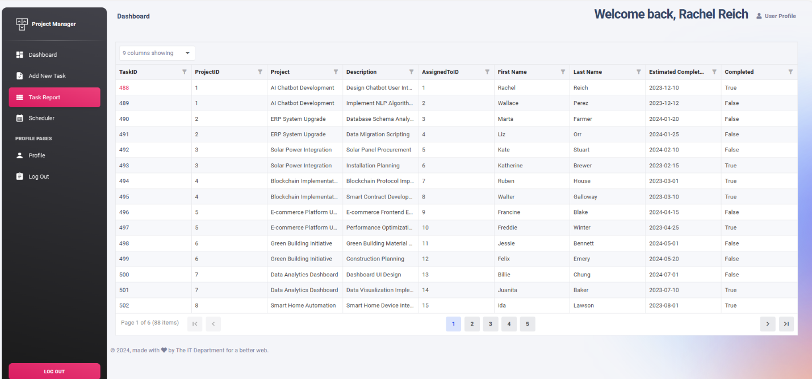**Task Report**

TaskID is a link to view the task

This page is an overview of all tasks. It’s a data grid that displays all information for each task. Information such as the task ID, project ID, project, task description, the ID of the employee assigned, the employees name, estimated completion date and whether or not it’s completed. The tasks are ordered in ascending order, based on the estimated completion date. On the top left of the grid, there is a dropdown box, where the user can select which columns to show and which ones to hide). Further, each column has a filter where the user can filter the data in that column

This data grid is linked to the Add New Task page. When the user clicks on an ID in the TaskID column, the data for that task will be displayed in the Add New Task page. If the user chooses, he/she can update the task there.

**Scheduler**

This page is a calendar that helps the users organize their tasks. Each task is listed on the calendar according to its estimated completion date. If the task color is red, that means the date has passed and if its blue then the date has not. The background color of today’s date is grey. On the top left of the calendar there are arrow buttons that allow the user to navigate to future or past dates. There is also a button labeled ‘Today’ that brings the user to the current date. In the top right corner, the user can choose a calendar view. It can be by the day, week, month or year. If the user clicks on the task in the calendar, it will display the tasks information in the Add New Task page.