Step 1

Download all the alphabet makers and print hard copy

<https://github.com/JSfam/ARAlphabet/blob/b1f620ae8c7a38ffc7bb9b96294ff88ce8926f24/assets/Print%20Marker.pdf>

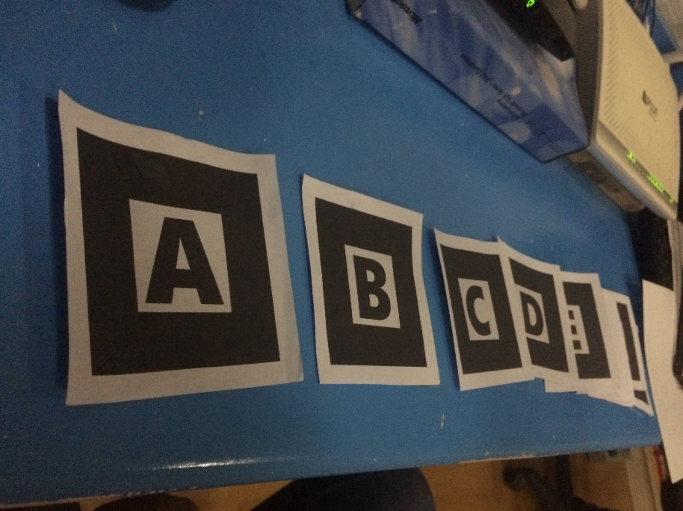

Step 2

1. Visit Link : [ar-alphabet.vercel.app](https://vercel.com/jsfam/ar-alphabet/7w1y8H3BoLweKxdcWxFrhgLr9dBx)

Using Chrome Browser for Mobile Devices

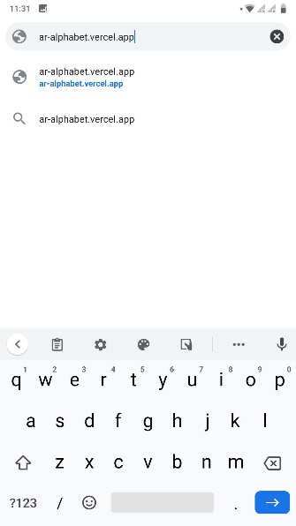

1. Allow Camera Access

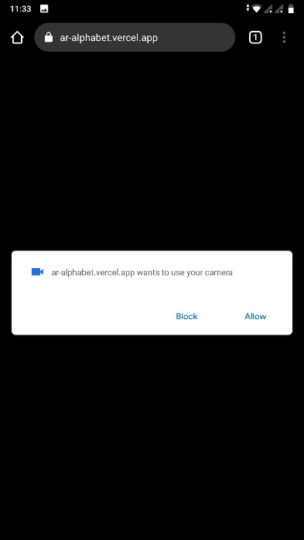

Step 3

1. choose desired marker to be Augmented

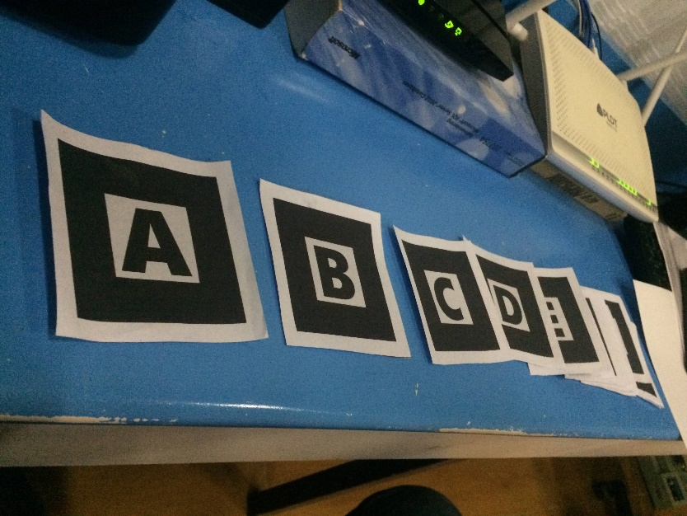

1. Point the Camera to the Marker

