1. **Array**

1.1 **What is an array**

In computer science array is a data structure or simply array is a container or bag which holds some elements. In array every element stored in to a position called index. In Java, arrays are objects.

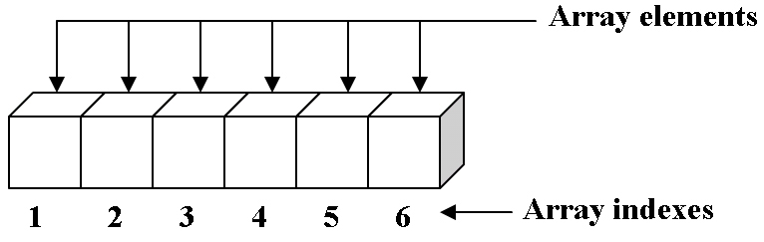

Image: It can be array of cars, cats, dogs, student

1.2 **Need of Array**

In any programming languages, when we want to store any value, we often use variables. But what if we have thousands of values, it seems horrible to create thousands of variables. Here array comes into picture. In array we can store many values under a single name.

1.3 **Declaration and Syntax**:

*<Array Variable declaration> = <Array Object Creation>*

1.3.a. **Array Variable declaration**:

1. <type> <var> [];

OR

1. <type> [] <var>;

*Examples:*

String names [];

OR

String [] names;

1.3.b. **Array Object declaration**:

In Java we can array object by two ways:

* Using new Operator:

**<type> [] <var> = new <type> [<Number of Elements>]**

***Example:*** String [] names= new String [3];

When we want to store 3 names, then we can declare an array by this way. But at this time we don’t have three names instead we reserve space to store three name values.

When we want to store data in above array, we can do by this way:

names [0] =” Sunny”;

names [1] =” Bunny”;

names [2] =” Tunny”;

* Using values:

**<type> [] <var> = {<values>}**

***Example:*** String [] names= {“Sunny”, “Bunny”, “Tunny”};

In this way, when we already know values, then we can use this approach.

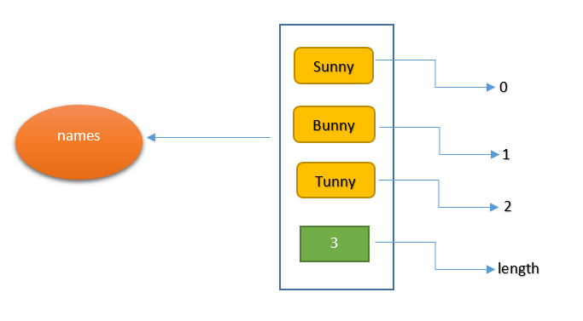

**Note:** If we want to know to size of array, then there is a field in array named length which contains the size of array.

System.***out***.println(names.length);

Revision:

1. What is right way to Initialize array?

A. int num[] = { 2, 4, 12, 5, 45, 5 };

B. int num{} = { 2, 4, 12, 5, 45, 5 };

C. int num{6} = { 2, 4, 12 };

D. int num(6) = { 2, 4, 12, 5, 45, 5 };

Correct Answer: A

* 1. **Insertion Operation on array:**

In java, arrays are fixed size means if we declare an array once we cannot change the size of an array. So u must have to very sure about number of elements as we don’t change size of array after its creation.

Let us take an array for storing 5 numbers, so we have to declare an array of size 5.

int [] nums= new int [5];

Now we can store maximum five values:

nums [0] =3;

nums [1] =5;

nums [2] =8;

nums [3] =12;

nums [4] =19;

But if anyone to add some more values in this array, Java report error at execution time.

nums [6] =2;

nums [-1] =17;

Note: We cannot access array with in valid indexes.

Valid Indexes are: 0 to (size -1)

Invalid Indexes are: all number except valid indices.

**1.4.a. Insertion in beginning:**

The very first position is denoted by zero index.

nums [0] =3;

**1.4.b. Insertion in end:**

The very last position is denoted by (length-1) index.

nums [4] =19;

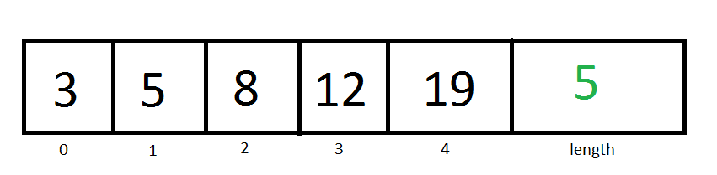

Revision:

1. How to find number of elements in an array named num?

A. num.size();

B. num.size;

C. num.length();

D. num.length;

Correct Answer: D