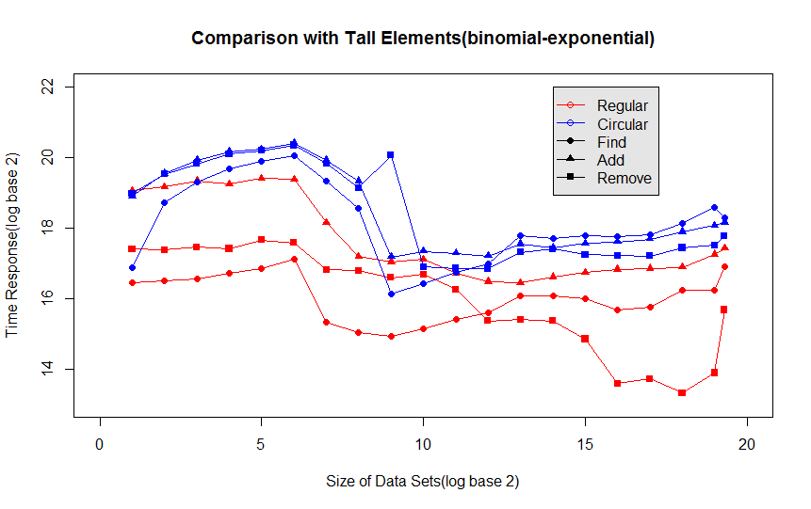

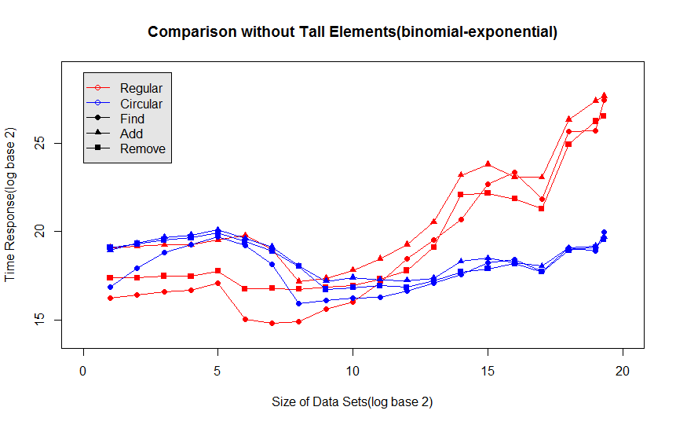

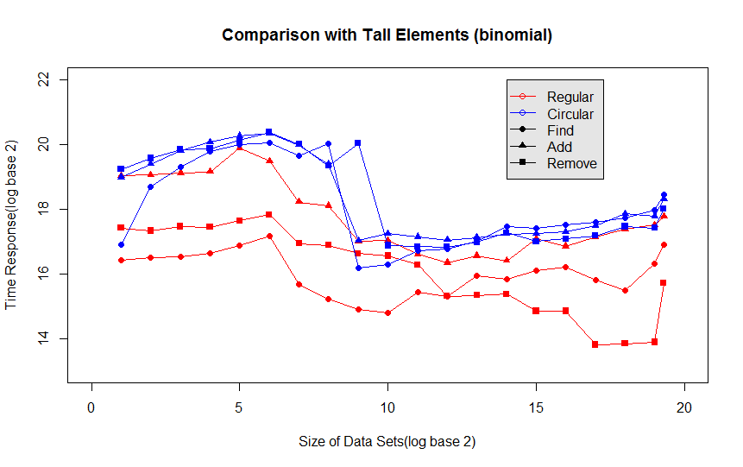

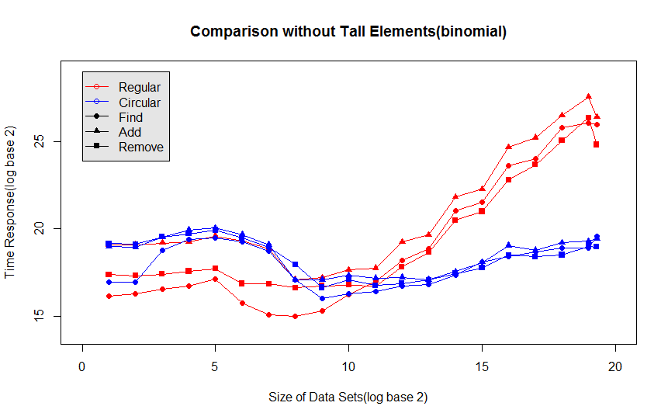

The fact that the blue ones are closer to each other makes the response time less informative than the red ones, because Find, Add, Remove tend to give the same response time which leads to less information of the size of the data set behind. The plots show that the blue ones are flatter over size than the other ones. This also suggests there’s less information of data size revealed by the blue ones than the red ones.