ECS 170

Artificial Intelligence
Fall 2026

Course Project: Stage 3 Report

Team Information
Enter Your Team Name Here 12
Student 1: Theresa Dinh | Student 1: 923017620 | Student 1: thtdinh@ucdavis.edu
Student 2: Justin Spenker | Student 2: 921684754 | Student 2: jdspenker@ucdavis.edu
Student 3: Andy Huang | Student 3: 924512302 | Student 3: xifhuang@ucdavis.edu
Student 4: Carley Smith | Student 4: 921776992 | Student 4: carsmi@ucdavis.edu
Student 5: Eugene Ferdinand Ogilvie | Student 5: 925245571 | Student 5: efogilvie@ucdavis.edu

Section 1: Task Description
In this stage we build convolutional neural network (CNN) models used for image classification on 3 data sets. We first train a CNN model on MNIST data, 28x28 grayscale images of handwritten digits (10 classes: 0-9), the same dataset we trained the MLP model on in stage 2. Then, we train a CNN on the ORL data set, consisting of 10 grayscale images each of 40 different faces (40 classes), each image at size 112x92. Finally, we train a CNN on the CIFAR dataset, 32x32 color images (3 channels) of everyday objects (10 classes). After training the models on these three datasets and reporting baseline results, we alter the configurations of the model and assess how these changes affect performance by looking at the changes in accuracy, precision, recall and F1-scores.

Section 2: Model Description
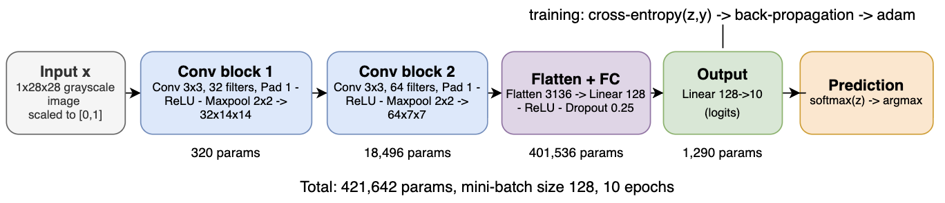
Figure 1: Baseline CNN for MNIST. The ORL and CIFAR models use the same design with different input sizes (Table 1)

The model is a convolutional neural network with two conv blocks, followed by a fully connected classifier (Figure 1). The input x ∈ ℝ^{(1x28x28)} passes through Conv(1→32, 3x3, pad 1) → ReLU → MaxPool(2x2), then Conv(32→64, 3x3, pad 1) → ReLU → MaxPool(2x2), then Flatten(3136) → Linear(3136→128) → ReLU → Dropout(0.25) → Linear(128→10). Convolution filters input to compute the weighted sum of a 3x3 patch, ensuring that equal weights will detect the same pattern anywhere in the image. Early layers of convolution detect edges which are later combined into feature shapes. Padding keeps height and width of each feature map constant, and ReLU avoids the saturation of sigmoid and tanh units. Max pooling picks out the strongest response in each 2x2 window, cutting the computation, and dropout (0.25) randomly zeros 25% of hidden units at each training step to reduce overfitting. The output layer produces one raw logit per class, and training loss is computed by applying log-softmax internally to logits using nn.CrossEntropyLoss. All weights are learned by back-propagation with mini-batch gradient descent using the Adam optimizer. ORL and CIFAR use the same architecture with different input sizes and number of classes (Table 1).

Property | MNIST | ORL | CIFAR
Input Shape | 1x28x28 | 1x112x92 | 3x32x32
After Block 1 | 32x14x14 | 32x56x46 | 32x16x16
After Block 2 | 64x7x7 | 64x28x23 | 64x8x8
Flattened Size | 3,136 | 41,216 | 4,096
Dropout | 0.25 | 0.5 | 0.25
Output Classes | 10 | 40 | 10
Conv Params (Both Blocks) | 18,816 | 18,816 | 19,392
FC Hidden Params (→128) | 401,536 | 5,275,776 | 524,416
Output Layer Params | 1,290 | 5,160 | 1,290
Epochs/Batch Size | 10/128 | 30/16 | 10/128
Train Size/Test Size | 60,000/10,000 | 360/40 | 50,000/10,000
Total Params | 421,642 | 5,299,752 | 545,098

Table 1: Baseline CNN for MNIST, ORL, and CIFAR

Section 3: Experiment Settings

3.1 Dataset Description
We use 3 datasets provided by the instructor for stage 3, one for each of the models: MNIST, ORL, and CIFAR-10. The MNIST dataset contains 70,000 grayscale images (28x28) of handwritten digits (0-9). The MNIST dataset is pre-partitioned into 60,000 training images and 10,000 testing images. The ORL dataset contains 400 grayscale images (112x92) of human faces, including 10 images for each of 40 individuals. The ORL dataset is pre-partitioned into 360 training images and 40 testing images. The CIFAR-10 dataset contains 60,000 color images (32x32x3), each depicting one of 10 different everyday objects. The CIFAR-10 dataset is pre-partitioned into 50,000 training images and 10,000 testing images.

3.2 Detailed Experimental Setups
The CNN models follow the architecture shown in Figure 1 (2 conv blocks → hidden FC → output) and layer sizes, batch sizes, epochs, and dropout shown in Table 1. All three inherit Adam optimizer, weight decay 0, and ReLU from the parent class Method_CNN. The models have learning rate 1e-3 and use cross-entropy loss on raw logits. PyTorch default initialization. All three datasets are preprocessed via pixel scaling to [0,1], ORL data is reduced from 3-channel to single-channel, and CIFAR data is kept as 3-channel. Random seed is fixed to 2 for NumPy and PyTorch for reproducibility. Settings across datasets differ in input size, number of classes, and training configuration. MNIST and CIFAR-10 each have 10 epochs, batch size 128, and dropout rate 0.25. ORL has 30 epochs, batch size 16, and dropout rate 0.5 (has only 360 images and needs more regularization). Model run on Python 3.13, PyTorch 2.5.1, scikit-learn 1.7.2, CPU (8 cores).

3.3 Evaluation Metrics
In the experiment, we will use Accuracy, Precision, Recall, F1 score as our evaluation metrics. Accuracy is the fraction of test instances whose predicted label equals the true label. For each class c, precision = TP/(TP+FP) (how many images predicted as c really are c), recall = TP/(TP+FN) (how many images of c are found), and F1 = 2·P·R/(P+R), their harmonic mean. Since the CNN models for MNIST, ORL, and CIFAR have 10, 40, and 10 output classes, respectively, we take the three averages: micro average, (uses the sum of all TP, FN, and FP over all classes), weighted average (mean weighted by number of test instances in each class), and macro average (unweighted mean over all classes). Since all three models use single label multi-class data, micro precision = micro recall = micro F1 (Table 2).

3.4 Source Code
Github: https://github.com/JSpenk/ECS170
The code follows the course template (abstract classes in local_code/base_class/). The Stage 3 files are:
- local_code/stage_3_code/Dataset_Loader.py – read the three pickle files (MNIST, ORL, and CIFAR) into features X with shape (n, channels, height, width), scaled to [0,1].
- Method_CNN.py – configurable convolutional neural network with same configurations (depth, width, activation, dropout, optimizer, learning rate, loss), mini-batch training loop and learning-curve history as Method_MLP.py. Only the network itself is replaced. The following are subclasses each pertaining to one of the three CNN models:
  - Method_CNN_MNIST.py
  - Method_CNN_ORL.py
  - Method_CNN_CIFAR.py
- Evaluate_Metrics.py – accuracy and macro / weighted / micro precision, recall, F1; Setting_Train_Test.py – runs the pre-partitioned train/test experiment; Result_Saver.py, Result_Loader.py, Plotter.py.
- script/stage_3_script — directory of 3 scripts which train and evaluates the final 3 models;
  - /script_cnn_mnist.py
  - /script_cnn_orl.py
  - /script_cnn_cifar.py
- script_ablation.py – runs ablation experiments and writes the results table and plots.

3.5 Training Convergence Plot
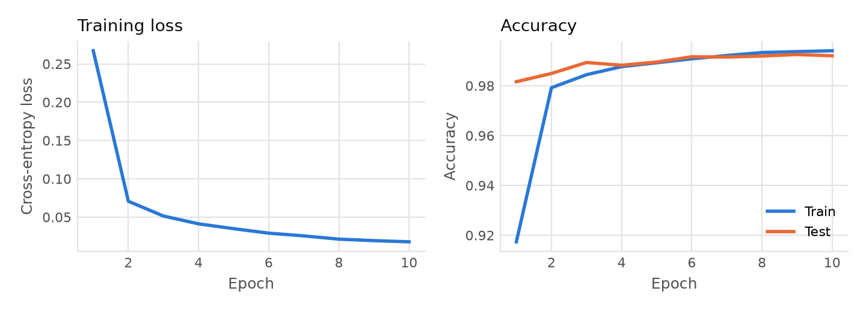

Figure 2: Training convergence of the final MNIST model: training loss (left) and train/test accuracy (right) per epoch.

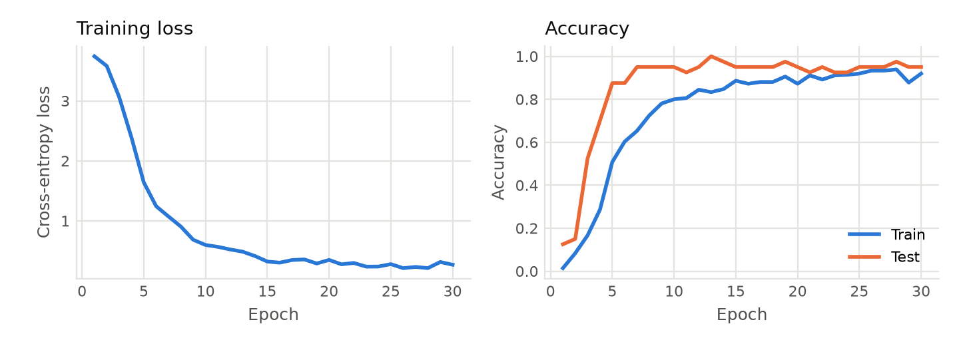

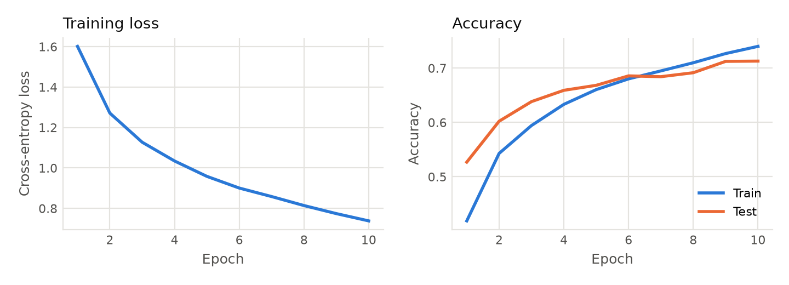
Figure 2: Training convergence of the final ORL model: training loss (left) and train/test accuracy (right) per epoch.

Figure 3: Training convergence of the final CIFAR model: training loss (left) and train/test accuracy (right) per epoch.

3.6 Model Performance

 | MNIST |  |  | ORL |  |  | CIFAR
Metric | Macro | Weighted | Micro | Macro | Weighted | Micro | Macro | Weighted | Micro
Precision | 0.9920 | 0.9920 | 0.9920 | 0.9250 | 0.9250 | 0.9500 | 0.7139 | 0.7139 | 0.7129
Recall | 0.9919 | 0.9920 | 0.9920 | 0.9500 | 0.9500 | 0.9500 | 0.7129 | 0.7129 | 0.7129
F1 | 0.9919 | 0.9920 | 0.9929 | 0.9333 | 0.9333 | 0.9500 | 0.7120 | 0.7121 | 0.7129
Accuracy | 0.9920 |  |  | 0.9500 |  |  | 0.7129

Table 2: Performance of the 3 final models on the testing sets.

3.7 Ablation Studies
We performed several ablation tests to measure how different CNN configurations (depth, kernel size, padding, stride, pooling, hidden dimensions, and loss function) affect performance against the MNIST, ORL, and CIFAR datasets. Each run tests the CNN with one setting changed from the baseline, keeping everything else fixed. Baseline settings are 2 convolution blocks, a 3x3 kernel, padding 1, stride 1, max pooling, 128 hidden dimensions, and the cross-entropy loss function. The baseline model differs across datasets with regard to dropout, batch size, and number of epochs. We recorded accuracy, precision, recall, and F1-scores for each setting change to a csv for each dataset (result/stage_3_result/ablation_table_*.csv). Table 3 displays accuracy of each configuration with three random seeds, reported as mean +- std (population std). Only results outside the seed spread should be considered real effects.

Factor | Setting Change | Accuracy
 |  | MNIST | ORL | CIFAR
Baseline Settings | 2 conv blocks, 3x3 kernel, padding 1, stride 1, max pooling, hidden dim 128, cross-entropy loss | 0.9915 +- 0.0004 | 0.9583 +- 0.0118 | 0.7015 +- 0.0083
Depth | 1 conv block | 0.9866 +- 0.0004 | 0.0333 +- 0.0118† | 0.6415 +- 0.0075
Depth | 3 conv blocks | 0.9921 +- 0.0009 | 0.9667 +- 0.0118 | 0.7274 +- 0.0051
Kernel size | 5x5 | 0.9926 +- 0.0013 | 0.9500 +- 0.0204 | 0.7071 +- 0.0058
Padding | padding 0 | 0.9919 +- 0.0003 | 0.9250 +- 0.0000 | 0.6776 +- 0.0100
Stride | stride 2 | 0.9864 +- 0.0009 | 0.9750 +- 0.0354 | 0.6028 +- 0.0073
Pooling | average | 0.9911 +- 0.0002 | 0.9750 +- 0.0204 | 0.6645 +- 0.0050
Hidden dim | 512 | 0.9912 +- 0.0005 | 0.9750 +- 0.0204 | 0.7332 +- 0.0040
Loss function | MSE on softmax | 0.9907 +- 0.0012 | 0.9667 +- 0.0236 | 0.6986 +- 0.0040
Table 3: Accuracy of the CNN on the three datasets with several setting changes.
† 1 convolution block on ORL: training failed to converge; not a reliable measure of depth

Analysis:
- Setting changes against the MNIST dataset caused effects which were mostly within noise. Only 1 convolution block and stride 2 are outside of the seed spread, both decreasing average accuracy by ~0.5 points.
- The CIFAR dataset saw clear results with ablation to depth, padding, stride, pooling, and hidden dimensions. Accuracy rose with depth (64→70→73 points) as well as with more hidden dimensions (70 points at 128 vs. 73 points at 512). Accuracy decreased with stride 2 by 9.9 points, with average pooling by 3.7 points, and with padding by 2.4 points. Effects of changes in kernel size and MSE loss function were within noise.
- The model scored roughly 2 points higher on the ORL dataset with average pooling, 512 hidden dimensions, and stride 2. Accuracy decreased by about 3 points with padding 0. However, with a testing set of 40 images, each test is worth 2.5 points before averaging between seeds. Therefore, differences between settings represent roughly one test image per run and are not distinguishable. The 1-conv-block run failed to converge (loss stayed at ln 40 ≈ 3.69), so it says nothing about depth.
- The effect of increasing from stride 1 to stride 2 varies across datasets. It was among the highest recorded accuracy, within noise, on the ORL dataset and garnered the lowest recorded accuracy for both the MNIST and CIFAR datasets (decreases of ~0.5 points and ~9.9 points from baseline, respectively). This may be due to the difference in image size, as the ORL images are significantly larger than the MNIST and CIFAR images. A larger stride is likely hurtful to performance of the CNN on smaller images because it throws away spatial details that are essential for classification.

