Crypto.com Arena: Vendor Onboarding Insights & Recommendations
Analyst: Spoon · Tools: Excel (data cleaning, live formula engine, dashboard), Claude (AI assistant)
Scope: 370 vendors · 7 onboarding coordinators · onboarding status snapshot
Context: A designed sourcing and procurement scenario. Onboarding the full supplier base that services an arena, from a raw 400-vendor list cleaned to 370.

Executive summary
Onboarding is progressing but not yet safe. 38% of the 370 vendors are fully onboarded (140) and 74% are on track (273, complete or in progress), which is healthy forward momentum. But 97 vendors (26%) are in a red-flag state, delayed or unresponsive, and they carry $8,711,400 in annual spend.
The number that should set the agenda is narrower and sharper. Of the 129 critical suppliers, the services the arena cannot open without, 32 are delayed or unresponsive, and they represent $5,550,000 in essential-services spend that is not yet secured. That is the real headline. The question is not "are we behind?" but "are the doors-open services locked down?" Right now, they are not.
The good news: the risk is concentrated and nameable. Two coordinators are carrying the onboarding effort, three specific coordinators hold every poor-communication flag, and the ten highest-dollar at-risk suppliers can be listed on one screen. That makes this a targeting problem, not a scramble.

Progress overview: the positive story first
Measure | Result
Fully onboarded | 38% (140 of 370)
On track (complete or in progress) | 74% (273 of 370)
Overall completion rate | 38%

Three of every four vendors are moving through the pipeline as intended. The onboarding machine works. The question is not whether it functions, but whether it is finishing the right vendors in time.
Status mix across all 370 vendors:
Status | Vendors | Share
Complete | 140 | 38%
Received (in progress) | 133 | 36%
Delayed | 62 | 17%
Delayed (EOD) | 12 | 3%
Poor Communication | 23 | 6%

The risk view: where the exposure actually sits
Completion percentage alone is a comfort metric. The number that matters for an arena is critical-supplier readiness, because a delayed napkin vendor and a delayed fire-and-life-safety vendor are not the same risk.
Critical supplier focus, 129 critical suppliers:
Status | Critical suppliers | Share
Complete | 64 | 50%
Received | 33 | 26%
Delayed | 26 | 20%
Delayed (EOD) | 2 | 2%
Poor Communication | 4 | 3%

Half of critical suppliers are secured, but 32 (25%) are delayed or unresponsive, and those 32 carry $5.55M in annual spend across the exact categories an arena cannot open without: HVAC, electrical, security, fire and life safety, and elevators. This is the single most important slice of the entire dataset.
Top critical suppliers at risk (highest-spend essential services not yet secured):
Supplier | Coordinator | Status | Annual $
Monarch Mechanical Partners | Marisol Reyes | Delayed | $434,200
Precision Electrical Co. | Trevor Nguyen | Delayed | $408,600
Allied Guard Services Inc. | Damon Fields | Delayed (EOD) | $313,400
SoCal Fire Protection Services | Andre Boseman | Delayed | $286,000
Coastal Climate Control | Marisol Reyes | Delayed | $283,800
Guardian Fire Protection Solutions | Marisol Reyes | Delayed | $279,000
Union Security Contractors | Priya Kapoor | Poor Comms | $272,500
Sequoia Electrical Associates | Trevor Nguyen | Delayed | $259,000
Golden State Technologies Services | Andre Boseman | Poor Comms | $248,800
Sterling Electrical LLC | Trevor Nguyen | Delayed | $244,300

Coordinator performance, and an important nuance
Coordinator | Total | Completion % | Critical at-risk | Spend at-risk
Marisol Reyes | 53 | 57% | 11 | $1,843,300
Trevor Nguyen | 53 | 57% | 9 | $1,627,600
Damon Fields | 53 | 38% | 4 | $1,656,700
Andre Boseman | 53 | 38% | 3 | $1,180,400
Hannah Whitlock | 52 | 29% | 2 | $1,303,600
Priya Kapoor | 53 | 28% | 3 | $920,600
Yuki Tanaka | 53 | 19% | 0 | $179,200

Marisol and Trevor lead on completion (57% each), but here is the nuance a good analyst catches: they also carry the highest at-risk exposure, because they were assigned the heaviest concentration of critical, high-dollar suppliers. Their 57% is more impressive, not less, because they are finishing the hardest books. Completion rate read in isolation would mislead a stakeholder. It has to be weighted by what each coordinator is actually carrying.
The same nuance runs the other direction with Yuki Tanaka: lowest completion at 19%, which looks alarming, but Yuki holds zero critical at-risk suppliers and only $179K of spend at risk, with a large Received pipeline still in motion. Yuki's book is low-criticality and mid-process, not a crisis. Low completion does not equal high risk.

Red flags: the concentration patterns
Two patterns jump out of the data that a status average would hide.
Poor communication is concentrated in three coordinators. All 23 poor-communication flags sit with Priya Kapoor (8), Hannah Whitlock (8), and Andre Boseman (7). The other four coordinators have none. When a problem clusters this cleanly, it is rarely coincidence. It points to either a workload imbalance, a batch of genuinely unresponsive vendors assigned to those three, or a coaching opportunity. It is worth diagnosing why before treating the symptom.
Every Delayed (EOD) flag belongs to one coordinator. All 12 end-of-day-deadline delays are Damon Fields's. A single coordinator holding 100% of the most time-sensitive delays signals a bottleneck. Damon may be carrying a batch of hard-deadline vendors that needs either reinforcement or reassignment before those deadlines pass.

Recommendations
Ordered by risk to opening day.

1. Triage the $5.55M in critical at-risk suppliers first
The 32 delayed-or-unresponsive critical suppliers are the only items that can stop the doors from opening. Escalate the top-ten at-risk list immediately, starting with Monarch Mechanical ($434K) and Precision Electrical ($408K), with direct outreach and firm deadlines. Everything else is secondary to securing HVAC, electrical, security, fire and life safety, and elevators.

2. Diagnose the poor-communication cluster
Priya, Hannah, and Andre hold all 23 poor-comms flags. Meet with these three to determine cause (workload, vendor quality, or process) and provide escalation support or reassign the truly unresponsive vendors. Solving this clears the softest, most fixable part of the risk.

3. Break the EOD bottleneck on Damon's book
All 12 end-of-day delays are Damon's. Reinforce or partially reassign his time-critical vendors so no deadline lapses simply because one person is the single point of contact.

4. Convert Yuki's Received backlog for a cheap completion bump
Yuki has 40 vendors received but only 10 completed: low criticality, high volume, mid-process. A focused documentation push here raises the overall completion rate quickly and safely, with minimal risk exposure.

5. Codify what Marisol and Trevor do
The two highest performers are also carrying the hardest books. Capture their onboarding approach as the standard operating procedure and use it to lift the middle of the pack. The best process improvement is already inside the team.

What success looks like
Opening readiness is not "100% of vendors onboarded." It is "100% of critical suppliers secured." The target is closing the 32 critical at-risk suppliers ($5.55M) before the arena opens, in priority order by spend and service type. The overall 38% completion figure will climb on its own as the pipeline drains. The critical-supplier number is the one that determines whether the building can operate.

Method note
This dashboard is fully live. A cleaned 370-vendor list feeds seven coordinator worksheets. A central formula engine (INDIRECT plus COUNTIFS and SUMIFS across all seven tabs) rolls each coordinator's status counts, critical-at-risk count, and at-risk spend into one table. The KPI cards, the completion-by-coordinator bar, the status donut, the critical-focus split, and the top-at-risk leaderboard (VSTACK plus FILTER plus SORT plus TAKE) all read from that engine, so the moment a coordinator updates a vendor's status, every number and chart re-ranks itself. Nothing on the dashboard is hardcoded. The raw data began as a deliberately dirty 400-row list (exact duplicates and fuzzy name variants) and was cleaned to 370 via Remove Duplicates and Fuzzy Lookup, the data-quality step that makes every downstream number trustworthy.

Appendix: The Live Engine
Nothing on the dashboard is hardcoded. A cleaned 370-vendor list feeds seven coordinator worksheets, and a central formula engine rolls every note, status, and success flag into one table, so the moment a coordinator updates a vendor, every number and chart re-ranks itself. The six captures below show the exact formulas, so the dashboard can be read, defended, and rebuilt from scratch.

Step 1 — Roll up Comm Notes (XLOOKUP + INDIRECT)
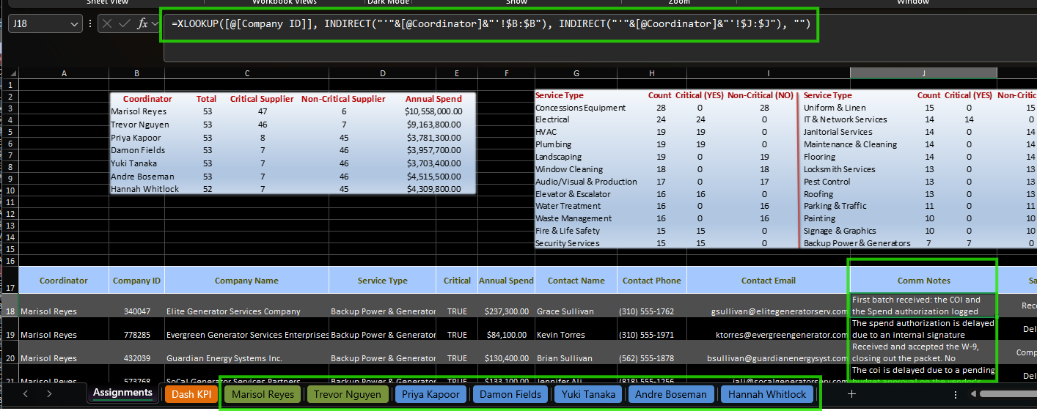
XLOOKUP finds each vendor by Company ID, and INDIRECT builds the sheet reference from the coordinator name, so all seven coordinator tabs feed the central Assignments engine with a single reusable formula.

Step 2 — Roll up onboarding Status
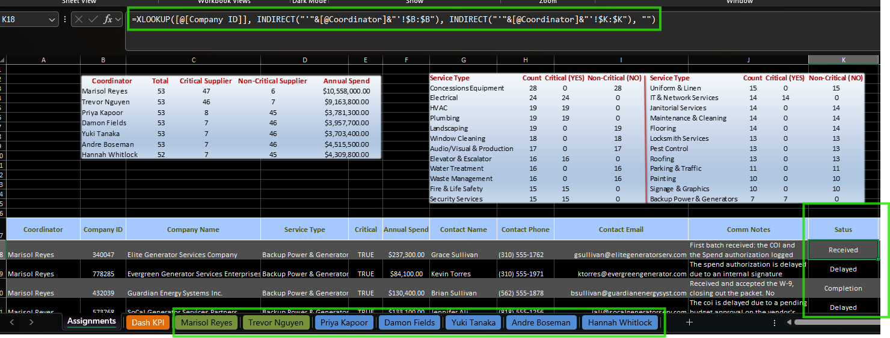
The same XLOOKUP + INDIRECT pattern, pointed at the Status column. Because the sheet reference is built from the Coordinator field, adding or renaming a coordinator tab needs no formula edits.

Step 3 — Roll up Onboard Success
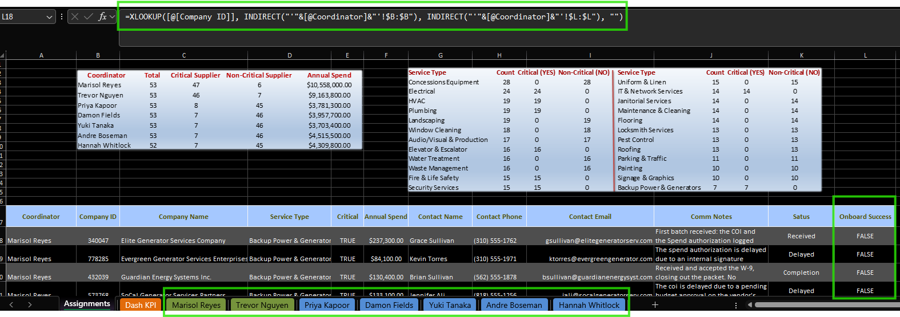
The third field completes the engine: three columns, one pattern, every vendor’s live state pulled into a single table that the KPI cards and charts read from.

Step 4 — Notes source (VLOOKUP into coordinator_notes.xlsx)
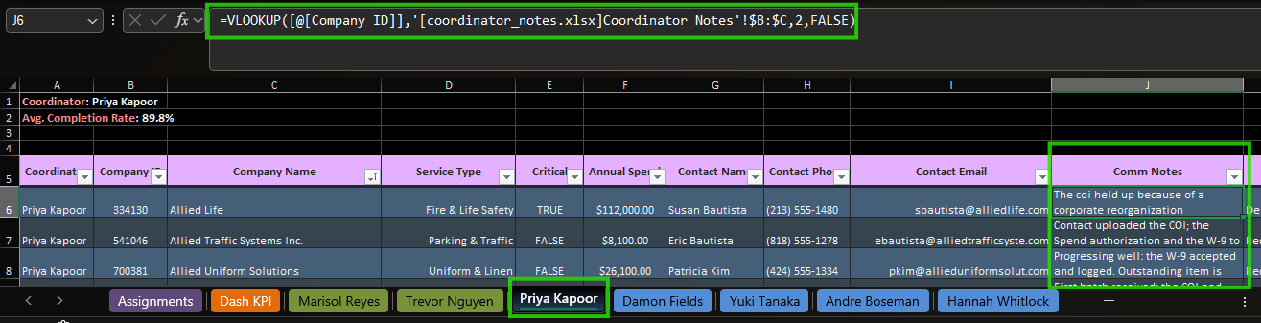
On each coordinator sheet, VLOOKUP pulls each vendor’s Comm Notes from a separate coordinator_notes.xlsx. Keeping the notes in their own file keeps the working sheets clean.

Step 5 — Status source (the same VLOOKUP)
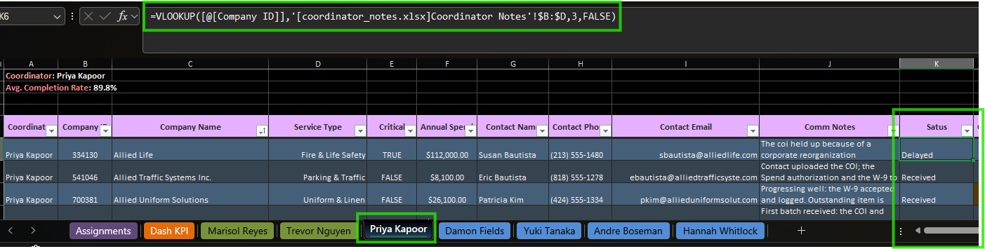
A second VLOOKUP against the same notes workbook returns each vendor’s Status. Status and notes resolve from the same source row, keyed on Company ID, so they never drift out of sync.

Step 6 — Onboard Success logic (IF / COUNTIF)
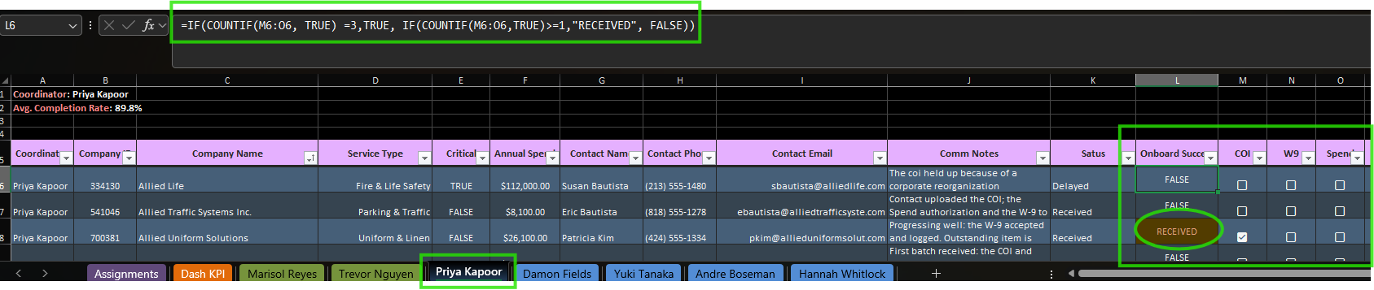
IF(COUNTIF over the COI, W9, and Spend checkboxes) returns TRUE only when all three documents are in, RECEIVED when some are, and FALSE otherwise. Conditional formatting shades RECEIVED yellow and TRUE green, so readiness is visible at a glance and impossible to fake.

