**AGRA:**

Certainly! Here's detailed information on three common ways to travel from Vijayawada to Agra:

### 1. By Air, Train, and Road:

#### Route:

1. **Vijayawada to Delhi by Air**: Fly from Vijayawada to Delhi, which is the capital city of India and has a major international airport.

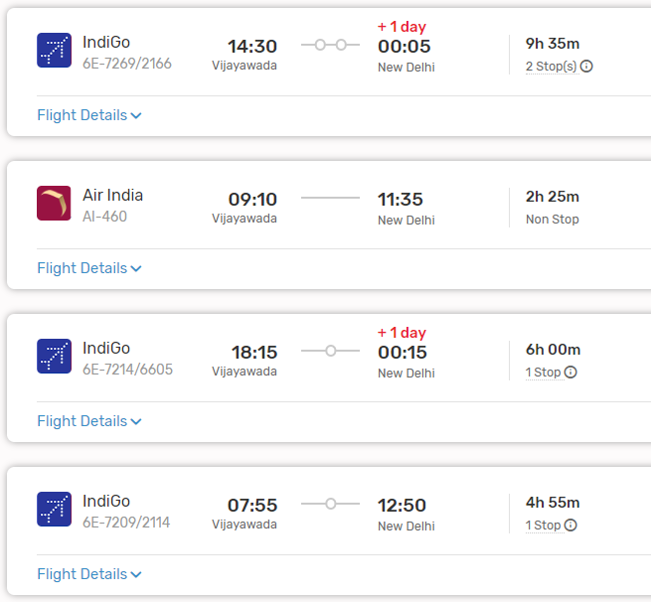

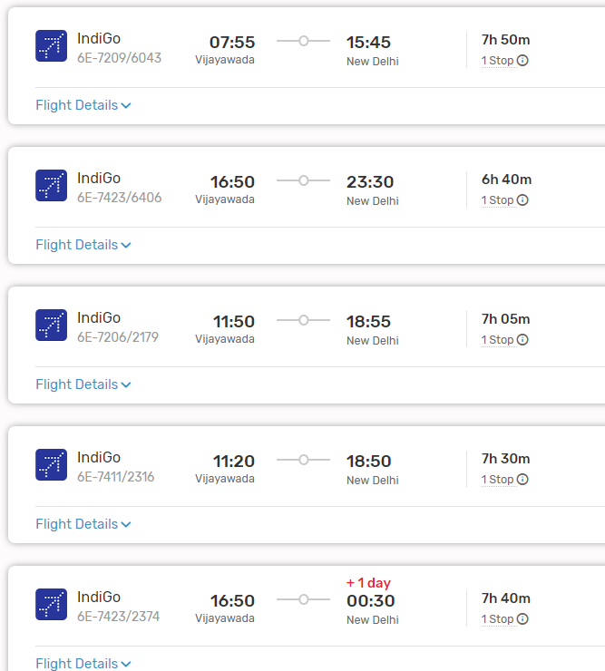

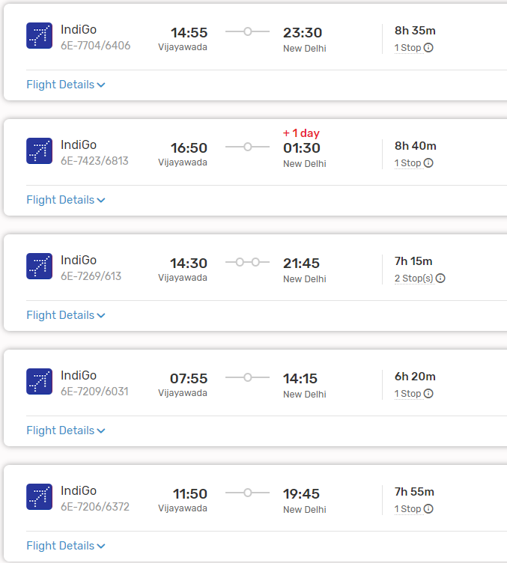

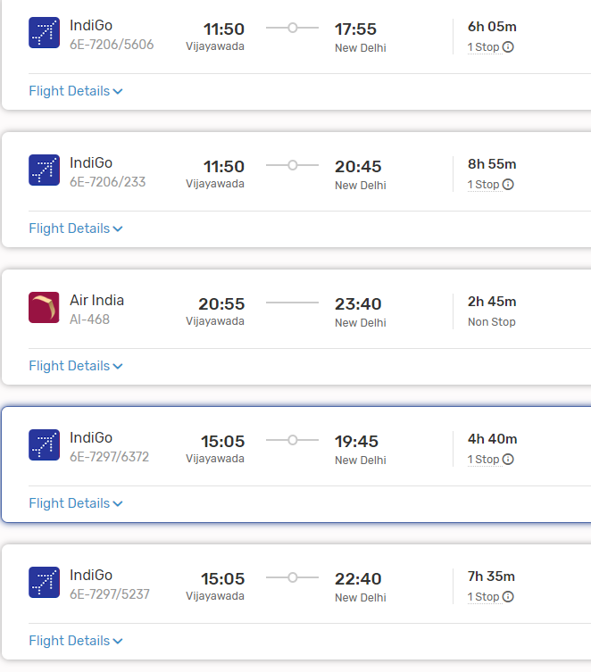

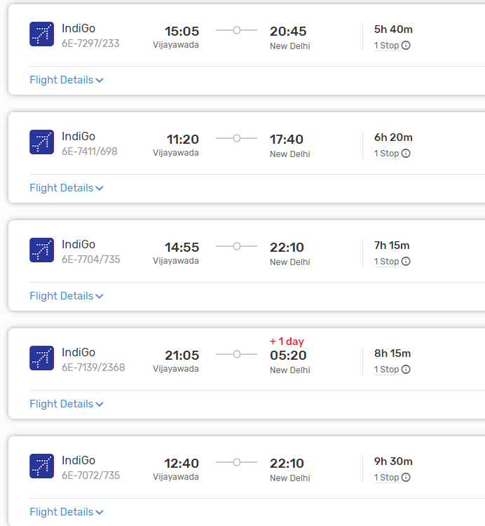

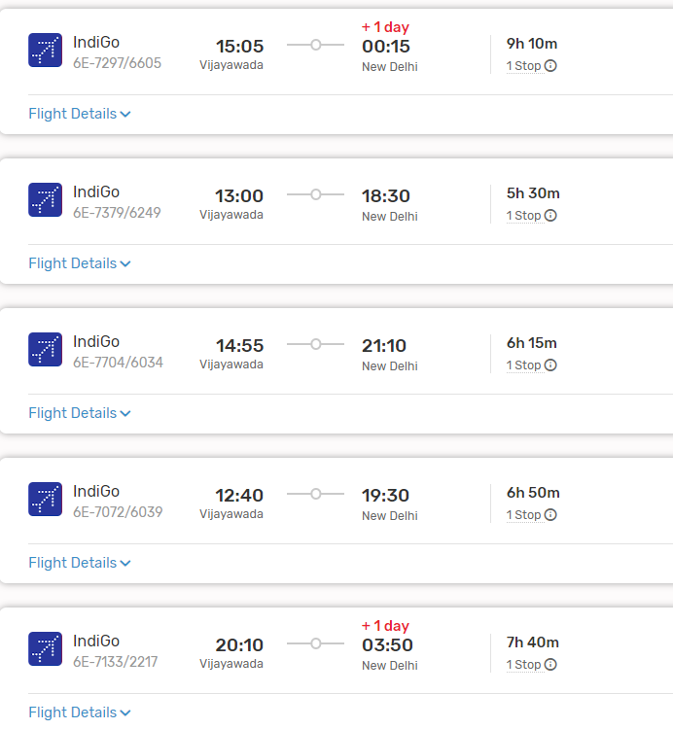

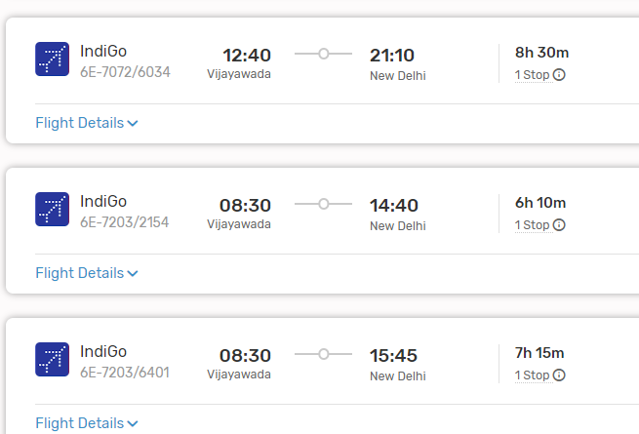

2. **Delhi to Agra by Train or Road**:

- **By Train**: Take a train from Delhi to Agra. Several trains operate on this route, including the Gatimaan Express, Shatabdi Express, and Taj Express. The journey takes around 1.5 to 2 hours by train.

- **By Road**: Alternatively, you can travel from Delhi to Agra by road. The distance between Delhi and Agra is approximately 230 kilometers, and the road journey takes around 4 to 5 hours, depending on traffic and road conditions.

#### From Agra Railway Station/Bus Stand to Your Destination:

- Upon reaching Agra by train or road, you can hire a taxi, use app-based cab services, or take local buses to reach your desired destination within Agra, such as the Taj Mahal or Agra Fort.

### 2. By Train:

#### Route:

- **Vijayawada to Agra by Train**: There are no direct trains from Vijayawada to Agra. You may need to take a train to a major railway junction like Delhi or Mathura and then transfer to a train bound for Agra.

#### Trains:

- Several trains connect Vijayawada to Delhi or Mathura, including the Telangana Express, Andhra Pradesh Express, and Tamil Nadu Express. From Delhi or Mathura, you can catch trains bound for Agra.

#### Duration:

- The duration of the train journey from Vijayawada to Agra can vary significantly depending on the chosen route and any layovers. It can take anywhere from 20 to 30 hours or more to reach Agra by train.

#### From Agra Railway Station to Your Destination:

- Upon reaching Agra by train, you can use local transportation options like taxis, auto-rickshaws, or cycle rickshaws to reach your desired destination within the city.

###ListOf Trains available:

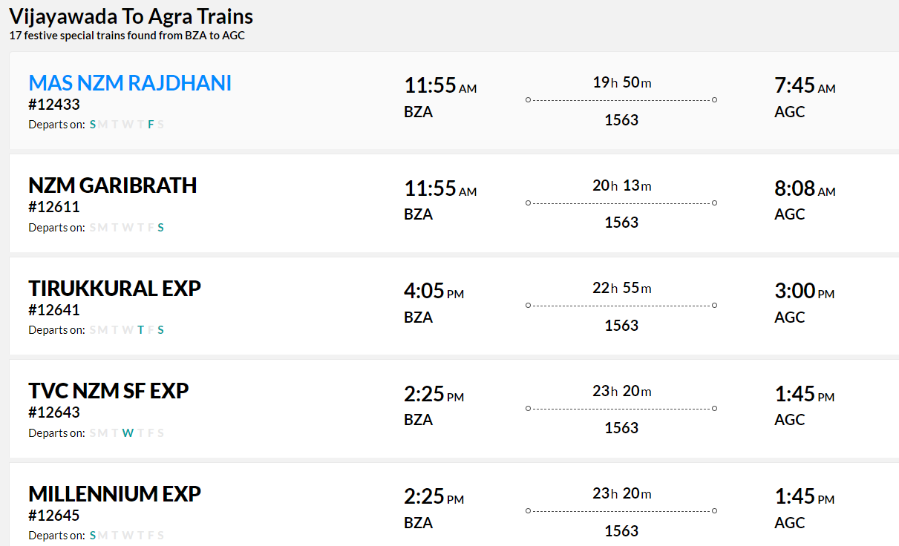

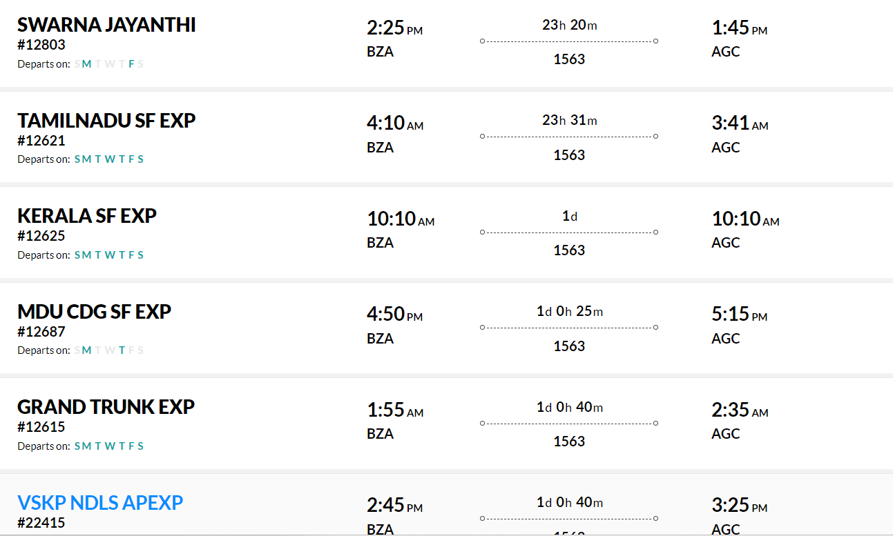

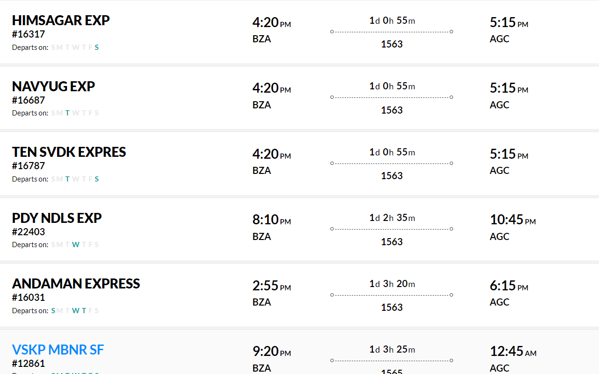

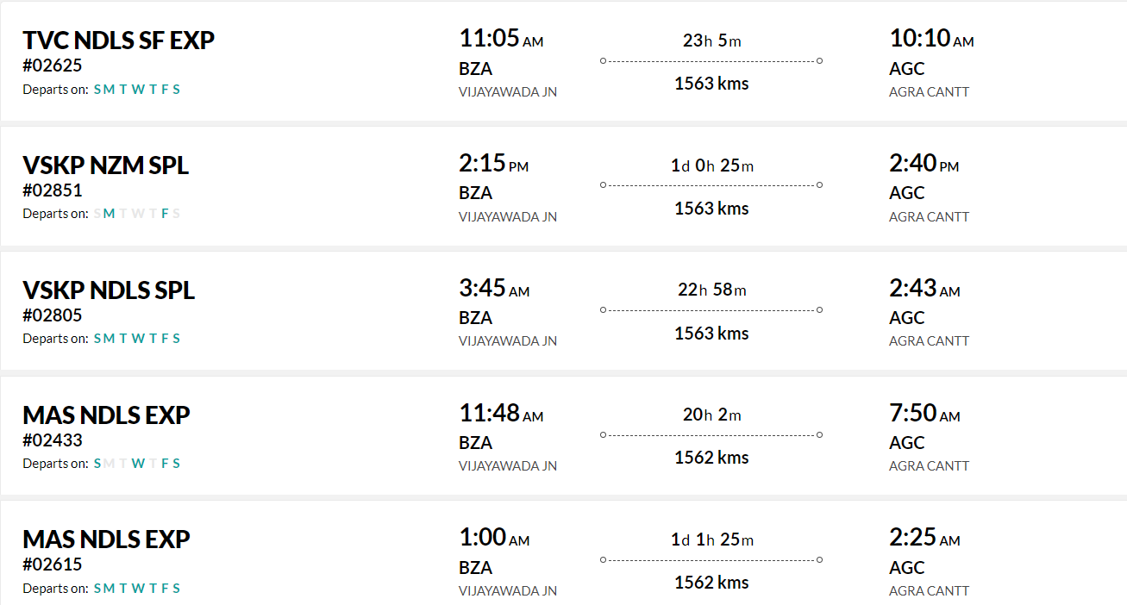

### 3. By Road:

#### Route:

- **Vijayawada to Agra by Road**: This route involves traveling by road via National Highways and State Highways.

#### Distance:

- The road distance between Vijayawada and Agra is approximately 1,400 to 1,500 kilometers, depending on the specific route taken.

#### Duration:

- The journey by road can take around 24 to 28 hours, depending on factors such as traffic, road conditions, and rest stops.

#### Route Options:

- You can take multiple route options, including via Hyderabad, Nagpur, and Bhopal, or via Varanasi and Allahabad. Each route offers different scenery and road conditions.

#### Facilities:

- Along the way, you'll find various amenities such as fuel stations, restaurants, and rest areas. It's advisable to plan your journey in advance, considering necessary stops for food, rest, and refueling.

#### Considerations:

- Before embarking on a long road trip, ensure your vehicle is in good condition and carry essential documents like your driver's license, vehicle registration, and insurance.

### Conclusion:

- Depending on your preferences, budget, and time constraints, you can choose between air, train, or road travel from Vijayawada to Agra. Each mode of transportation offers its own advantages, so consider factors such as convenience, cost, and comfort when planning your journey.