**AYODHYA**:

Sure, here's a detailed overview of three common ways to travel from Vijayawada to Ayodhya:

### 1. By Air:

#### Route:

- **Vijayawada Airport (VGA) to Lucknow Airport (LKO)**: There are no direct flights from Vijayawada to Ayodhya. The most convenient route is to fly from Vijayawada to Lucknow, which is the nearest major airport to Ayodhya.

#### Airlines:

- Several airlines operate flights on this route, including IndiGo, SpiceJet, and Air India. You can check their websites or use flight booking platforms to find the most suitable option for your travel dates.

#### Duration:

- The flight duration from Vijayawada to Lucknow is typically around 2.5 to 3 hours, depending on the airline and any layovers.

#### Layovers:

- Layovers may vary depending on the flight schedule and airline. Common layover airports include Hyderabad, Delhi, and Mumbai.

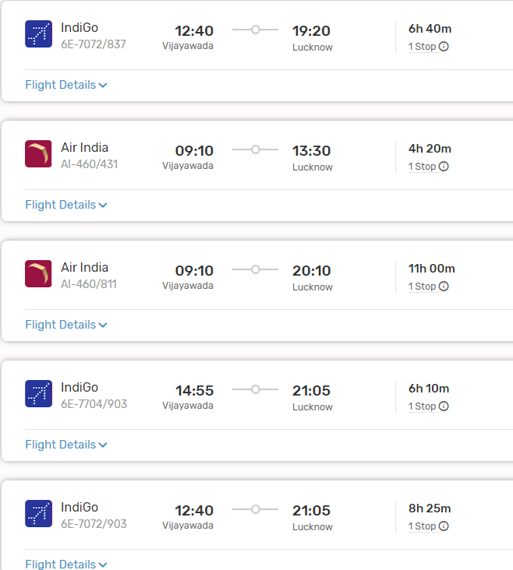

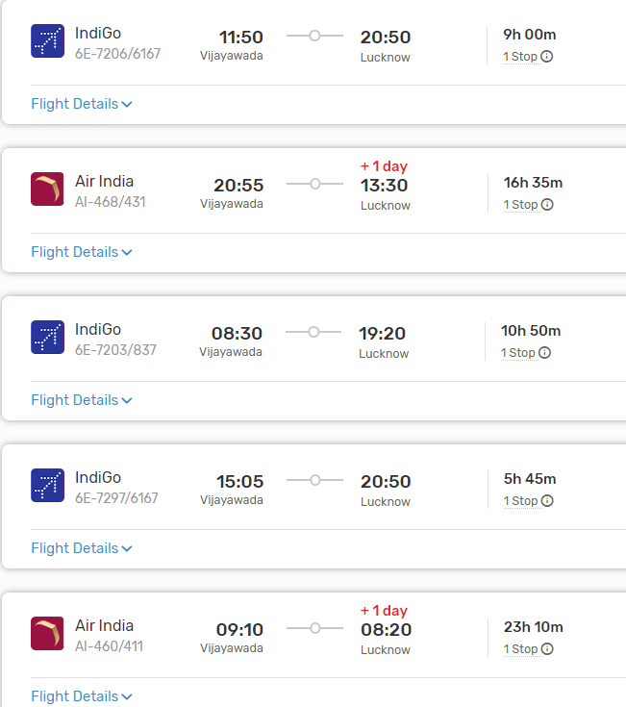

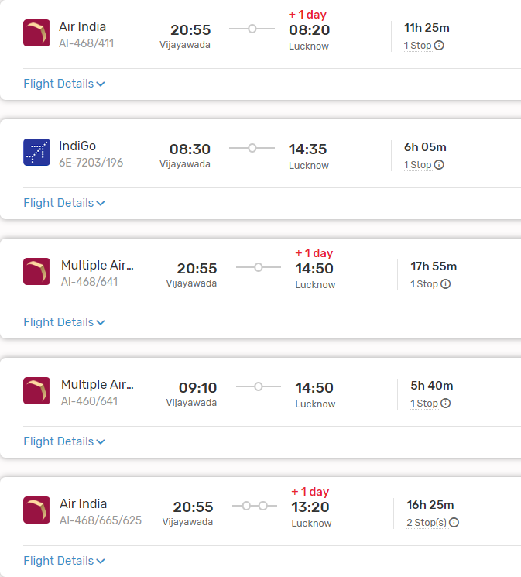

#### From Lucknow to Ayodhya:

- Upon reaching Lucknow Airport, you can travel to Ayodhya by road. The distance between Lucknow and Ayodhya is approximately 135 kilometers, and the journey takes around 3 to 4 hours by car or bus.

### 2. By Train:

#### Route:

- **Vijayawada Railway Station (BZA) to Faizabad Junction (FD)**: Faizabad Junction is the nearest railway station to Ayodhya.

#### Trains:

- There are no direct trains from Vijayawada to Faizabad. You may need to take a train to a major junction like Lucknow or Varanasi and then transfer to a train bound for Faizabad.

#### Duration:

- The duration of the train journey can vary significantly depending on the chosen route and any layovers. It can take anywhere from 20 to 30 hours or more to reach Faizabad from Vijayawada by train.

#### From Faizabad to Ayodhya:

- Once you reach Faizabad Junction, you can take a taxi, auto-rickshaw, or bus to Ayodhya, which is approximately 7 kilometers away.

###ListOf Trains available:

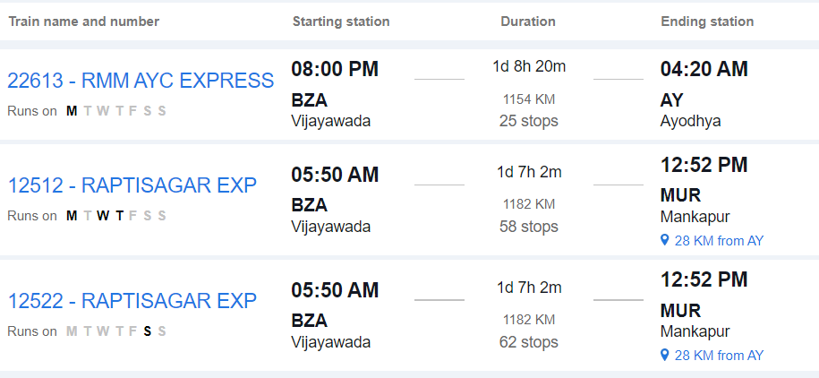



### 3. By Road:

#### Route:

- **Vijayawada to Ayodhya by Road**: This route involves traveling by road via National Highways and State Highways.

#### Distance:

- The road distance between Vijayawada and Ayodhya is approximately 1,400 to 1,500 kilometers, depending on the specific route taken.

#### Duration:

- The journey by road can take around 24 to 30 hours, depending on factors such as traffic, road conditions, and rest stops.

#### Route Options:

- You can take multiple route options, including via Hyderabad, Nagpur, and Allahabad, or via Varanasi. Each route offers different scenery and road conditions.

#### Facilities:

- Along the way, you'll find various amenities such as fuel stations, restaurants, and rest areas. It's advisable to plan your journey in advance, considering necessary stops for food, rest, and refueling.

#### Considerations:

- Before embarking on a long road trip, ensure your vehicle is in good condition and carry essential documents like your driver's license, vehicle registration, and insurance.

### Conclusion:

- Depending on your preferences, budget, and time constraints, you can choose between air, train, or road travel from Vijayawada to Ayodhya. Each mode of transportation offers its own advantages, so consider factors such as convenience, cost, and comfort when planning your journey.