**DWARAKA:**

Certainly! Here's detailed information on three common ways to travel from Vijayawada to Dwarka:

### 1. By Air:

#### Route:

- **Vijayawada Airport (VGA) to Jamnagar Airport (JGA)**: There are no direct flights from Vijayawada to Dwarka. The most convenient route is to fly from Vijayawada to Jamnagar, which is the nearest major airport to Dwarka.

#### Airlines:

- Several airlines operate flights on this route, including IndiGo and Air India. You can check their websites or use flight booking platforms to find the most suitable option for your travel dates.

#### Duration:

- The flight duration from Vijayawada to Jamnagar is typically around 3 to 4 hours, depending on the airline and any layovers.

#### Layovers:

- Layovers may vary depending on the flight schedule and airline. Common layover airports include Hyderabad, Mumbai, and Delhi.

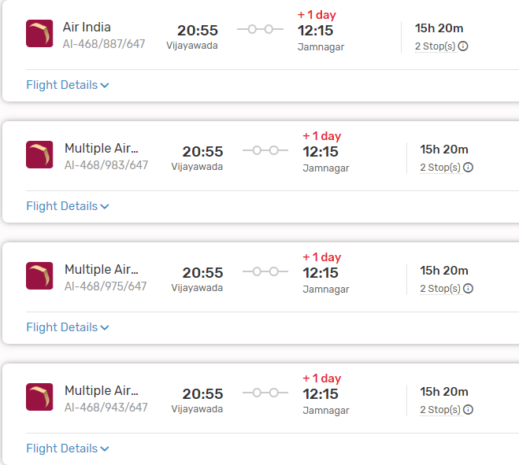

#### From Jamnagar to Dwarka:

- Upon reaching Jamnagar Airport, you can travel to Dwarka by road. The distance between Jamnagar and Dwarka is approximately 130 kilometers, and the journey takes around 3 to 4 hours by car or bus.

### 2. By Train:

#### Route:

- **Vijayawada Railway Station (BZA) to Dwarka Railway Station (DWK)**: Dwarka Railway Station is the main railway station serving Dwarka.

#### Trains:

- There are no direct trains from Vijayawada to Dwarka. You may need to take a train to a major junction like Ahmedabad or Rajkot and then transfer to a train bound for Dwarka.

#### Duration:

- The duration of the train journey can vary significantly depending on the chosen route and any layovers. It can take anywhere from 25 to 40 hours or more to reach Dwarka from Vijayawada by train.

#### From Dwarka Railway Station to Dwarka:

- Dwarka Railway Station is located near the city center of Dwarka, allowing easy access to various modes of local transportation to reach your destination within Dwarka.

###ListOf Trains available:

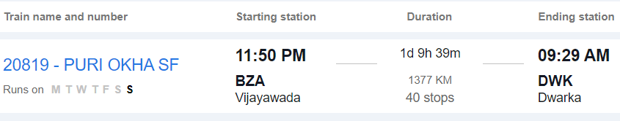



### 3. By Road:

#### Route:

- **Vijayawada to Dwarka by Road**: This route involves traveling by road via National Highways and State Highways.

#### Distance:

- The road distance between Vijayawada and Dwarka is approximately 1,800 to 1,900 kilometers, depending on the specific route taken.

#### Duration:

- The journey by road can take around 30 to 35 hours, depending on factors such as traffic, road conditions, and rest stops.

#### Route Options:

- You can take multiple route options, including via Hyderabad, Solapur, and Ahmedabad, or via Nagpur and Vadodara. Each route offers different scenery and road conditions.

#### Facilities:

- Along the way, you'll find various amenities such as fuel stations, restaurants, and rest areas. It's advisable to plan your journey in advance, considering necessary stops for food, rest, and refueling.

#### Considerations:

- Before embarking on a long road trip, ensure your vehicle is in good condition and carry essential documents like your driver's license, vehicle registration, and insurance.

### Conclusion:

- Depending on your preferences, budget, and time constraints, you can choose between air, train, or road travel from Vijayawada to Dwarka. Each mode of transportation offers its own advantages, so consider factors such as convenience, cost, and comfort when planning your journey.