**GOA:**

Certainly! Here's detailed information on three common ways to travel from Vijayawada to Goa:

### 1. By Air:

#### Route:

- **Vijayawada Airport (VGA) to Goa Airport (GOI)**: Fly from Vijayawada to Goa, which has an airport located near the capital city, Panaji.

#### Airlines:

- Several airlines operate flights on this route, including IndiGo, SpiceJet, and Air India. You can check their websites or use flight booking platforms to find the most suitable option for your travel dates.

#### Duration:

- The flight duration from Vijayawada to Goa is typically around 2 to 3 hours, depending on the airline and any layovers.

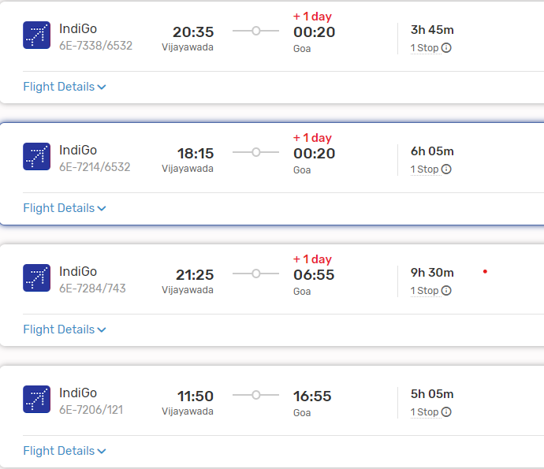

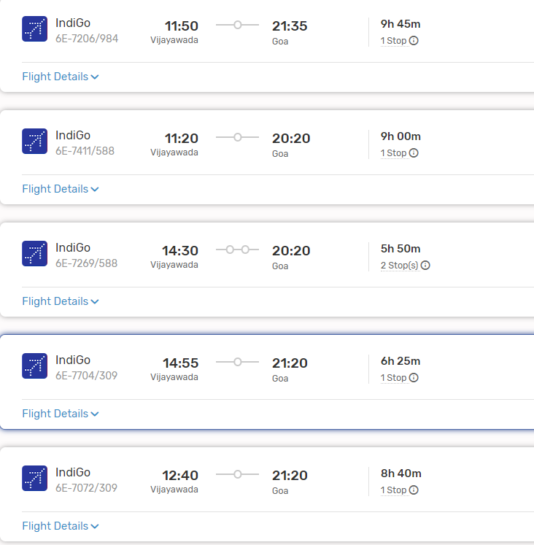

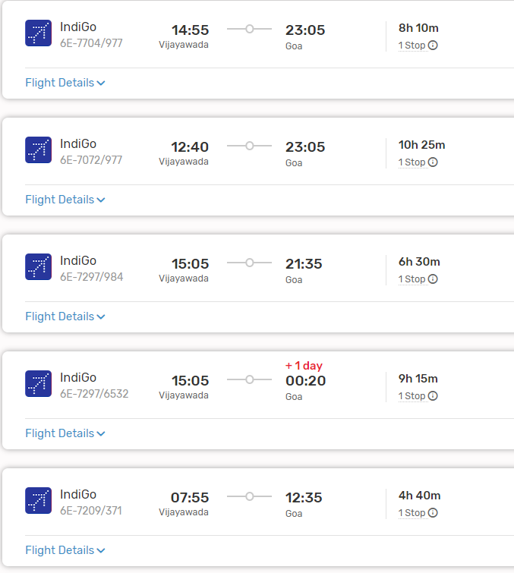

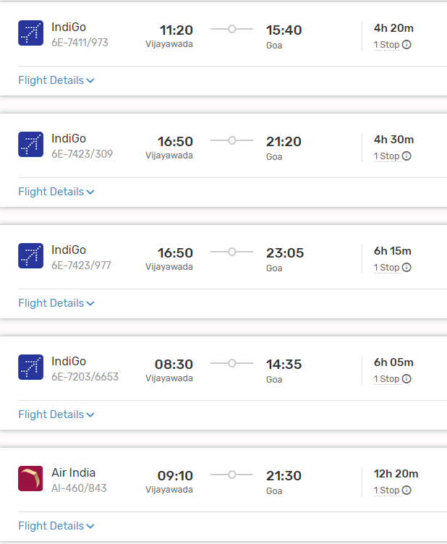

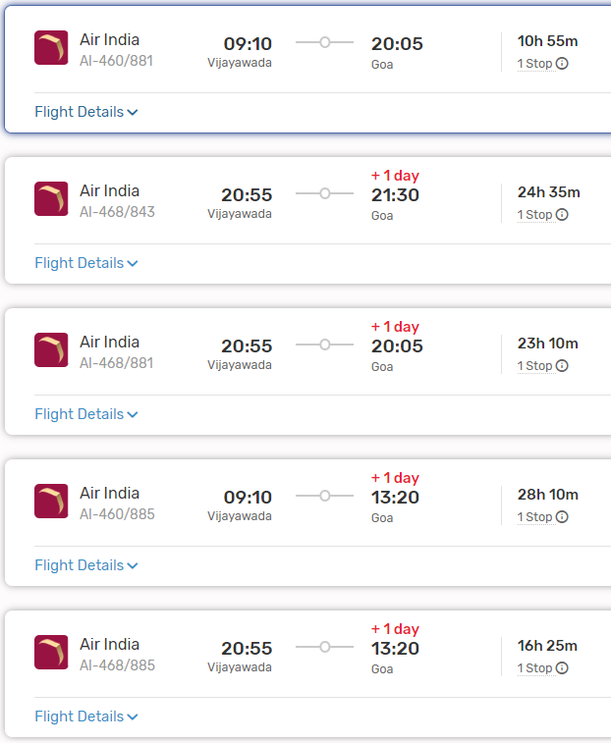

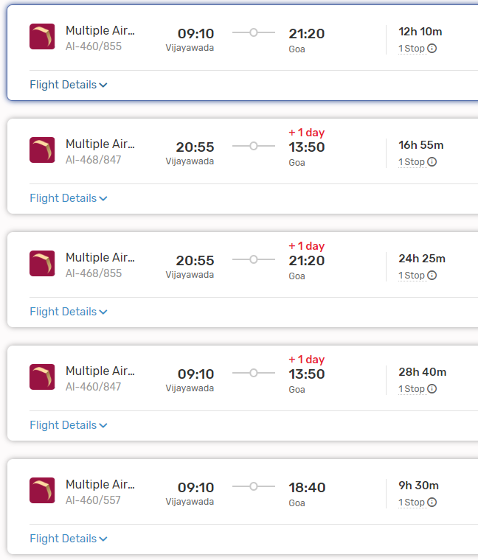

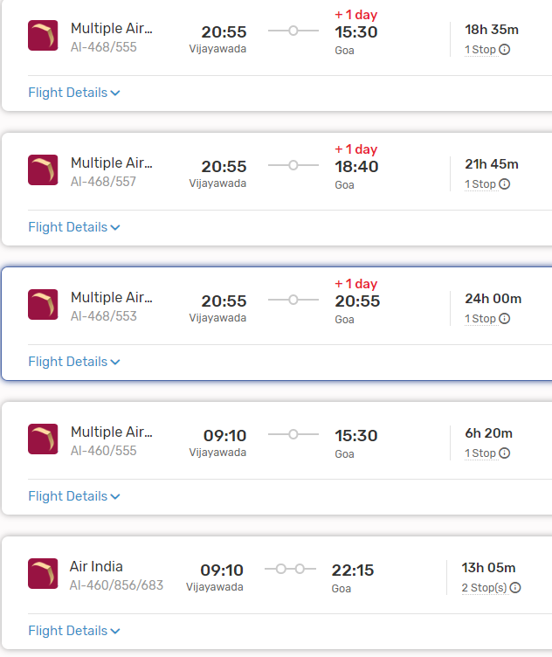

#### Layovers:

- Layovers may vary depending on the flight schedule and airline. Common layover airports include Hyderabad, Bengaluru, and Mumbai.

#### From Goa Airport to Your Destination:

- Upon reaching Goa Airport, you can travel to your desired destination within Goa by taxi, pre-booked car rental, or other local transportation options.

### 2. By Train:

#### Route:

- **Vijayawada Railway Station (BZA) to Madgaon Railway Station (MAO)**: Madgaon Railway Station is one of the major railway stations in Goa.

#### Trains:

- There are several trains connecting Vijayawada to Madgaon, including the Konark Express, Amaravati Express, and Vasco Da Gama Express. You can check the Indian Railways website or use other online platforms to find suitable train options based on your travel dates and preferences.

#### Duration:

- The duration of the train journey can vary significantly depending on the chosen train and any layovers. It can take anywhere from 20 to 30 hours or more to reach Madgaon from Vijayawada by train.

#### From Madgaon Railway Station to Your Destination:

- Madgaon Railway Station is located in South Goa. Depending on your specific destination within Goa, you can hire a taxi, use app-based cab services, or take local buses to reach your accommodation or desired locations.

###ListOf Trains available:

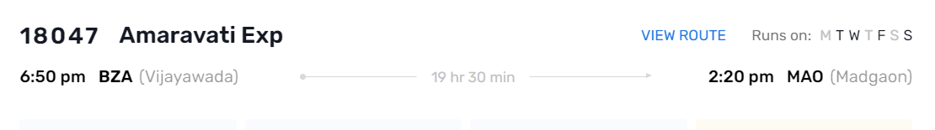

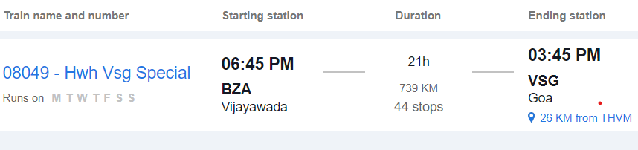

### 3. By Road:

#### Route:

- **Vijayawada to Goa by Road**: This route involves traveling by road via National Highways and State Highways.

#### Distance:

- The road distance between Vijayawada and Goa is approximately 1,200 to 1,300 kilometers, depending on the specific route taken.

#### Duration:

- The journey by road can take around 20 to 24 hours, depending on factors such as traffic, road conditions, and rest stops.

#### Route Options:

- You can take multiple route options, including via Hyderabad, Bengaluru, and Belagavi, or via Pune and Kolhapur. Each route offers different scenery and road conditions.

#### Facilities:

- Along the way, you'll find various amenities such as fuel stations, restaurants, and rest areas. It's advisable to plan your journey in advance, considering necessary stops for food, rest, and refueling.

#### Considerations:

- Before embarking on a long road trip, ensure your vehicle is in good condition and carry essential documents like your driver's license, vehicle registration, and insurance.

### Conclusion:

- Depending on your preferences, budget, and time constraints, you can choose between air, train, or road travel from Vijayawada to Goa. Each mode of transportation offers its own advantages, so consider factors such as convenience, cost, and comfort when planning your journey.