**HAMPI:**

Traveling from Vijayawada to Hampi offers several transportation options due to the distance and accessibility. Here's a detailed overview of each mode of transportation:

### 1. By Train and Road:

#### Route:

1. **Vijayawada to Hospet by Train**: Take a train from Vijayawada Junction to Hospet Junction, which is the nearest railway station to Hampi. Several trains connect Vijayawada to Hospet, including express and superfast trains.

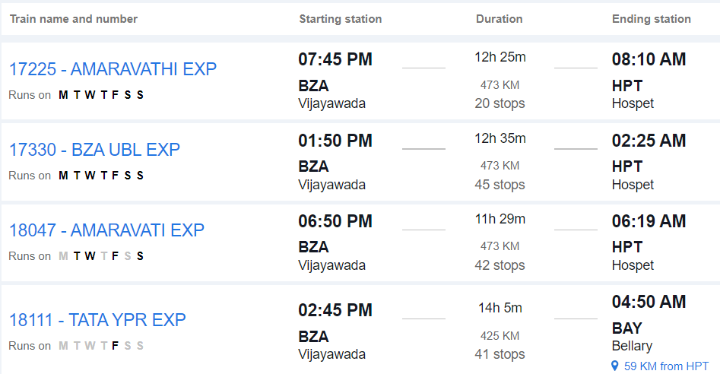

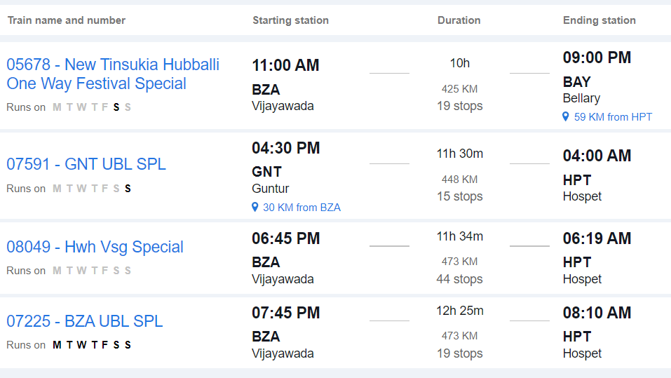

2. **Hospet to Hampi by Road**: From Hospet, travel to Hampi by road. Hampi is located approximately 13 kilometers from Hospet, and the road journey takes around 30 to 45 minutes, depending on traffic and mode of transport.

#### From Hospet to Hampi:

- Upon reaching Hospet, you can hire a taxi, use app-based cab services, or take a local bus to reach Hampi.

### 2. By Road Only:

#### Route:

- **Vijayawada to Hampi by Road**: Travel directly from Vijayawada to Hampi by road via National Highways and State Highways.

#### Distance:

- The road distance between Vijayawada and Hampi is approximately 400 to 450 kilometers, depending on the specific route taken.

#### Duration:

- The journey by road can take around 8 to 10 hours, depending on factors such as traffic, road conditions, and rest stops.

#### Route Options:

- You can take multiple route options, including via Hyderabad, Raichur, and Hospet, or via Kurnool, Bellary, and Hospet. Each route offers different scenery and road conditions.

#### Facilities:

- Along the way, you'll find various amenities such as fuel stations, restaurants, and rest areas. It's advisable to plan your journey in advance, considering necessary stops for food, rest, and refueling.

#### Considerations:

- Before embarking on a long road trip, ensure your vehicle is in good condition and carry essential documents like your driver's license, vehicle registration, and insurance.

### 3. By Air and Road:

#### Route:

1. **Vijayawada to Hubli by Air**: Fly from Vijayawada Airport (VGA) to Hubli Airport (HBX).

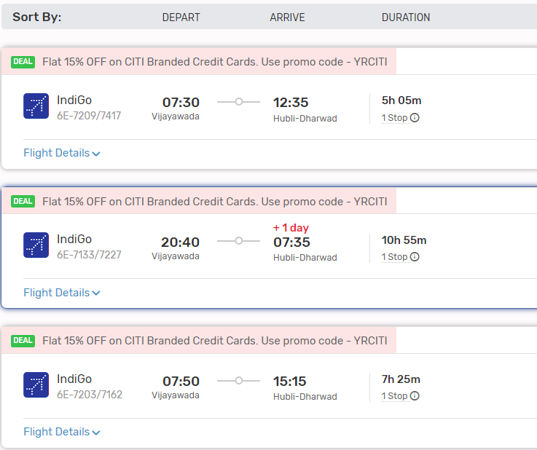

2. **Hubli to Hampi by Road**: From Hubli, travel to Hampi by road. Hampi is located approximately 160 kilometers from Hubli, and the road journey takes around 4 to 5 hours, depending on traffic and mode of transport.

#### From Hubli to Hampi:

- Upon reaching Hubli, you can hire a taxi, use app-based cab services, or take a local bus to reach Hampi.

### Conclusion:

- Depending on your preferences, budget, and time constraints, you can choose between train and road travel or a combination of air and road travel to reach Hampi from Vijayawada. Each mode of transportation offers its own advantages, so consider factors such as convenience, cost, and comfort when planning your journey.