**JAIPUR:**

Traveling from Vijayawada to Jaipur can be done through various modes of transportation. Here's a detailed overview of each option:

### 1. By Air:

#### Route:

1. **Vijayawada to Jaipur by Air**: Fly from Vijayawada Airport (VGA) to Jaipur International Airport (JAI).

#### Flight Duration:

- The direct flight from Vijayawada to Jaipur typically takes around 3 to 4 hours, depending on the airline and any layovers.

#### Airlines:

- Several airlines operate flights between major Indian cities, including Vijayawada and Jaipur. It's advisable to check the flight schedules and book tickets in advance to secure the best deals.

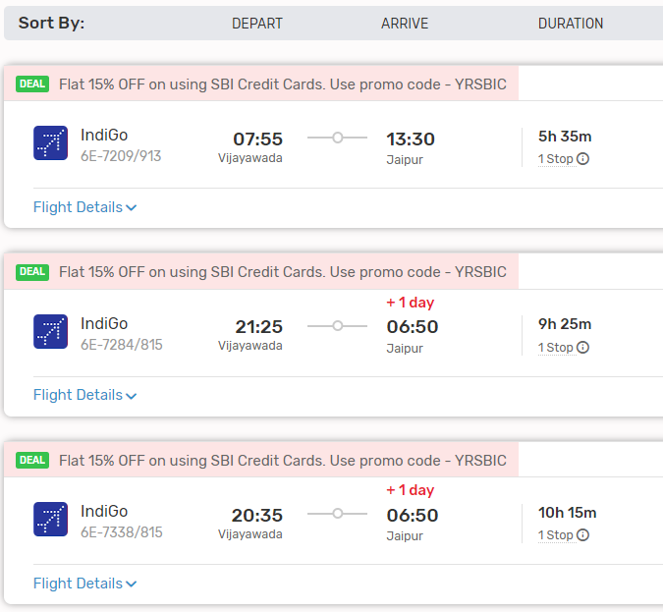

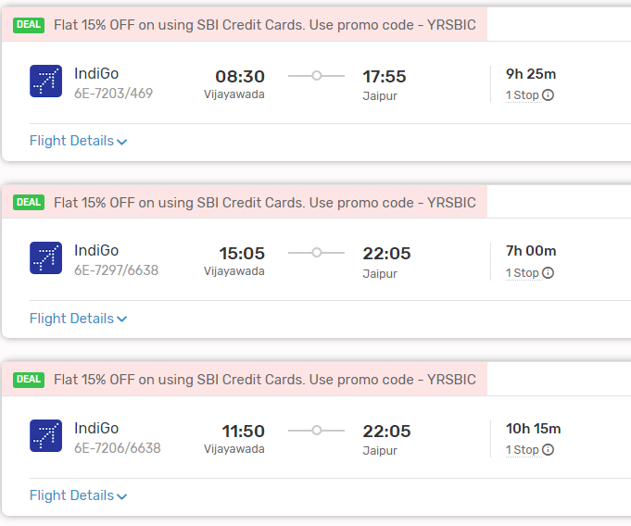

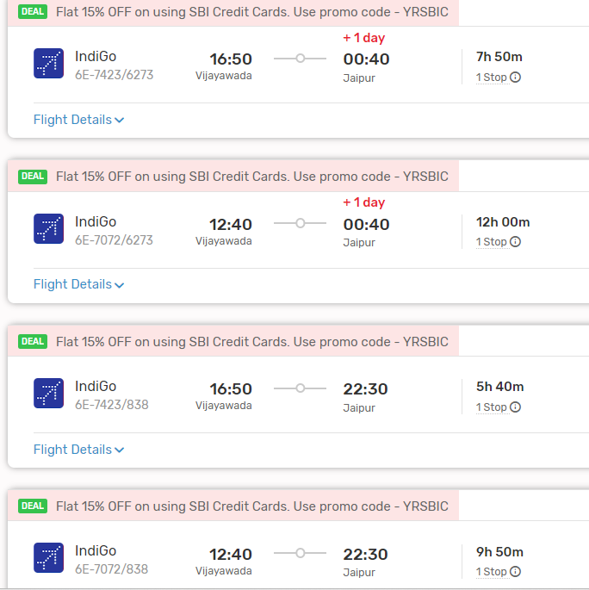

#### Airport Transfers:

- Upon arrival at Jaipur International Airport, you can use taxis, app-based cab services, or airport shuttle services to reach your destination within Jaipur city.

### 2. By Train:

#### Route:

- **Vijayawada to Jaipur by Train**: Travel from Vijayawada Junction to Jaipur Junction by train. Several trains connect Vijayawada to Jaipur, including express and superfast trains.

#### Train Duration:

- The train journey from Vijayawada to Jaipur typically takes around 24 to 30 hours, depending on the specific train and route chosen.

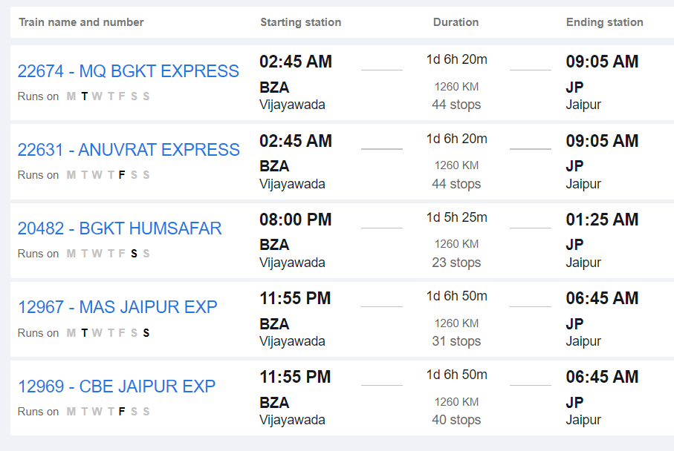

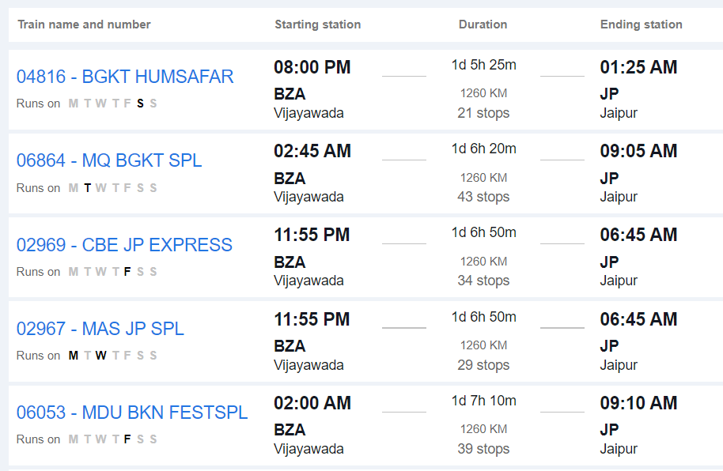

#### Train Classes:

- Trains offer various classes of seating, including sleeper class, third AC, second AC, and first AC. It's advisable to book tickets in advance, especially during peak travel seasons.

#### Jaipur Railway Station:

- Upon arrival at Jaipur Junction, you can use taxis, auto-rickshaws, or app-based cab services to reach your destination within Jaipur city.

### 3. By Road:

#### Route:

- **Vijayawada to Jaipur by Road**: Travel directly from Vijayawada to Jaipur by road via National Highways and State Highways.

#### Distance:

- The road distance between Vijayawada and Jaipur is approximately 1,600 to 1,700 kilometers, depending on the specific route taken.

#### Duration:

- The journey by road can take around 25 to 30 hours, depending on factors such as traffic, road conditions, and rest stops.

#### Route Options:

- You can take multiple route options, including via Hyderabad, Nagpur, and Kota, or via Hyderabad, Sagar, and Kota. Each route offers different scenery and road conditions.

#### Facilities:

- Along the way, you'll find various amenities such as fuel stations, restaurants, and rest areas. It's advisable to plan your journey in advance, considering necessary stops for food, rest, and refueling.

#### Considerations:

- Before embarking on a long road trip, ensure your vehicle is in good condition and carry essential documents like your driver's license, vehicle registration, and insurance.

### Conclusion:

- Depending on your preferences, budget, and time constraints, you can choose between air, train, and road travel to reach Jaipur from Vijayawada. Each mode of transportation offers its own advantages, so consider factors such as convenience, cost, and comfort when planning your journey.