**KATRA**:

Sure, here's a detailed overview of three common ways to travel from Vijayawada to Katra:

### 1. By Air:

#### Route:

- **Vijayawada Airport (VGA) to Jammu Airport (IXJ)**: There are no direct flights from Vijayawada to Katra. The most convenient route is to fly from Vijayawada to Jammu, which is the nearest major airport to Katra.

#### Airlines:

- Several airlines operate flights on this route, including IndiGo, SpiceJet, and Air India. You can check their websites or use flight booking platforms to find the most suitable option for your travel dates.

#### Duration:

- The flight duration from Vijayawada to Jammu is typically around 3 to 4 hours, depending on the airline and any layovers.

#### Layovers:

- Layovers may vary depending on the flight schedule and airline. Common layover airports include Delhi, Hyderabad, and Mumbai.

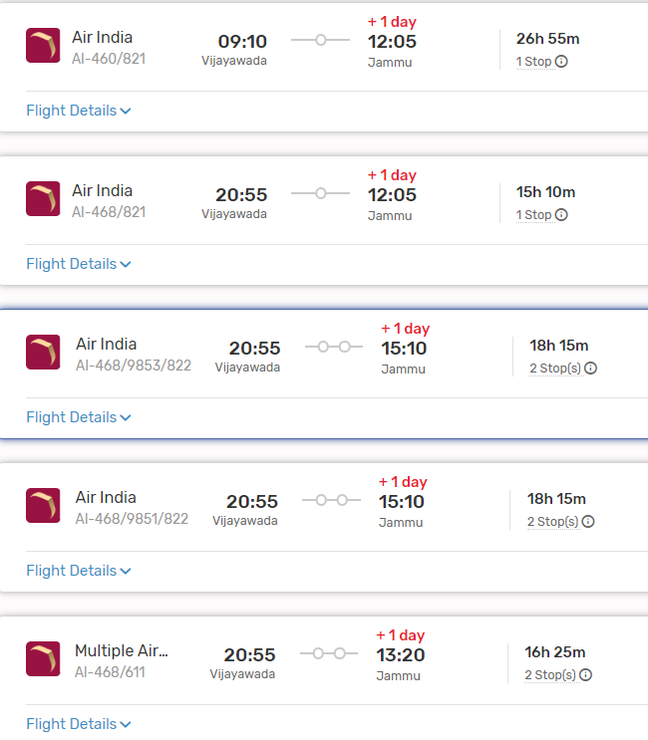

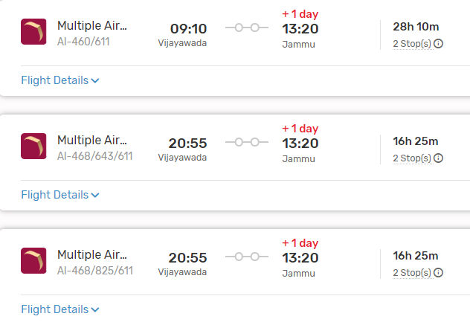

#### From Jammu to Katra:

- Upon reaching Jammu Airport, you can travel to Katra by road. The distance between Jammu and Katra is approximately 50 kilometers, and the journey takes around 1.5 to 2 hours by car or bus.

### 2. By Train:

#### Route:

- **Vijayawada Railway Station (BZA) to Shri Mata Vaishno Devi Katra Railway Station (SVDK)**: Shri Mata Vaishno Devi Katra Railway Station is the nearest railway station to Katra.

#### Trains:

- There are no direct trains from Vijayawada to Katra. You may need to take a train to a major junction like Jammu Tawi or Pathankot and then transfer to a train bound for Shri Mata Vaishno Devi Katra.

#### Duration:

- The duration of the train journey can vary significantly depending on the chosen route and any layovers. It can take anywhere from 30 to 40 hours or more to reach Katra from Vijayawada by train.

#### From Shri Mata Vaishno Devi Katra Railway Station to Katra:

- Once you reach Shri Mata Vaishno Devi Katra Railway Station, you can easily walk or take a short auto-rickshaw ride to reach the town of Katra.

###ListOf Trains available:

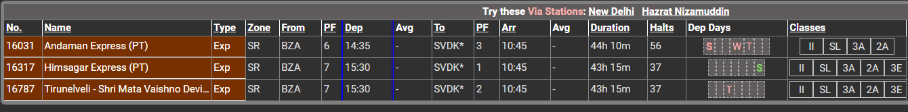

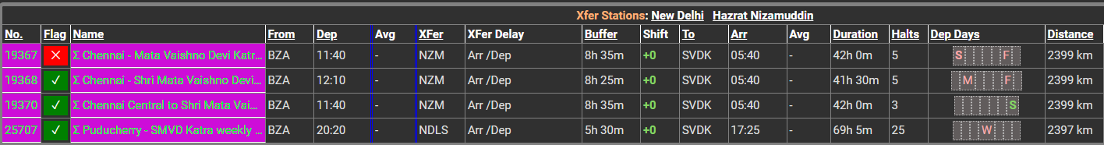

### 3. By Road:

#### Route:

- **Vijayawada to Katra by Road**: This route involves traveling by road via National Highways and State Highways.

#### Distance:

- The road distance between Vijayawada and Katra is approximately 2,000 to 2,200 kilometers, depending on the specific route taken.

#### Duration:

- The journey by road can take around 35 to 40 hours, depending on factors such as traffic, road conditions, and rest stops.

#### Route Options:

- You can take multiple route options, including via Delhi, Chandigarh, and Jammu, or via Nagpur and Indore. Each route offers different scenery and road conditions.

#### Facilities:

- Along the way, you'll find various amenities such as fuel stations, restaurants, and rest areas. It's advisable to plan your journey in advance, considering necessary stops for food, rest, and refueling.

#### Considerations:

- Before embarking on a long road trip, ensure your vehicle is in good condition and carry essential documents like your driver's license, vehicle registration, and insurance.

### Conclusion:

- Depending on your preferences, budget, and time constraints, you can choose between air, train, or road travel from Vijayawada to Katra. Each mode of transportation offers its own advantages, so consider factors such as convenience, cost, and comfort when planning your journey.