**KEDARNATH:**

Reaching Kedarnath from Vijayawada involves a combination of different modes of transportation due to the remote location of Kedarnath in the Himalayas. Here's detailed information on three common ways to travel from Vijayawada to Kedarnath:

### 1. By Air, Road, and Trekking:

#### Route:

1. **Vijayawada to Dehradun by Air**: Fly from Vijayawada to Dehradun, which is the nearest major airport to Kedarnath.

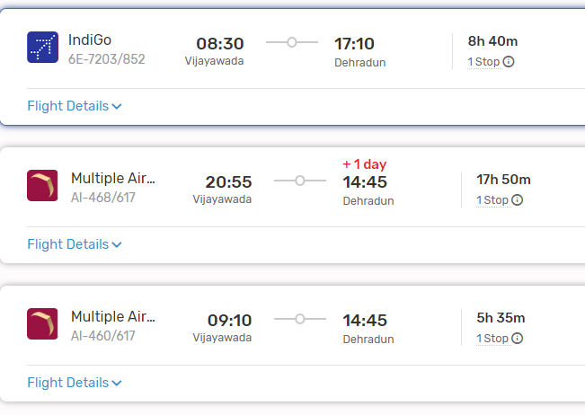

2. **Dehradun to Gaurikund by Road**: Take a taxi or bus from Dehradun to Gaurikund, which is the base camp for the trek to Kedarnath. The road journey takes approximately 7 to 8 hours and covers a distance of around 200 kilometers.

3. **Gaurikund to Kedarnath Temple by Trek**: From Gaurikund, trek to Kedarnath Temple. The trek is approximately 16 kilometers long and usually takes around 6 to 8 hours, depending on individual fitness levels and weather conditions.

#### Facilities:

- Ensure you have proper trekking gear, including sturdy shoes, warm clothing, rain gear, and water bottles.

- Accommodations are available in Gaurikund and along the trekking route, but it's advisable to book in advance during peak pilgrimage seasons.

### 2. By Train, Road, and Trekking:

#### Route:

1. **Vijayawada to Haridwar/Rishikesh by Train**: Take a train from Vijayawada to Haridwar or Rishikesh, which are major railway stations in Uttarakhand.

2. **Haridwar/Rishikesh to Gaurikund by Road**: From Haridwar or Rishikesh, hire a taxi or take a bus to Gaurikund. The road journey takes approximately 9 to 10 hours from Haridwar and around 7 to 8 hours from Rishikesh.

3. **Gaurikund to Kedarnath Temple by Trek**: Follow the same trekking route from Gaurikund to Kedarnath Temple as mentioned in the first option.

#### Facilities:

- Similar to the first option, ensure you have proper trekking gear and accommodations booked in advance.

###ListOf Trains available:

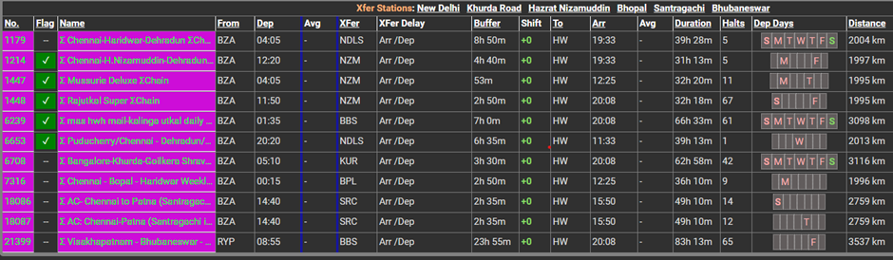

**Rishikesh to Kedarnath via Rudraprayag:**

**Distance: Approximately 207 km.**

**Route: Rishikesh — Rudraprayag — Agastyamuni — Kund — Guptkashi — Gaurikund (base for Kedarnath trek) — Kedarnath.**

This route takes you through Rudraprayag, a picturesque town located at the confluence of the rivers Alaknanda and Mandakini. The journey begins in Rishikesh, renowned for its spiritual significance, and moves toward Devprayag, where the rivers Alaknanda and Bhagirathi merge to form the holy Ganges. The route then leads to Rudraprayag, offering splendid views of the Garhwal Himalayas along the way. From Rudraprayag, the path ascends towards Gaurikund, where the Kedarnath trek begins. This route is ideal for travellers who wish to soak in stunning landscapes while experiencing the essence of Uttarakhand’s spirituality.

**Rishikesh to Kedarnath via Devprayag:**

**Distance: Approximately 197 km.**

**You can go from**[**Rishikesh to Gaurikund**](https://universaladventures.in/products/kedarnath-group-tour-from-haridwar-with-rishikesh-stay)**via Devprayag — Srinagar — Rudraprayag — Agastyamuni — Kund — Guptkashi — Gaurikund (base for Kedarnath trek) — Kedarnath.**

The route from Rishikesh to Kedarnath via Devprayag is a sacred and picturesque pilgrimage that takes travellers through the heart of Uttarakhand’s majestic Himalayan landscapes. Devprayag, the confluence of the rivers Alaknanda and Bhagirathi, holds immense religious significance and marks the beginning of the journey towards the revered Kedarnath Temple.

### 3. By Road and Trekking:

#### Route:

1. **Vijayawada to Gaurikund by Road**: Travel by road from Vijayawada to Gaurikund via major highways and state roads. The road distance is approximately 1,800 to 1,900 kilometers and may take around 2 to 3 days depending on the route and stops.

2. **Gaurikund to Kedarnath Temple by Trek**: Trek from Gaurikund to Kedarnath Temple following the same route as mentioned in the first option.

#### Facilities:

- This option requires extensive road travel and trekking, so ensure you have sufficient time, proper vehicle, and accommodations planned along the route.

### Conclusion:

- Reaching Kedarnath from Vijayawada involves a combination of air travel, road journeys, and trekking due to the remote location of Kedarnath. Choose the option that best suits your preferences, time constraints, and physical fitness level. Additionally, it's essential to be well-prepared with necessary gear and accommodations to ensure a safe and enjoyable pilgrimage to Kedarnath.