**LAKSHADWEEP**:

Traveling to Lakshadweep islands from Vijayawada involves multiple modes of transportation due to the geographical distance and the unique nature of the islands. Here are the common ways to reach Lakshadweep islands from Vijayawada:

### 1. By Air and Sea:

#### Route:

1. **Vijayawada to Kochi (By Air)**: Fly from Vijayawada to Kochi (Cochin), which is one of the major cities in Kerala and has an international airport.

2. **Kochi to Lakshadweep (By Sea)**: From Kochi, you can travel to Lakshadweep islands by ship or ferry. Ships and ferries depart from the Kochi Port to various islands of Lakshadweep, including Agatti, Kavaratti, and Kadmat.

#### Duration:

- The flight duration from Vijayawada to Kochi is approximately 1.5 to 2 hours.

- The sea journey from Kochi to Lakshadweep islands can take around 12 to 24 hours, depending on the destination island and the type of vessel.

#### From Lakshadweep Harbor to Your Destination:

- Upon reaching the Lakshadweep islands, you can use local transportation options such as taxis, auto-rickshaws, or pre-arranged transportation provided by resorts/hotels to reach your accommodation or desired locations within the islands.

### 2. By Air and Helicopter:

#### Route:

1. **Vijayawada to Kochi (By Air)**: Follow the same route as mentioned above.

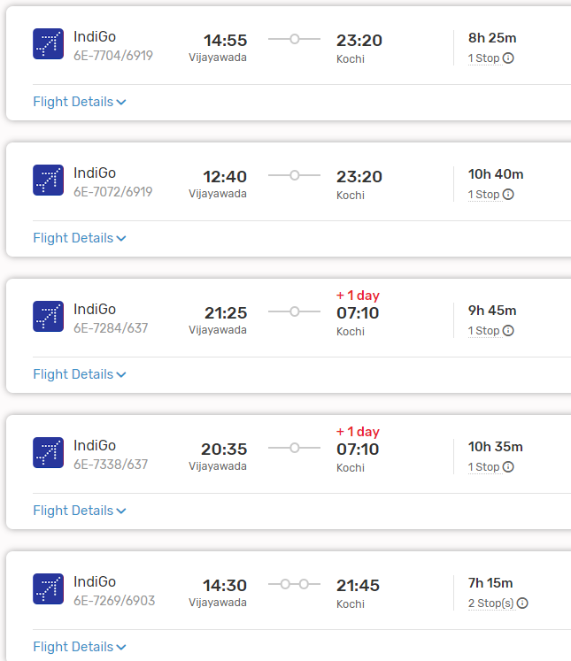

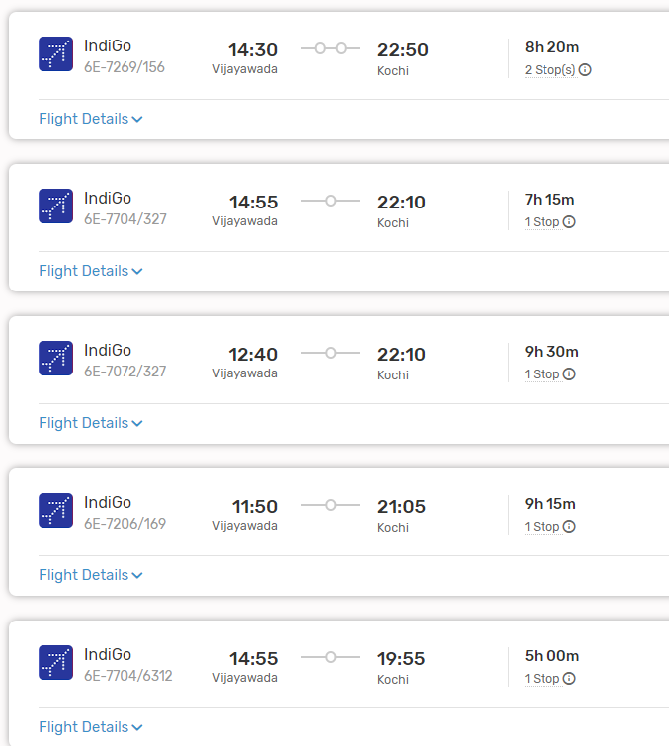

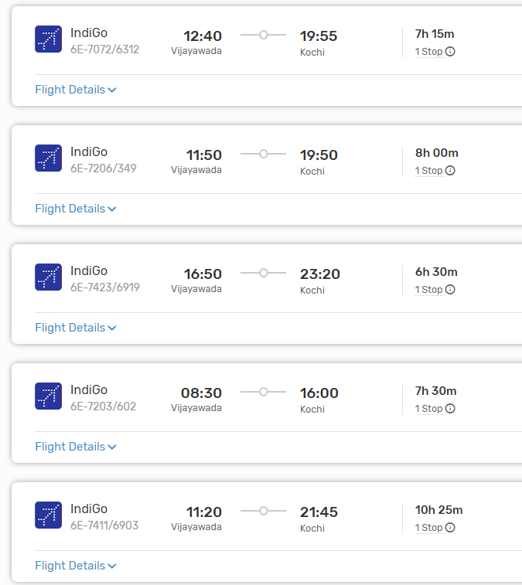

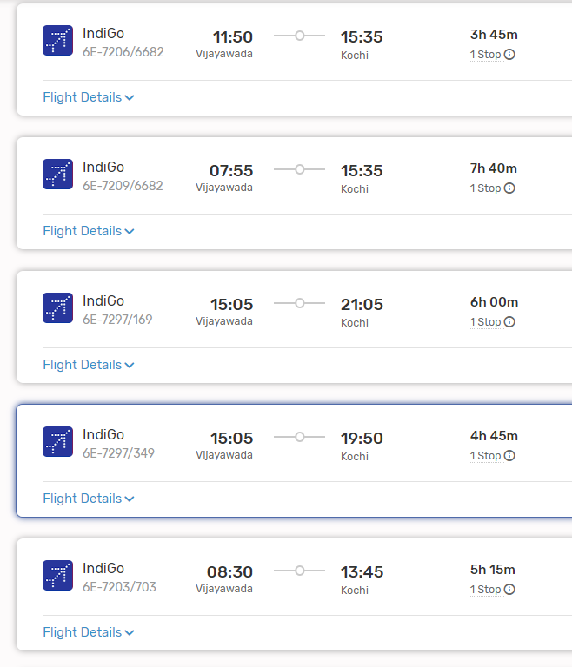

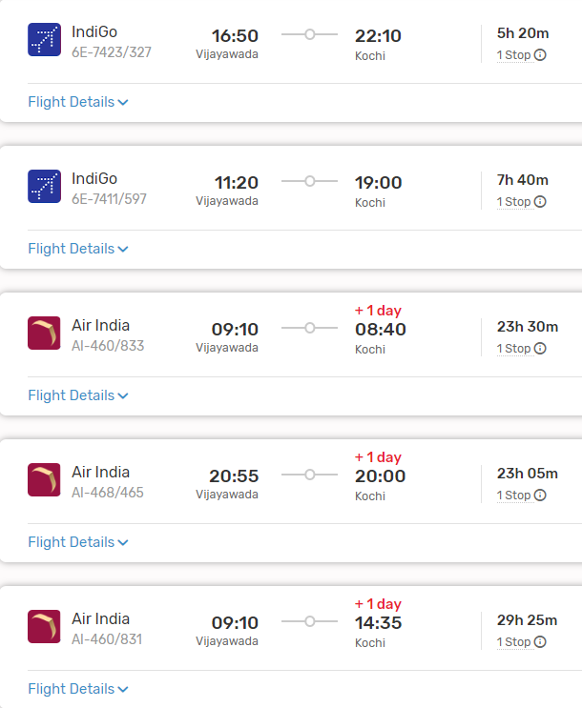

2. **Kochi to Lakshadweep (By Helicopter)**: Some islands in Lakshadweep, such as Agatti, have helicopter services available from Kochi. These services offer a faster and more convenient mode of transportation compared to sea travel.

#### Duration:

- The flight duration from Vijayawada to Kochi remains the same.

- The helicopter journey from Kochi to Lakshadweep islands is much shorter, usually around 1 to 2 hours, depending on the destination island.

#### From Agatti Helipad to Your Destination:

- Upon arrival at the helipad on the designated island, you can use local transportation options to reach your accommodation or desired locations within the island.

### 3. By Air and Private Yacht/Chartered Boat:

#### Route:

1. **Vijayawada to Kochi (By Air)**: Follow the same route as mentioned above.

2. **Kochi to Lakshadweep (By Private Yacht/Chartered Boat)**: For a luxurious and exclusive travel experience, you can charter a private yacht or boat from Kochi to Lakshadweep islands. This option offers flexibility in terms of itinerary and allows you to explore multiple islands at your own pace.

#### Duration:

- The flight duration from Vijayawada to Kochi remains the same.

- The duration of the yacht/boat journey from Kochi to Lakshadweep islands varies depending on the route, vessel speed, and chosen itinerary. It can range from a few hours to a couple of days.

#### From Lakshadweep Harbor to Your Destination:

- Upon reaching the Lakshadweep islands, you can use local transportation options or services provided by the yacht/boat crew to reach your accommodation or desired locations within the islands.

### Conclusion:

- Traveling to Lakshadweep islands from Vijayawada requires a combination of air and sea or air and helicopter transportation. Each mode of transportation offers its own advantages in terms of travel time, convenience, and experience. It's advisable to plan your trip well in advance, considering factors such as availability, weather conditions, and accommodation options on the islands.