**MADURAI:**

Sure, here's detailed information on three common ways to travel from Vijayawada to Madurai, including via air:

### 1. By Air:

#### Route:

1. **Vijayawada to Madurai by Air**: Fly from Vijayawada Airport (VGA) to Madurai Airport (IXM).

#### Airlines:

- Airlines like IndiGo, SpiceJet, and Air India operate flights between Vijayawada and Madurai. Flight schedules and availability can be checked on airline websites or travel booking platforms.

#### Duration:

- The flight duration from Vijayawada to Madurai is approximately 1.5 to 2 hours, depending on the airline and any layovers.

#### From Madurai Airport to Your Destination:

- Upon arrival at Madurai Airport, you can hire a taxi, use app-based cab services, or take a pre-booked car rental to reach your destination within Madurai.

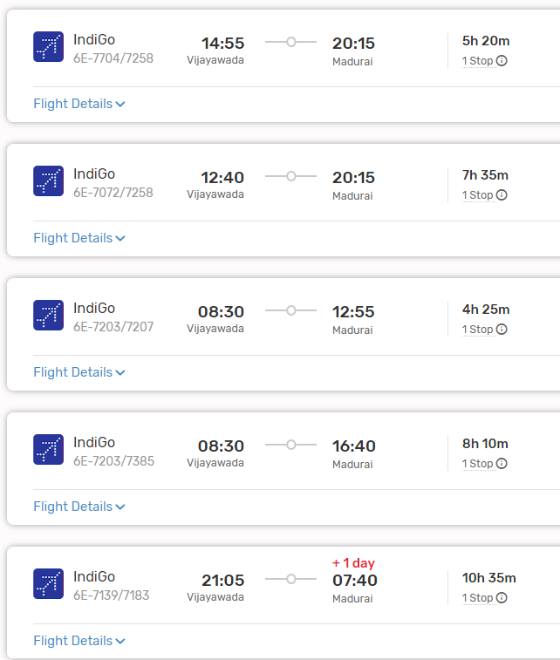

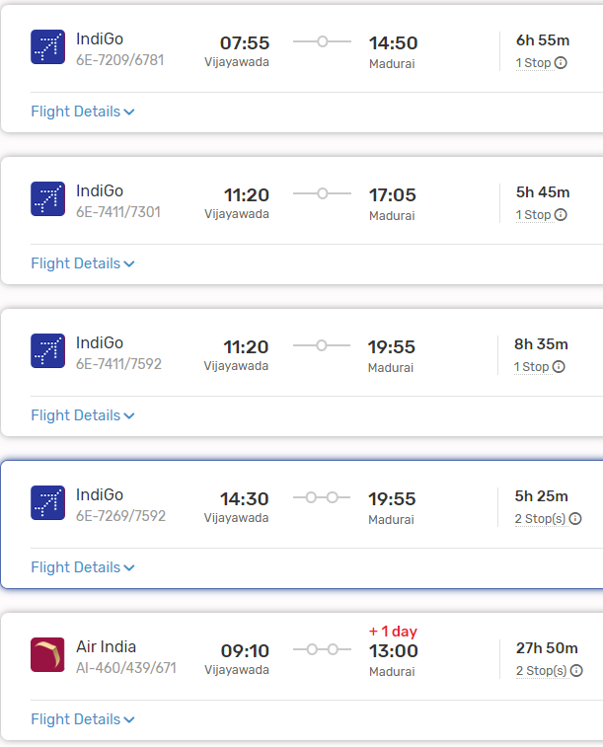

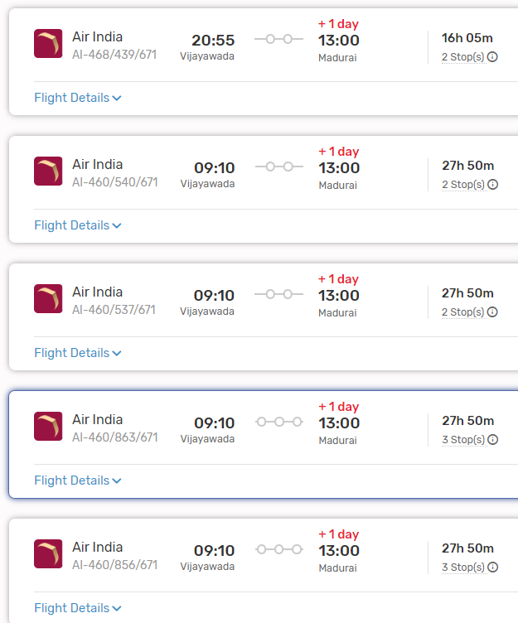

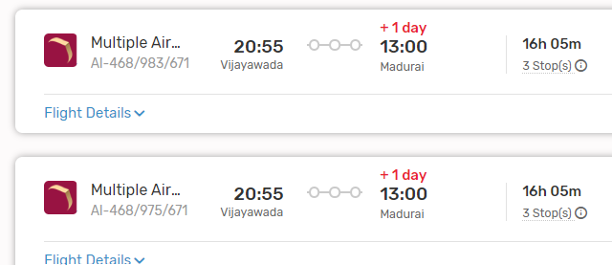

### 2. By Train:

#### Route:

- **Vijayawada to Madurai by Train**: Several trains connect Vijayawada to Madurai. You can check the Indian Railways website or use other online platforms to find suitable train options based on your travel dates and preferences.

#### Duration:

- The duration of the train journey from Vijayawada to Madurai can vary depending on the chosen train and any layovers. It can take anywhere from 12 to 16 hours to reach Madurai by train.

#### Facilities:

- Trains offer various classes of travel, including Sleeper Class, AC 3 Tier, AC 2 Tier, and First Class, allowing passengers to choose according to their comfort and budget.

#### From Madurai Railway Station to Your Destination:

- Madurai Railway Station is well-connected to different parts of the city. Upon arrival, you can hire a taxi, use app-based cab services, or take local buses to reach your desired destination within Madurai.

###List Of Trains Available:

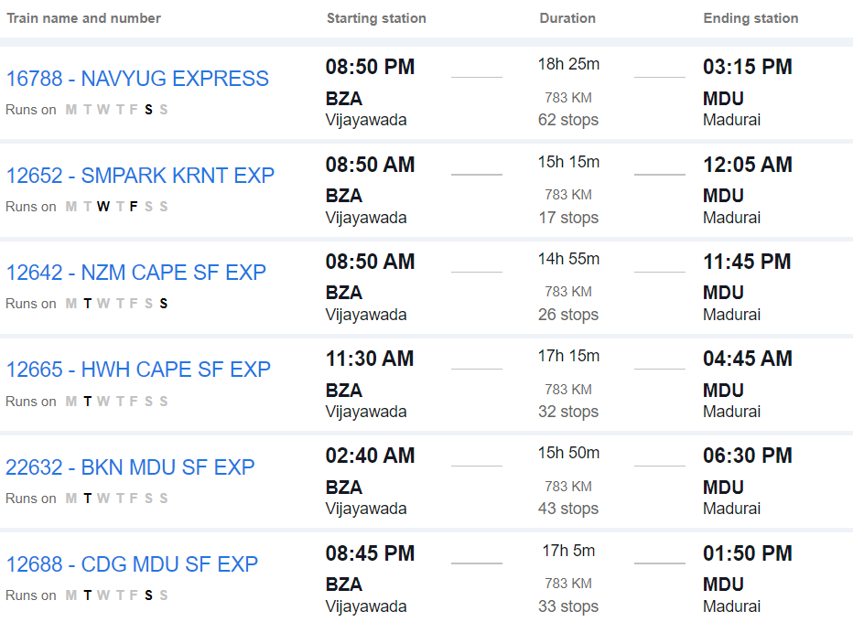

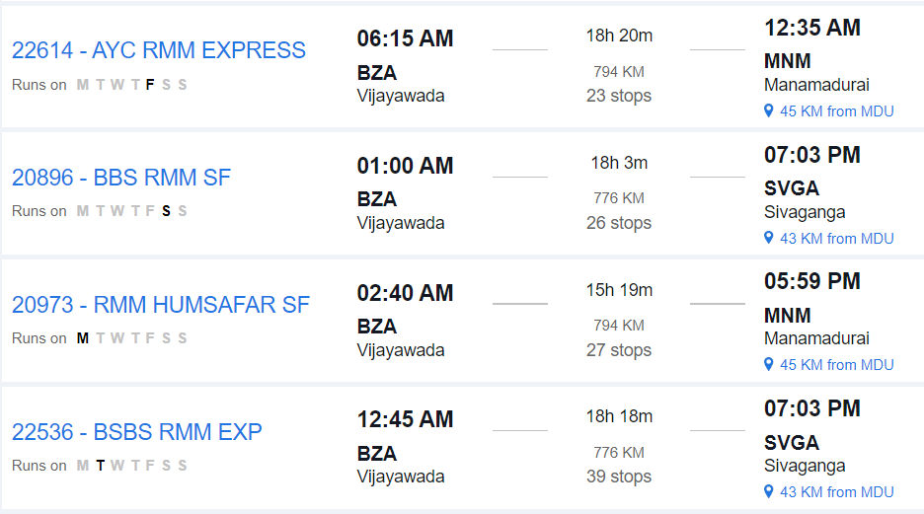

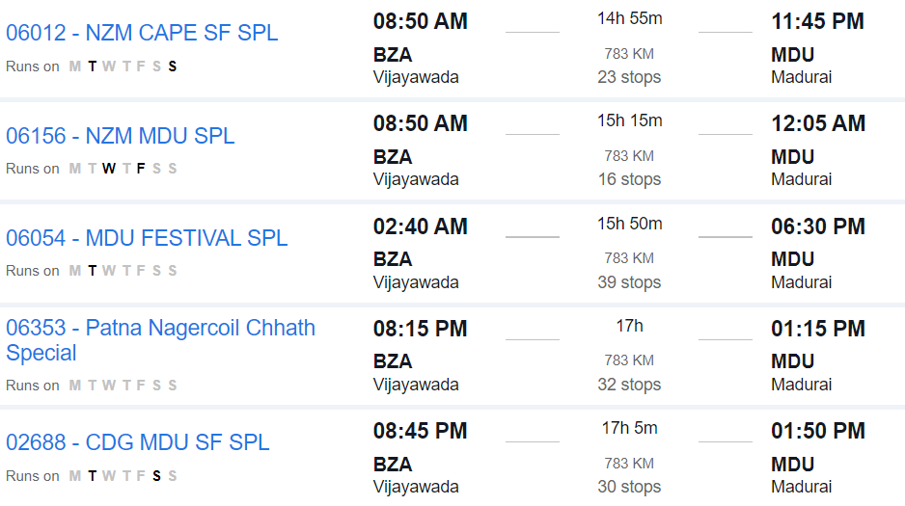

### 3. By Road:

#### Route:

- **Vijayawada to Madurai by Road**: Travel from Vijayawada to Madurai by road via National Highways and State Highways.

#### Distance:

- The road distance between Vijayawada and Madurai is approximately 850 to 900 kilometers, depending on the specific route taken.

#### Duration:

- The journey by road can take around 14 to 16 hours, depending on factors such as traffic, road conditions, and rest stops.

#### Route Options:

- You can take multiple route options, including via Hyderabad, Bengaluru, and Salem, or via Tirupati and Salem. Each route offers different scenery and road conditions.

#### Facilities:

- Along the way, you'll find various amenities such as fuel stations, restaurants, and rest areas. It's advisable to plan your journey in advance, considering necessary stops for food, rest, and refueling.

#### Considerations:

- Before embarking on a long road trip, ensure your vehicle is in good condition and carry essential documents like your driver's license, vehicle registration, and insurance.

### Conclusion:

- Depending on your preferences, budget, and time constraints, you can choose between air, train, or road travel from Vijayawada to Madurai. Each mode of transportation offers its own advantages, so consider factors such as convenience, cost, and comfort when planning your journey.