**MANALI:**

Traveling from Vijayawada to Manali involves multiple modes of transportation due to the distance and geographical location. Here's a detailed overview of each option:

### 1. By Air, Train, and Road:

#### Route:

1. **Vijayawada to Delhi by Air**: Fly from Vijayawada Airport (VGA) to Indira Gandhi International Airport (DEL) in Delhi, the capital city of India.

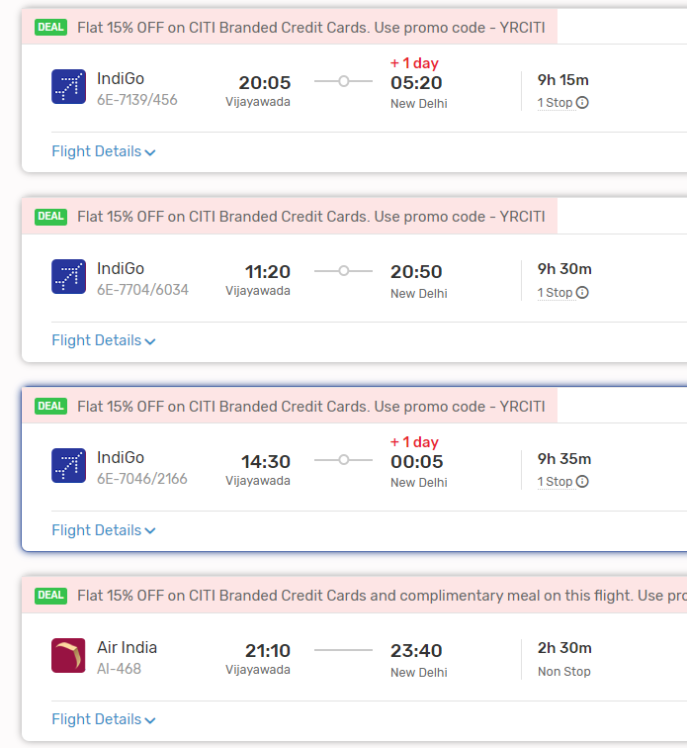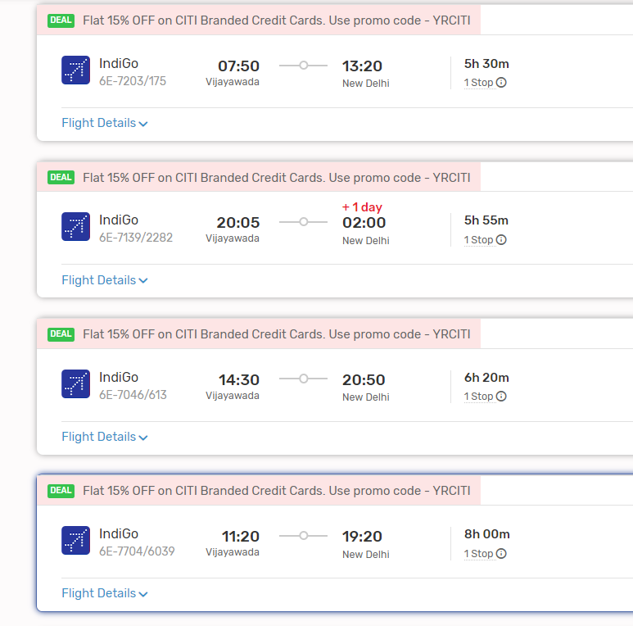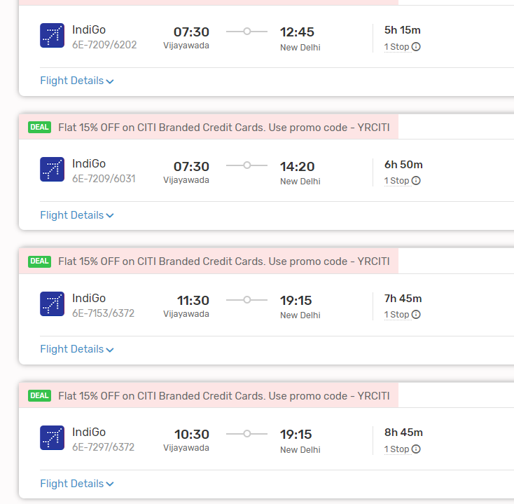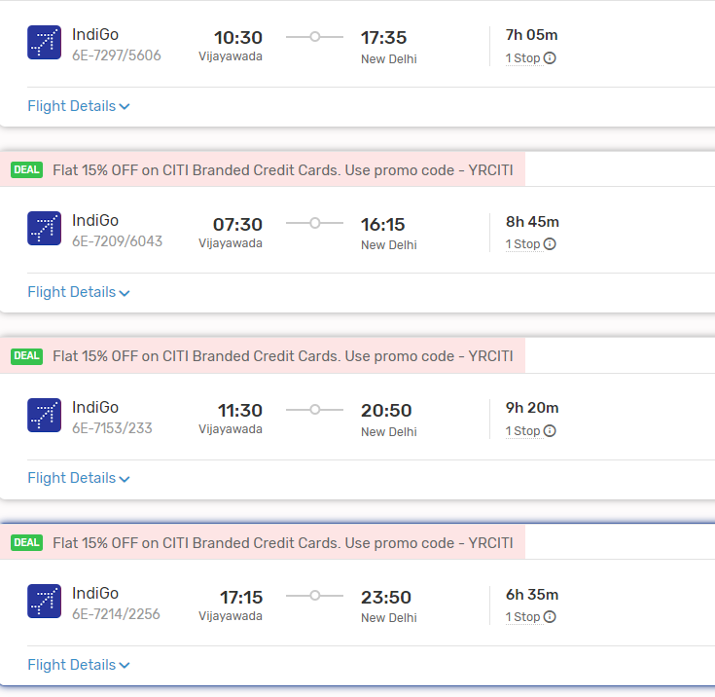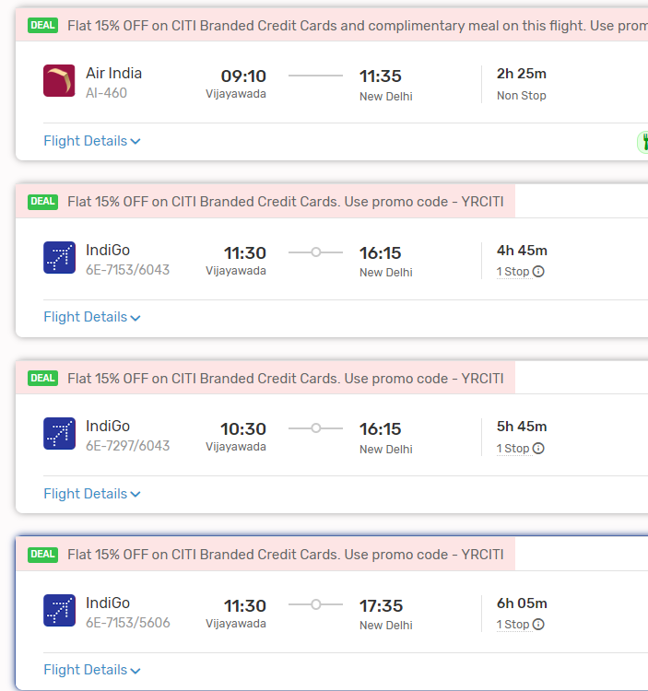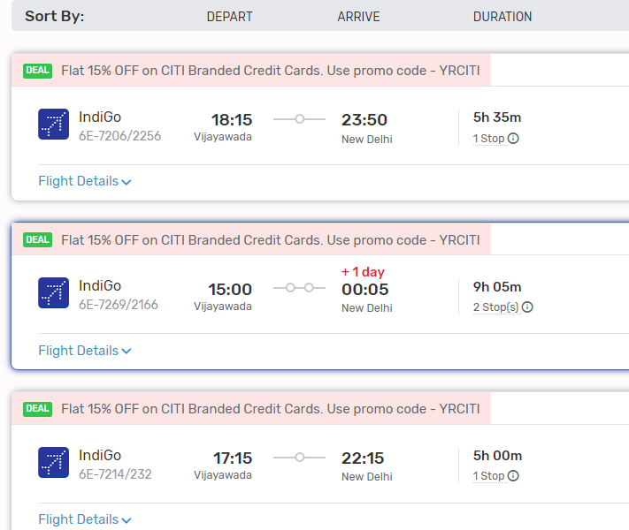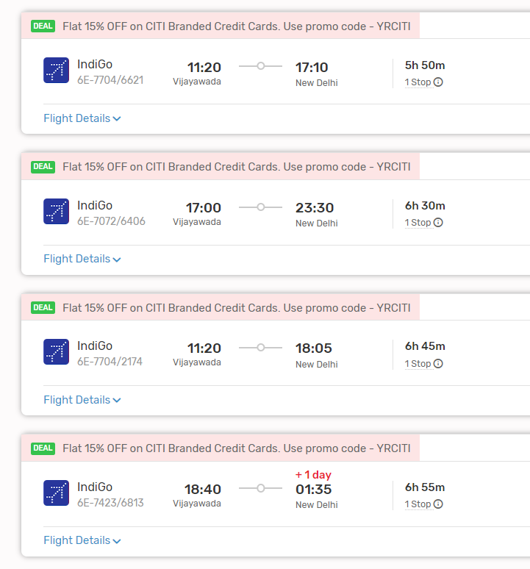

2. **Delhi to Chandigarh by Air or Train**: From Delhi, you can either fly to Chandigarh Airport (IXC) or take a train to Chandigarh Junction. Several flights and trains operate between Delhi and Chandigarh.

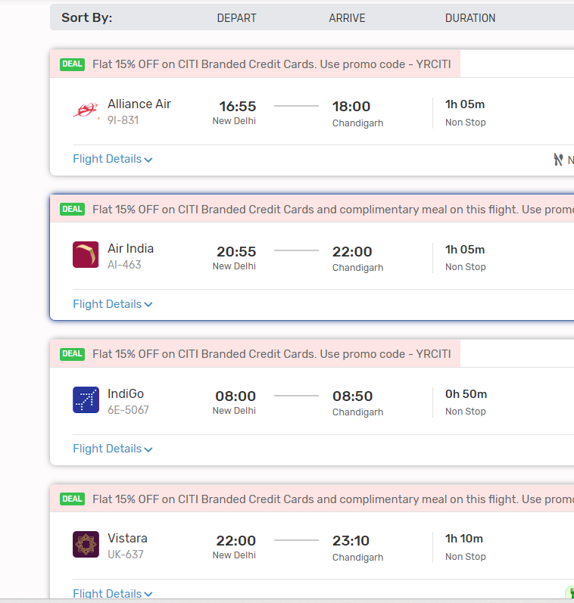

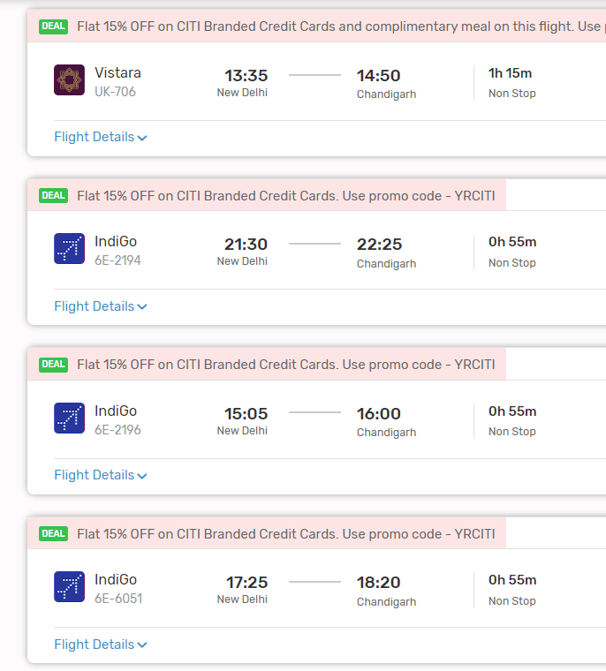

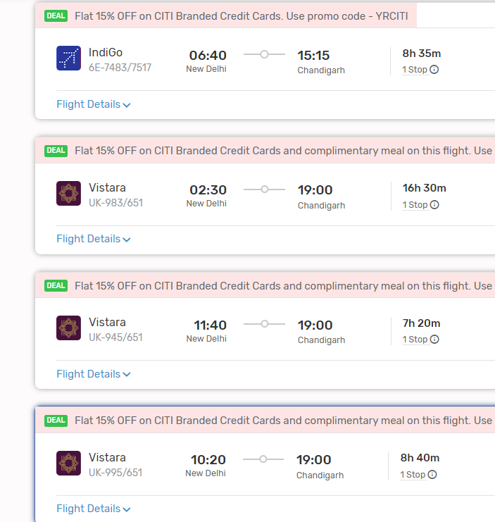

**OR**

TRAINS LIST:

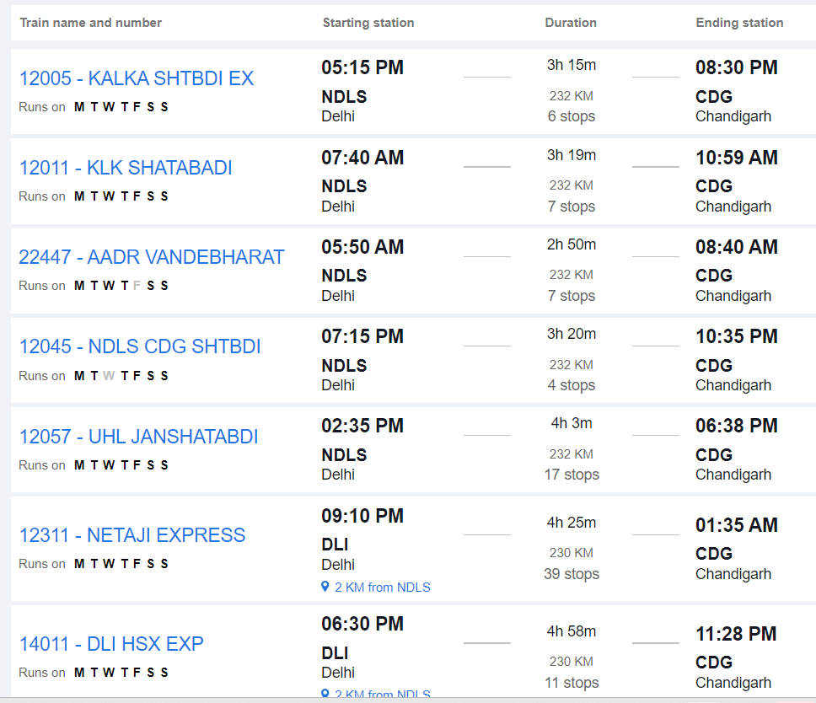

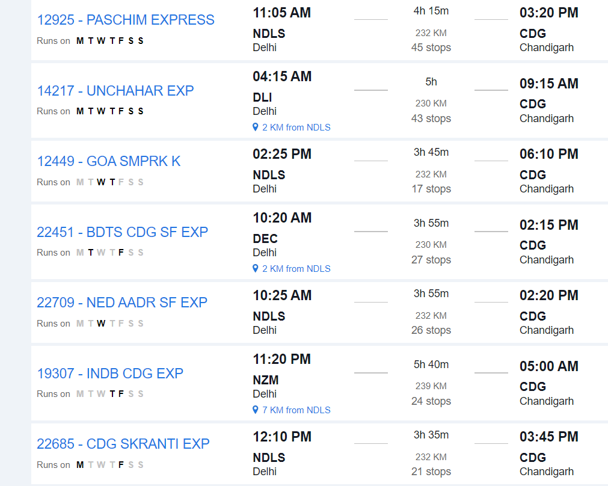

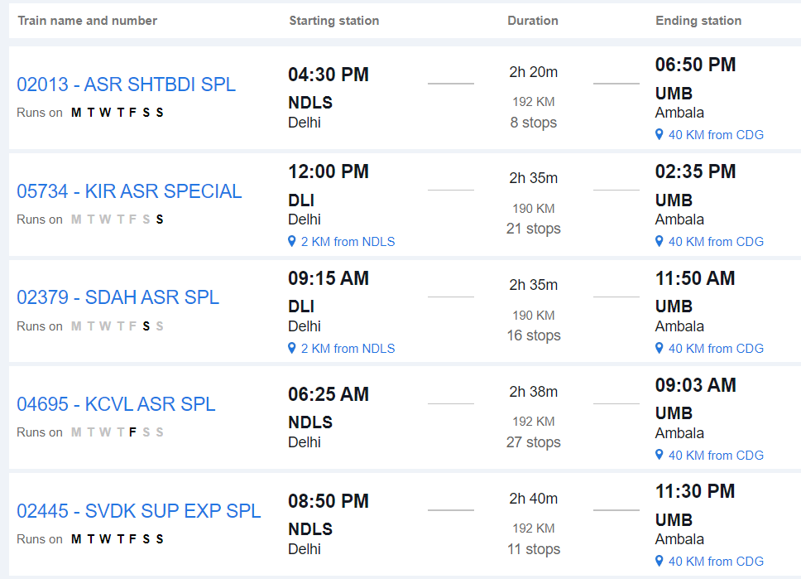

3. **Chandigarh to Manali by Road**: From Chandigarh, travel to Manali by road. Manali is approximately 300 kilometers from Chandigarh, and the road journey takes around 8 to 10 hours, depending on traffic and road conditions.

#### From Chandigarh to Manali:

- Upon reaching Chandigarh, you can hire a taxi, use app-based cab services, or take a bus to reach Manali. The road journey offers scenic views of the Himalayan mountains and valleys.

### 2. By Train and Road:

#### Route:

1. **Vijayawada to Delhi by Train**: Travel from Vijayawada Junction to New Delhi Railway Station by train. Several trains connect Vijayawada to New Delhi, including express and superfast trains.

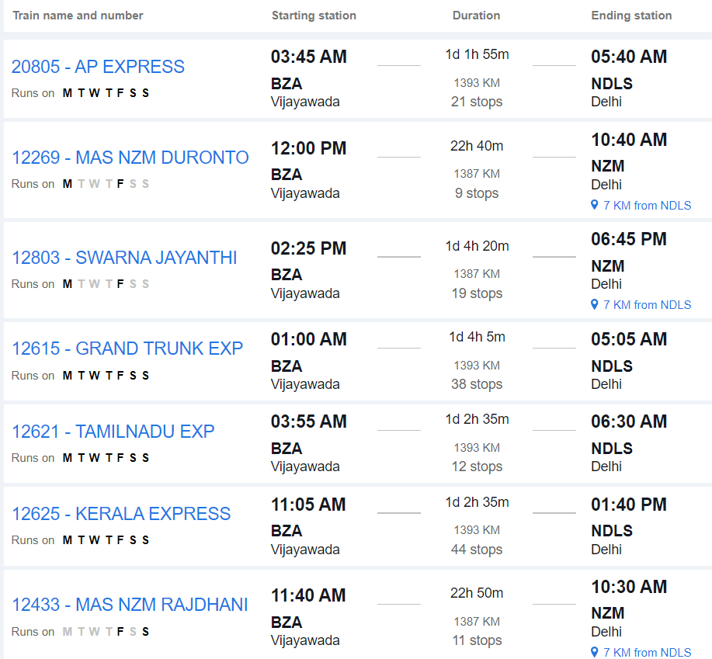

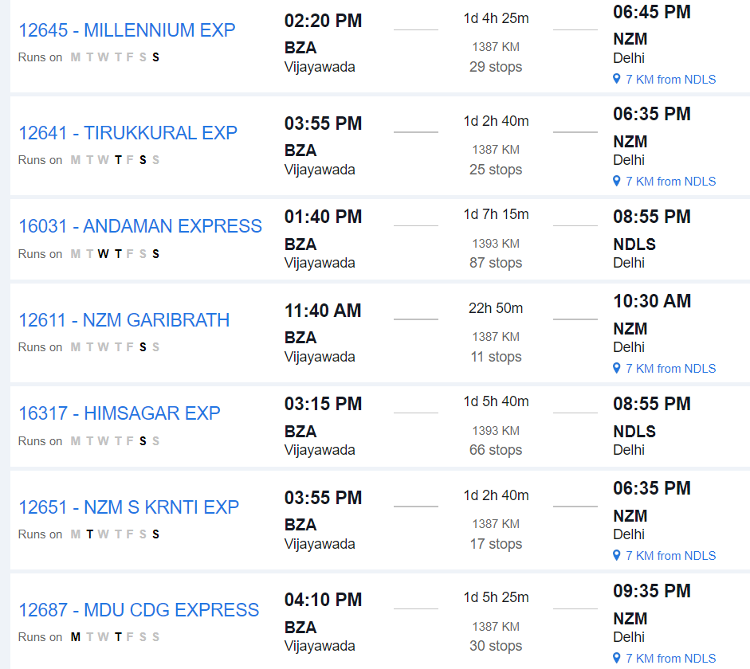

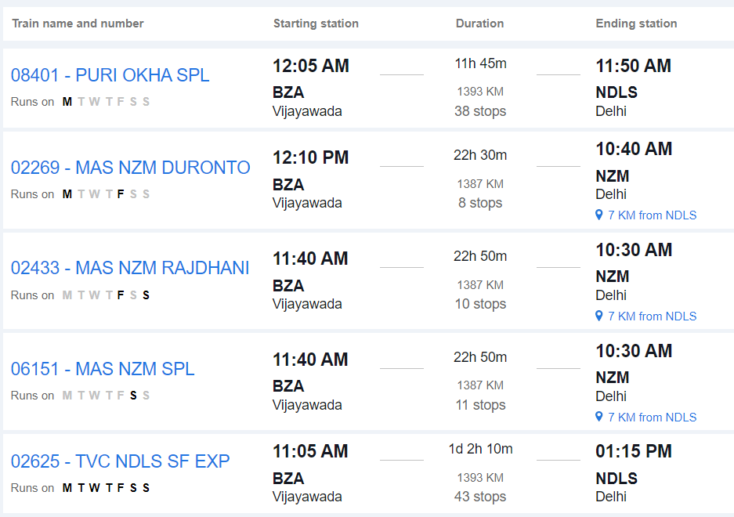

2. **Delhi to Chandigarh by Train or Road**: From Delhi, you can either take a train to Chandigarh Junction or travel by road to Chandigarh. The road distance between Delhi and Chandigarh is approximately 250 kilometers, and the journey takes around 5 to 6 hours by car or bus.







3. **Chandigarh to Manali by Road**: From Chandigarh, travel to Manali by road, as described in the previous section.

#### From Chandigarh to Manali:

- Upon reaching Chandigarh, you can hire a taxi, use app-based cab services, or take a bus to reach Manali.

### 3. By Road Only:

#### Route:

- **Vijayawada to Manali by Road**: Travel directly from Vijayawada to Manali by road via National Highways and State Highways.

#### Distance:

- The road distance between Vijayawada and Manali is approximately 2,000 to 2,100 kilometers, depending on the specific route taken.

#### Duration:

- The journey by road can take around 35 to 40 hours, depending on factors such as traffic, road conditions, and rest stops.

#### Route Options:

- You can take multiple route options, including via Delhi, Chandigarh, and Mandi, or via Hyderabad, Nagpur, and Chandigarh. Each route offers different scenery and road conditions.

#### Facilities:

- Along the way, you'll find various amenities such as fuel stations, restaurants, and rest areas. It's advisable to plan your journey in advance, considering necessary stops for food, rest, and refueling.

#### Considerations:

- Before embarking on a long road trip, ensure your vehicle is in good condition and carry essential documents like your driver's license, vehicle registration, and insurance.

### Conclusion:

- Depending on your preferences, budget, and time constraints, you can choose between air, train, and road travel or a combination of these modes to reach Manali from Vijayawada. Each mode of transportation offers its own advantages, so consider factors such as convenience, cost, and comfort when planning your journey.