**MUNNAR:**Certainly! Here's detailed information on three common ways to travel from Vijayawada to Munnar:

### 1. By Train, Bus, and Taxi:

#### Route:

1. **Vijayawada to Ernakulam by Train**: Take a train from Vijayawada to Ernakulam, which is one of the major railway stations in Kerala.

2. **Ernakulam to Munnar by Bus**: From Ernakulam, take a state-run or private bus to Munnar. The bus journey takes approximately 4 to 5 hours, depending on traffic and road conditions.

3. **Munnar Bus Stand to Your Destination by Taxi**: Upon reaching Munnar, you can hire a taxi or use local transportation to reach your accommodation or desired locations within Munnar.

#### From Ernakulam to Munnar:

- Several buses operate from Ernakulam to Munnar at regular intervals throughout the day. You can check the bus schedule and availability at the Ernakulam bus station.

###List Of Trains Available:

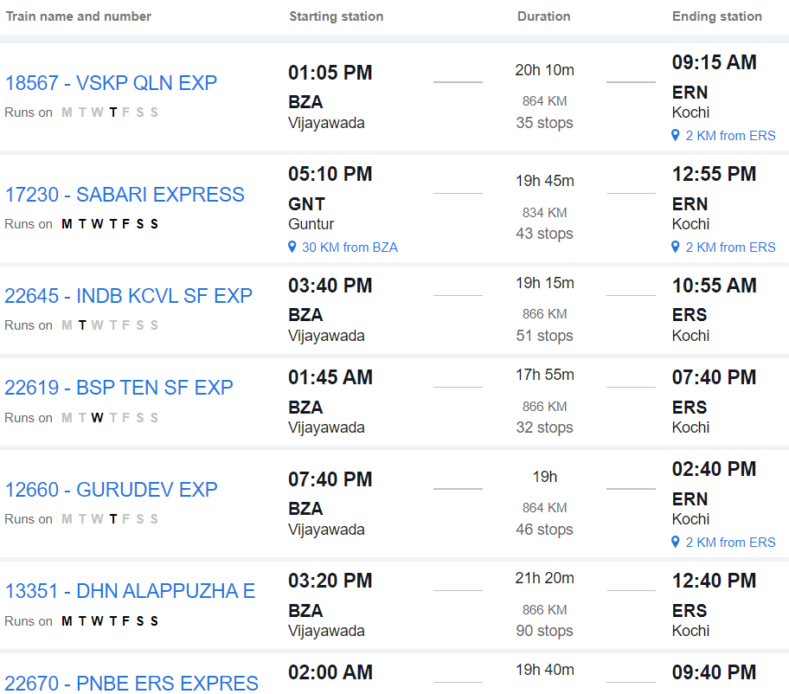

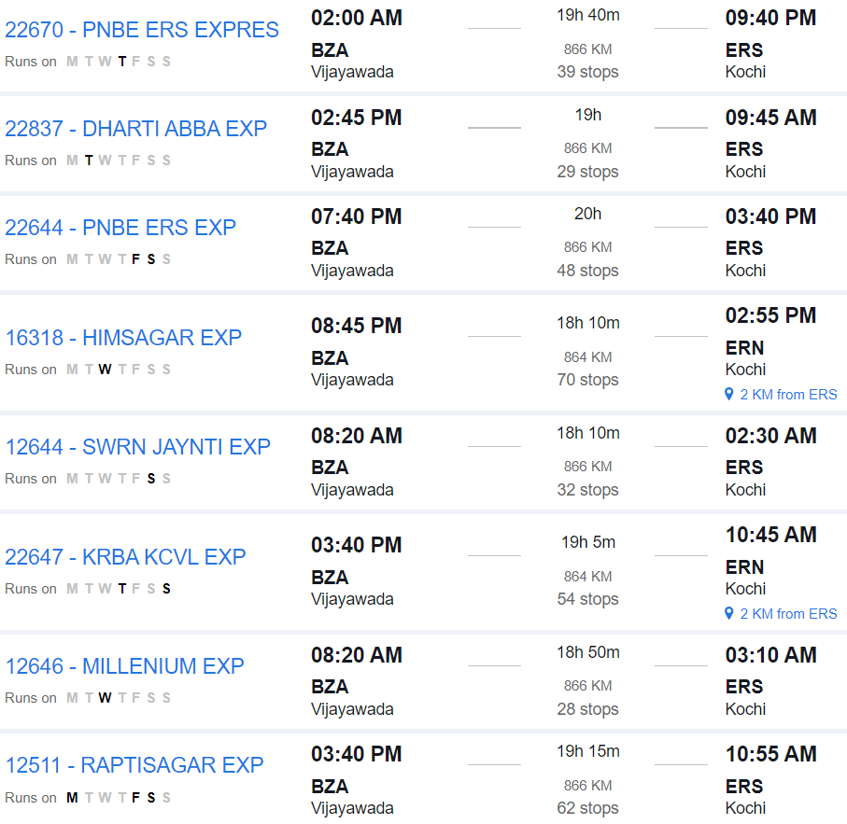

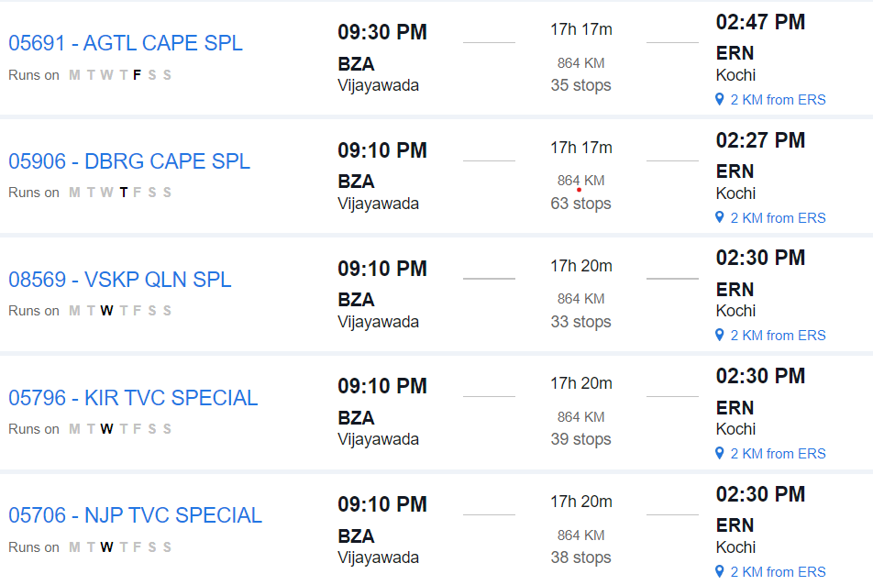

### 2. By Road:

#### Route:

- **Vijayawada to Munnar by Road**: Travel directly from Vijayawada to Munnar by road. This route involves traveling via National Highways and State Highways.

#### Distance:

- The road distance between Vijayawada and Munnar is approximately 1,200 to 1,300 kilometers, depending on the specific route taken.

#### Duration:

- The journey by road can take around 20 to 24 hours, depending on factors such as traffic, road conditions, and rest stops.

#### Route Options:

- You can take multiple route options, including via Bengaluru, Salem, and Coimbatore, or via Hyderabad, Bengaluru, and Salem. Each route offers different scenery and road conditions.

#### Facilities:

- Along the way, you'll find various amenities such as fuel stations, restaurants, and rest areas. It's advisable to plan your journey in advance, considering necessary stops for food, rest, and refueling.

#### Considerations:

- Before embarking on a long road trip, ensure your vehicle is in good condition and carry essential documents like your driver's license, vehicle registration, and insurance.

### 3. By Air and Taxi:

#### Route:

1. **Vijayawada to Cochin by Air**: Fly from Vijayawada to Cochin (Kochi), which has an international airport.

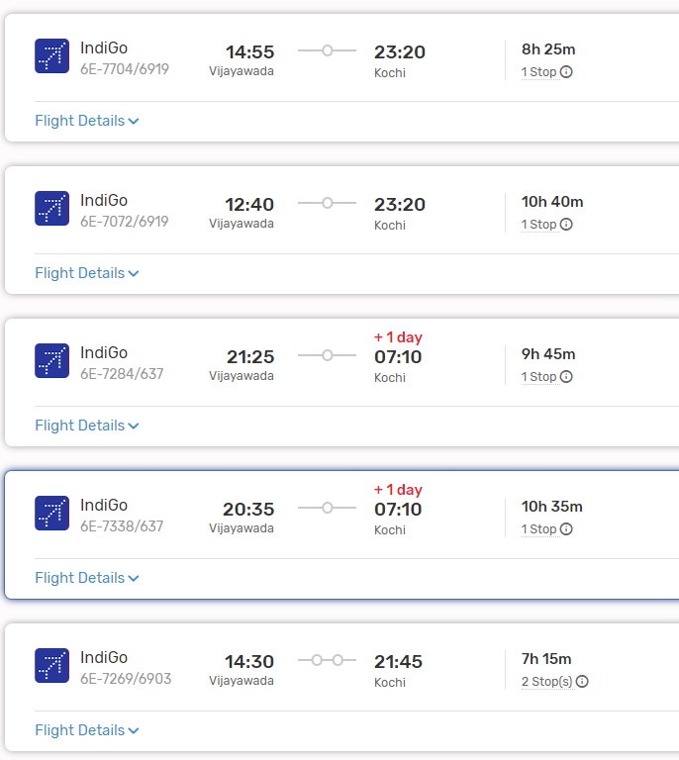

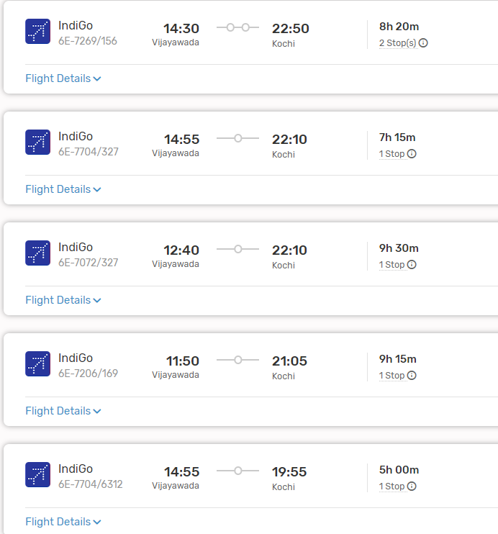

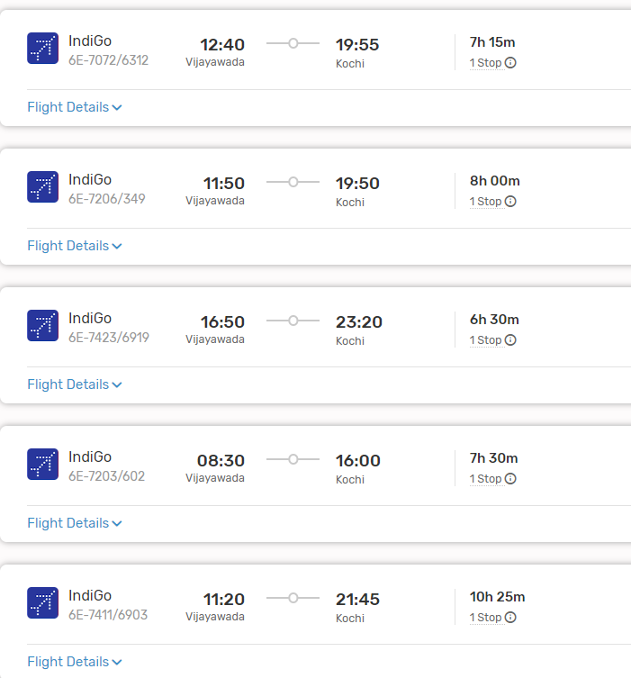

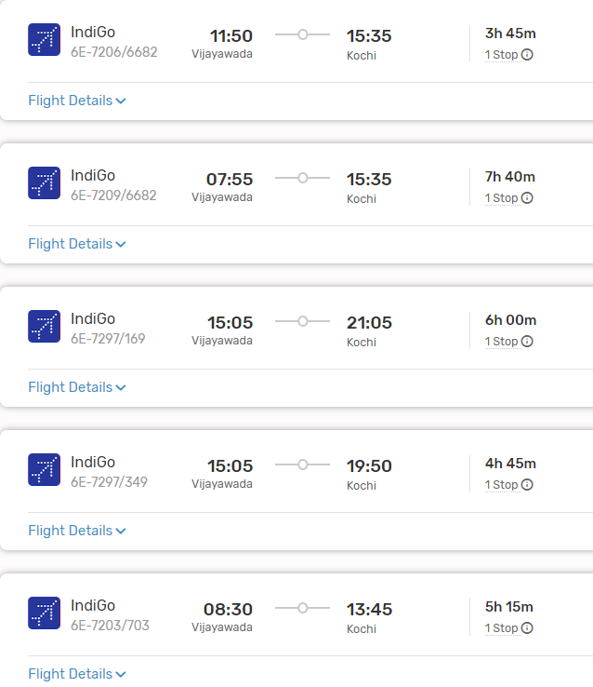

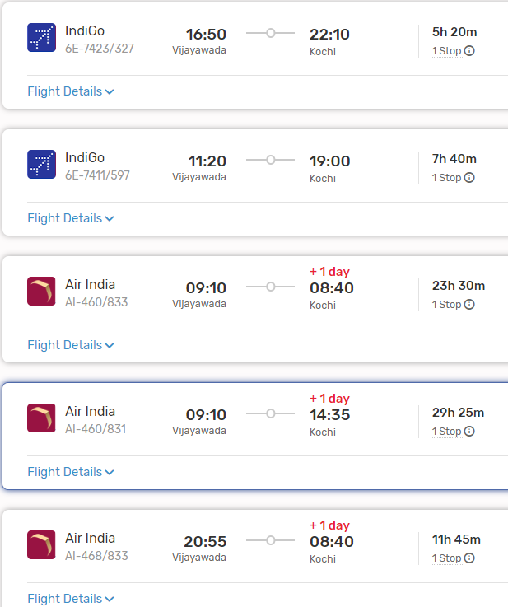

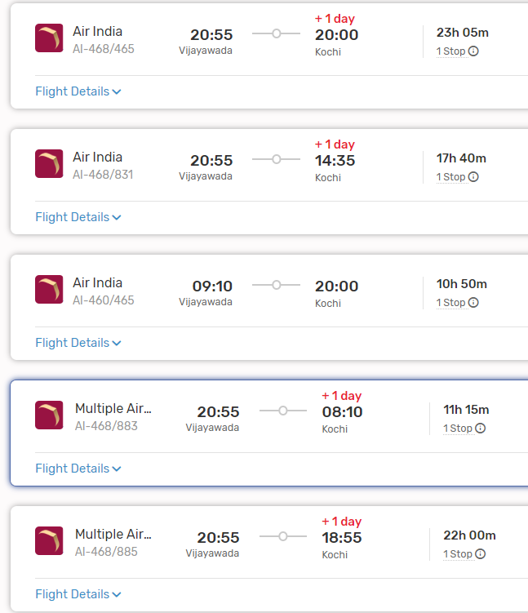

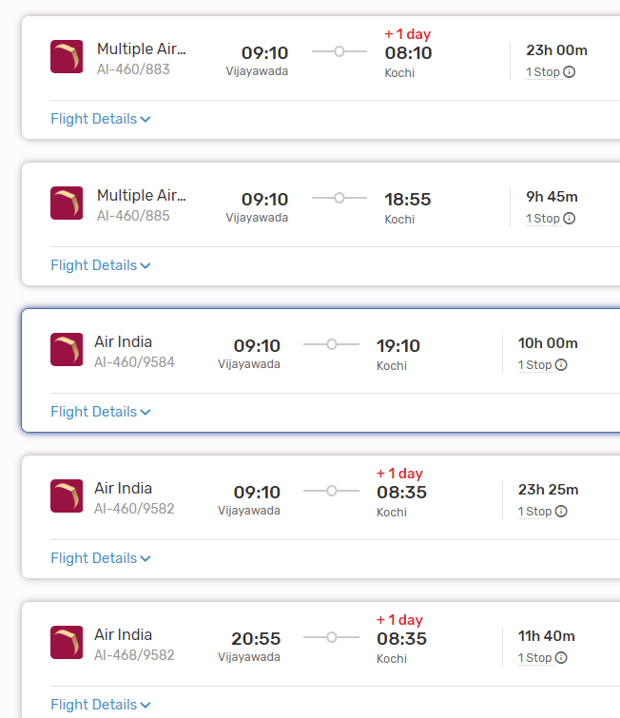

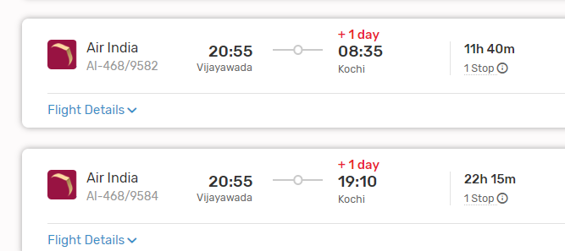

2. **Cochin Airport to Munnar by Taxi**: From Cochin, hire a taxi or use pre-booked car rental services to travel to Munnar. The road journey takes approximately 4 to 5 hours, depending on traffic and road conditions.

#### From Cochin to Munnar:

- Cochin is the nearest major airport to Munnar. Upon reaching Cochin, you can hire a taxi or use pre-booked car rental services to travel to Munnar.

### Conclusion:

- Depending on your preferences, budget, and time constraints, you can choose between train and bus travel, direct road travel, or air and taxi travel from Vijayawada to Munnar. Each mode of transportation offers its own advantages, so consider factors such as convenience, cost, and comfort when planning your journey.