OOTY (UDAGAMANDALAM):

Certainly! Here's detailed information on three common ways to travel from Vijayawada to Ooty:

### 1. By Train and Road:

#### Route:

1. **Vijayawada to Coimbatore by Train**: Take a train from Vijayawada to Coimbatore, which is a major railway junction in Tamil Nadu.

2. **Coimbatore to Ooty by Road**: From Coimbatore, travel to Ooty by road. Ooty is approximately 85 kilometers away from Coimbatore, and the road journey takes around 3 to 4 hours, depending on the mode of transport and road conditions.

#### From Coimbatore to Ooty:

- You can hire a taxi, take a bus, or drive your own vehicle from Coimbatore to Ooty. The road to Ooty from Coimbatore passes through scenic landscapes and hills, offering picturesque views along the way.

#### Facilities:

- Coimbatore is well-connected by train from Vijayawada, and there are numerous options for transportation from Coimbatore to Ooty, including taxis, buses, and private vehicles.

###ListOf Trains available:

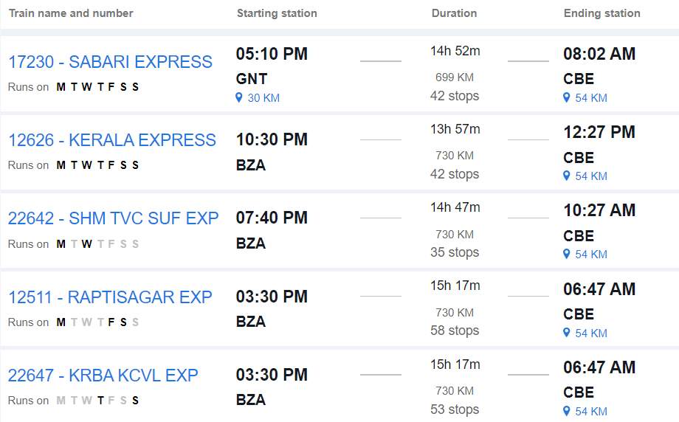

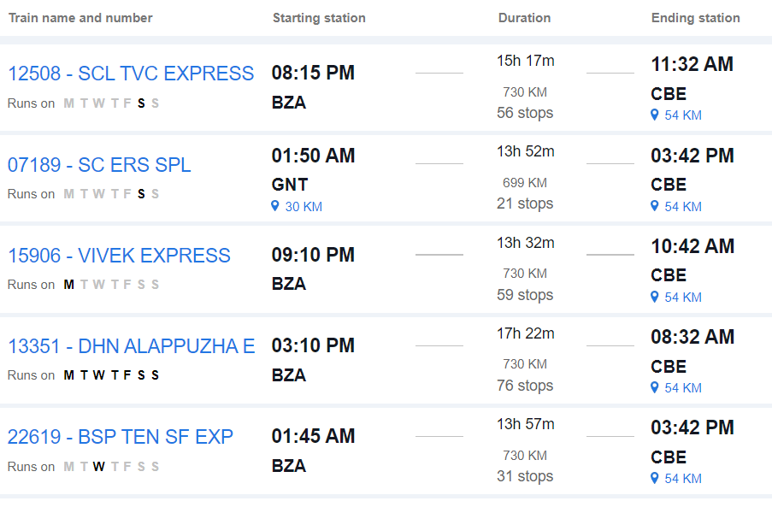

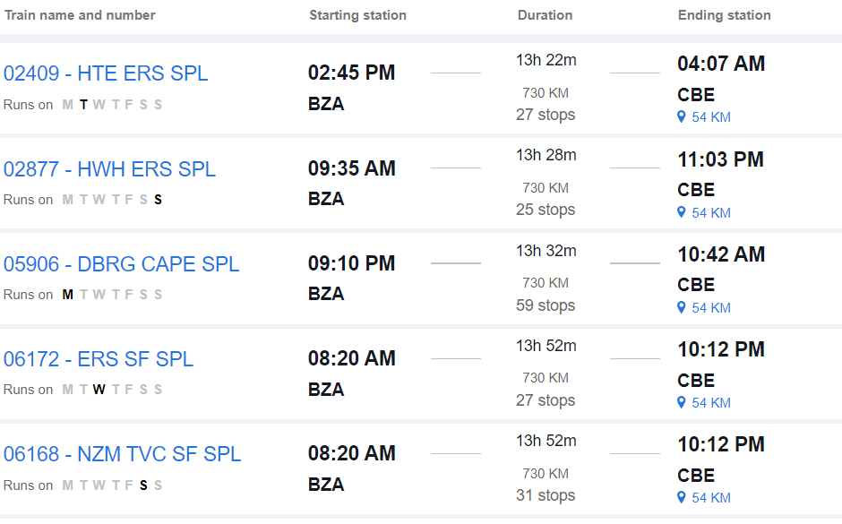

### 2. By Road:

#### Route:

- **Vijayawada to Ooty by Road**: Travel directly from Vijayawada to Ooty by road. This route involves traveling via National Highways and State Highways.

#### Distance:

- The road distance between Vijayawada and Ooty is approximately 950 to 1,000 kilometers, depending on the specific route taken.

#### Duration:

- The journey by road can take around 18 to 20 hours, depending on factors such as traffic, road conditions, and rest stops.

#### Route Options:

- You can take multiple route options, including via Bengaluru or via Salem and Coimbatore. Each route offers different scenery and road conditions.

#### Facilities:

- Along the way, you'll find various amenities such as fuel stations, restaurants, and rest areas. It's advisable to plan your journey in advance, considering necessary stops for food, rest, and refueling.

#### Considerations:

- Before embarking on a long road trip, ensure your vehicle is in good condition and carry essential documents like your driver's license, vehicle registration, and insurance.

### 3. By Air and Road:

#### Route:

1. **Vijayawada to Coimbatore by Air**: Fly from Vijayawada to Coimbatore, which has an airport with regular flight services

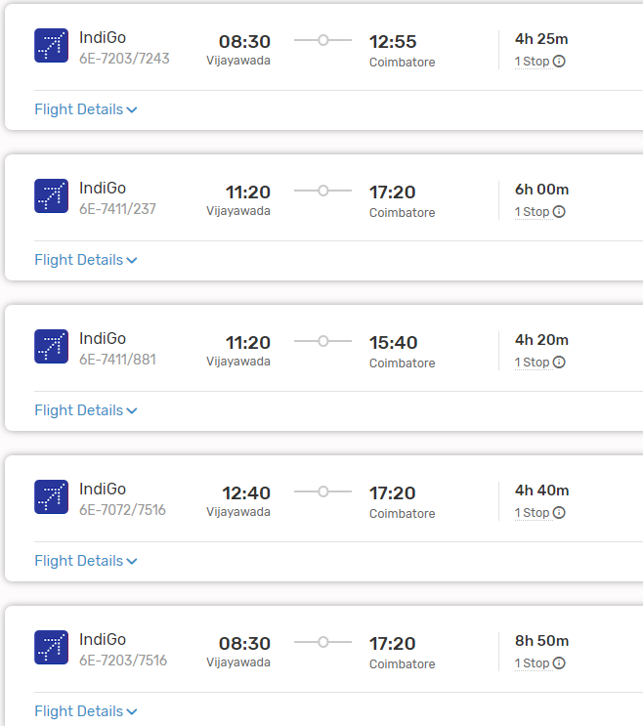

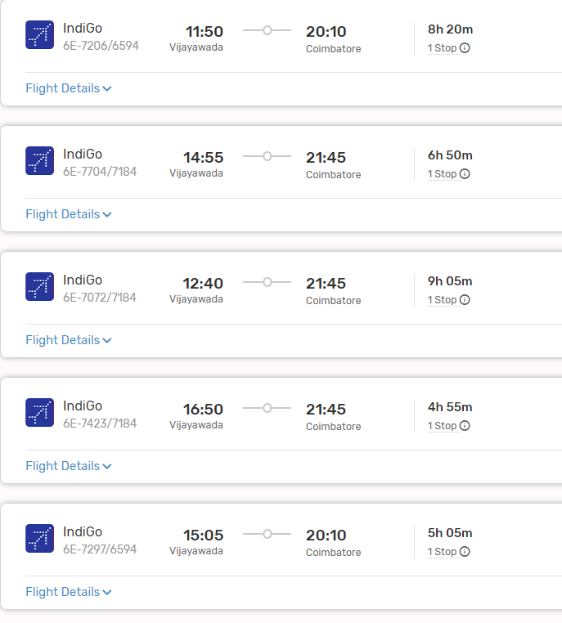

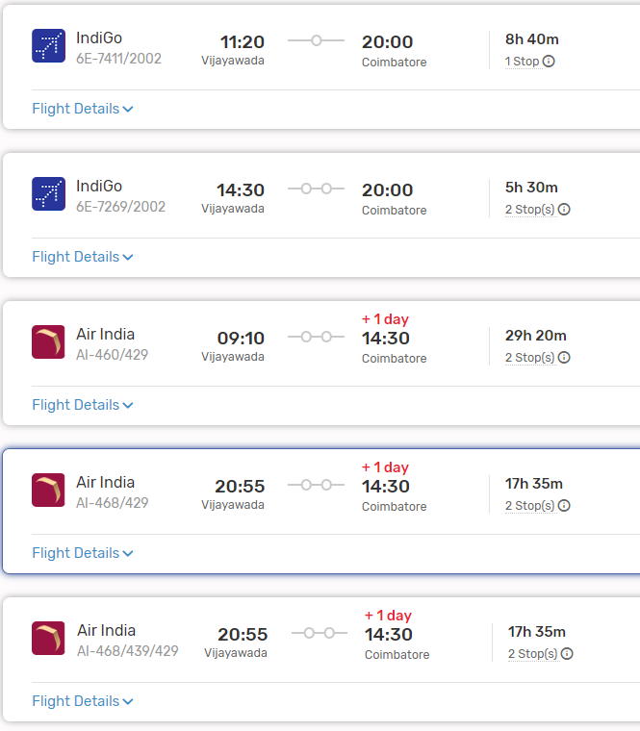

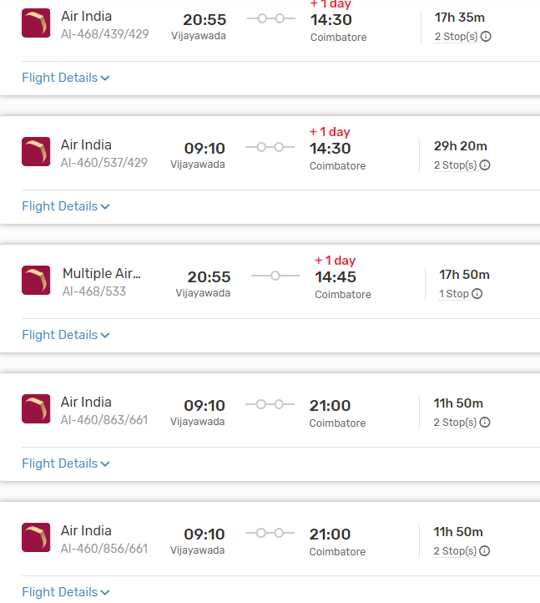

2. **Coimbatore to Ooty by Road**: From Coimbatore, travel to Ooty by road as described in the first option.

#### From Coimbatore to Ooty:

- Follow the same transportation options as described in the first option.

#### Facilities:

- Flying from Vijayawada to Coimbatore offers a faster mode of transportation, and Coimbatore is well-connected by road to Ooty.

### Conclusion:

- Depending on your preferences, budget, and time constraints, you can choose between train and road travel, direct road travel, or air and road travel from Vijayawada to Ooty. Each mode of transportation offers its own advantages, so consider factors such as convenience, cost, and comfort when planning your journey.