**PONDICHERRY**:

Sure, here's detailed information on three common ways to travel from Vijayawada to Pondicherry:

### 1. By Train and Road:

#### Route:

1. **Vijayawada to Villupuram by Train**: Take a train from Vijayawada Junction to Villupuram Junction, which is one of the major railway stations near Pondicherry. Several trains connect Vijayawada to Villupuram Junction, including express and superfast trains.

2. **Villupuram to Pondicherry by Road**: From Villupuram, travel to Pondicherry by road. Pondicherry is located approximately 38 kilometers from Villupuram, and the road journey takes around 1 hour, depending on traffic and mode of transport.

#### From Villupuram to Pondicherry:

- Upon reaching Villupuram, you can hire a taxi, use app-based cab services, or take local buses to reach Pondicherry.

#### List Of Trains Available:

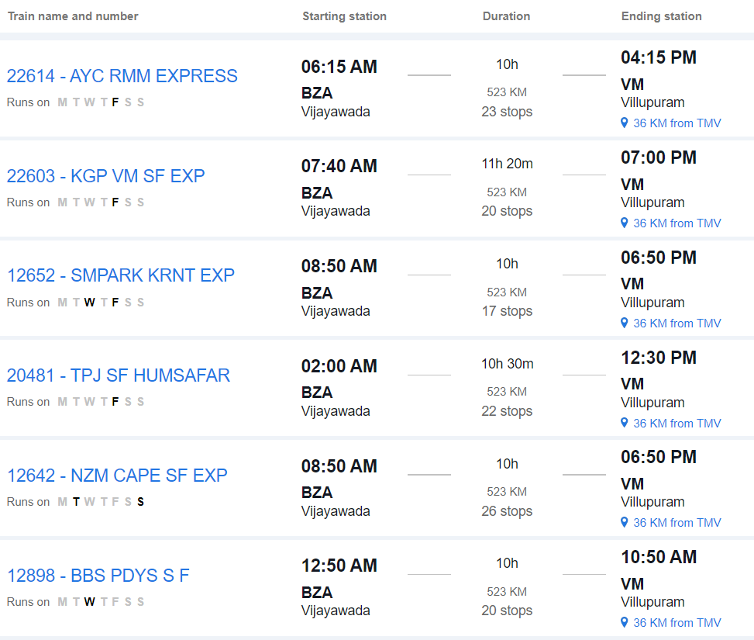

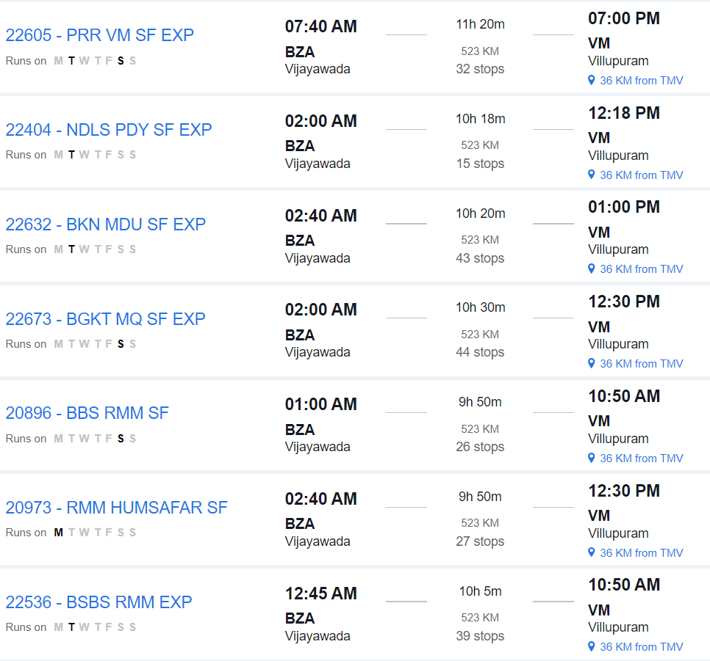

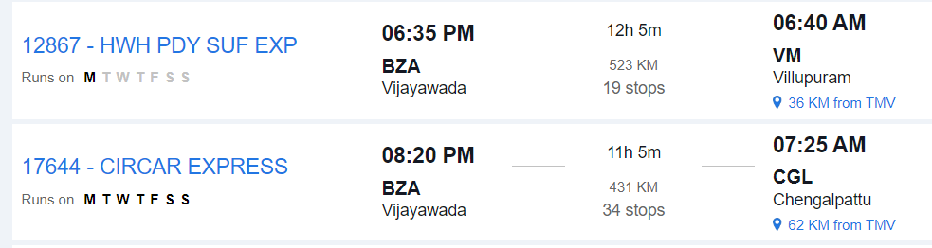

### 2. By Road:

#### Route:

- **Vijayawada to Pondicherry by Road**: Travel directly from Vijayawada to Pondicherry by road via National Highways and State Highways.

#### Distance:

- The road distance between Vijayawada and Pondicherry is approximately 620 to 650 kilometers, depending on the specific route taken.

#### Duration:

- The journey by road can take around 10 to 12 hours, depending on factors such as traffic, road conditions, and rest stops.

#### Route Options:

- You can take multiple route options, including via Chennai or via Nellore and Tindivanam. Each route offers different scenery and road conditions.

#### Facilities:

- Along the way, you'll find various amenities such as fuel stations, restaurants, and rest areas. It's advisable to plan your journey in advance, considering necessary stops for food, rest, and refueling.

#### Considerations:

- Before embarking on a long road trip, ensure your vehicle is in good condition and carry essential documents like your driver's license, vehicle registration, and insurance.

### 3. By Air and Road:

#### Route:

1. **Vijayawada to Chennai by Air**: Fly from Vijayawada Airport (VGA) to Chennai Airport (MAA).

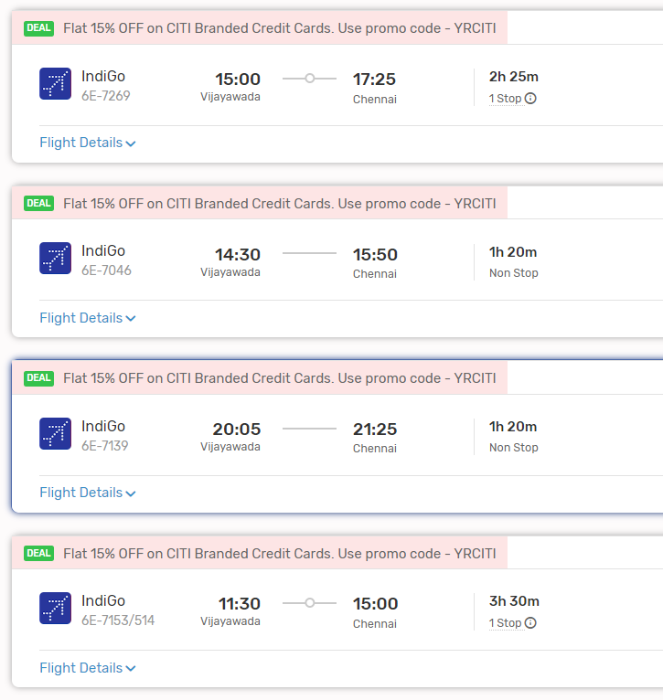

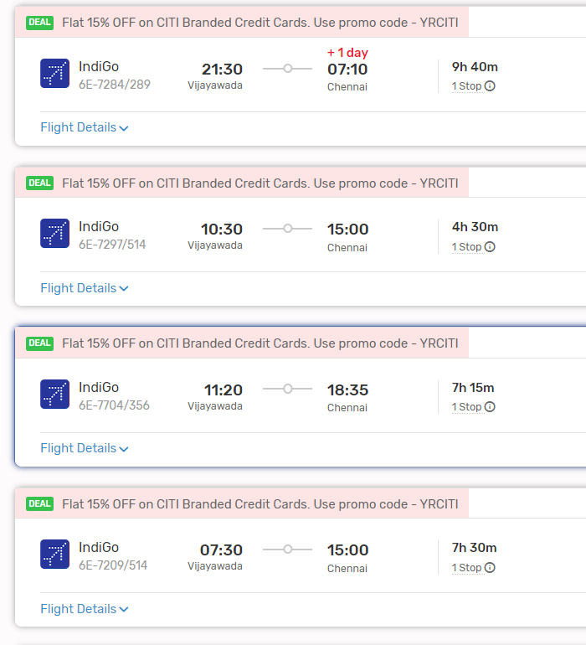

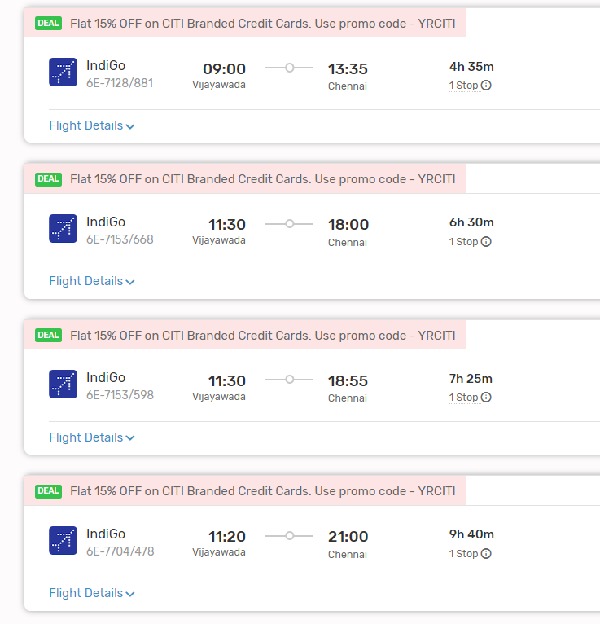

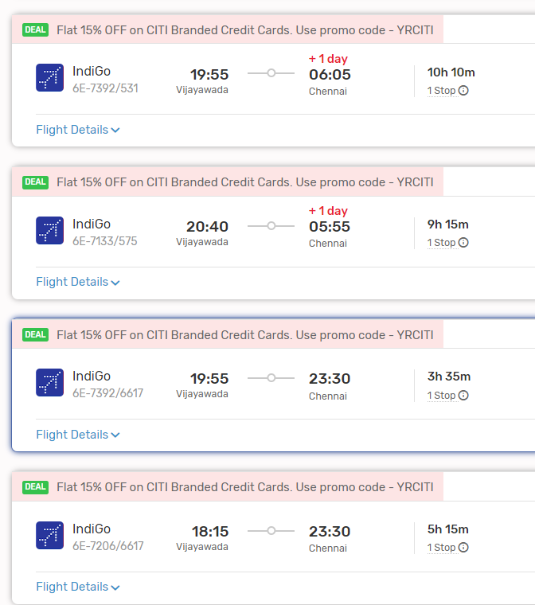

2. **Chennai to Pondicherry by Road**: From Chennai, travel to Pondicherry by road. Pondicherry is located approximately 160 kilometers from Chennai, and the road journey takes around 3 to 4 hours, depending on traffic and mode of transport.

#### From Chennai to Pondicherry:

- Upon reaching Chennai, you can hire a taxi, use app-based cab services, or take local buses to reach Pondicherry.

### Conclusion:

- Depending on your preferences, budget, and time constraints, you can choose between train and road travel, direct road travel, or air and road travel from Vijayawada to Pondicherry. Each mode of transportation offers its own advantages, so consider factors such as convenience, cost, and comfort when planning your journey.