**PURI**:

Certainly! Here's detailed information on three common ways to travel from Vijayawada to Puri:

### 1. By Train:

#### Route:

- **Vijayawada to Puri by Train**: Several trains connect Vijayawada to Puri. You can check the Indian Railways website or use other online platforms to find suitable train options based on your travel dates and preferences.

#### Duration:

- The duration of the train journey from Vijayawada to Puri can vary depending on the chosen train and any layovers. It can take anywhere from 15 to 20 hours to reach Puri by train.

#### Facilities:

- Trains offer various classes of travel, including Sleeper Class, AC 3 Tier, AC 2 Tier, and First Class, allowing passengers to choose according to their comfort and budget.

#### From Puri Railway Station to Your Destination:

- Puri Railway Station is well-connected to different parts of the city. Upon arrival, you can hire a taxi, use app-based cab services, or take local buses to reach your desired destination within Puri.

###List Of Trains Available:

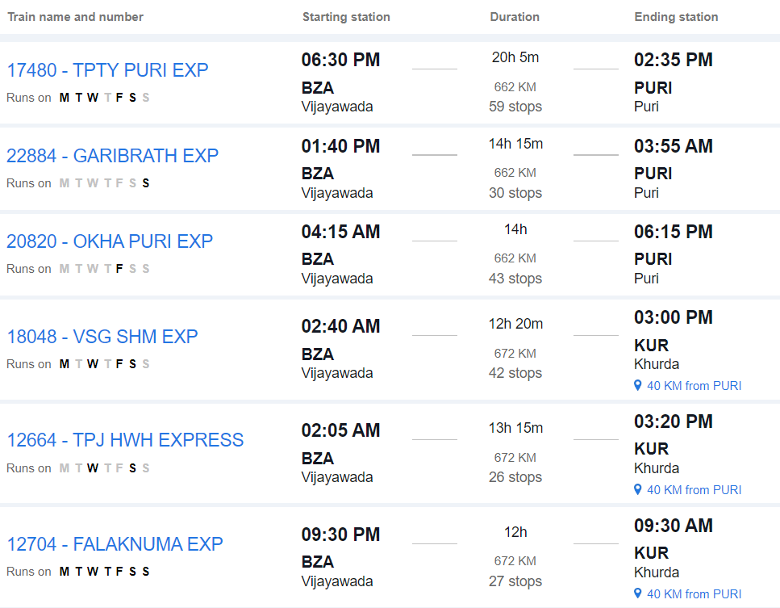

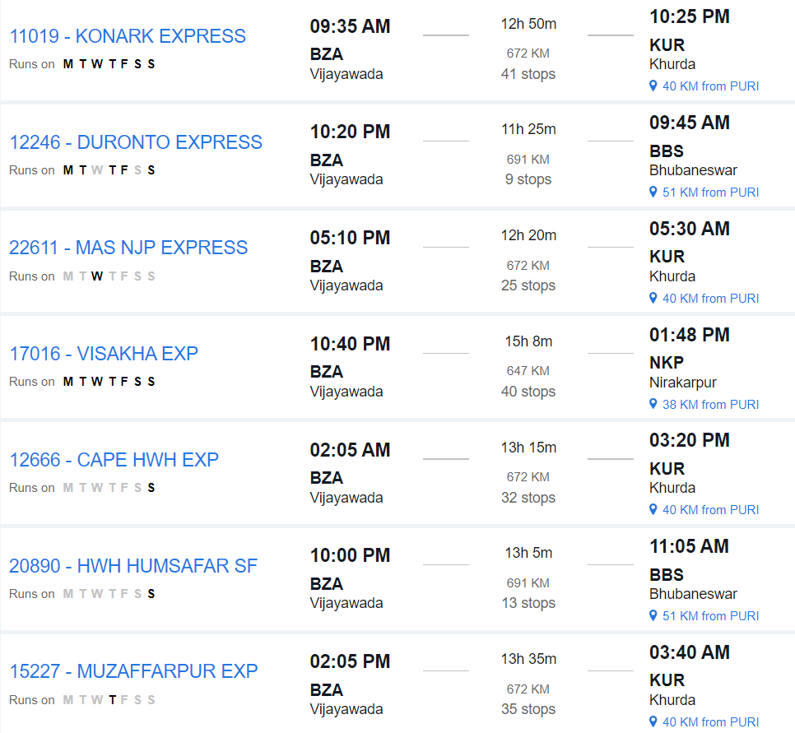

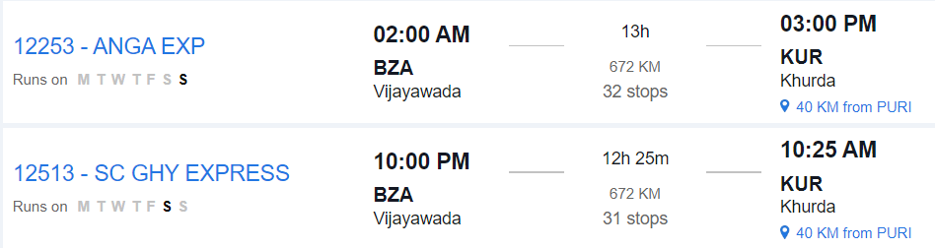

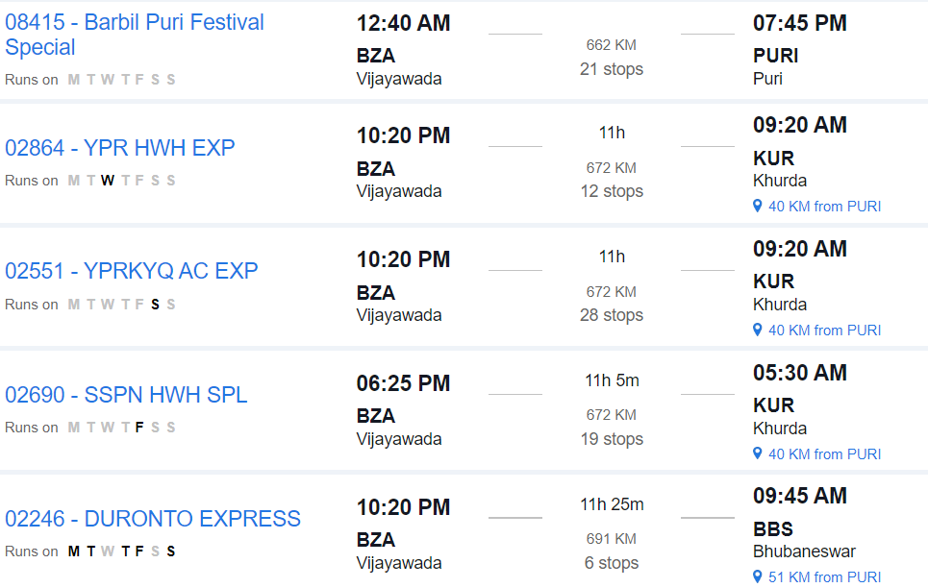

### 2. By Road:

#### Route:

- **Vijayawada to Puri by Road**: Travel from Vijayawada to Puri by road via National Highways and State Highways.

#### Distance:

- The road distance between Vijayawada and Puri is approximately 880 to 930 kilometers, depending on the specific route taken.

#### Duration:

- The journey by road can take around 16 to 18 hours, depending on factors such as traffic, road conditions, and rest stops.

#### Route Options:

- You can take multiple route options, including via Visakhapatnam and Bhubaneswar, or via Cuttack and Bhubaneswar. Each route offers different scenery and road conditions.

#### Facilities:

- Along the way, you'll find various amenities such as fuel stations, restaurants, and rest areas. It's advisable to plan your journey in advance, considering necessary stops for food, rest, and refueling.

#### Considerations:

- Before embarking on a long road trip, ensure your vehicle is in good condition and carry essential documents like your driver's license, vehicle registration, and insurance.

### 3. By Air and Taxi:

#### Route:

1. **Vijayawada to Bhubaneswar by Air**: Fly from Vijayawada Airport (VGA) to Bhubaneswar Airport (BBI).

1. **Bhubaneswar to Puri by Taxi**: From Bhubaneswar, hire a taxi or use pre-booked car rental services to travel to Puri. The road journey takes approximately 2 to 3 hours, depending on traffic and road conditions

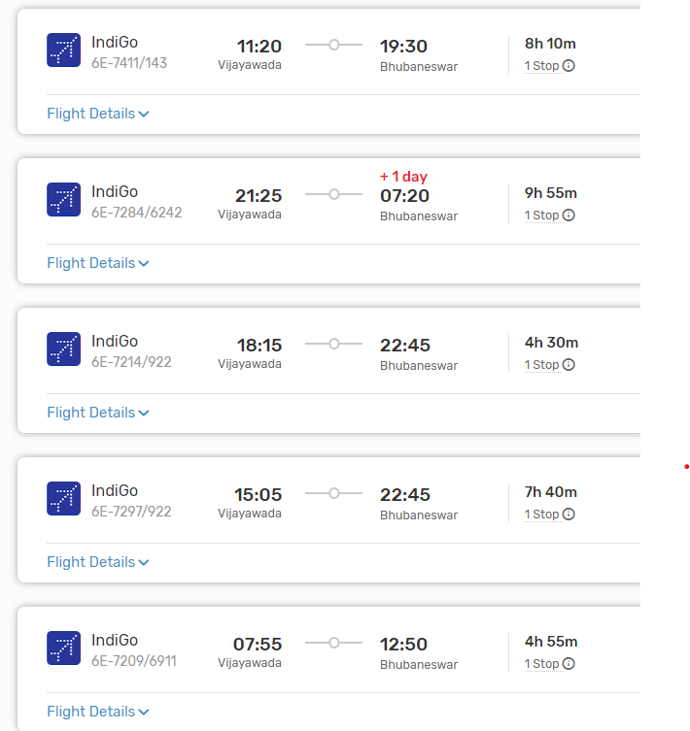

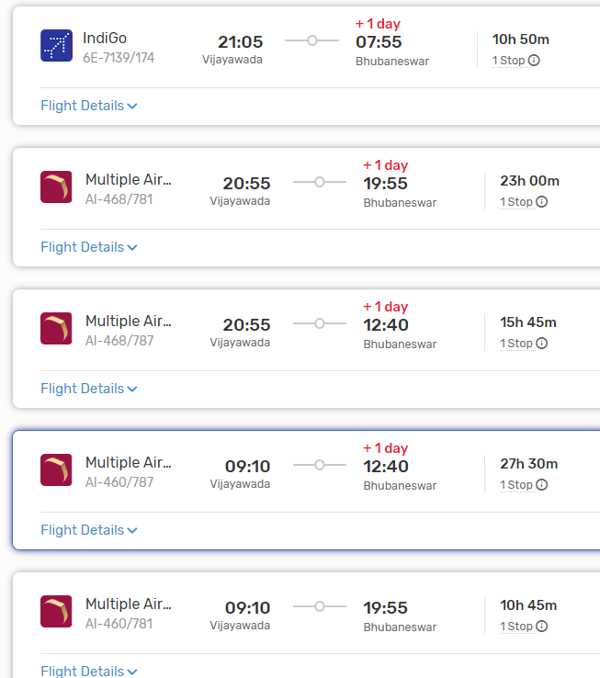

#### From Puri:

- Upon reaching Puri, you can hire a taxi, use app-based cab services, or take local buses to reach your accommodation or desired locations within Puri.

### Conclusion:

- Depending on your preferences, budget, and time constraints, you can choose between train, road, or air and taxi travel from Vijayawada to Puri. Each mode of transportation offers its own advantages, so consider factors such as convenience, cost, and comfort when planning your journey.