**SHIMLA:**

Reaching Shimla from Vijayawada involves multiple modes of transportation due to the distance and geographical location. Here's a detailed overview of the transportation options:

### 1. By Air, Train, and Road:

#### Route:

1. **Vijayawada to Delhi by Air**: Fly from Vijayawada Airport (VGA) to Indira Gandhi International Airport (DEL) in Delhi, the capital city of India.

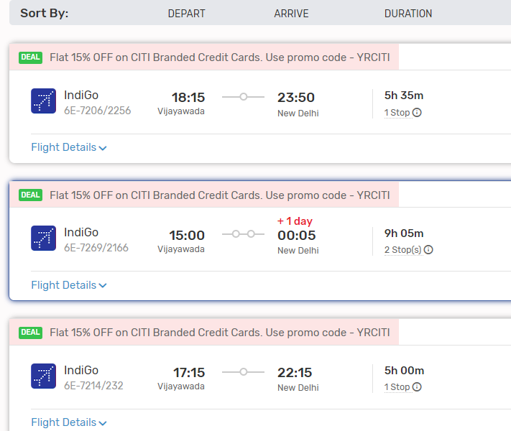

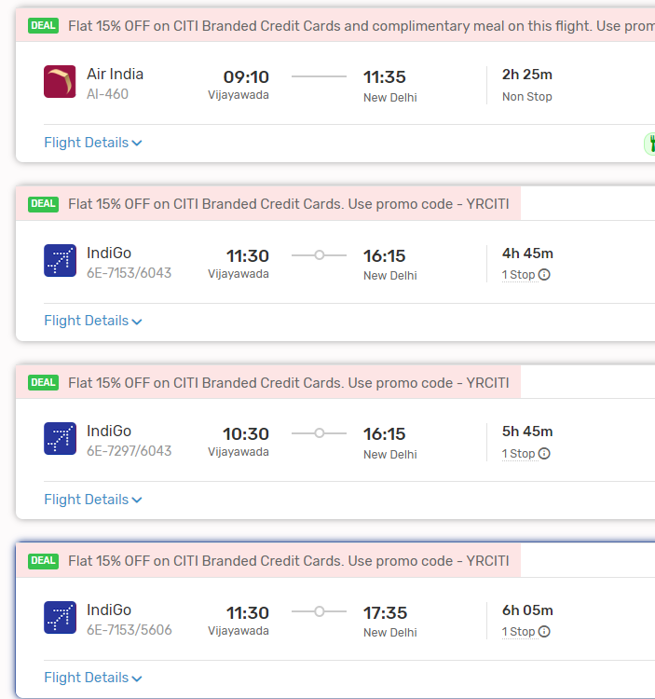

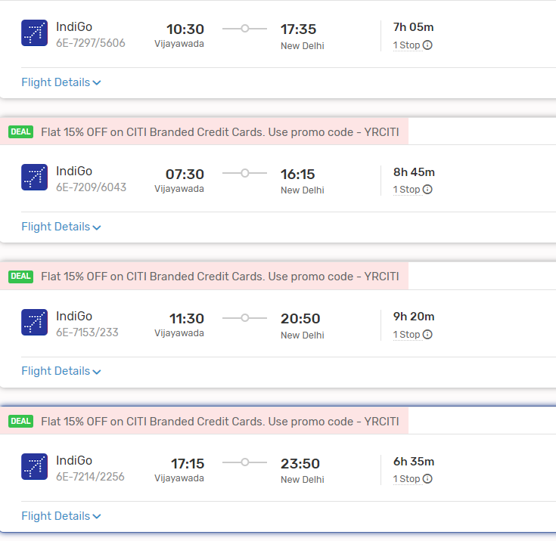

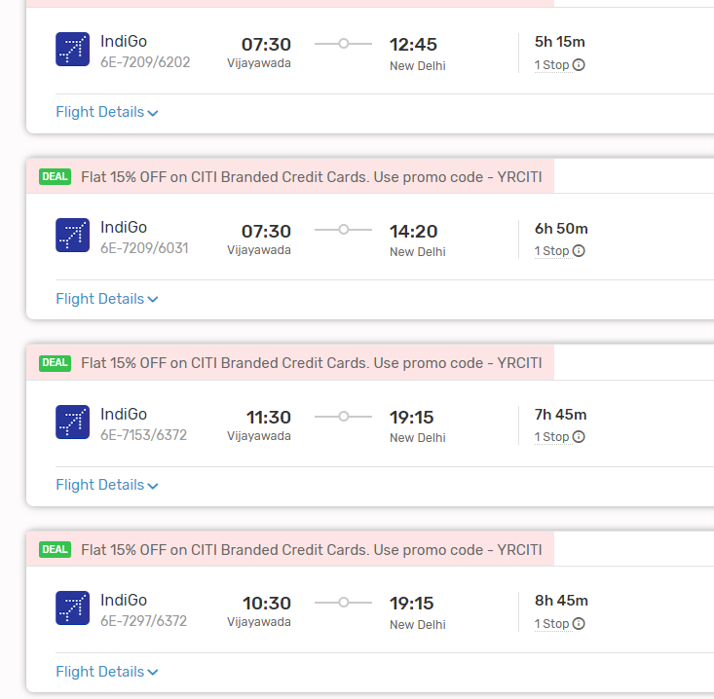

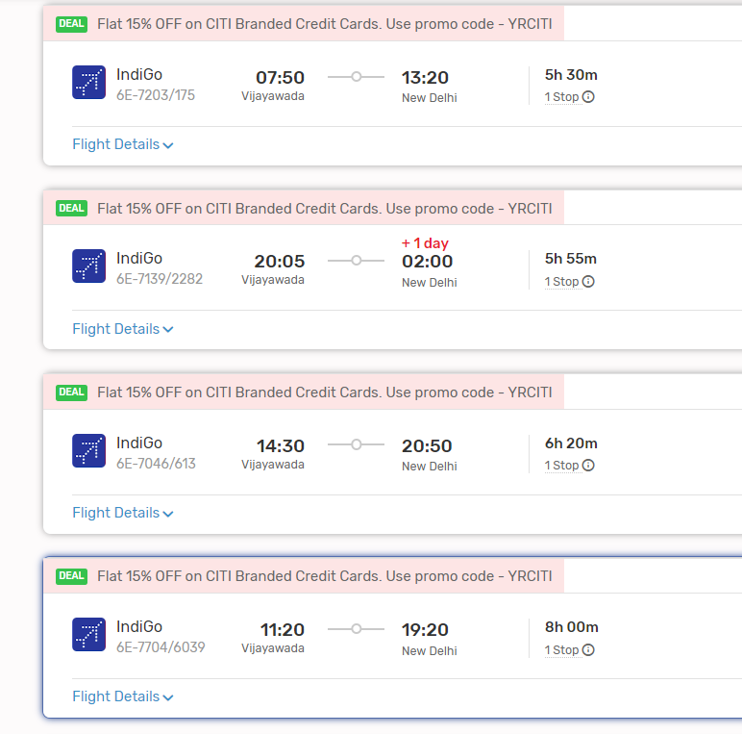

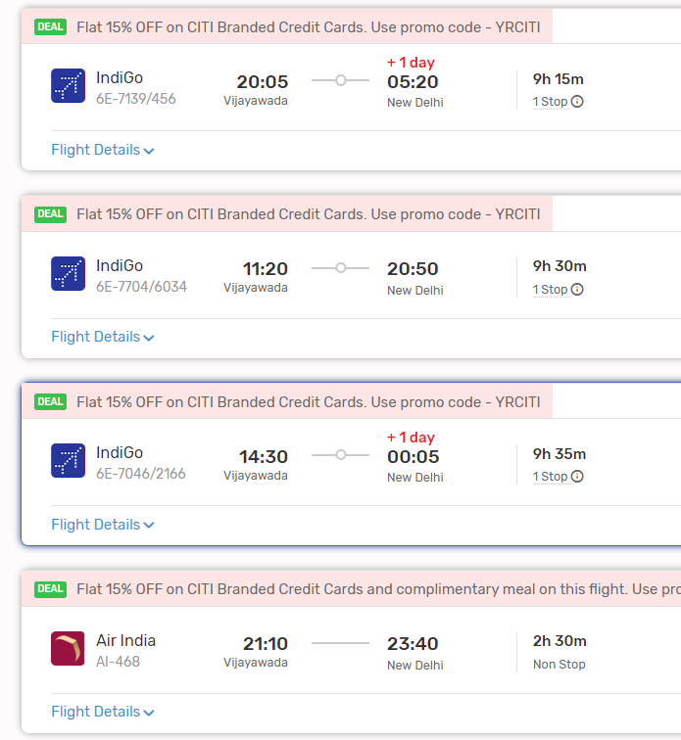

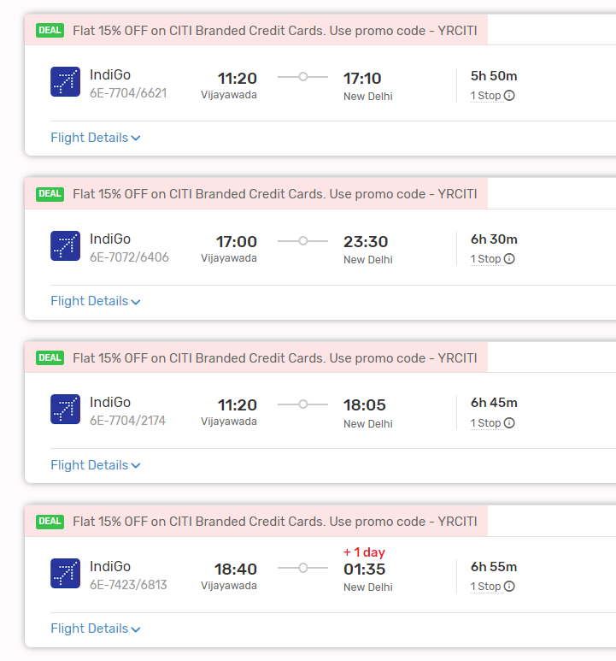

2. **Delhi to Kalka by Train**: Take a train from New Delhi Railway Station to Kalka Railway Station. Several trains, including Shatabdi Express and Himalayan Queen, operate on this route. Kalka is the nearest railway station to Shimla.

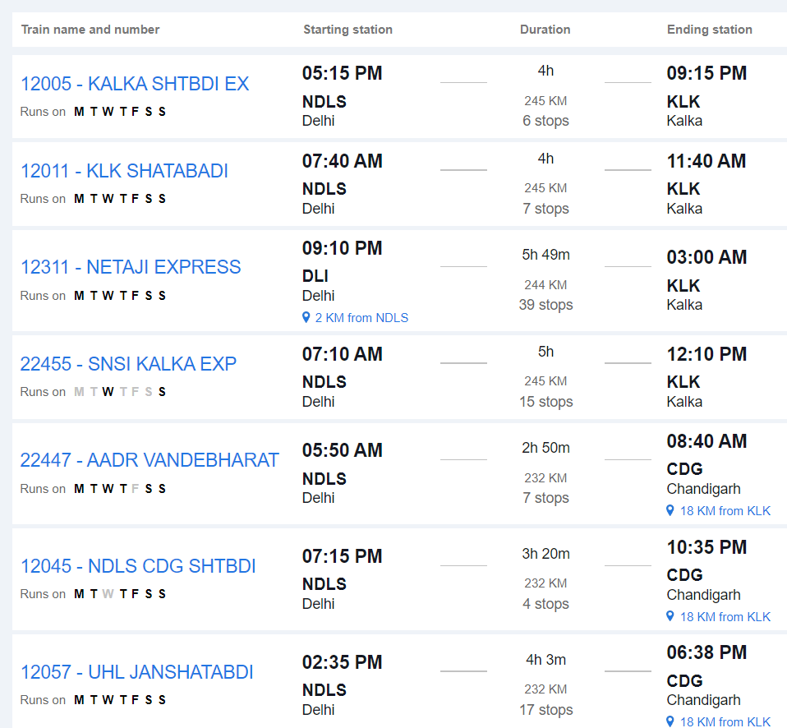

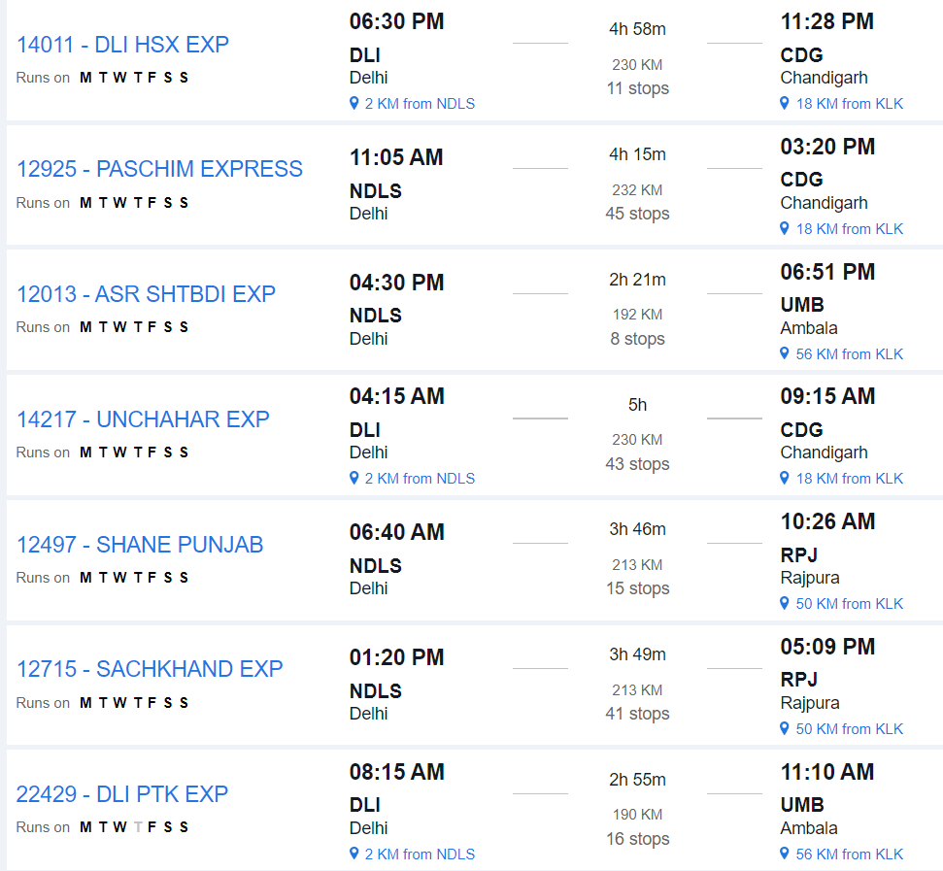

3. **Kalka to Shimla by Toy Train or Road**: From Kalka, you can board the UNESCO World Heritage-listed Kalka-Shimla Toy Train, which offers a scenic journey through the hills. Alternatively, you can travel by road from Kalka to Shimla, which takes approximately 4 to 5 hours.

#### From Kalka to Shimla:

- The Kalka-Shimla Toy Train covers a distance of about 96 kilometers and takes around 5 to 6 hours to reach Shimla. The road journey from Kalka to Shimla is approximately 85 kilometers and takes around 4 to 5 hours by car or bus.

#### Toy Train:

- The Kalka-Shimla Toy Train operates multiple times a day, offering various classes of seating, including first-class, second-class, and unreserved. It's advisable to book tickets in advance, especially during the peak tourist season.

#### Road:

- If you choose to travel by road, you can hire a taxi, use app-based cab services, or take a bus from Kalka to Shimla. The road journey offers beautiful views of the Himalayan mountains and valleys.

### 2. By Train and Road:

#### Route:

1. **Vijayawada to Delhi by Train**: Travel from Vijayawada to Delhi by train. Several trains connect Vijayawada Junction to New Delhi Railway Station, including express and superfast trains.

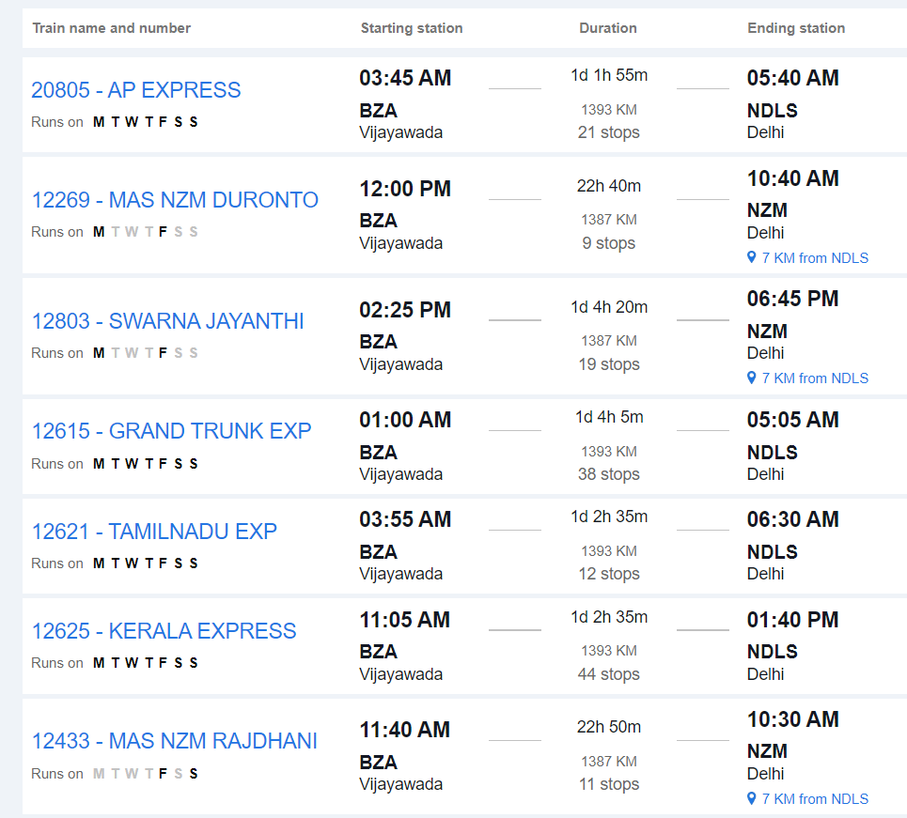

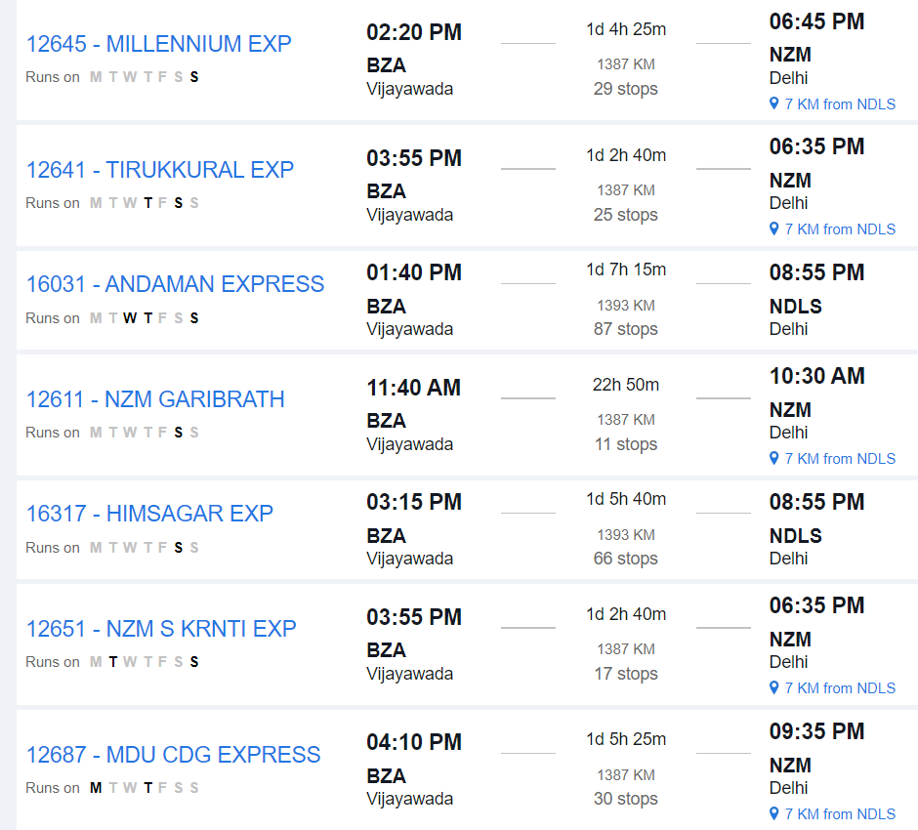

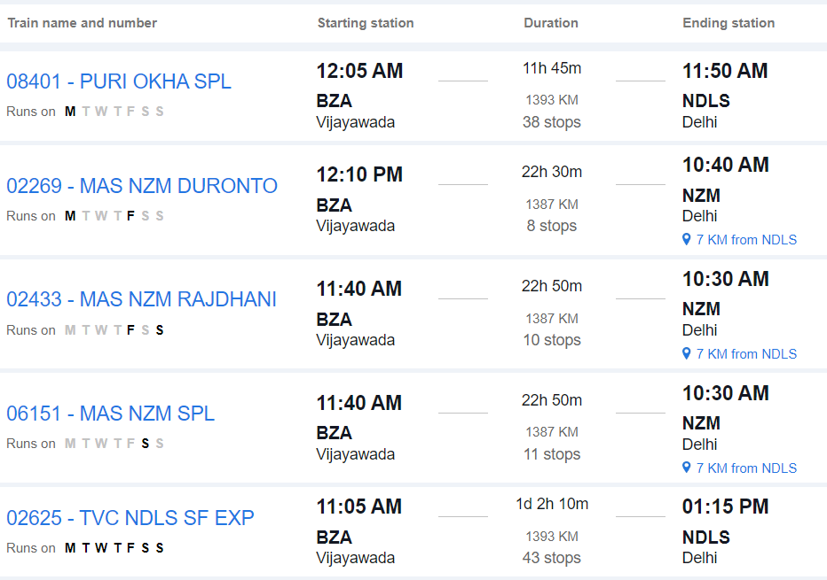

2. **Delhi to Shimla by Road**: From Delhi, you can travel to Shimla by road. The road distance between Delhi and Shimla is approximately 340 to 380 kilometers, depending on the specific route taken. The journey takes around 8 to 10 hours by car or bus.

#### From Delhi to Shimla:

- Upon reaching Delhi, you can hire a taxi, use app-based cab services, or take a bus to Shimla. The road journey offers scenic views of the countryside and Himalayan foothills.

### 3. By Road Only:

#### Route:

- **Vijayawada to Shimla by Road**: Travel directly from Vijayawada to Shimla by road via National Highways and State Highways.

#### Distance:

- The road distance between Vijayawada and Shimla is approximately 1,800 to 1,900 kilometers, depending on the specific route taken.

#### Duration:

- The journey by road can take around 30 to 35 hours, depending on factors such as traffic, road conditions, and rest stops.

#### Facilities:

- Along the way, you'll find various amenities such as fuel stations, restaurants, and rest areas. It's advisable to plan your journey in advance, considering necessary stops for food, rest, and refueling.

#### Considerations:

- Before embarking on a long road trip, ensure your vehicle is in good condition and carry essential documents like your driver's license, vehicle registration, and insurance.

### Conclusion:

- Depending on your preferences, budget, and time constraints, you can choose between air, train, and road travel or a combination of these modes to reach Shimla from Vijayawada. Each mode of transportation offers its own advantages, so consider factors such as convenience, cost, and comfort when planning your journey.