**SHIRDI**:

Sure, here's detailed information on three common ways to travel from Vijayawada to Shirdi:

### 1. By Train and Road:

#### Route:

1. **Vijayawada to Manmad by Train**: Take a train from Vijayawada to Manmad Junction, which is one of the major railway stations near Shirdi. Several trains connect Vijayawada to Manmad Junction, including express and superfast trains.

**Manmad to Shirdi by Road**: From Manmad, travel to Shirdi by road. Shirdi is located approximately 80 kilometers from Manmad, and the road journey takes around 2 to 3 hours, depending on traffic and mode of transport.

#### List Of Trains Available:

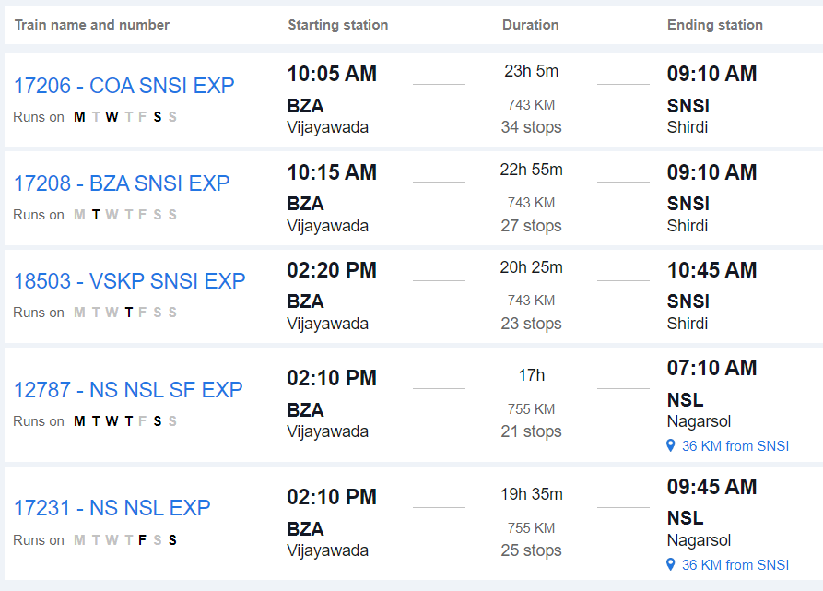

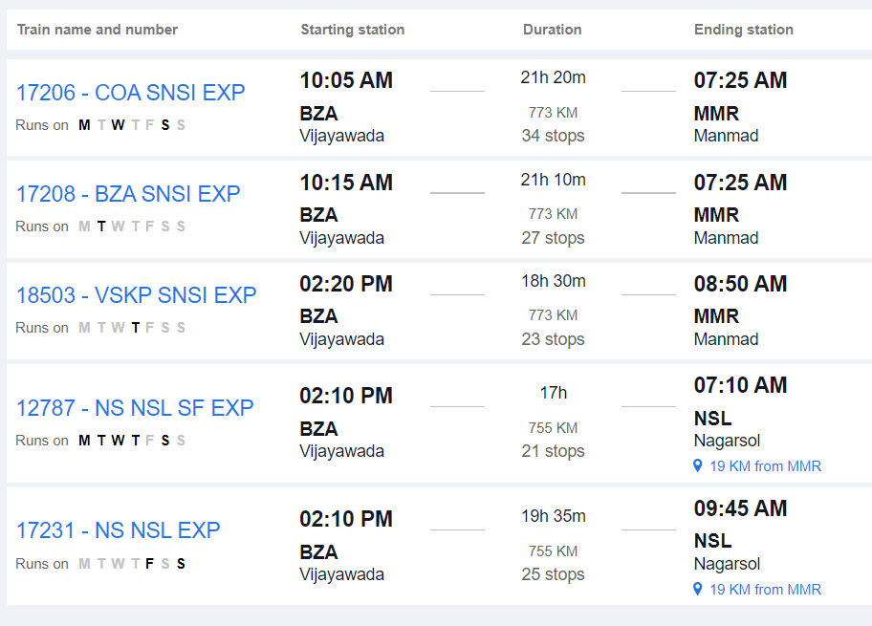

#### From Manmad to Shirdi:

- Upon reaching Manmad, you can hire a taxi, use app-based cab services, or take local buses to reach Shirdi. Shared taxis and buses are also available from Manmad to Shirdi.

### 2. By Road:

#### Route:

- **Vijayawada to Shirdi by Road**: Travel directly from Vijayawada to Shirdi by road via National Highways and State Highways.

#### Distance:

- The road distance between Vijayawada and Shirdi is approximately 1,000 to 1,100 kilometers, depending on the specific route taken.

#### Duration:

- The journey by road can take around 18 to 20 hours, depending on factors such as traffic, road conditions, and rest stops.

#### Route Options:

- You can take multiple route options, including via Hyderabad, Solapur, and Ahmednagar, or via Nagpur, Akola, and Aurangabad. Each route offers different scenery and road conditions.

#### Facilities:

- Along the way, you'll find various amenities such as fuel stations, restaurants, and rest areas. It's advisable to plan your journey in advance, considering necessary stops for food, rest, and refueling.

#### Considerations:

- Before embarking on a long road trip, ensure your vehicle is in good condition and carry essential documents like your driver's license, vehicle registration, and insurance.

### 3. By Air and Road:

#### Route:

1. **Vijayawada to Pune by Air**: Fly from Vijayawada Airport (VGA) to Pune Airport (PNQ).

2. **Pune to Shirdi by Road**: From Pune, travel to Shirdi by road. Shirdi is located approximately 200 kilometers from Pune, and the road journey takes around 4 to 5 hours, depending on traffic and mode of transport.

#### From Pune to Shirdi:

- Upon reaching Pune, you can hire a taxi, use app-based cab services, or take local buses to reach Shirdi.

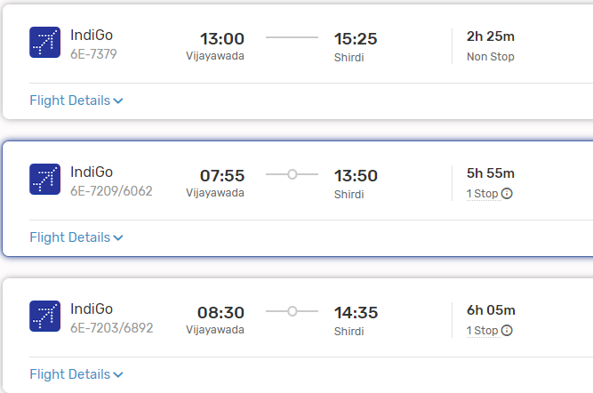

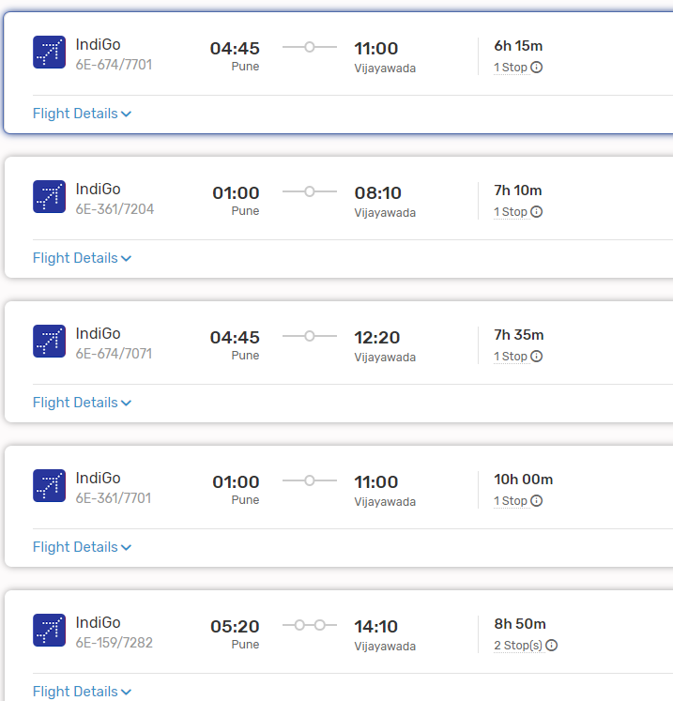

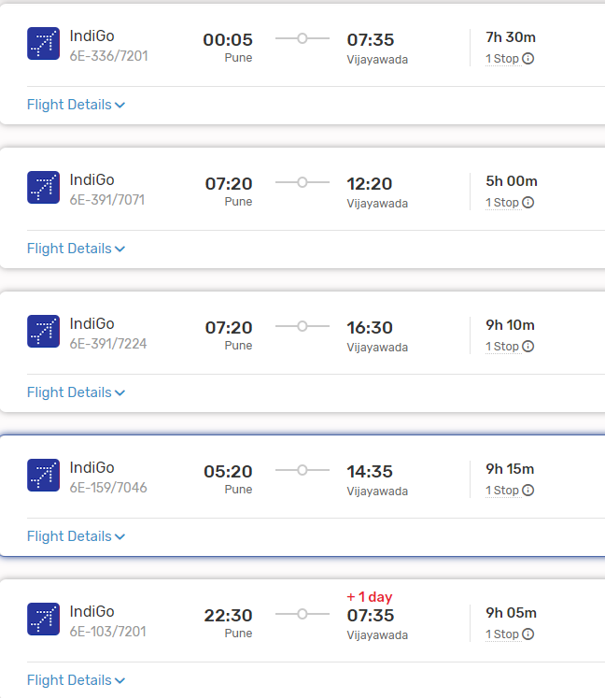

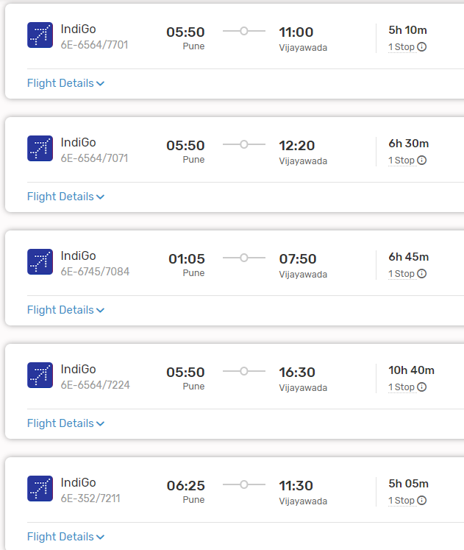

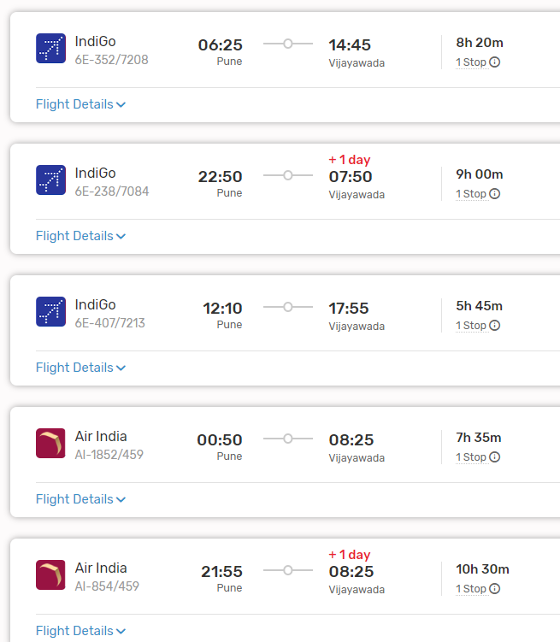

### Conclusion:

- Depending on your preferences, budget, and time constraints, you can choose between train and road travel, direct road travel, or air and road travel from Vijayawada to Shirdi. Each mode of transportation offers its own advantages, so consider factors such as convenience, cost, and comfort when planning your journey.