**TIRUPATI:**

Certainly! Here's detailed information on three common ways to travel from Vijayawada to Tirupati:

### 1. By Air:

#### Route:

- **Vijayawada Airport (VGA) to Tirupati Airport (TIR)**: There are no direct flights from Vijayawada to Tirupati. The most convenient route is to fly from Vijayawada to Tirupati, which has an airport.

#### Airlines:

- Currently, there might not be regular commercial flights between Vijayawada and Tirupati due to the short distance and low demand. However, you can check for charter or private flight options.

#### Duration:

- The flight duration for a direct flight between Vijayawada and Tirupati, if available, would typically be around 1 to 1.5 hours.

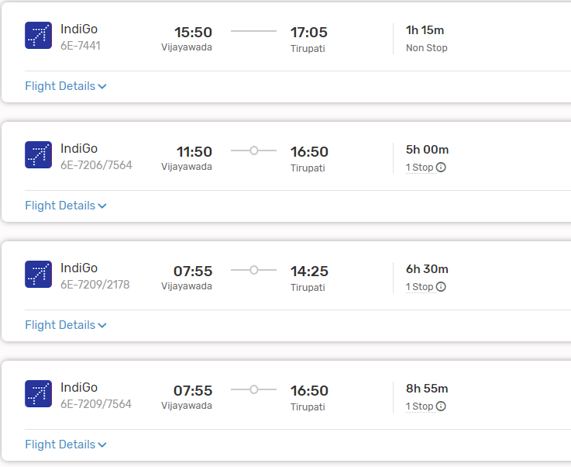

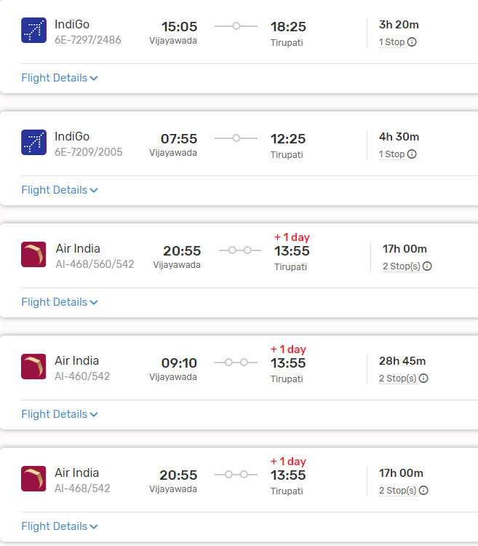

#### Layovers:

- As direct flights might not be available, there won't be layovers to consider. However, if connecting through other airports, layovers could vary depending on the airline and route.

#### From Tirupati Airport to Tirupati City:

- Tirupati Airport is located around 15 kilometers from Tirupati city center. You can hire a taxi, use app-based cab services, or take a local bus to reach Tirupati city.

### 2. By Train:

#### Route:

- **Vijayawada Railway Station (BZA) to Tirupati Railway Station (TPTY)**: Tirupati Railway Station is the main railway station serving Tirupati.

#### Trains:

- There are several trains connecting Vijayawada to Tirupati, including passenger trains and express trains like Venkatadri Express, Narayanadri Express, and Rayalaseema Express.

#### Duration:

- The duration of the train journey can vary depending on the chosen train and its schedule. Typically, it takes around 6 to 8 hours to reach Tirupati from Vijayawada by train.

#### From Tirupati Railway Station to Tirupati City:

- Tirupati Railway Station is located near the city center of Tirupati, allowing easy access to various modes of local transportation to reach your destination within Tirupati.

###ListOf Trains available:

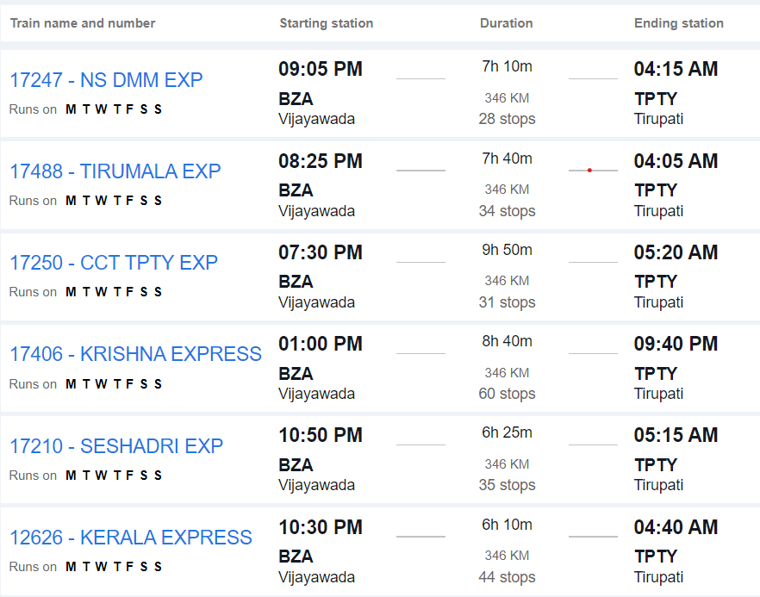

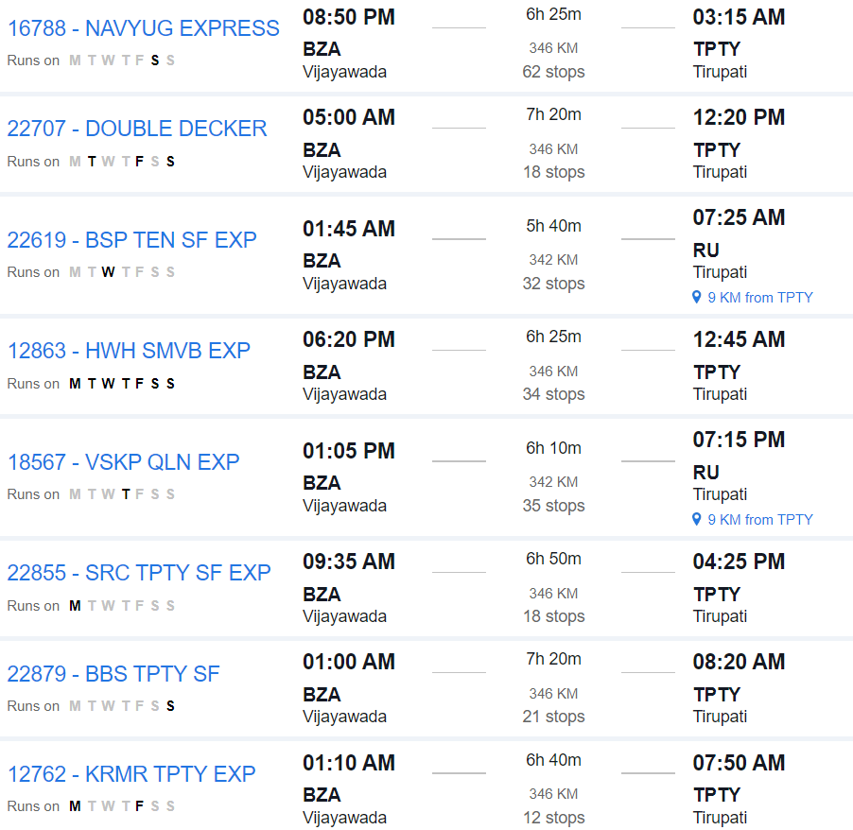

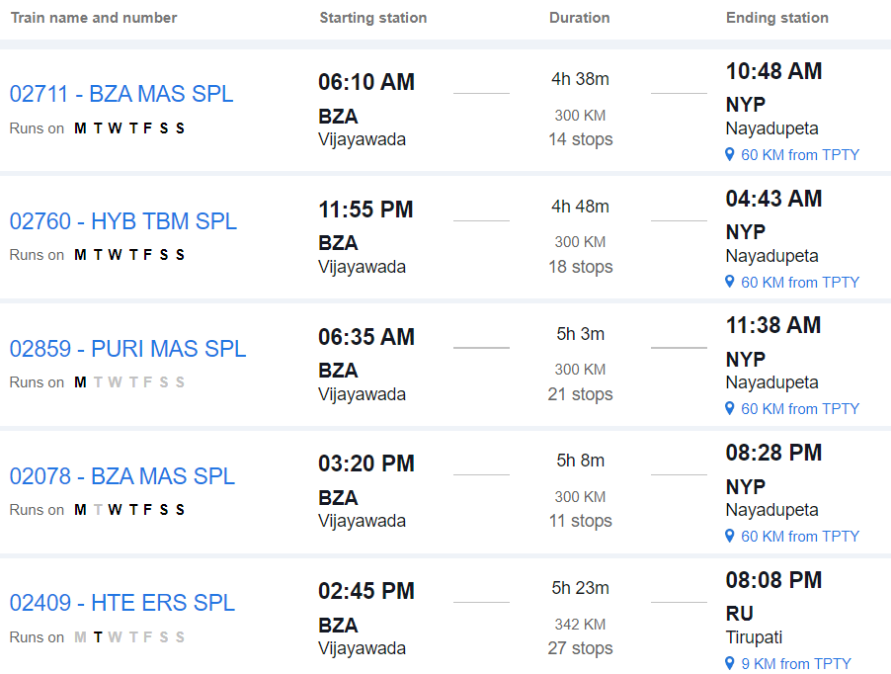

### 3. By Road:

#### Route:

- **Vijayawada to Tirupati by Road**: This route involves traveling by road via National Highways and State Highways.

#### Distance:

- The road distance between Vijayawada and Tirupati is approximately 380 to 400 kilometers, depending on the specific route taken.

#### Duration:

- The journey by road can take around 6 to 8 hours, depending on factors such as traffic, road conditions, and rest stops.

#### Route Options:

- You can take multiple route options, including via Nellore, or via Ongole and Naidupeta. Each route offers different scenery and road conditions.

#### Facilities:

- Along the way, you'll find various amenities such as fuel stations, restaurants, and rest areas. It's advisable to plan your journey in advance, considering necessary stops for food, rest, and refueling.

#### Considerations:

- Before embarking on a road trip, ensure your vehicle is in good condition and carry essential documents like your driver's license, vehicle registration, and insurance.

### Conclusion:

- Depending on your preferences, budget, and time constraints, you can choose between train, road, or air travel from Vijayawada to Tirupati. Each mode of transportation offers its own advantages, so consider factors such as convenience, cost, and comfort when planning your journey.