**VARANASI**:

Sure, here's detailed information on three common ways to travel from Vijayawada to Kashi (Varanasi):

### 1. By Air:

#### Route:

- **Vijayawada Airport (VGA) to Varanasi Airport (VNS)**: There are no direct flights from Vijayawada to Varanasi. The most convenient route is to fly from Vijayawada to Varanasi, which has an airport.

#### Airlines:

- Several airlines operate flights on this route, including IndiGo, SpiceJet, and Air India. You can check their websites or use flight booking platforms to find the most suitable option for your travel dates.

#### Duration:

- The flight duration from Vijayawada to Varanasi is typically around 3 to 4 hours, depending on the airline and any layovers.

#### Layovers:

- Layovers may vary depending on the flight schedule and airline. Common layover airports include Delhi, Hyderabad, and Mumbai.

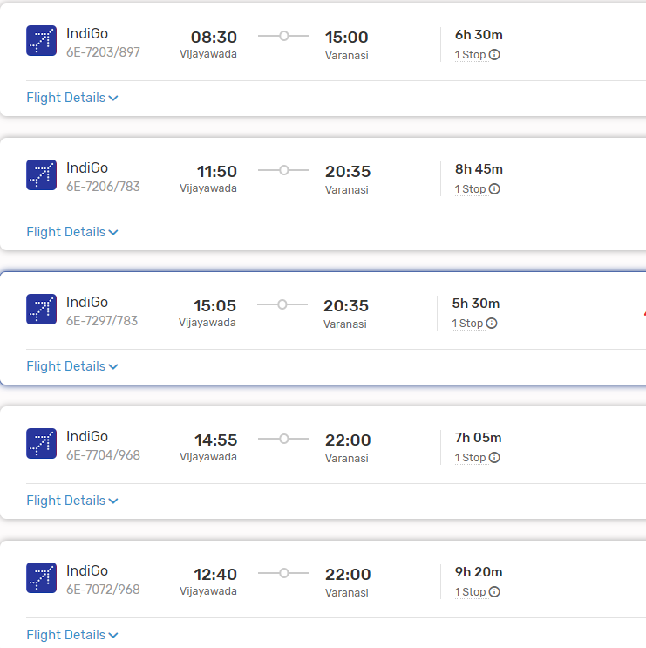

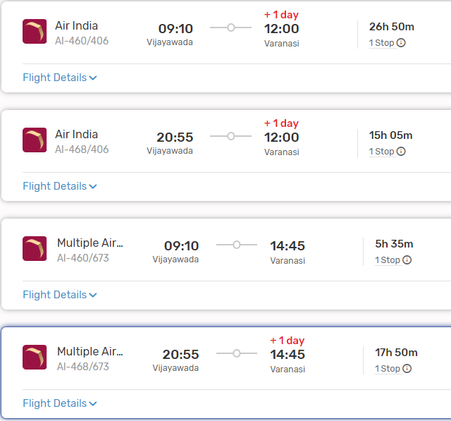

#### From Varanasi to Kashi:

- Varanasi is also known as Kashi. Upon reaching Varanasi Airport, you can travel to the city center of Varanasi, which is Kashi, by taxi, auto-rickshaw, or other local transportation options.

### 2. By Train:

#### Route:

- **Vijayawada Railway Station (BZA) to Varanasi Junction (BSB)**: Varanasi Junction is the main railway station serving Varanasi.

#### Trains:

- There are multiple trains connecting Vijayawada to Varanasi, including the LTT RMM Express, Godavari Express, and Amaravati Express. You can check the Indian Railways website or use other online platforms to find suitable train options based on your travel dates and preferences.

#### Duration:

- The duration of the train journey can vary significantly depending on the chosen train and any layovers. It can take anywhere from 25 to 35 hours or more to reach Varanasi from Vijayawada by train.

#### From Varanasi Junction to Kashi:

- Varanasi Junction is located in the heart of Varanasi (Kashi). Upon reaching the railway station, you can easily access various modes of local transportation to reach your destination within Kashi.

###ListOf Trains available:

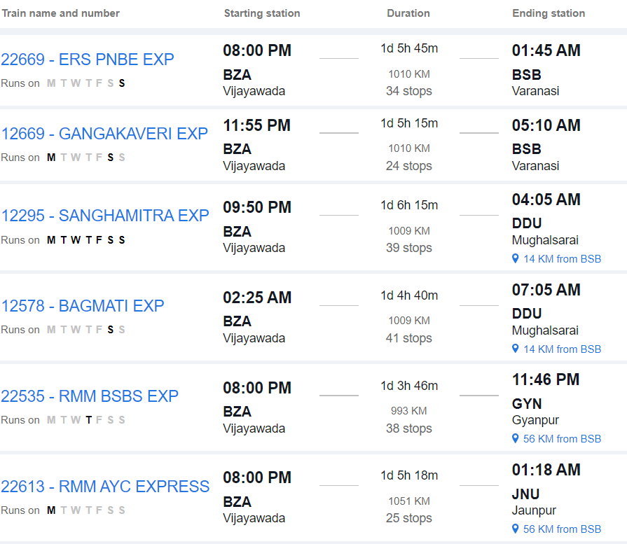

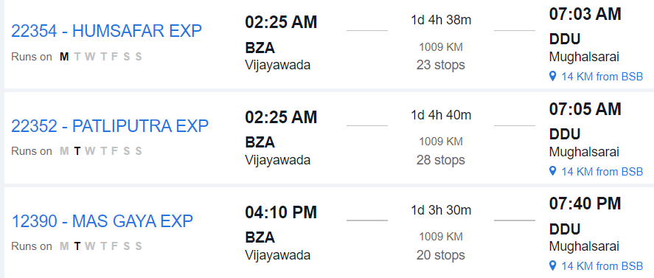

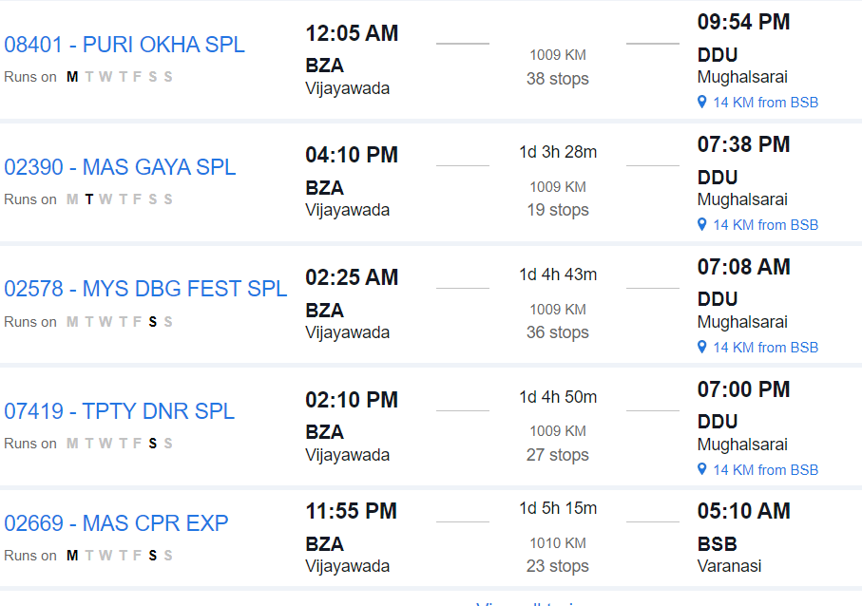

### 3. By Road:

#### Route:

- **Vijayawada to Kashi by Road**: This route involves traveling by road via National Highways and State Highways.

#### Distance:

- The road distance between Vijayawada and Varanasi (Kashi) is approximately 1,400 to 1,500 kilometers, depending on the specific route taken.

#### Duration:

- The journey by road can take around 24 to 30 hours, depending on factors such as traffic, road conditions, and rest stops.

#### Route Options:

- You can take multiple route options, including via Hyderabad, Nagpur, and Allahabad, or via Kolkata. Each route offers different scenery and road conditions.

#### Facilities:

- Along the way, you'll find various amenities such as fuel stations, restaurants, and rest areas. It's advisable to plan your journey in advance, considering necessary stops for food, rest, and refueling.

#### Considerations:

- Before embarking on a long road trip, ensure your vehicle is in good condition and carry essential documents like your driver's license, vehicle registration, and insurance.

### Conclusion:

- Depending on your preferences, budget, and time constraints, you can choose between air, train, or road travel from Vijayawada to Kashi (Varanasi). Each mode of transportation offers its own advantages, so consider factors such as convenience, cost, and comfort when planning your journey.