**VRINDAVAN**:

Certainly! Here's detailed information on three common ways to travel from Vijayawada to Vrindavan:

### 1. By Train and Road:

#### Route:

1. **Vijayawada to Mathura by Train**: Take a train from Vijayawada to Mathura, which is one of the major railway stations near Vrindavan.

2. **Mathura to Vrindavan by Road**: From Mathura, travel to Vrindavan by road. Vrindavan is located approximately 11 kilometers from Mathura, and the road journey takes around 30 minutes to 1 hour, depending on traffic and mode of transport.

#### From Mathura to Vrindavan:

- Upon reaching Mathura, you can hire a taxi, use app-based cab services, or take local buses to reach Vrindavan.

###List Of Trains Available:

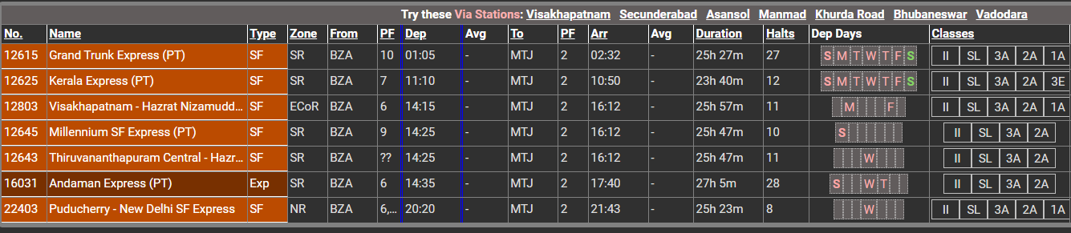

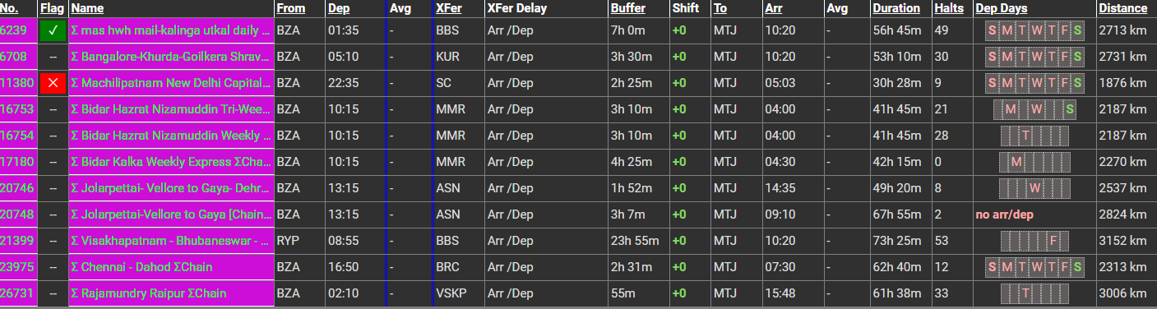

### 2. By Road:

#### Route:

- **Vijayawada to Vrindavan by Road**: Travel directly from Vijayawada to Vrindavan by road. This route involves traveling via National Highways and State Highways.

#### Distance:

- The road distance between Vijayawada and Vrindavan is approximately 1,600 to 1,700 kilometers, depending on the specific route taken.

#### Duration:

- The journey by road can take around 24 to 30 hours, depending on factors such as traffic, road conditions, and rest stops.

#### Route Options:

- You can take multiple route options, including via Hyderabad, Nagpur, and Agra, or via Bengaluru, Nagpur, and Agra. Each route offers different scenery and road conditions.

#### Facilities:

- Along the way, you'll find various amenities such as fuel stations, restaurants, and rest areas. It's advisable to plan your journey in advance, considering necessary stops for food, rest, and refueling.

#### Considerations:

- Before embarking on a long road trip, ensure your vehicle is in good condition and carry essential documents like your driver's license, vehicle registration, and insurance.

### 3. By Air and Road:

#### Route:

1. **Vijayawada to Delhi by Air**: Fly from Vijayawada to Delhi, which has a major international airport.

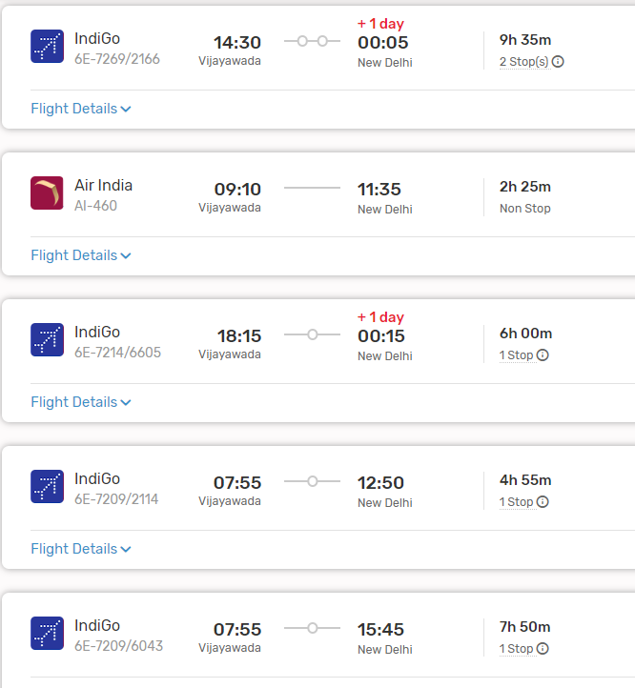

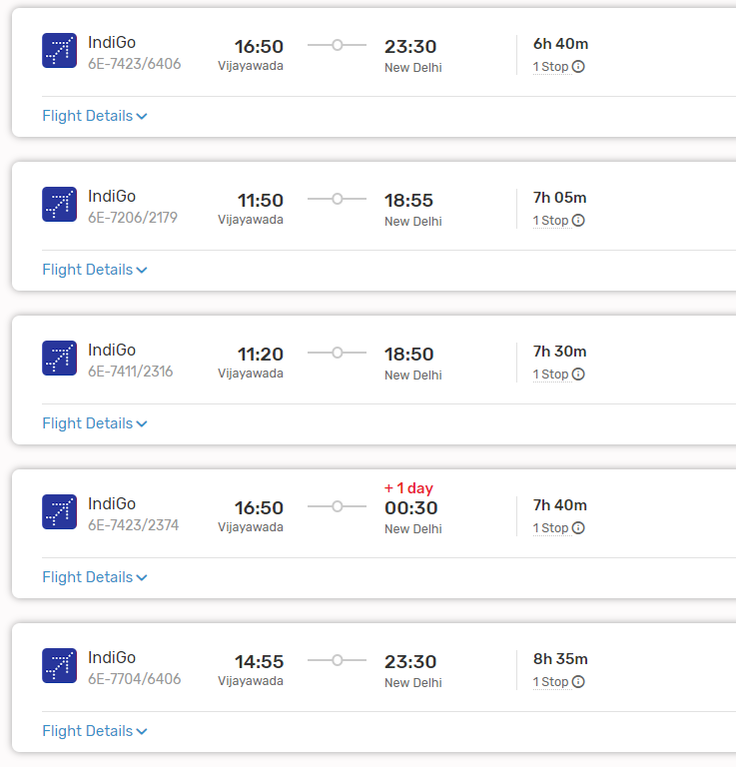

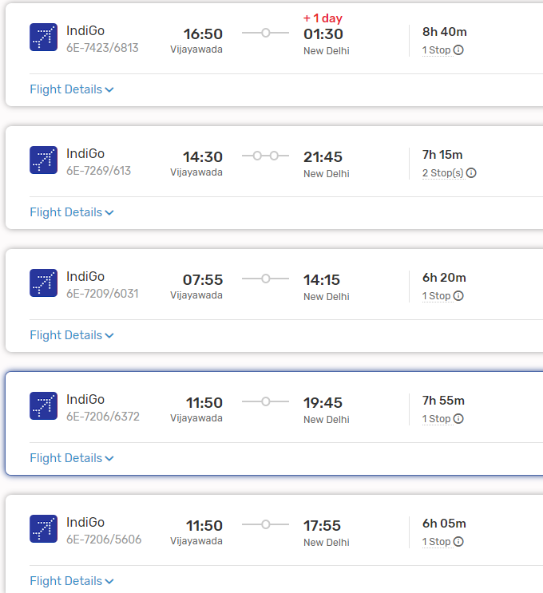

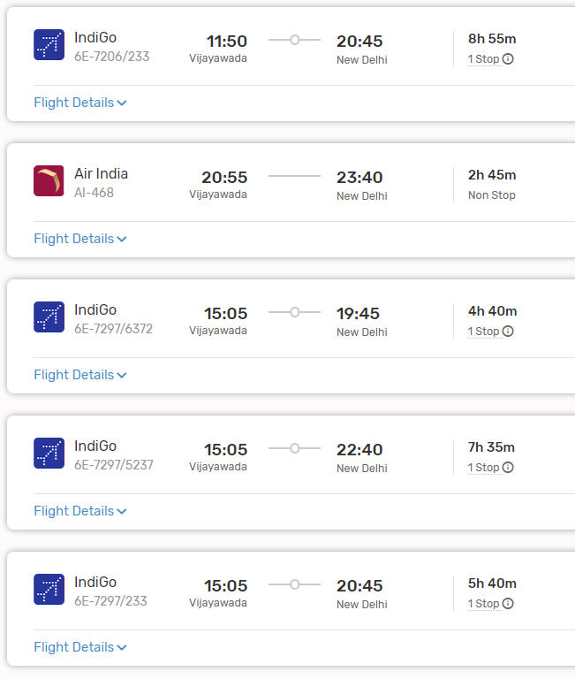

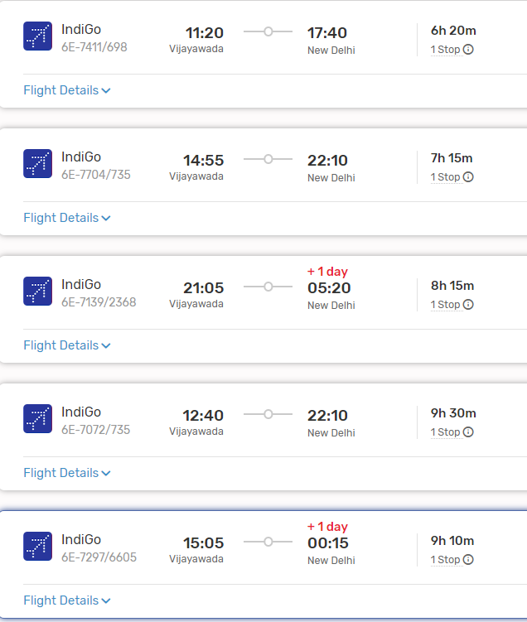

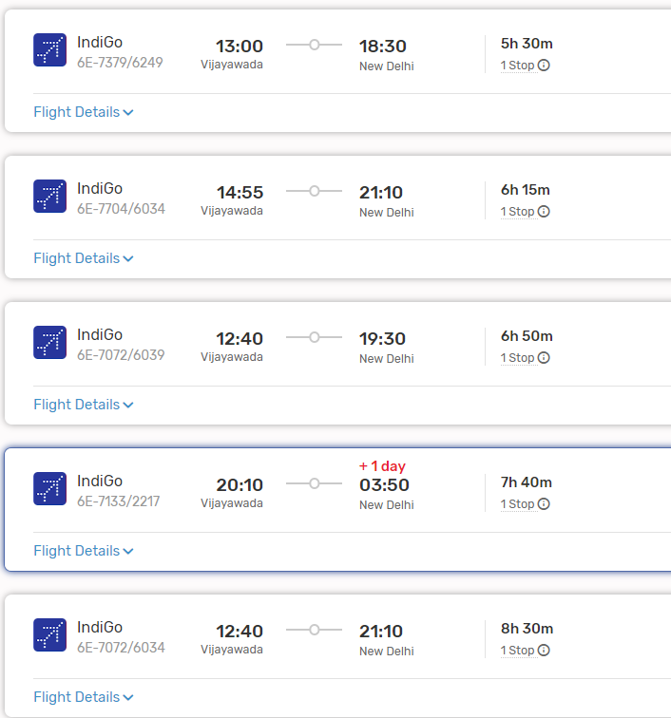

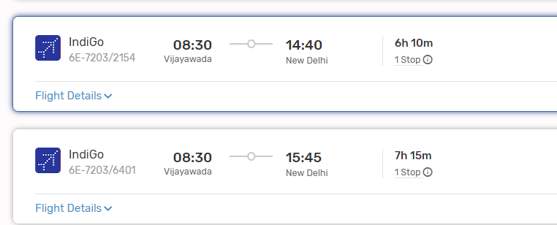

2. **Delhi to Vrindavan by Road**: From Delhi, travel to Vrindavan by road. Vrindavan is approximately 150 kilometers from Delhi, and the road journey takes around 3 to 4 hours, depending on traffic and mode of transport.

#### From Delhi to Vrindavan:

- Upon reaching Delhi, you can hire a taxi, use app-based cab services, or take local buses to reach Vrindavan.

### Conclusion:

- Depending on your preferences, budget, and time constraints, you can choose between train and road travel, direct road travel, or air and road travel from Vijayawada to Vrindavan. Each mode of transportation offers its own advantages, so consider factors such as convenience, cost, and comfort when planning your journey.