How to get Alienware lighting to work on MSI Raider motherboard with R4 type case

Wiring: Connect extension cable from PCB panel cable to near the front panel header.  
Connect Power ON jumper from header pins 6,8 to 6,8 of extension cable  
Connect PWR LED jumper from header pins 2,4 to pins 2,4 of extension cable. Watch + and -

Power system up. The LED lights will disappear.

Export the following key. I named it “msi-raider-bios”

[HKEY_LOCAL_MACHINE\HARDWARE\DESCRIPTION\System\BIOS]

Run the following 2 register mods to force Area51 R4 bios description and fix “unknown” FX

AlienwareAlienFRX  
r4_bios

Bring up the device manager. Look for an unknown USB device and disable it.

Then enable the unknown device. If all works correctly, the device will be enabled and will disappear from the device manager. Run the app usbview.exe and look for a USB with following properties:

idVendor:  0x187C  
idProduct: 0x0526

Download and install Alienware-Command-Center-for-Desktops_J7XK6_WIN64_4.8.23.0_A00  
Reboot and be sure to fix the unknown device. Do not attempt to run AWCC unless the unknown device is fixed! Select a theme. I restored my “MSI Raider bios” after that AWCC app was installed.

Remove the PWR LED jumper from the extension pins 2,4 and put them on 1,3 (the HDD LED pins on the extension cable) You will have pins 2,4 of MSI header connected to pins 1,3 of extension. Shut the system down. A reboot will not work. Power the system up and the lights should start working. It will not be possible to fix the unknown USB device and consequently the AWCC app cannot be used.

If a problem occurs then run that vs2022 application “USBapp.exe” to reset the PCB.

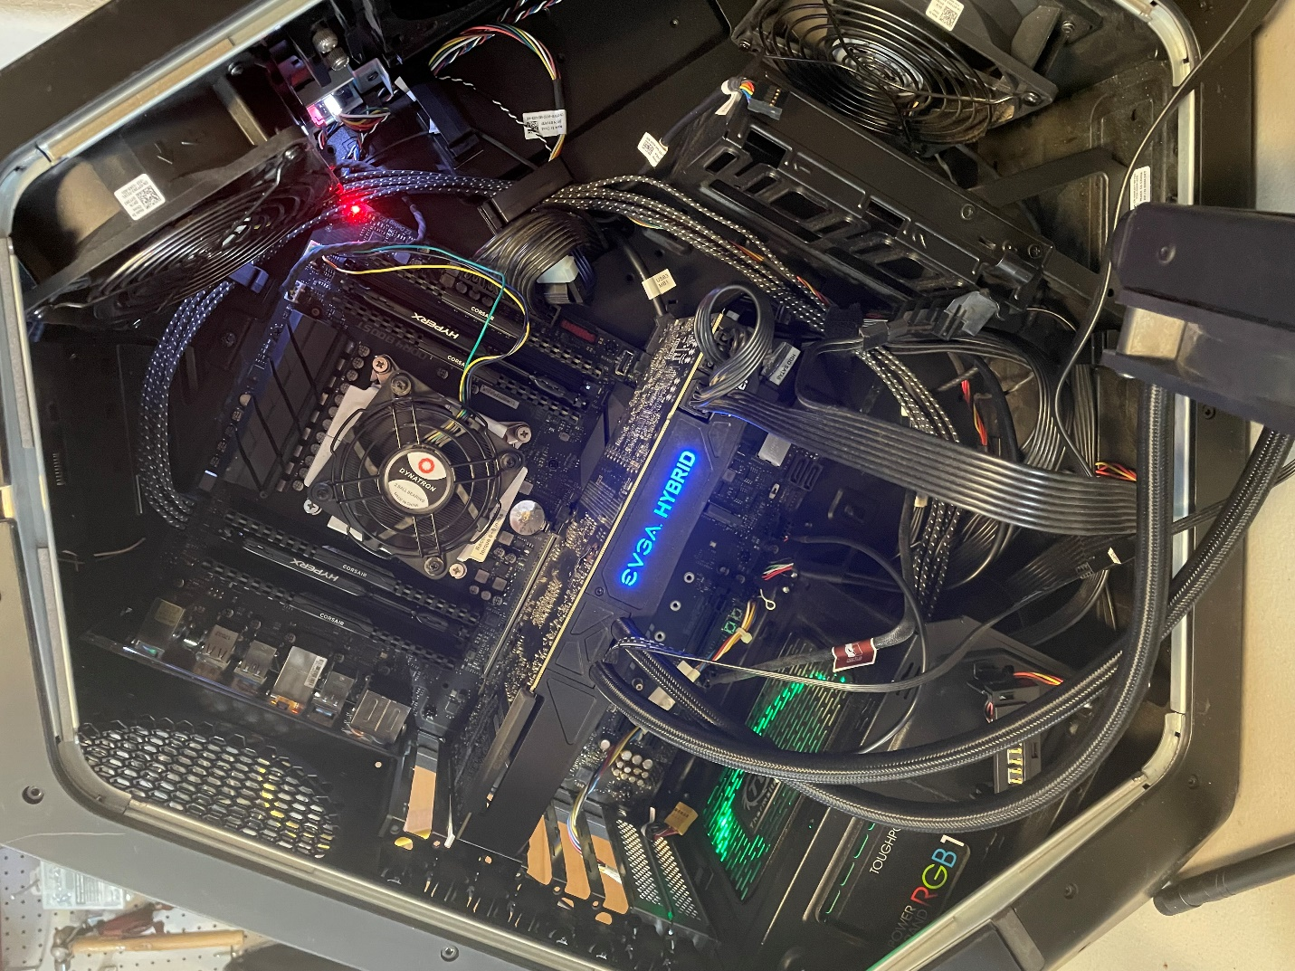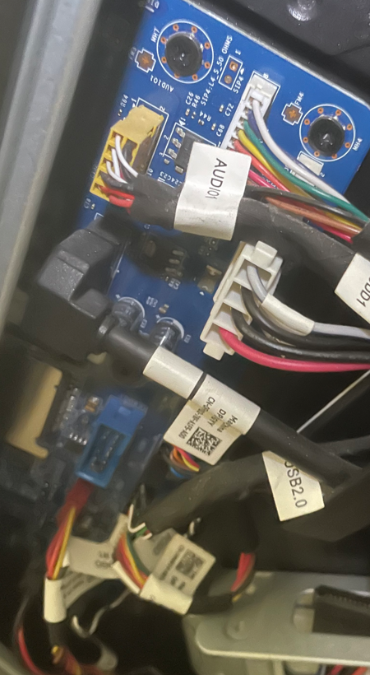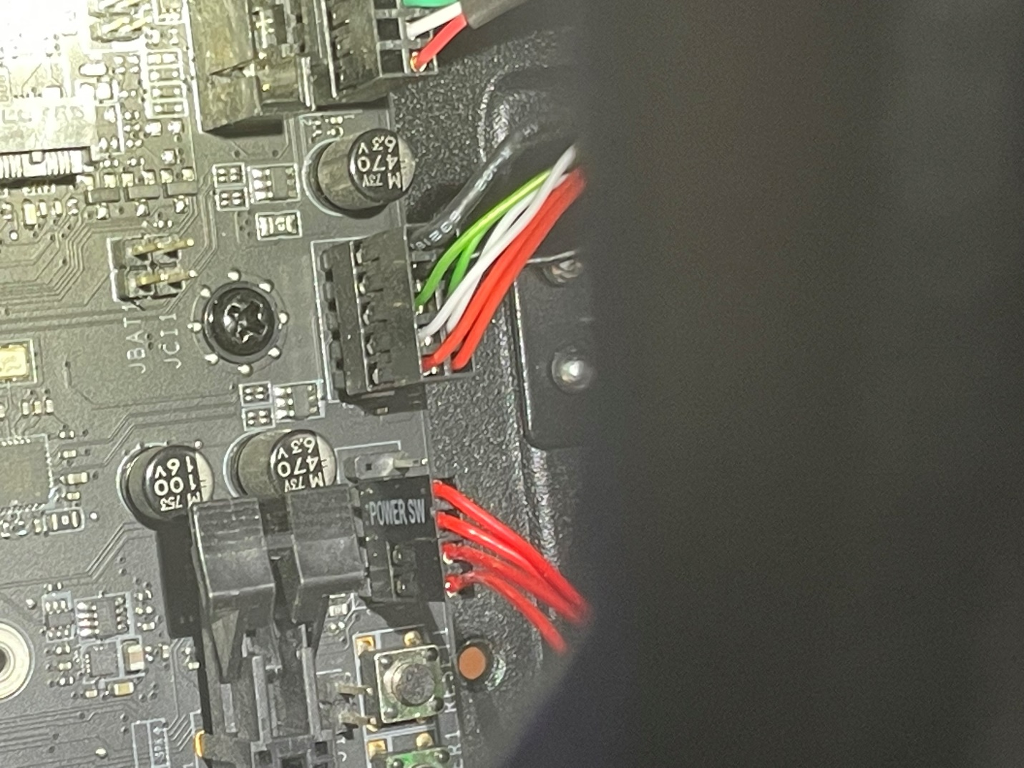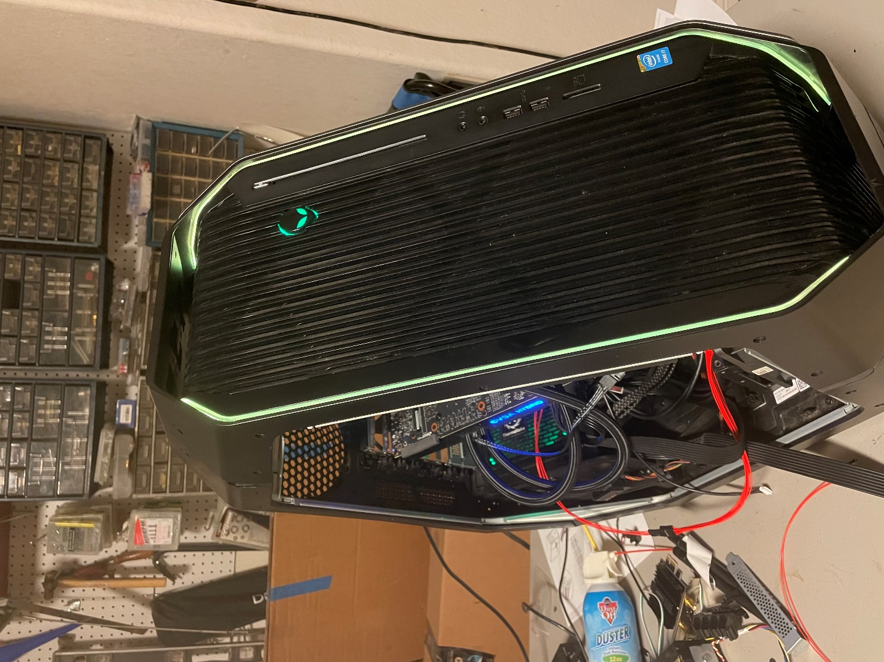

The image below shows the connection needed to boot and see the lights turned on. As described earlier the pwr led jumper needs be moved underneath the power on/off so that the unknown device can be enabled allowing the AWCC app to run correctly,.

