This program will obtain the most recent credit information, calculate the averages and list the most efficient system

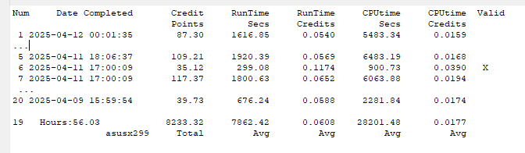
PC name (if known): asusx299: 56 hours elapsed to gather the 20 credits. A total of 8233 points
Runtime/credit of 0.0608 means each second you obtained that much credit.
CPUtime/credit is similar but the .0177 indicates
1 – If this was a CPU bound task then more than 1 CPU was used else the value would have been the same as the Runtime.
2 – The task used a GPU and very little CPU time was needed

To see all your credits you must have all your Project IDs available for each PC.

Requirements
1- You must have the BOINC client running on every remote system you have.
2- If not using BoincTasks then your localhost is used to ask the BOINC client for tasking information.
3- If using BoincTasks then all remote BOINC clients must not have a local password. I did not implement asking for password. If your remote PCs have passwords, then you must assemble your own list of Project Name and Project Identifiers. Passwords are not needed for any public projects.

Definitions
Sample Url: https://einsteinathome.org/host/12850601/tasks/4/56
Project Name: einstein
Project Study (56): The numeric value that indicates which application is being used. Some project have only one application.
Project Identifier(1285061): The numeric value called HOST or HOST_ID by the project.
State(4) : This value is used to obtain only valid statistics. Even though statistics are valid, this application can remove any values that lie outside two standard deviations.

How to obtain your Project Information from BoincTasks
- Bring up Configure
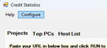
- Select the PC List tab

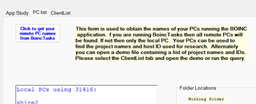

If in demo mode you will see a list of PCs. To obtain your own PCs
Click the button “Click to get…”
Any PCs shown in red are not online
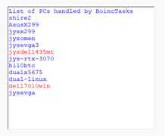
- To obtain client information (file IDs) select the ClientList tab
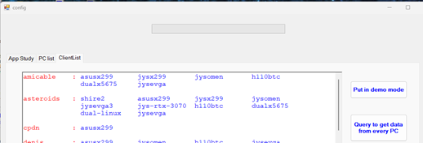

- Click the “Query to get data from every PC” to obtain the file IDs
If you are in demo mode that button is not enabled. See (2) above to get out
of demo mode. Each PC in the list shown by (2) will be queried to obtain
every project the PC is working on the ID the project assigned to the PC

How to get credit information for a specific project from one of your PCs.
- Select the Host List tab in the application
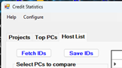
- Look down at the group titled Change Default Project PC
- Select the PC that you want to get credit info from
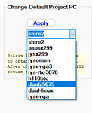
- Click the Apply button (you will be taken to tab 1)
- Select the project you are interested in.
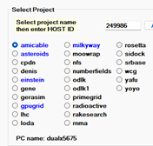
- Click the RUN button
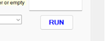
- Wait for the data to arrive. Some projects will take a long time. The data below came from einstein.
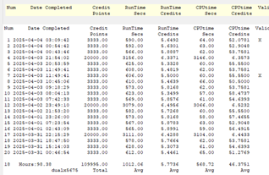
- To get more than 20 items, click the NEXT button.

