This shows how to run or exit the demo project information

When running the app for the first time you will be asked if you want demo mode.
you will be asked only one time. You can enter or exit the demo mode using the
configure menu. You can also run the program from the command line with the
reset option: “CreditStatitics.exe reset”

- To exit demo mode bring up the configure menu
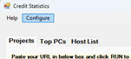

- Select PC List
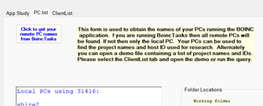
Click the button to get your list of PCs from boinctasks
- The PCs shown in red are offline
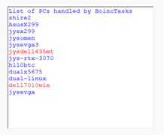
- You must now obtain the IDs assigned to those PCs by the project.
select the Client List tab and press the Query button
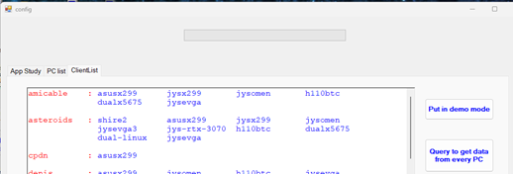
If the query button is not enabled then you need to do item (2) above.
- You can re-enter demo mode by clicking the Put in demo mode button.

