How to get anyone BOINC project credit information

You must find a BOINC users PC and obtain the Project ID for the project
- Bring up a BOINC project using any browser. For example using Bing or Google search for milkway at home
- Alternatively use application tab Top PCs, select one and click View Selected
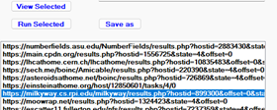

- Your URL may look like this:
https://milkyway.cs.rpi.edu/milkyway/results.php?hostid=899300&offset=0&state=4
- Highlight the URL and copy it into the windows clipboard.
- With the URL is in the clipboard select application tab Projects
- Click the PASTE button. The URL will be parsed for errors and a default study may be added.
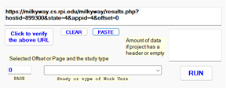

- Click the RUN button to obtain credit statistics

